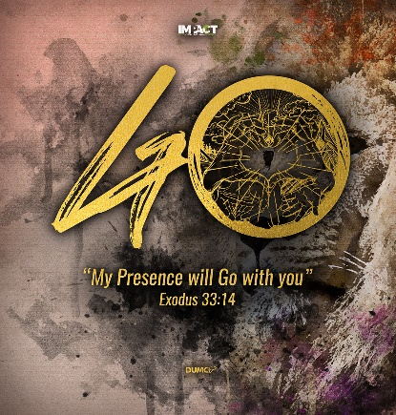
Apostles’ Creed VII: The Forgiveness of Sins
Matthew 18:21-35
Pastor Mike Ngui

Then Peter came to Jesus and asked, “Lord, how many times shall I forgive my brother or sister who sins against me? Up to seven times?” Jesus answered, “I tell you, not seven times, but seventy-seven times. “Therefore, the kingdom of heaven is like a king who wanted to settle accounts with his servants. As he began the settlement, a man who owed him ten thousand bags of gold was brought to him. Since he was not able to pay, the master ordered that he and his wife and his children and all that he had be sold to repay the debt. “At this the servant fell on his knees before him. ‘Be patient with me,’ he begged, ‘and I will pay back everything.’ The servant’s master took pity on him, canceled the debt and let him go. “But when that servant went out, he found one of his fellow servants who owed him a hundred silver coins. He grabbed him and began to choke him. ‘Pay back what you owe me!’ he demanded. “His fellow servant fell to his knees and begged him, ‘Be patient with me, and I will pay it back.’ “But he refused. Instead, he went off and had the man thrown into prison until he could pay the debt. When the other servants saw what had happened, they were outraged and went and told their master everything that had happened. “Then the master called the servant in. ‘You wicked servant,’ he said, ‘I canceled all that debt of yours because you begged me to. Shouldn’t you have had mercy on your fellow servant just as I had on you?’ In anger his master handed him over to the jailers to be tortured, until he should pay back all he owed. “This is how my heavenly Father will treat each of you unless you forgive your brother or sister from your heart.” (Matthew 18:21-35)

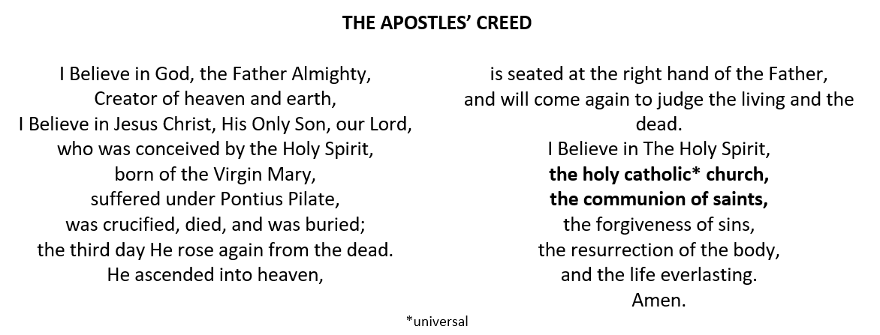
BIG IDEA:
Man’s unparalleled arrogance.
God’s incomparable forgiveness.

Introduction

“I believe in… the forgiveness of sins”

The sinfulness of man deserves the righteous, judgment of God. What is the big deal about ‘forgiveness of sin’? Why do we need to be reminded constantly about the forgiveness of sins?

The Problem: Recalcitrant Rebels
In Genesis 3, the serpent tempted Eve to be like God.

“For God knows that when you eat from it your eyes will be opened, and you will be like God, knowing good and evil.” (Genesis 3:5)

The temptation here is to be like God, not being under God’s rule, to rule and decide what is right and wrong for themselves, instead of taking it from God.

Sin is treason against God.

We who have sinned have rebelled against the righteous Creator King. If we are honest with ourselves, we would rather rule than be ruled. We want to be independent. The Bible calls this desire to be independent of all authority, most of all against God’s authority, treason.

Consequences of Man’s Treason
- “creation was subjected to frustration”
- “the whole creation has been groaning as in the pains of childbirth”

All of creation suffered the consequences of man’s treason against the rightful rule of God. Who is guilty of this treason? Everyone.

for all have sinned and fall short of the glory of God (Romans 3:23)

Every single one of us is guilty of this treason.

As for you, you were dead in your transgressions and sins, in which you used to live when you followed the ways of this world and of the ruler of the kingdom of the air, the spirit who is now at work in those who are disobedient. All of us also lived among them at one time, gratifying the cravings of our flesh[a] and following its desires and thoughts. Like the rest, we were by nature deserving of wrath. (Ephesians 2:1-3)

If we claim to be without sin, we deceive ourselves and the truth is not in us. (1 John 1:8)

What is the sentence for treason?

For as in Adam all die (1 Corinthians 15:22a)
We do not take sin seriously enough. Sin is not nice. To be told that you are wrong, and seriously wrong is not nice. People flock to preachers who preach the prosperity gospel, who preaches health and wealth. It is an appeal to our desires to lead better lives without acknowledging and recognising the real problem. Some prefers self-help, self-reliance, without the need for God. These treat the symptom, and not the disease. We must see sin as God sees it.

Sin is usurping God, as King.

When David became king, he forgot that he was king under God, Who is the King, and he did whatever he wanted. David raped Bathsheba and killed her husband Uriah, so that David will not be found out. But God exposed him through the prophet Nathan.

For I know my transgressions, and my sin is always before me. Against you, you only, have I sinned and done what is evil in your sight; so you are right in your verdict and justified when you judge. (Psalm 51: 3, 4)
David felt the enormity of sin and knew that he sinned against God. He knew he sinned against Bathsheba and Uriah. But he recognised that ultimately, his sin was that he usurped God’s rightful place in his life.

Sin is domesticating God.

Domesticating God is like reducing God to a nice, little package that we can control, that we like him in a particular way, we design Him to fit into our lives, not to an inconvenience for us

Our greatest sin of all amounts to nothing less than to want God to cease to be God. And we want to be God. We are asking God to step down from His throne so that we can be on that throne. Our sin wishes the Creator to relinquish His rightful role and claim to glory and give way to our will. This is serious.

What can we do about our sin? Absolutely nothing.
What do we need? We need to be forgiven.
Who does God send? God sent Christ who came to atone for us and took our place.
What is the solution?

The Solution: Glorious Grace

For Christ did not enter a sanctuary made with human hands that was only a copy of the true one; he entered heaven itself, now to appear for us in God’s presence. Nor did he enter heaven to offer himself again and again, the way the high priest enters the Most Holy Place every year with blood that is not his own. Otherwise Christ would have had to suffer many times since the creation of the world. But he has appeared once for all at the culmination of the ages to do away with sin by the sacrifice of himself. (Hebrews 9: 24-26)

Jesus came to do away with our sins. Christ alone is the sufficient sacrifice for our sins. We agree with the Bible that we need help, we cannot help ourselves. We also agree that it is God Who came to help us.
Here is a trustworthy saying that deserves full acceptance: Christ Jesus came into the world to save sinners—of whom I am the worst. (1 Timothy 1:15)

But God demonstrates his own love for us in this: While we were still sinners, Christ died for us. (Romans 5:8)

This is glorious grace of God. While we were still rebels, lifting up our fists in treason against God, Christ came to die for us.

For God so loved the world that he gave his one and only Son, that whoever believes in him shall not perish but have eternal life. (John 3:16)

This gift of eternal life is only possible because of the forgiveness of sins. This forgiveness is only possible because Christ died for our sins. Christ hanging on the cross was the culmination of salvation history. The greatest plot reversal in the story of mankind that God has worked on. All creations groaned waiting for that day. The promise in Genesis 3 to crush the head of the serpent was fulfilled that day when Christ hung on the cross, breathed his last and died, bearing our sins on Him. All the sacrifices that were offered yearly at the tabernacles were but shadows of the once-for-all sacrifice that happened that Friday afternoon at Calvary. The sins of humanity were laid on the back of Jesus Christ, the incarnate Son of God, the second person of the Trinity, and God poured out His wrath on His Son, that would have been and should have been ours to bear.

God made him who had no sin to be sin for us, so that in him we might become the righteousness of God. (2 Corinthians 5:21)

This is unimaginable. We the depraved, the rebels, the unfaithful, the adulterous, we who wished God would be no more, have Jesus, God Incarnate to pay the price for our treason, our rebellion, our insurrection. This is the glorious grace of God. We are given the full forgiveness and pardon of sin. The atoning work of Christ on the cross is the basis for our confession of the Apostles’ Creed “I believe in… the forgiveness of sins”. The offence is more than what our minds can comprehend. And yet, Christ bore our punishment fully.

What is the response of the Christian who confesses the Apostles’ Creed?

The Response: Forgiven and Forgiving
We need to learn to live forgiven. We need to recognise that our sins is the reason for our guilt, and admit it.

If we claim to be without sin, we deceive ourselves and the truth is not in us. If we confess our sins, he is faithful and just and will forgive us our sins and purify us from all unrighteousness. (1 John 1:8, 9)

When we confess our sins, when we acknowledge that we need forgiveness, God forgives us, and we can then live forgiven. Don’t live under the burden of guilt. Come to God and receive the forgiveness that is already yours in Christ Jesus. Live in that forgiveness and live forgiven.

For some, it is to live forgiving others as well. We need to recognise that we need to forgive each other as well as ourselves.

You wicked servant,’ he said, ‘I canceled all that debt of yours because you begged me to. Shouldn’t you have had mercy on your fellow servant just as I had on you?’ (Matthew 18: 32, 33)
What is Jesus’ point in this parable? If you have known forgiveness, you will need to learn to forgive others. Our sin against God is cosmic in scale. Our sin against one another is not cosmic in scale. If God forgives us for our cosmic-sized sins, should we not then forgive one another for our trivial offenses by comparison? Is there someone in your life who has offended, hurt you and is continuing to do so, and did not bother to apologise? What is the response of the Christian who has been forgiven? It is to forgive. We cannot learn to forgive until we realise that we ourselves have been forgiven. To understand the enormity of God’s grace when He forgives us, begins for us the place to forgive others.

When we confess the Apostles’ Creed, we remember and agree with God that we are sinners. We agree with God, of His glorious grace, sending Jesus Christ to this world to lay down His life for us.

Conclusion

One of Pastor Mike’s favourite movie is one that is entitled ‘The Mission’ which starred Liam Neeson, Jeremy Irons, Robert De Niro and others. The story is about a Spanish Jesuit priest, Father Gabriel played by Jeremy Irons, who enters this South American jungle, to build a mission station and convert a community, called the Guarani, to Christianity. The previous missionary had been massacred by these Guaranic Indians. They live above the spectacular Iguazu Falls. Father Gabriel goes to them and win them over. Another character is a mercenary and slaver Rodrigo Mendoza, played by Robert De Niro. He makes his living by kidnapping the natives and selling them to nearby plantations. He returns home to find his fiancée having an affair with his brother, Felipe. He killed Felipe in a duel in a rage. After realising what he had done, Mendoza spirals into depression. Father Gabriel visits Mendoza and challenges him to undertake penance for his gross sins. So, Mendoza agrees and he accompanies the Jesuits back to the Guarani. At the top of the Iguazu Falls, he was dragging a heavy bundle, in a rope net tied to his body carrying his armour and sword, representing his old life that he wanted to get rid of. The Guaranis greet Father Gabriel with much joy and celebration with Mendoza struggling and trailing behind. One of the Guarani boys recognised him as Rodrigo Mendoza, the mercenary slaver. He went to tell the Guarani chief, and what ensued was a pivotal moment in that movie.

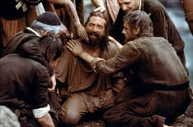
Initially, the Guaranis watched Mendoza with much suspicion and disdain. After some deliberation among themselves, a Guarani man ran towards Mendoza with a knife, holding it to Mendoza’s neck. The Guarani man then proceeded to cut off Mendoza’s heavy burden and threw it down the falls. Mendoza cried with much relief.

This is a tremendous picture of the need for and power of forgiveness. The power of forgiveness to set us free.

Sermon summary contributed by May.

