SBJn4: I Am the Living Bread
Senior Pastor Chris Kam

When they found him on the other side of the lake, they asked him, “Rabbi, when did you get here?” Jesus answered, “Very truly I tell you, you are looking for me, not because you saw the signs I performed but because you ate the loaves and had your fill. Do not work for food that spoils, but for food that endures to eternal life, which the Son of Man will give you. For on him God the Father has placed his seal of approval.” Then they asked him, “What must we do to do the works God requires?” Jesus answered, “The work of God is this: to believe in the one he has sent.” (John 6: 25-29)

Introduction

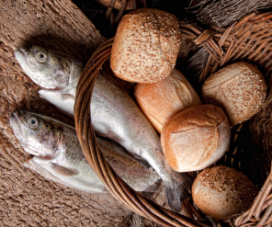
John 6 opens with the miracle of feeding the 5,000 men with only 5 small barley loaves and 2 fish. Despite the challenges calculated and acknowledged by the disciples, Jesus took what was offered, gave thanks and distributed the food – which resulted in 12 baskets of leftovers (John 6: 8-13) – proving that God can multiply what we already have, and multiply in abundance.

After that incident, Jesus went away because he knew that the people intended to come and make him king by force (John 6: 14-15). When some men finally found him, Jesus knew that they were looking for him because of the food given to them, not because of his teaching. In the same way, sometimes our desire for physical comforts drive us toward God. We need to be mindful and translate the desire for physical comfort into a desire for God.

BIG IDEA: Seek the Giver, not the gifts.

Jesus came to meet our needs
When they found him on the other side of the lake, they asked him, “Rabbi, when did you get here?” Jesus answered, “Very truly I tell you, you are looking for me, not because you saw the signs I performed but because you ate the loaves and had your fill. (John 6:25-26)

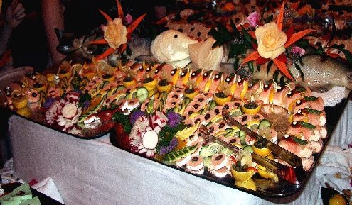
Many of us love food – so much so that we are willing to queue, drive long distances, and even take leaves to go on a food trip. Likewise, when there is a way to have an easy life, many would pay money to fengshui masters, bomohs, and visit various places of worship to boost up the chances to an easy life. But when it comes to church and related activities, suddenly the distance seems long and cumbersome.

That just shows that we have misplaced priorities. We need to get right with God, and stop working for the material things of this world. We need to understand that God is not interested in giving us the material comforts, but in making us holy and acceptable in his eyes. Acknowledging that whatever we do will not satisfy the void we feel inside, is the first step in recognizing God is the only one who can fulfil the needs in our lives. Jesus tells each of us to believe in Him, and that he will fulfil our needs.

Jesus came to give us eternal life
Then Jesus declared, “I am the bread of life. Whoever comes to me will never go hungry, and whoever believes in me will never be thirsty. (Joshua 6:35)

The Doomsday Clock is a symbolic clock face that represents a countdown to a possible global catastrophe – such as a nuclear war or climate change. It was first introduced in 1947 by the members of The Bulletin of the Atomic Scientists' Science and Security Board. As of 2016, the clock is at three minutes to midnight – a very bad prognosis for the world.

However, there is a hope in us from God above. Jesus’s coming and dying on the cross for our sins gives us that hope – eternal life in heaven with Him. For whatever reasons we have in coming to Him, we need to put our trust in Him and that He will give us something better, beyond our thoughts.
I am torn between the two: I desire to depart and be with Christ, which is better by far; but it is more necessary for you that I remain in the body. (Philippians 1:23-24)

Apostle Paul was longing for a better home, but as he also knows that he had to fulfil his calling and spread the Word of God to the Gentiles. Likewise, even as we look forward to spending eternity in His courts, we also need to ponder upon ourselves on why we are put here and for what purpose.

Jesus came to multiply the fruits of our lives
Jesus said to them, “Very truly I tell you, unless you eat the flesh of the Son of Man and drink his blood, you have no life in you. Whoever eats my flesh and drinks my blood has eternal life, and I will raise them up at the last day. For my flesh is real food and my blood is real drink. Whoever eats my flesh and drinks my blood remains in me, and I in them. (John 6: 53-56)

All of us have the need to consume to live. But here the consumption mentioned here is symbolic, where we ‘consume’ and allow the Holy Spirit to live in us and empower the life He has intended for us to have.

I am not saying this because I am in need, for I have learned to be content whatever the circumstances. I know what it is to be in need, and I know what it is to have plenty. I have learned the secret of being content in any and every situation, whether well fed or hungry, whether living in plenty or in want. I can do all this through Him who gives me strength. (Philippians 4:11-13)

Paul experienced life on both spectrums of rich and poor. Through the experiences, he found that to have a fulfilling life is to live God’s intention for us. It is about allowing God to come into our lives, to grow us and to add on blessings to our lives and to other around us.

Conclusion

God doesn’t need much to work with. After all, he fed the 5000 with only 5 barley loaves and 2 fish, yet there were 12 baskets of leftovers! All he needs is for us to surrender what we have to Him.
What will be your choice today?
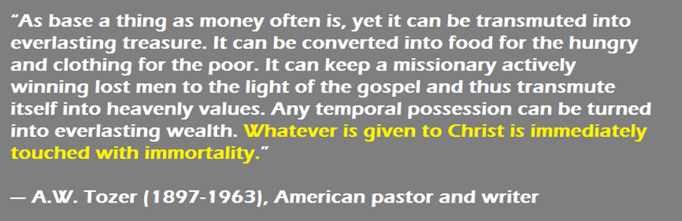

Sermon summary contributed by Adeliyn Lim
Prayer items by Chrisandra Wong

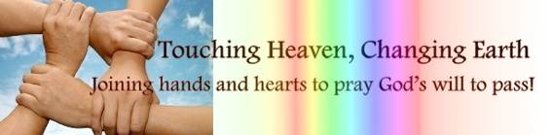

SERMON: I Am the Living Bread
Pray:
- Christians to seek first our Lord instead of what He is going to bless us with (Seek the Giver, not the gifts).
- As Christians, we will place our hope in God and not the world.
- We will be able to identify needs from wants and recognize God’s plan and purpose for us.
- We will consume the living bread in our lives, be a giver and blessing to other people.
This is the bread that came down from heaven. Your ancestors ate manna and died, but whoever feeds on this bread will live forever.” (John 6:58)

MINISTRIES & EVENTS: 3-Day Fast & Prayer / Church Morning Prayer
There will be a 3-Day Fast and Prayer from 11th to 13th October 2016 (Tuesday-Thursday) in DUMC.
Pray:
- God’s presence throughout the 3 days of fast and prayer.
- Christians will come and pray together.
- Christians to cast all worries to our Maker who made Heaven and earth.
- Personal encounter between Jesus Christ and those who seek.
- Energy for those who woke up early for the prayer and continue the day with work and errands.
- Journey mercy for those travelling to church before dawn.
- God’s anointing to be upon the speakers and all those who are serving.
"Then was a widow until she was eighty-four. She never left the temple but worshiped night and day, fasting and praying" (Luke 2:37)

MALAYSIA MY NATION: HFMD in Preschool and Nurseries
The country is on alert level following an outbreak of the hand, foot and mouth disease (HFMD) nationwide.
Pray:
- Nurseries and preschools to observe greater hygiene.
- Situation under control and that there will be no new outbreak.
- God’s healing upon those who were infected, both children and adults.
- Public awareness and prevention steps to be taken by all parties: Families, schools and businesses.
Do you not know that your bodies are temples of the Holy Spirit, who is in you, whom you have received from God? You are not your own; you were bought at a price. Therefore honor God with your bodies. (1 Corinthians 6:19-20)

- A TRANSFORMED WORLD: Matthew Hurricane in Western East Coast, USA.
States of emergency declared in Florida, Georgia, South Carolina and North Carolina for the life-threatening hurricane-force winds and flash flooding. The storm has killed hundreds in the Caribbean, almost entirely in Haiti. At least 300 people died in Haiti, four deaths reported in the Dominican Republic and one in St. Vincent and the Grenadines, and four people died as a result of the storm in Florida.

Pray:
- God’s mercy to be upon people living in the affected regions.
- God’s protection on those who are evacuating the affected areas as well as some who are reluctant to evacuate.
- Comfort and peace for all who are affected by this calamity.
- Perseverance, hope and courage for those affected as they rebuild their homes and businesses.
- People and nations to turn to God and repent, and that many will come to know Jesus as their Lord and personal saviour.
- People to demonstrate compassion and love during crisis such as this.
If calamity comes upon us, whether the sword of judgment, or plague or famine, we will stand in your presence before this temple that bears your Name and will cry out to you in our distress, and you will hear us and save us. (2 Chronicles 20:9)

