I am the Resurrection and the Life (John 11:1-44)
Pastor Mike Ngui

On his arrival, Jesus found that Lazarus had already been in the tomb for four days. Now Bethany was less than two miles from Jerusalem, and many Jews had come to Martha and Mary to comfort them in the loss of their brother. When Martha heard that Jesus was coming, she went out to meet him, but Mary stayed at home. “Lord,” Martha said to Jesus, “if you had been here, my brother would not have died. But I know that even now God will give you whatever you ask.” Jesus said to her, “Your brother will rise again.” Martha answered, “I know he will rise again in the resurrection at the last day.” Jesus said to her, “I am the resurrection and the life. The one who believes in me will live, even though they die; and whoever lives by believing in me will never die. Do you believe this?” “Yes, Lord,” she replied, “I believe that you are the Messiah, the Son of God, who is to come into the world.” (John 11:17-27)

Introduction
A man looks down as the plane makes its landing approach toward the airport. He sees the highway heading home is congested. From his vantage point, it seems people were getting out of their cars and even climbing onto them to try and see what was going on ahead. As the plane banked to make its landing, he then saw that the traffic was easing up a distance away. Secure with this knowledge from his perspective in the air, he got into his car upon landing, knowing that he would get home in good time; whereas the people stuck in traffic were bewildered and could not know what was going on from their perspective on the ground.
So it was when it came to take on Goliath – while the soldiers thought of him as a huge, undefeatable obstacle, David saw him only as a huge target that he couldn’t possibly miss.
Perspective makes the difference. We are earthbound and live and respond as such. If we could see differently, we would respond differently.
Jesus’s conversation with the two sisters, captured for us in the Book of John, demonstrates to us that we need to learn to consider the perspective from above, instead of being bound to the point of view of the man on the ground.

The Big Idea: In the face of death, Christ calls us to His life-giving perspectives

The Perspective of His Enduring Love (John 11:1-6)

A different perspective
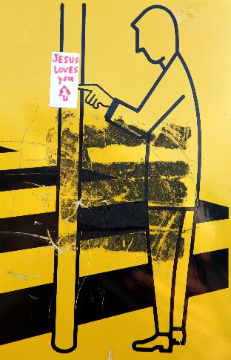
When he heard this, Jesus said, “This sickness will not end in death. No, it is for God’s glory so that God’s Son may be glorified through it.” (John 11: 4)
God sees what we cannot see, and from His perspective He can see all, whereas we cannot comprehend and question, “Why has this happened?” We may feel like Joseph, who was imprisoned by Potiphar in spite of doing everything right (Genesis 39), but still we must be faithful and trust in the Lord’s love for us.

A different way of loving
Now Jesus loved Martha and her sister and Lazarus. So when he heard that Lazarus was sick, he stayed where he was two more days (John 11: 5-6)
God loves us unconditionally, and therefore sometimes He waits until it is the right time for His intervention. We need to remember, God does not change his mind about us – His love for us is unchanging. Imagine how Mary and Martha felt while waiting for Jesus. They knew that Jesus could heal their brother, Lazarus. By the time Jesus arrived in Bethany, Lazarus was dead for 4 days.
Blessed are all who wait for Him (Isaiah 30:18), and let us stop and consider, what His intentions for us are, rather than to rail against Him (Romans 2:4).

The Perspective of His Eternal Truth (John 11:17-27)

Challenging the Lord
“Lord,” Martha said to Jesus, “if you had been here, my brother would not have died. But I know that even now God will give you whatever you ask.” Jesus said to her, “Your brother will rise again.” (John 11: 21-23)
Sometimes we are frustrated or disappointed with God, and we wish to surrender these feelings to the Lord. Even the Psalmist who speaks reverently manages to convey his resentment and frustration at times. God does not rebuke us for our frustrations, instead He response in love and truth.

He replies with the truth
Jesus said to her, “I am the resurrection and the life. The one who believes in me will live, even though they die; and whoever lives by believing in me will never die. Do you believe this?” “Yes, Lord,” she replied, “I believe that you are the Messiah, the Son of God, who is to come into the world.” (John 11: 25-27)
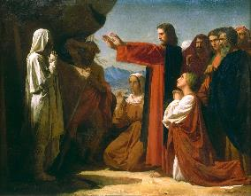
God is the source of life itself. He pushes our boundaries so that we may understand. Remember that He who came to give us life to the full is the One who conquered death and holds the keys of death and Hades (Revelation 1:18).
Ask yourself: Do you believe that the Lord can bring back to life the “dead” parts of you –relationships, dreams, expectations, health?
The truth will continue to remain true even if you don’t believe in it; so why not choose to believe and benefit from the truth today?

The Perspective of His Empathetic Presence (John 11:28-35)
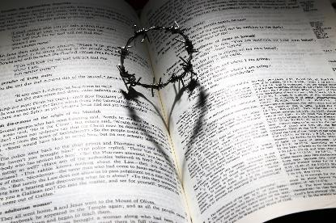
When Jesus saw her weeping, and the Jews who had come along with her also weeping, he was deeply moved in spirit and troubled. “Where have you laid him?” he asked. “Come and see, Lord,” they replied. Jesus wept. (John 11: 33-35)
The Lord is not a stoic, unfeeling God. Jesus is the imprint of the Father, who lived among us. If Jesus feels pain, the Father does too. God not only feels our pain, He feels the depth of our pain and weeps with us. Jesus empathizes with us (Hebrews 4:15).
John 11:35 is the shortest verse in the Bible (“Jesus wept”) but yet it shows us that Jesus feels and understands the pain we go through. God loves us no less in our “death”. He feels our pain.

Conclusion
Perspective is everything, especially in times of pain and sorrow. Look not at death and mourn – instead, invite the heavenly perspective despite of what you may be going through. Take comfort and know that He feels your pain.

The challenge for each of us this day is: Are you taking on His perspective in order to have life despite the pain?

Sermon summary contributed by Adeliyn Lim.
Prayer items by Prudence Tay

SERMON: I am the Resurrection and the Life
Pray:
- We will be patient as we wait for God’s timing and His answers.
- We will know truly the depth of God’s love for us that no matter what we have done or not done, God loves us dearly.
- We will come to God in times of our “death” and find life.
- We will believe that God is the true source of life.
Jesus said to her, “I am the resurrection and the life. The one who believes in me will live, even though they die; and whoever lives by believing in me will never die. Do you believe this?” (John 11:25, 26)

MINISTRIES & EVENTS: Vacation Bible School – Mission Him-Possible
Vacation Bible School (VBS) is for children aged 5 – 12 years old. It will be on December 1 – 3, 2016.
Pray:
- Children to sign up for this VBS.
- God to prepare the children and plant a word into their hearts.
- God’s hand upon all the logistics preparations for the VBS.
- God’s anointing upon the speakers, facilitators and helpers of the respective sessions and program.
Start children off on the way they should go, and even when they are old they will not turn from it. (Proverbs 22:6)

MALAYSIA MY NATION: Year End School Holidays
2016 is soon coming to an end and the school year for most will end by November 25th. People will be taking holidays and travelling back to their home towns.
Pray:
- Students who still have to attend school will be able to concentrate on their studies.
- Journey mercies for everyone who will be travelling during this season. Patience for all drivers when they are stuck in traffic jams while travelling.
- A good time of fellowship and bonding for families and friends as they spend time together.
- Protection upon the properties of people as they leave their homes vacant while travelling.
- Christian parents will make extra effort during this holiday to spent time with their children, teaching them the word of God.
Wives, submit yourselves to your husbands, as is fitting in the Lord. Husbands, love your wives and do not be harsh with them. Children, obey your parents in everything, for this pleases the Lord. Fathers, do not embitter your children, or they will become discouraged. (Colossians 3:18-22)

- A TRANSFORMED WORLD: Train Derailment in India
Once again a train in northern India has derailed, killing at least 90 people and injuring dozens more. It was travelling between the cities of Patna and Indore when it came off the tracks near Kanpur city. Fourteen carriages of the train derailed. There are still people trapped in the carriages.
Pray:
- Protection and wisdom upon the rescue workers as they continue to look for survivors.
- The injured will be attended to quickly.
- God’s comfort upon the injured and those that have lost their loved ones.
- During this time of tragedy, the people will find the true source of peace and comfort in our God.
- The cause of the derailment will be known and prevention of further derailment in India.
Even though I walk through the darkest valley, I will fear no evil, for you are with me; your rod and your staff, they comfort me. (Psalms 23:4)

