I am the Way, the Truth and the Life (John 14:1-31)
Pastor Gilbert Tan
“Do not let your hearts be troubled. You believe in God; believe also in me. My Father’s house has many rooms; if that were not so, would I have told you that I am going there to prepare a place for you? And if I go and prepare a place for you, I will come back and take you to be with me that you also may be where I am. You know the way to the place where I am going.”Thomas said to him, “Lord, we don’t know where you are going, so how can we know the way?”
Jesus answered, “I am the way and the truth and the life. No one comes to the Father except through me. If you really know me, you will know my Father as well. From now on, you do know him and have seen him.”
Philip said, “Lord, show us the Father and that will be enough for us.”
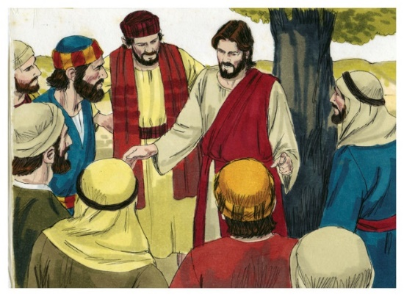
Jesus answered: “Don’t you know me, Philip, even after I have been among you such a long time? Anyone who has seen me has seen the Father. How can you say, ‘Show us the Father’? Don’t you believe that I am in the Father, and that the Father is in me? The words I say to you I do not speak on my own authority. Rather, it is the Father, living in me, who is doing his work. Believe me when I say that I am in the Father and the Father is in me; or at least believe on the evidence of the works themselves. Very truly I tell you, whoever believes in me will do the works I have been doing, and they will do even greater things than these, because I am going to the Father. And I will do whatever you ask in my name, so that the Father may be glorified in the Son. You may ask me for anything in my name, and I will do it. (John 14:1-14)

Jesus replied, “Anyone who loves me will obey my teaching. My Father will love them, and we will come to them and make our home with them. Anyone who does not love me will not obey my teaching. These words you hear are not my own; they belong to the Father who sent me.
“All this I have spoken while still with you. But the Advocate, the Holy Spirit, whom the Father will send in my name, will teach you all things and will remind you of everything I have said to you. Peace I leave with you; my peace I give you. I do not give to you as the world gives. Do not let your hearts be troubled and do not be afraid.
(John 14:23-27)

Introduction
Jesus started by saying to His disciples:

“Do not let your hearts be troubled…” (John 14:1)

In John 13, Jesus told the disciples what is to come namely that one of them will betray Him and that Peter will deny Him three times. It is sobering to wonder what will happen to us in the future. Likewise, Jesus tells us not to let our hearts be troubled, instead you should believe in God and believe in Christ. When times are difficult and challenging, God needs to be real in our hearts and not just in our heads. Do we actually know Christ?

Big Idea: Believe in God, Believe in Christ

The Doubt
After Jesus said to believe in Him, Thomas asked where Jesus was going to.
Thomas said to him, “Lord, we don’t know where you are going, so how can we know the way?” (John 14:5)

Sometimes we still face doubts especially in difficult and challenging times. We may doubt whether God is real. Despite doubts, we can trust in the Lord and believe that God is still in control in the midst of turmoil and difficulties and question marks in life. Whenever there is death, there will be doubts. We should also identify with Thomas because upon seeing the wounds of Christ, he had an immediate revelation of who the Lord was in his life. Similarly, in uncertainties and despair and struggle, Christ can reveal Himself to you powerfully.
Thomas said to him, "My Lord and my God!" (John 20:28)

Thomas, among the twelve, would go the furthest to preach the gospel. He went to India to share the Gospel and poured out his life to the Indians. As he cried out “Lord Jesus, I love you!”, he was speared to death. He was changed and transformed after encountering Christ.
In moments of doubt and uncertainties, let this be a catalyst of new revelation of Christ in your life.
How can we know the way? Jesus gave one of the most powerful answers to all of us: I am the way, I am the truth and I am the life. Even in the midst of troubles, we do not give up because Jesus is with us at all times.

The Answer
Jesus answered, “I am the way and the truth and the life. No one comes to the Father except through me. (John 14:6)
Jesus was speaking to the disciples, wanting them to be encouraged.

I am the WAY
He wants us to follow Him and take the ‘Jesus way’. The ‘Jesus way’ is as stated:

“Enter through the narrow gate. For wide is the gate and broad is the road that leads to destruction, and many enter through it. But small is the gate and narrow the road that leads to life, and only a few find it. (Matthew 7:13-14)

In a narrow road, we cannot see what is ahead beyond a few steps. You may not know where you are going. However, Jesus is with us at all times. He may not tell us where to go but He is with us every step of the way. The narrow road can be lonely and difficult to travel on. Only Christ may know where you are going to.

Keep your eyes straight ahead; ignore all sideshow distractions. Watch your step, and the road will stretch out smooth before you. Look neither right nor left; leave evil in the dust. (Proverbs 4:26-27 The Message)
We are on a long-haul journey with ups-and-downs in life. We can trust that God is sovereign and He is good despite the bumps in life. God says to us to keep walking ahead, regardless of how big our steps are. If we slow down, we lose momentum. Christ is with us every step of the way.

I am the TRUTH
All words from God are true and absolute. The Bible is the truth. Christ is the Living Word in us. Are we truly alive right now? Do the words that we read give us life?

They asked each other. “Were not our hearts burning within us while he talked with us on the road and opened the Scriptures to us?” (Luke 24:32)
Truth reveals our sinful nature. The Word of God reveals the wickedness of our hearts.
Your word is a lamp for my feet, a light on my path. (Psalm 119:105)
If we are distracted by sin, the Word of God brings light so we can return to the right path.

How often do we come before the Word of God and do we read the Word of God daily? Read the Word of God as it gives us life.

I am the LIFE
Jesus is not here to enrich our lives only but to give us eternal life and to be in His Presence forever. We should not be caught in things that are temporal. We should also share this life with our friends and share the gospel to others at all times and at all places. As followers of Christ, we should have a bigger perspective of what life is and share the eternal life that we have with others as well. We have life eternally and life abundantly.

The Revelation
Philip said, “Lord, show us the Father and that will be enough for us.” (John 14:8)

The keyword in John 14 is the Father. Jesus is showing us the way to God the Father and wants us to believe in the Father. Our heavenly Father wants to be intimate and personal with us. When we talk to our earthly Fathers, there is a sense of affection and love. Some may have absentee fathers, but God wants to tell us that He is our heavenly Father.

Jesus shows us the love of the Father towards us.

Don’t you believe that I am in the Father, and that the Father is in me? The words I say to you I do not speak on my own authority. Rather, it is the Father, living in me, who is doing his work. Believe me when I say that I am in the Father and the Father is in me; or at least believe on the evidence of the works themselves. (John 14:10-11)

The works Jesus has done are the works God the Father is involved in as well.

Jesus replied, “Anyone who loves me will obey my teaching. My Father will love them, and we will come to them and make our home with them. (John 14:23)

Jesus and the Father will come to you and make their home with you. The Holy Spirit will also be sent to you.
But the Advocate, the Holy Spirit, whom the Father will send in my name, will teach you all things and will remind you of everything I have said to you. (John 14:26)

You have God the Father, Jesus the Son and the Holy Spirit with you at all times. Therefore, you do not need to be troubled and have doubts.

However, there is a condition: obedience. What parents desire is obedient children. Likewise, the Father desires that we obey Him at all costs. Obedience is the requirement that God seeks from us.

Conclusion
We may have troubled hearts and doubts and we are looking for peace in life. Only God the Father can provide it. The rest the world offers is fragile, elusive and temporal. We always have to work out this worldly peace on our own – this is not the way of the Father

Peace I leave with you; my peace I give you. I do not give to you as the world gives. Do not let your hearts be troubled and do not be afraid. (John 14:27)

Peace and rest given to us is eternal. There is healing and restoration that God the Father gives to us.
My heart is not proud, Lord, my eyes are not haughty; I do not concern myself with great matters or things too wonderful for me.
But I have calmed and quieted myself, I am like a weaned child with its mother; like a weaned child I am content. (Psalm 131:1, 2)

David had a great understanding of God and he had a personal relationship with God. He understood what it is to be a child before God. The picture is that of a child content in the mother’s arms – at rest and with no cares of life because the Lord takes care of His child. This child is a calm and quietened soul.
How calm and quiet is your soul? Even in the midst of difficult situations, we can remain calm and rested like a child in the storms of life because God the Father is in control.
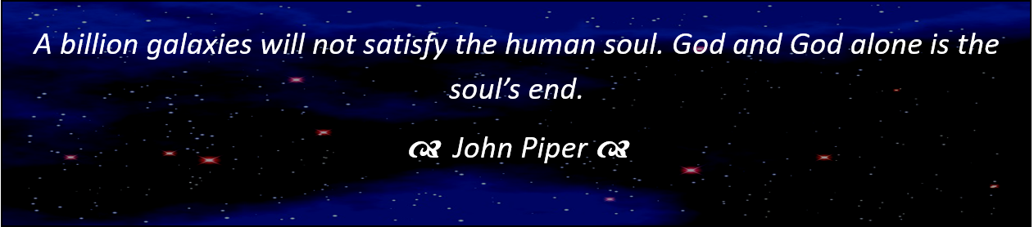
Sermon summary contributed by Zhenli
Prayer pointers contributed by Abbey

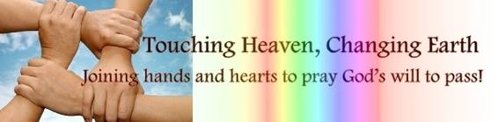

SERMON: I am the way, the truth and the Life
Pray:
- We will accept Jesus as the I Am God who is concerned about us.
- We will truly believe in a God we cannot see.
- We will encounter God’s Word every day because Jesus is alive.
- We will believe that Jesus is the way and he is always there with us.
- We will look forward to spending an eternity with God.
Jesus answered, "I am the way and the truth and the life. No one comes to the Father except through me. (John 14:6)

MINISTRIES & EVENTS: Children Zone Vacation Bible School
Pray:
- Spiritual protection for the teachers and the organization team.
- Parents of non-believers will send their children to the VBS.
- Children will be well-behaved and have open hearts.
- Teachers will have the patience to handle the children.
- God’s name will be glorified and his power will be seen in the VBS
But Jesus called the children to him and said, "Let the little children come to me, and do not hinder them, for the kingdom of God belongs to such as these. (Luke 18:16)
MALAYSIA MY NATION: TRAFFICKING OF BABIES
KUALA LUMPUR: Bukit Aman has refuted allegations by Al-Jazeera that Malaysia is a hub for the sale of babies. Inspector General of Police Tan Sri Khalid Abu Bakar said the 25-minute documentary by the media network, which aired on Nov 25, portrays Malaysia as a booming hub for sales of babies, with syndicates working together with civil servants. "The documentary also claims that the syndicate involved a network of traffickers, doctors and government officials allegedly involved in the trafficking of babies. (thestar.com)
Pray:
- Instead of being defensive, our country will work and investigate this case fairly.
- Malaysians will treat all children as their own and protect them without totally blaming the police or the government.
- Hospitals will be working together and handling these cases transparently, fairly and justly.
- The media will be more transparent in telling news without any biases.
- Christian churches will help in any way they can.

Lord, are you not from everlasting? My God, my Holy One, you will never die.
You, Lord, have appointed them to execute judgment; you, my Rock, have ordained them to punish. (Habakkuk 1:12)

- A TRANSFORMED WORLD: Islamophobia
LOS ANGELES - Hateful letters sent anonymously to three mosques in California with a warning that President-elect Donald Trump would "cleanse" the United States of Muslims have stirred fears among congregants, a community leader said on Saturday. Hussam Ayloush, executive director of the Los Angeles chapter of the Council on American-Islamic Relations, said the letters were identical and were postmarked as being sent from Santa Clarita just north of Los Angeles. (Reuters)
Pray:
- Christians will be an example of peace and tolerance to the Muslims.
- The election of Trump will not cause fear to the Muslims.
- Americans, regardless of their beliefs will continue to live their lives normally without any fear.
- People will be wise to separate rumours from the truth and act accordingly.
Make every effort to keep the unity of the Spirit through the bond of peace. (Ephesians 4:3)

