A Three-Part Series on the Book of Joshua: Legacy Makers – What will you leave behind? Part One
SBJ2: The Harlot, the Scarlet Thread and Other Stories (Joshua 2)
Pastor Alex Tan
Then Joshua son of Nun secretly sent two spies from Shittim. “Go, look over the land,” he said, “especially Jericho.” So they went and entered the house of a prostitute named Rahab and stayed there. The king of Jericho was told, “Look, some of the Israelites have come here tonight to spy out the land.” So the king of Jericho sent this message to Rahab: “Bring out the men who came to you and entered your house, because they have come to spy out the whole land.” (Joshua 2:1-3)

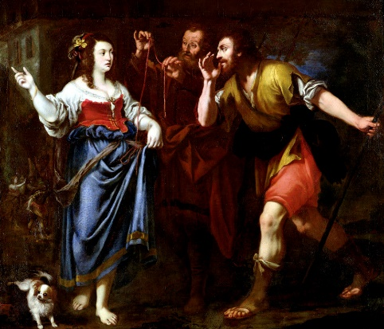
Before the spies lay down for the night, she went up on the roof and said to them, “I know that the LORD has given you this land and that a great fear of you has fallen on us, so that all who live in this country are melting in fear because of you. We have heard how the LORD dried up the water of the Red Sea for you when you came out of Egypt, and what you did to Sihon and Og, the two kings of the Amorites east of the Jordan, whom you completely destroyed. When we heard of it, our hearts melted in fear and everyone’s courage failed because of you, for the LORD your God is God in heaven above and on the earth below. “Now then, please swear to me by the LORD that you will show kindness to my family, because I have shown kindness to you. Give me a sure sign that you will spare the lives of my father and mother, my brothers and sisters, and all who belong to them – and that you will save us from death.” (Joshua 2:8-13)

Now the men had said to her, “This oath you made us swear will not be binding on us unless, when we enter the land, you have tied this scarlet cord in the window through which you let us down, and unless you have brought your father and mother, your brothers and all your family into your house. (Joshua 2:17-18)

When they left, they went into the hills and stayed there three days, until the pursuers had searched all along the road and returned without finding them. Then the two men started back. They went down out of the hills, forded the river and came to Joshua son of Nun and told him everything that had happened to them. They said to Joshua, “The LORD has surely given the whole land into our hands; all the people are melting in fear because of us.” (Joshua 2:22-24)

By faith the prostitute Rahab, because she welcomed the spies, was not killed with those who were disobedient. (Hebrews 11:31)

Brief synopsis of the book of Joshua and the Sermon Series

Moses left a legacy (heritage) for Joshua and nation of Israel. The book is divided like a sandwich. The top slice (Chapter 1) describes the commissioning of Joshua as a leader. The bottom slice (Chapters 23 and 24) talk of Joshua’s final sermon and his death and burial. In between is the account of how Israel possessed the land that God had promised them.
Chapters 2-5: Cover the entering of the land of Canaan through the crossing of River Jordan.
Chapters 6-12: Detail how they conquered the land, with a list of the 31 kings that Joshua defeated being given in Chapter 12.
Chapters 33-22 cover the dividing of the land between the tribes who had conquered it.
Moses had led Israel out of Egypt and now Joshua would lead them into the Promised Land. The Law is not mentioned in the book of Joshua. Instead, we have the practical outworking of the Law and Promises mentioned in previous books. Every story in this book illustrates a simple principle. “Follow me, you win. Leave me, you lose.” Or, to put it another way, “Obedience brings blessings. Disobedience brings curses.” It is a choice. Joshua succinctly put it this way: “But as for me and my household, we will serve the LORD.” (Joshua 24:15)
Moses left a legacy for Joshua, an indelible mark in Joshua’s life. Joshua watched how Moses lived his life as he (Moses) followed God, and learnt what cost Moses the opportunity of entering the Promised Land. We are stewards of what and who God has entrusted to us. Whether or not we are intentionally mentoring another person, someone is always being influenced by observing how we live our lives. As good stewards, we must take this privilege seriously by being intentional in leaving our legacy to the next generation – What have we been given, and what will we do with it the rest of our life?

Introduction
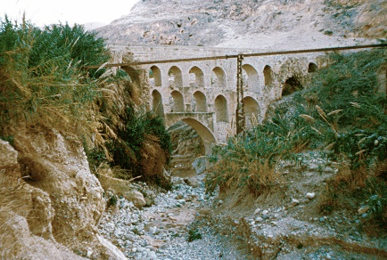
Joshua 2 is located in the midst of the story of Jericho. God had told Joshua to be strong and courageous. The fourth time, however, these words came from the people. Similarly we should encourage our pastor to be strong and courageous.

It would have been controversial for the two spies to enter the house of a prostitute. Two spies were saved but not first without an agreement and an oath to secrecy. The other condition was that Rahab would tie a scarlet cord to the window through which they escaped. When the spies came back to Joshua after three days of hiding, this is what they had to say:

“The Lord has surely given the whole land into our hands; all the people are melting in fear because of us.” (Joshua 2:24)

This story is a game-changer not because God cannot conquer the land without a prostitute, but because he would not without Rahab. God includes people in the picture. He includes people who are misfits, broken and frowned upon by society. This is one story of a misfit who fits the sovereign plan of God. What is your story?

Big Idea: Surrender your story to God’s bigger story to leave behind a legacy.

The harlot: what’s her story

God looks beyond labels and meets us where we are.
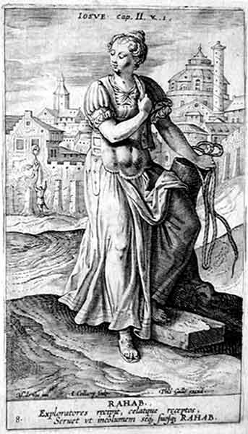
Rahab played a part to welcome the spies in. Hers was a profession which would not even let her stand a chance to get married. Prostitution is not commonly a choice but due to circumstances. God did not wait for Rahab to clean up her act. Right where she was at, in her current label that she carried, God stepped in. There was a scarlet thread or cord that was woven through her life story. God does not wait for us to be respectable before he uses us.

God looks for faith; not perfection
We should look to be more like Jesus but God looks for faith. Rahab had faith. Faith saved her. By faith, she welcomed two spies and that is why she was saved.

And without faith it is impossible to please God, because anyone who comes to him must believe that he exists and that he rewards those who earnestly seek him. (Hebrews 11:6)

She was willing to betray her own people and risk her own life and that of her family for this God

Rahab was surrounded by a hostile and awesome environment…she was still surrounded by a monolithic mentality, and entire world-view. She was pressured by a powerful city and an ancient culture… At the moment she could see nothing with her eyes which indicated it would fall…[Nevertheless] Rahab knew! And what she knew was totally against her culture. She believed in a new God, a God totally and diametrically opposed to the gods of Jericho…she stood for the unseen against the seen, standing in acute danger until Jericho fell. (Francis Schaeffer)

Rahab was not perfect. In fact she lied. In the midst of her imperfection and flaws, God used her and she was saved by faith.

God’s mercy does not leave us where we are
God’s character is redemptive. Rahab was found in the lineage of Jesus as Rahab married Salmon and the lineage continued right up to David. This woman was controversial. God stepped in and she was instrumental in bringing forth Jesus. God’s mercy does not leave us where we are. You may have been struggling, questioning, at a crossroads, messed up, grieved, hurt or angry with God but God is merciful and He is able to change and comfort you.

The scarlet thread: what’s the story
Scarlet in ancient times spoke of royalty. Scarlet also speaks of sin and sinfulness. There is a certain paradox in speaking of the sinful one and sinless one. In the story of Tamar in Genesis, there is a scarlet thread as well.

As she was giving birth, one of them put out his hand; so the midwife took a scarlet thread and tied it on his wrist and said, “This one came out first.” But when he drew back his hand, his brother came out, and she said, “So this is how you have broken out!” And he was named Perez. Then his brother, who had the scarlet thread on his wrist, came out. And he was named Zerah. (Genesis 38:28-30)
“Come now, let us settle the matter,” says the Lord. “Though your sins are like scarlet, they shall be as white as snow; though they are red as crimson, they shall be like wool. (Isaiah 1:18)

Jesus was also asked to put on a scarlet robe:

They stripped him and put a scarlet robe on him (Matthew 27:28)

It is a thread of destiny. God had determined that He would send His son to die upon the cross. The scarlet thread was woven throughout scripture and history. Even during the Passover, the doorposts were sprinkled with blood so that there will not be any death in those families.

Rahab’s immoral background was no disqualifier from her redemptive destiny through the atoning work of Christ on the cross, where His blood was shed for us.
They stripped him and put a scarlet robe on him, and then twisted together a crown of thorns and set it on his head. They put a staff in his right hand. Then they knelt in front of him and mocked him. “Hail, king of the Jews!” they said. They spit on him, and took the staff and struck him on the head again and again. After they had mocked him, they took off the robe and put his own clothes on him. Then they led him away to crucify him. (Matthew 27:28-31)

Jesus went through death, burial and resurrection as part of the redemptive plan of a loving Father who meets you where you are.

But now in Christ Jesus you who once were far away have been brought near by the blood of Christ. (Ephesians 2:13)

The scarlet thread is part of a tapestry woven together. Your story is part of this bigger story. Each of us has stories of brokenness, of misfits and labels but God is at work.

Other stories: What’s yours?

We have heard… (Joshua 2:10-11)
We have heard how the LORD dried up the water of the Red Sea for you when you came out of Egypt, and what you did to Sihon and Og, the two kings of the Amorites east of the Jordan, whom you completely destroyed. When we heard of it, our hearts melted in fear and everyone’s courage failed because of you, for the LORD your God is God in heaven above and on the earth below. (Joshua 2:10-11)

Stories inspire faith. Rahab heard stories, possibly through her clients. Stories were being shared even at the place of work. Everyone’s courage was failing because of these stories. The Bible is filled with stories of faith, trust and obedience to a God who delivers. This God is still at work today and we need to remember stories in the Bible of faith and victories. There are stories of God’s favour and grace upon our church. May the next generation hear and see God at work in our lives. How do we capture these stories?

“Hashtagged” stories
Hashtags bring alignment to our thoughts. We need to share our stories whether verbally or on social media. Our stories need to be “hashtagged” with God. May our stories contain or reveal God’s faithfulness and point people to Christ. Each of us has a “hashtagged” story. Each of us has a story to share.

Pastor Alex has been trying to share the stories of people who are serving. Even if we do not have epic stories, small stories also need to be told and “hashtagged”. There are stories in our midst worth sharing in our local community. Every story can be part of the bigger story. We can use technology and social media as a powerful tool to share stories and see what God is doing globally or nationally and be inspired.

Conclusion
Stories of our own people can be captured. What is your story and how can your story fit into the greatest story ever told – the Jesus story? Legacy makers, surrender your story to God’s bigger story to leave behind a legacy.

As we reflect upon the life of Rahab and how she was saved, for some of us we need to encounter a certain divine interruption by a God who wants to bring us to an eternal destiny. Some of us need to bring our sin and brokenness to Jesus and His call upon our lives. The Bible is filled with stories of misfits and impossible situations where God breaks through. Bring your brokenness and sin to Jesus today and embrace His love and His call upon your life. Some of us need to tell our stories more, in order to mentor and disciple others.

Encounter God, bring your sin and brokenness, and join others to tell your story. Find your identity in Christ.

Sermon summary contributed by Zhenli.
Prayer items by Loong.

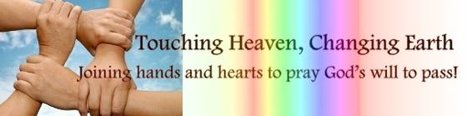

SERMON: Studies in the Book of Joshua Legacy Makers – What will you leave behind?
Pray:
- Understanding that our background does not stop God from choosing us to do His work, church members will step up to God’s calling.
- We will not be discouraged by our strife for perfection or past transgression, instead, we choose to put our faith in God.
- We will obey God and allow our life stories to be interwoven with God’s story.
- We will live with a deliberate and conscious purpose to leave a great legacy.
And without faith it is impossible to please God, because anyone who comes to him must believe that he exists and that he rewards those who earnestly seek him. (Hebrews 11:6)

MINISTRIES & EVENTS: Chosen: A Man’s Conference
`DUMC will host Chosen: A Man’s Conference with speakers Patrick Morley (author of Man in the Mirror) and Senior Pastor Chris Kam from 20/10/2016 to 22/10/2016 in the Dream Centre.
Pray:
- Men from different churches will register and attend this conference, especially the session on first day for future leaders / leaders and pastors.
- Delegates will find out the men God intended them to be and step up to play the role effectively in the Kingdom of God.
- Men will discover the importance of their role in a family and help transform the family and the community.
- Men will network with one another in their Christian walk.
Be watchful, stand firm in the faith, act like men, be strong. (1 Corinthians 16:13)
MALAYSIA MY NATION: Truth to prevail
More and more discoveries are made as investigations on the 1MDB funds started in many fronts.
Pray:
- Anyone who broke the law for their own interests will be brought to a court of law, tried fairly with punishment meted out justly.
- The truth will be exposed, attempts to cover up will fail.
- The people will observe the unfolding of the events calmly and not be played into the hands of those who would stoke the sentiments of the people for their own interest.
- The people will learn the truth.
- Those the people put in positions of power to represent them will learn to carry out their responsibilities with integrity.
- The dignity of Malaysia will once again be restored, no longer will it be seen as a nation reeking with corruption, nepotism, quality of education, human trafficking, etc.
But let justice roll on like a river, righteousness like a never-failing stream! (Amos 5:24)

- A TRANSFORMED WORLD: Suicide Bombing in Kabul
A 3-pronged suicide bombing rocked Kabul, the capital of Afghanistan and killed 81, injured 286. The attack happened at Dehmazamg Square near the Kabul Zoo on the main road to the Parliament. There was a demonstration demanding the building of a regional electrical line in the impoverished home region.

Pray:
- The authorities will be able to restore order quickly.
- Peace be upon the injured and family and friends of those who perished.
- The perpetrators will be identified with actions taken against them.
- The law enforcement body will be able to deter and prevent such heinous acts of violence.
- The church in Afghanistan will be able to bring hope and comfort to the people and bring them to know Christ.
God is our refuge and strength, an ever-present help in trouble. (Psalm 46:1)

