A Three-Part Series on the Book of Joshua: Legacy Makers – What will you leave behind? Part One
SBJ3: Crossing the Impossible Situations
(Joshua 3-4)
Reverend Dr T. Jeyakumar
Early in the morning Joshua and all the Israelites set out from Shittim and went to the Jordan, where they camped before crossing over. After three days the officers went throughout the camp, giving orders to the people: “When you see the ark of the covenant of the Lord your God, and the Levitical priests carrying it, you are to move out from your positions and follow it. Then you will know which way to go, since you have never been this way before. But keep a distance of about two thousand cubits between you and the ark; do not go near it.” Joshua told the people, “Consecrate yourselves, for tomorrow the Lord will do amazing things among you.” Joshua said to the priests, “Take up the Ark of the Covenant and pass on ahead of the people.” So they took it up and went ahead of them. And the Lord said to Joshua, “Today I will begin to exalt you in the eyes of all Israel, so they may know that I am with you as I was with Moses. Tell the priests who carry the Ark of the Covenant: ‘When you reach the edge of the Jordan’s waters, go and stand in the river.’” (Joshua 3:1-8)

On the tenth day of the first month the people went up from the Jordan and camped at Gilgal on the eastern border of Jericho. And Joshua set up at Gilgal the twelve stones they had taken out of the Jordan. He said to the Israelites, “In the future when your descendants ask their parents, ‘What do these stones mean?’ tell them, ‘Israel crossed the Jordan on dry ground.’ For the Lord your God dried up the Jordan before you until you had crossed over. The Lord your God did to the Jordan what he had done to the Red Sea when he dried it up before us until we had crossed over. He did this so that all the peoples of the earth might know that the hand of the Lord is powerful and so that you might always fear the Lord your God.” (Joshua 4:19-24)

Introduction
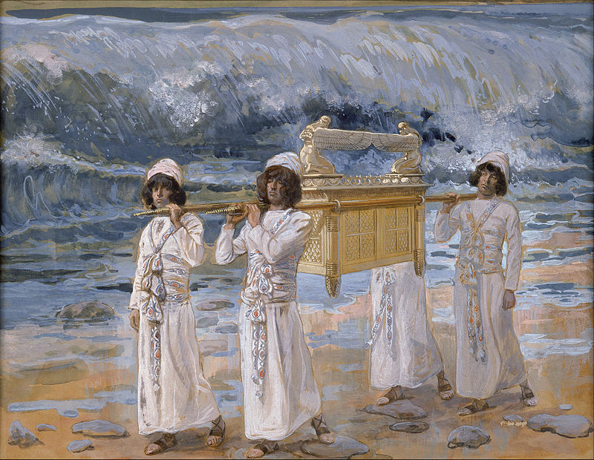
Israel had just completed 40 years in the wilderness, leaving only 2 living witnesses of the miraculous Red Sea crossing. God has just spoken to the Israelites to cross the river Jordan, which was now at flood stage. Following our human senses and reasoning, this task would be impossible. But by God’s instruction, the Levitical priests carried the Ark of Covenant and all Israelites witnesses the river ‘piled up in a heap a great distance away, at a town called Adam in the vicinity of Zarethan, while the water flowing down to the Sea of the Arabah (that is, the Dead Sea) was completely cut off.’ (Joshua 3:16b) Everyone crossed the river dry and safely.
Big Idea: The impossible is possible with God

Reaching the Impossible

The forward movement in faith unleashed God’s power
Joshua told the people, “Consecrate yourselves, for tomorrow the Lord will do amazing things among you.” (Joshua 3:5)
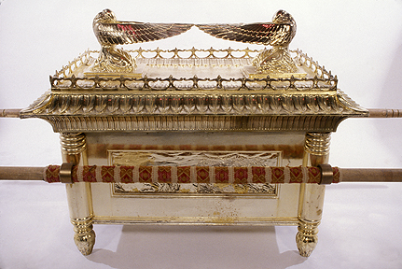
The Ark of Covenant was a physical representation of the invisible presence of God to the Israelites. It meant that as the Levitical priests carried the Ark and lead the people to the surging river, God was going before the people. And because the people followed in faith, they completed the crossing on dry ground. They saw the power of God in their obedience and faith.

Likewise, we are not to guess what God will do. Our eyes are to be focused on Him who is able, and not our circumstances. Reverend William Bridge (1600-1670) once said “God the father opens his hand by degrees, first one finger, then another, and then another, and at last his whole hand.” God will show His plans for us one at a time. We just need to follow in faith.

The forward movement in faith was based on facts
And the Lord said to Joshua, “Today I will begin to exalt you in the eyes of all Israel, so they may know that I am with you as I was with Moses. Tell the priests who carry the ark of the covenant: ‘When you reach the edge of the Jordan’s waters, go and stand in the river.’” (Joshua 3:7-8)
The decision to cross the river Jordan was because God said so. Joshua and the people had been waiting on the Lord for the next course of action. They could have crossed the river in the dry season when the river was low. But God had something else in mind: to teach the Israelites to learn faith. God intended for them to cross the river when it was at flood stage.
The fact is: God spoke to the Israelites. And in faith, they responded by taking instructions from God. For us to act in faith, we need to first hear God say it; because faith takes instructions from God.

Remembering the Impossible
On the tenth day of the first month the people went up from the Jordan and camped at Gilgal on the eastern border of Jericho. And Joshua set up at Gilgal the twelve stones they had taken out of the Jordan. He said to the Israelites, “In the future when your descendants ask their parents, ‘What do these stones mean?’ tell them, ‘Israel crossed the Jordan on dry ground.’ For the Lord your God dried up the Jordan before you until you had crossed over. The Lord your God did to the Jordan what he had done to the Red Sea when he dried it up before us until we had crossed over. He did this so that all the peoples of the earth might know that the hand of the Lord is powerful and so that you might always fear the Lord your God.” (Joshua 4:19-24)

The 12-stone memorial us the inform the future generations if God’s power
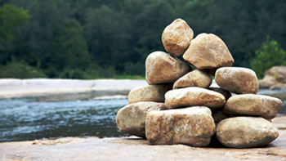
It is to remind the future generations of Israelites of where and what had happened. There was no inscription to mark the place. The testimony of God’s work and the Israelites’ faith was meant to be passed down from generation to generation. It also served as a reminder that their lives were meant to be a memorial passed down to the generations.
Chris Boyatzis, Professor of Psychology at Bucknell University once remarked that there were 3 crucial components to be passed on the children.
- Integrity – articulates our lives and values.
- Intentionality – living intentionally & mindfully; think about what you want to children to be).
- Accountability – be accountable to people around us, to God and to the community of faith.

The 12-stone memorial is to help cultivate the fear of God
He did this so that all the peoples of the earth might know that the hand of the Lord is powerful and so that you might always fear the Lord your God.” (Joshua 4:24)
The fear of God is a central idea. The word “fear” in this context is to have the highest respect or to hold in awe – because God is great and holy. It is to remind us that no matter how close we are to God, we are to always respect and have feelings of awe towards God.

Conclusion
Without God, situations and circumstances will always present themselves as impossible. Therefore, do not leave God out of the equation. Involve Him in everything because He has plans for each and every one of us. He will take us through every situation and circumstance, even life itself.

Start thinking that the impossible is possible when God is leading. Would you let Him get involved with you?

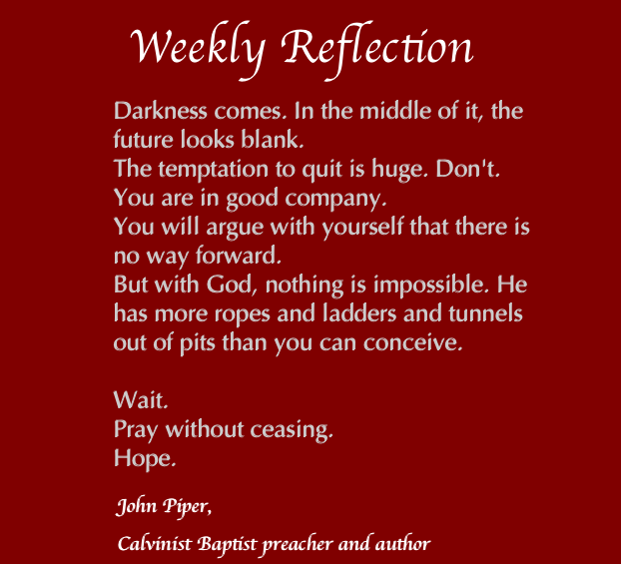

Sermon summary contributed by Adeliyn Lim.
Prayer items by Prudence Tay.

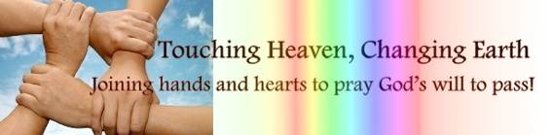

SERMON: Crossing the Impossible Situations
Pray:
- We will read and know the Word of God and build our faith on it.
- We will trust God to help us overcome the things in our lives or the situations we are in that seem impossible.
- We will live our lives according to God’s ways as an example to the younger generations around us.
- Went God tells us to do something, we will trust and do it even though we cannot see the final outcome.
Joshua told the people, “Consecrate yourselves, for tomorrow the Lord will do amazing things among you.” (Joshua 3:5)

MINISTRIES & EVENTS: Faith@work Forum: Excelling in your work
4 August 2016
Pray:
- God’s anointing upon all the people who will be speaking and sharing during the Forum.
- Many adults will attend this forum.
- The participants, will learn how to honour God in their work places.
- God will do a deep work in the participants work attitudes.
- As these participants go into their individual work places, they will bring God with them and change their work place.
Whatever you do, work at it with all your heart, as working for the Lord, not for human masters, (Colossians 3:23)
MALAYSIA MY NATION: Heavy rains and Flash flood
That time of the year is upon us where we get heavy downpour of rain. This will subsequently cause flash floods as some of our drainage systems cannot cater for the sudden excess of water.
Pray:
- People will be mindfully to throw rubbish in the correct places and not clog up drains.
- The relevant authorities will maintain our drainage systems and even improve it where necessary.
- Alertness of drivers when driving in the heavy rains and being careful and cautious when driving into water puddles.
- God’s hand upon our weather in preventing prolong rain fall that will result in flash floods.
He provides rain for the earth; he sends water on the countryside. (Job 5:10)

- A TRANSFORMED WORLD: Terrorist attacks in Europe
There has been a spate of violence and terrorist attacks around the world and we hear of many in the European countries. The latest being the slaying of a priest in Normandy, France in the name of ISIS.
Pray:
- Peace and comfort for the community as they deal with this situation.
- For the local Muslim community and leaders as they refuse to bury (unless asked by the authorities) the terrorist who was shot dead in the aftermath of the slaying, saying that, “they did not want to ‘taint’ Islam by having any association”.
- Alertness and protection of governments and security agencies as they fight against terrorist attacks.
- People will be aware of any suspicious behaviour of people around them.
- People fear God above the fear of the terrorist and place their trust in God.
- God’s hand upon this world and the treat of terrorist attacks.
God is our refuge and strength, an ever-present help in trouble. Therefore we will not fear, though the earth give way and the mountains fall into the heart of the sea, (Psalm 46:1-2)

