Servers and Senders I: The Empty Tomb (John 20)
Pastor Bill Wilson

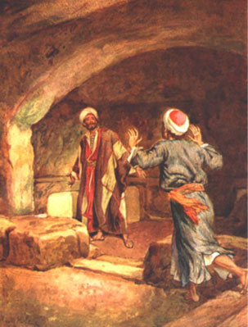
Early on the first day of the week, while it was still dark, Mary Magdalene went to the tomb and saw that the stone had been removed from the entrance. So she came running to Simon Peter and the other disciple, the one Jesus loved, and said, “They have taken the Lord out of the tomb, and we don’t know where they have put him!”

So Peter and the other disciple started for the tomb. Both were running, but the other disciple outran Peter and reached the tomb first. He bent over and looked in at the strips of linen lying there but did not go in. Then Simon Peter came along behind him and went straight into the tomb. He saw the strips of linen lying there, as well as the cloth that had been wrapped around Jesus’ head. The cloth was still lying in its place, separate from the linen. Finally the other disciple, who had reached the tomb first, also went inside. He saw and believed. (John 20:1-8)

Introduction
One person can make a difference. Pastor Bill Wilson related the story of how he was abandoned by his mother on a street corner and later rescued by an ordinary Christian man although that man had problems at home with a child ill with leukaemia. Pastor Bill was “a little boy that nobody wanted” whose life was flipped. He also related his experiences while ministering in different parts of the world and encountering various dangerous situations.
Someone once asked him, “What do you see, Pastor Bill, when you go to these places?” In other words, what moves you to do things?
John 20 tells the story of the empty tomb and how three of Jesus’ closest friends, namely Mary Magdalene, Peter and John reacted when they were confronted with an empty tomb. They knew Jesus extremely well, they heard His message and saw His miracles first-hand. Most people do not see a miracle because they do not stick around long enough. These three people heard Him say He was going to die and three days later, He would rise. Now they come to the empty tomb and look in to find a fulfilled prophecy. What do they see? What do you see?
1. Mary: “blepo”
Early on the first day of the week, while it was still dark, Mary Magdalene went to the tomb and saw that the stone had been removed from the entrance. (John 20:1)
When Mary Magdalene came to the tomb, the word “blepo” was used. This meant that Mary looks in and sees but does not understand. Have we seen so much that we become desensitised? Mary just sees with her eyes.
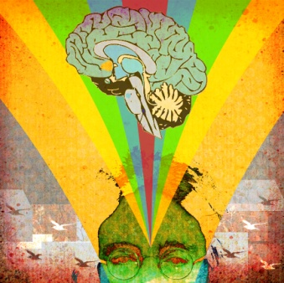
2. Peter: “theoreo”
Then Simon Peter came along behind him and went straight into the tomb. He saw the strips of linen lying there (John 20:6)

The word “saw” here was translated from “theoreo” which is the root word of the English word “theory”. Peter saw the exact same thing, but developed a theory and generated a hypothesis. Mary saw with her eyes but Peter saw with his mind. Education is important and having a clear understanding of everything is important but this only leaves us with head knowledge. Peter cannot put the pieces together.
3. John: “eido”
Finally the other disciple, who had reached the tomb first, also went inside. He saw and believed. (John 20:8)
The word “saw” here was translated from the Greek word “eido”. “Eido” means he saw and believed. He got it. John looks in and he saw with his heart, and it was real. Seeing and experiencing changes everything. Be somebody who does not give up. Do you believe what you say you believe in, or do you not?
Conclusion
What do you see now? We need to see with the eyes of our hearts.
Sermon summary: Zhenli and Phoebe Leong

