Legacy Makers: Tearing Down Life’s Stronghold
(Joshua 6:1-27)
Pastor Mike Ngui

Now when Joshua was near Jericho, he looked up and saw a man standing in front of him with a drawn sword in his hand. Joshua went up to him and asked, “Are you for us or for our enemies?”
“Neither,” he replied, “but as commander of the army of the Lord I have now come.” Then Joshua fell facedown to the ground in reverence, and asked him, “What message does my Lord have for his servant?” The commander of the Lord’s army replied, “Take off your sandals, for the place where you are standing is holy.” And Joshua did so. Now the gates of Jericho were securely barred because of the Israelites. No one went out and no one came in. Then the Lord said to Joshua, “See, I have delivered Jericho into your hands, along with its king and its fighting men. March around the city once with all the armed men. Do this for six days. Have seven priests carry trumpets of rams’ horns in front of the ark. On the seventh day, march around the city seven times, with the priests blowing the trumpets. When you hear them sound a long blast on the trumpets, have the whole army give a loud shout; then the wall of the city will collapse and the army will go up, everyone straight in.” (Joshua 5:13-6:5)

Introduction
Now when Joshua was near Jericho, he looked up and saw a man standing in front of him with a drawn sword in his hand. Joshua went up to him and asked, “Are you for us or for our enemies?”
“Neither,” he replied, “but as commander of the army of the Lord I have now come.” (Joshua 5:13-14a)
Big Idea: We overcome, God’s way and not “my way”!

The story of Jericho began in Joshua 5. With the Israelites crossing the dry river of Jordan, renewed covenant, circumcision, etc.- all these signify that they were with God. God promised them a new identity, new nature and new destiny. These promises were given long ago to Abraham, Isaac and Jacob.

Jericho was a two-walled city. It is very commanding city, in a strategic location. Geographically, Jericho is one of the toughest cities to conquer.
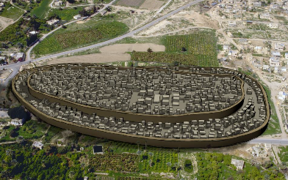
(Left) An illustration of how Jericho city was like. Notice the structure of the city that was built with two walls.

Israel had fought in open ground, without siege machine, and with no experience in seizures. Jericho, on the other hand, had their walls and could easily fight from the wall. It was a stronghold to Israel, which was why they need to fight the battle.
What is stronghold?
A grip that affect everything else. It seems to be the most basic issue in our life, and what the Ten Commandments dealt with.
With all that the Israelites had and what Jericho was, it was almost impossible for the city to be conquered. With human’s way it is impossible, but not when we do it His way!
Big Idea: We overcome, God’s way and not “my way”!

We overcome when WE are on GOD’s side

In this consumer-oriented society, we usually wanted God to be on our side. How often it is, in our prayer and petition to Him, we asked God to do things “our” way, or asking Him to fulfil “our” wish and desire, rather than surrendering to His will?

God is not on our side. We need to be on His side.

God does not subject to our will, but we subject to His will.

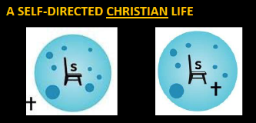

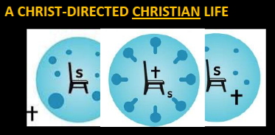

Then Joshua fell facedown to the ground in reverence, and asked him, “What message does my Lord have for his servant?” The commander of the Lord’s army replied, “Take off your sandals, for the place where you are standing is holy.” And Joshua did so. (Joshua 5:14b-15)

Know that God is King, Worship Him.
God is the commander of the army that we could be in. Instead of asking if God is for me or against me, ask “Lord, what message do you have for me?”
Joshua, worrying over Jericho was reminded that God looms above all these. Compelled to worship Jehovah. Surrendering the throne of our lives, and it all come from worship.

Paul said that if the God whom I serve did not spare his own Son (Romans 8); If this God can give us His son to reconcile with us; how much lesser would He give us? It is only through worship that we can truly surrender.

We overcome when we OBEY God in faith
March around the city once with all the armed men. Do this for six days. Have seven priests carry trumpets of rams’ horns in front of the ark. On the seventh day, march around the city seven times, with the priests blowing the trumpets. When you hear them sound a long blast on the trumpets, have the whole army give a loud shout; then the wall of the city will collapse and the army will go up, everyone straight in.” (Joshua 6:3-5)

As much as Joshua wished he could explain why he was instructed to do what seems to be nonsensical, he could not. But he obeyed without questioning. God’s way may not make sense at times, but we are demanded to obey Him in faith and at all costs. His instruction to us is to simply to obey. God’s ways are not bound by conventional ways.

But we have this treasure in jars of clay to show that this all-surpassing power is from God and not from us. (2 Corinthians 4:7)

So on the second day they marched around the city once and returned to the camp. They did this for six days. On the seventh day, they got up at daybreak and marched around the city seven times in the same manner, except that on that day they circled the city seven times. (Joshua 6:14-15)

The seventh time around, when the priests sounded the trumpet blast, Joshua commanded the army, “Shout! For the Lord has given you the city! When the trumpets sounded, the army shouted, and at the sound of the trumpet, when the men gave a loud shout, the wall collapsed; so everyone charged straight in, and they took the city. (Joshua 6:16-20)

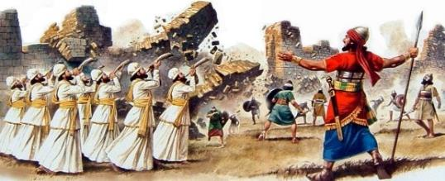

We overcome when we DON’T QUIT obeying
By faith the walls of Jericho fell, after the army had marched around them for seven days. (Hebrews 11:30)
People usually quit before their prayers are answered. The fall of the wall of Jericho serves as a good reminder to us to not quit obeying God’s instruction, keep getting up, just like the bobo doll in Kung Fu Panda.

What pleases God?
It is persistence obedience.

Conclusion

What is the Jericho in our life?
Jericho to Israel is just like the stronghold in our life. Sometimes we do not overcome them, but fall into it. Bitterness, anger, lust, forgiveness, pride (evidences itself in arrogance, jealousy and self-centeredness), lust, something deep within us, greed, covetousness, etc.- are example of stronghold one may have in life. Lo and behold, the greatest stronghold in our life is SIN, something that we could never have overcome except that Christ overcame it for us. It is a victory that had been handed to us, and we are to receive it with faith.

What should we do now?

Recognize our stronghold and ask God to help us overcome it. Definitely not easy, but the big idea is, we overcome it the God’s way!
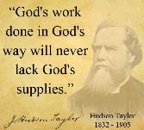
- We overcome when we are on God’s side because God is always with us.
- We overcome when we obey God in faith, even when it made no sense!
- We overcome when we don’t quit obeying. In the process of obeying, nothing seems to come out of it, but we just keep obeying.

Sermon summary contributed by Chrisandra Wong.
Prayer items by Michelle Wong.

SERMON: Tearing Down Life’s Stronghold
Pray:
- All the people of God will understand that they can overcome their stronghold only by following God’s way and not their own way.
- God’s people are on His side and do His will to overcome their stronghold.
- We will make a deliberate choice to obey His will to overcome our strongholds.
- People of God will persevere in faith and not quit obeying Him.
“Therefore, since through God’s mercy we have this ministry, we do not lose heart.” (2 Corinthians 4:1)

MINISTRIES & EVENTS: MISSIONS MYANMAR
26 August – 2 September 2016
Pray:
- God’s protection will be on His chosen people in countries where sharing His Word is prohibited.
- God will give wisdom to the chosen ones in presenting the Gospel to those ready for His kingdom and bring them to salvation with the wisdom of God.
- God will enable the Bamar people to be open and receptive to the Gospel and put their trust in Jesus.
- God will instil the spirit of team unity & humility, compassion & love for the Bamar people and a special encounter with the Lord.
Be strong and courageous. Do not be afraid or terrified because of them, for the Lord your God goes with you; He will never leave you nor forsake you. (Deuteronomy 31:6)

MALAYSIA MY NATION: CHURCH IN MALAYSIA
40 days fast & prayer: the family
Pray:
- God will convict the hearts of all believers in Malaysia to fast & pray in repentance for their family in the areas of marital and parental relationships.
- People of God will pray for the restoration of biblical identity and roles of husband and wife in marriage and His protection against adultery, divorce and abuse.
- People of God will fast & pray for the restoration of biblical identity of individual single man or woman and His protection on their singlehood in purity and purpose as they serve Him.
- Parents to be convicted to raise up God-fearing children by setting up Family prayer alters for the restoration of biblical parenting.
“I will give them an undivided heart and put a new spirit in them; I will remove from them their heart of stone and give them a heart of flesh.”(Ezekiel 11:19)

- A TRANSFORMED WORLD: TURKEY
Terrorists attacks
Pray:
- The Police force in Turkey to have a breakthrough in their investigations on the bombings in Ankara and Gazientap.
- The people in Turkey to be convicted in their hearts and be brave to come forward to assist the Police in their investigations.
- God’s wisdom and protection on the Deputy Prime Minister Mehmek Simsek as he carries out investigations on the bombings by IS.
- People of God in Turkey to reach out to help the families of victims of the bombing in Ankara and Gazientap.
- God to open the eyes of those who live in darkness to see the light through the work done by God’s people.
But we have this treasure in jars of clay to show that this all-surpassing power is from God and not from us. (2 Corinthians 4:7)

