Advent 1: Good News of Great Joy (Luke 2: 8-20)
Pastor Tan Moy How

In the same region there were some shepherds staying out in the fields and keeping watch over their flock by night. And an angel of the Lord suddenly stood before them, and the glory of the Lord shone around them; and they were terribly frightened. But the angel said to them, “Do not be afraid; for behold, I bring you good news of great joy which will be for all the people; for today in the city of David there has been born for you a Savior, who is Christ the Lord. “This will be a sign for you: you will find a baby wrapped in cloths and lying in a manger.” And suddenly there appeared with the angel a multitude of the heavenly host praising God and saying, “Glory to God in the highest and on earth peace among men with whom He is pleased.” When the angels had gone away from them into heaven, the shepherds began saying to one another, “Let us go straight to Bethlehem then, and see this thing that has happened which the Lord has made known to us.” So they came in a hurry and found their way to Mary and Joseph, and the baby as He lay in the manger. When they had seen this, they made known the statement which had been told them about this Child. And all who heard it wondered at the things which were told them by the shepherds. But Mary treasured all these things, pondering them in her heart. The shepherds went back, glorifying and praising God for all that they had heard and seen, just as had been told them. (Luke 2: 8-20)

Introduction

But the angel said to them, “Do not be afraid; for behold, I bring you good news of great joy which will be for all the people; for today in the city of David there has been born for you a Savior, who is Christ the Lord. (Luke 2:10)
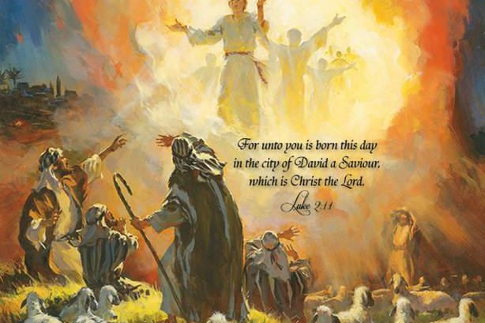
How many people feel joyful? Many people confuse joy and happiness and find them in the wrong places such as malls, parties and other methods. The shepherds were doing their work when an angel gave them an exciting announcement about the birth of Christ.

Christ brings Joy.

THE BIG IDEA: CHRIST THE LORD, THE GOOD NEWS THAT BRINGS GREAT JOY.

Jesus is born
for today in the city of David there has been born for you a Savior (Luke 2:11)The Word became flesh and made his dwelling among us. We have seen his glory, the glory of the one and only Son, who came from the Father, full of grace and truth. (John 1:14)

There is no greater joy than witnessing the birth of a child. Pastor Moy How had the privilege of witnessing the birth of four children in the hospital. Each came after great hours of labour and he told everyone about it.

The Reality of Jesus Birth:

There were no recorded miracles associated with the physical birth of Jesus
The miracle occurred 9 months earlier when Mary was pregnant.
Pastor Moy How got a call from a pregnant cell member saying that they were having a baby. Pastor and his wife were asking them to go to the hospital but to no avail. They sensed something was wrong and they went to their house. When they reached, they were shocked to find that the baby was on the way out. Since the ambulance would take some time to arrive, Pastor called a doctor from church and doctor helped them deliver the baby at home. They rushed to the hospital immediately after.

The word Today means it really happened.
The birth of Christ through Mary is the truth. There is no two ways about it. Francis Schaeffer talks about the “lower story” and “upper story”. Lower story relates to what actually happened. Upper story talks about fables and myths. It is not a legend or rumour as other people saw it.

Jesus is Savior, Christ and Lord
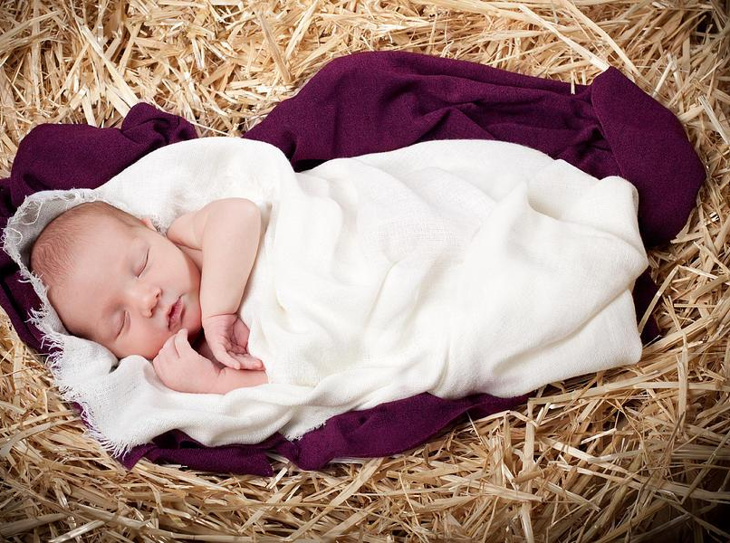
...who is Christ the Lord. “ (Luke 2:11)

Saviour is “One who delivers his people”
Jesus came to save His people. On a beach or swimming pool, there is always a lifeguard stationed to help the helpless who are drowning regardless of who they are and where they are from. Likewise, Jesus came to save everyone; He came for you and me.

Christ means “The anointed One”
God sent His Own Son. He didn't send a task force or His personal assistant to solve the problem.

Lord is the synonym for God
He is the Deity. He is the ruler of the universe and will return to earth and rule.

Jesus is Good News.
for today in the city of David there has been born for you a Savior, who is Christ the Lord. (Luke 2:11)
God sent the angels to the shepherds. According to the Talmud, shepherds were unclean and shunned by the Jewish community during religious duties.

The shepherds were:

- Unclean: They are not allowed to perform religious duties.
- Forgotten: People don't associate with them.
- Mistrusted: They are often suspected for stealing with others.
- Brash

The Lord appears to Lowly shepherds, like you and I (Max Lucado)

Conclusion
The Lord came for you
But when Jesus heard this, He said, “It is not those who are healthy who need a physician, but those who are sick. “But go and learn what this means: ‘I DESIRE COMPASSION, AND NOT SACRIFICE,’ for I did not come to call the righteous, but sinners.” (Matthew 9:12-13)

If Jesus was born one thousand times in Bethlehem and not in me, then I would still be lost - Corrie Ten Boom
What will you do to the best announcement ever?

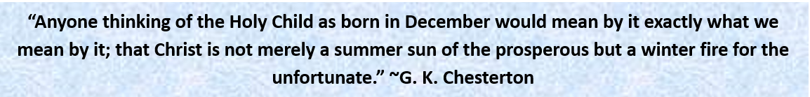

Sermon summary contributed by Abbey Thangiah
Prayer points contributed by Loong

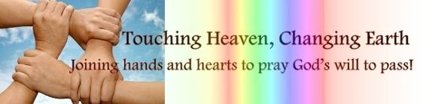

SERMON: Advent I
Pray:
- We take comfort that the Lord has come for us.
- We will actively and purposefully share the Good News of Jesus with the people around us.
- We will bring hope to this seemingly hopeless world.
- We will share the joy we have in Christ with our friends.
Today in the town of David a Savior has been born to you; he is the Messiah, the Lord. (Luke 2:11)

MINISTRIES & EVENTS: Choices
DUMC is running a Christmas production called Choices on 16 and 17 Dec, starting at 8:00 pm on both nights.
Pray:
- Everyone involved in the performance will make the choice to practice well in order to perform well.
- Members will make the choice to invite their friends to the 2 performances.
- Invited guests will make the choice to come to see the performance.
- Those who do not know Jesus will make a choice to respond to the altar call and to receive Jesus.
- Those who know Jesus will make a choice to remember the reason Jesus came and live an even more purposeful life.
For to us a child is born, to us a son is given, and the government will be on his shoulders. And he will be called Wonderful Counselor, Mighty God, Everlasting Father, Prince of Peace (Isaiah 9:6)

MALAYSIA MY NATION: Unilateral Conversion by One Parent in Perlis
The Perlis state government amended an enactment that allows the unilateral conversion of a non-Muslim child by a newly converted parent without the consent of the non-Muslim parent.
Pray:
- The supremacy of the Federal Constitution will be upheld according to the Rukun Negara.
- Any laws at the state level that contravenes with the Federal Constitution will be repealed.
- Family will live in harmony and married couples will not abuse this law to get back at their estranged spouses.
- The freedom of religion especially for the children will be preserved.
Yet to all who did receive him, to those who believed in his name, he gave the right to become children of God— 13 children born not of natural descent, nor of human decision or a husband’s will, but born of God. (John 1:12, 13)

- A TRANSFORMED WORLD: Earthquakes
A 6.5 magnitude earthquake strike Aceh, Indonesia on 07 Dec, killing 100 people and injuring 750. Solomon Island was hit twice on 07 Dec (7.8 magnitude) and 09 Dec (6.9 magnitude). Tsunami warnings have been issued and cancelled. A magnitude 6.5 earthquake hit about 160 KM off the Northern California coast, with no casualties reported yet.
Pray:
- Precautions will be taken to prevent great damages caused by natural disasters.
- Safety measures will be taken in the design of buildings and structures.
- Local authorities will work together with civilians to save lives and properties and disasters strike.
- Victims will receive the help that they need to overcome the situation and to rebuild their homes.
- People will help one another during times of calamities.
God is our refuge and strength, an ever-present help in trouble. Therefore we will not fear, though the earth give way and the mountains fall into the heart of the sea, though its waters roar and foam and the mountains quake with their surging. (Psalm 46:1-3)

