Advent 2: The Coming That Transforms (Matthew 2:1-12)
Pastor Dato’ Dr Daniel Ho

After Jesus was born in Bethlehem in Judea, during the time of King Herod, Magi from the east came to Jerusalem and asked, “Where is the one who has been born king of the Jews? We saw his star when it rose and have come to worship him.” When King Herod heard this he was disturbed, and all Jerusalem with him. When he had called together all the people’s chief priests and teachers of the law, he asked them where the Messiah was to be born.
“In Bethlehem in Judea,” they replied, “for this is what the prophet has written: “ ‘But you, Bethlehem, in the land of Judah, are by no means least among the rulers of Judah; for out of you will come a ruler who will shepherd my people Israel.’ ”
Then Herod called the Magi secretly and found out from them the exact time the star had appeared.
He sent them to Bethlehem and said, “Go and search carefully for the child. As soon as you find him, report to me, so that I too may go and worship him.” After they had heard the king, they went on their way, and the star they had seen when it rose went ahead of them until it stopped over the place where the child was. When they saw the star, they were overjoyed. On coming to the house, they saw the child with his mother Mary, and they bowed down and worshiped him. Then they opened their treasures and presented him with gifts of gold, frankincense and myrrh. And having been warned in a dream not to go back to Herod, they returned to their country by another route. (Matthew 2:1-12)

Introduction
Remember those days when we used to be so excited about the glorious Milo van that would drop by our schools every once or twice a year? We would jump for joy when we heard the inevitable sound the truck makes when it stopped in the school compound, and pushed our way through the crowd, just to get one tiny cup of the famous, Milo. Picture that for a second. Now, fit that picture into the well known story of the coming of Christ. The story that some of us, as second or third generation Christians are so familiar with. Which is why we need to take a moment to ponder: have we lost the wonder of His birth?

1. The amazing foretelling of His coming
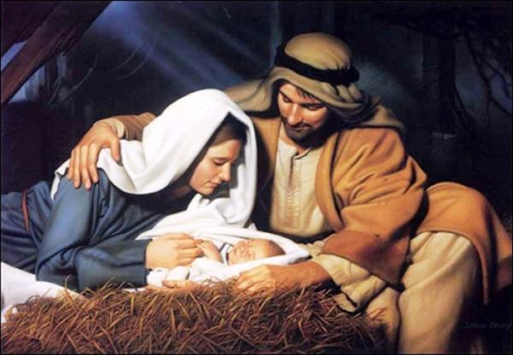
There are prophecies in scriptures of the Old Testament that speaks of the coming of Jesus. Such as:-
- WHERE he is going to be born and his lineage
“But you, Bethlehem Ephrathah, though you are small among the clans of Judah, out of you will come for me one who will be ruler over Israel, whose origins are from of old, from ancient times.” (Micah 5:2)

It was mentioned specifically where Jesus was going to be born- Bethlehem Ephrathah. Jesus was also prophesied to be from among the clans of Judah, along the lineage of King David.
- HOW he was going to be born
Therefore the Lord himself will give you a sign: The virgin will conceive and give birth to a son, and will call him Immanuel. (Isaiah 7:14)

Isaiah lived 700 years before the birth of Christ! He prophesied that the birth of Jesus would be from a virgin, which was physically impossible! But with the Spirit, all things are possible.
- The MANY prophecies about his life, his work and his death and its purpose in the Old Testament
Rejoice greatly, Daughter Zion! Shout, Daughter Jerusalem! See, your king comes to you, righteous and victorious, lowly and riding on a donkey, on a colt, the foal of a donkey. (Zechariah 9:9)

He was despised and rejected by mankind, a man of suffering, and familiar with pain. Like one from whom people hide their faces he was despised, and we held him in low esteem. Surely he took up our pain and bore our suffering, yet we considered him punished by God, stricken by him, and afflicted. But he was pierced for our transgressions, he was crushed for our iniquities; the punishment that brought us peace was on him, and by his wounds we are healed. (Isaiah 53:3-5)

The scriptures spoke about the purpose of Jesus and the work He came to do. It spoke about the rejection he would receive and the suffering he came to endure. Jesus Christ came to give us a future and a hope.
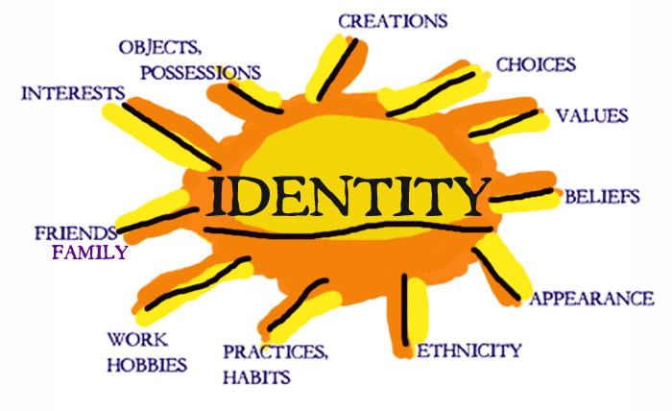
There are five questions in life that we would have to answer:-
1. Who am I?
2. Why am I here?
3. Where am I going?
4. Where do I belong?
5. Is there any value in life?
We will never be able to answer these questions until we discover who He is.

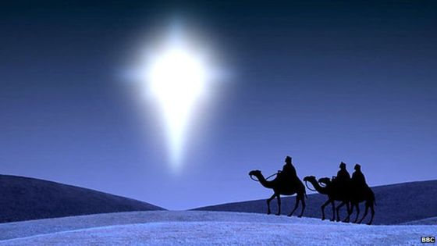
2. The insatiable fervency to His coming
Insatiable- Unquenchable
- The Magi noticed something MYSTERIOUS
“We saw his star when it rose and have come to worship him.” (v.2)
- They recognized something MARVELLOUS
- They foresee something MIRACULOUS
After Jesus was born in Bethlehem in Judea, during the time of King Herod, Magi from the east came to Jerusalem and asked, “Where is the one who has been born king of the Jews? We saw his star when it rose and have come to worship him.” (v. 1, 2)

The distance from where they were to Jerusalem was at least 1000 miles. These wise men had to go through the hardships of the journey to witness and behold the great miracle, to marvel at the complete demonstration of God’s power. They were fervent about the fact that something marvellous and miraculous has taken place, and were willing to make sacrifices and go through the heartaches and the pain the journey would bring.

3. The remarkable fulfillment of His coming

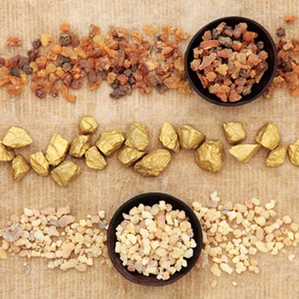
After they had heard the king, they went on their way, and the star they had seen when it rose went ahead of them until it stopped over the place where the child was.
When they saw the star, they were overjoyed. On coming to the house, they saw the child with his mother Mary, and they bowed down and worshiped him. Then they opened their treasures and presented him with gifts of gold, frankincense and myrrh. (Matthew 2:9-11)

- Gold represents royalty, incense represents worship and myrrh represents death and burial
The presentations of the gifts speak about the birth, life death and sacrifice of Jesus in his coming.

Conclusion
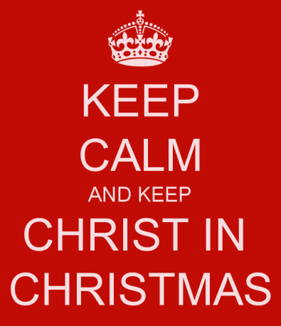
2 questions the coming of Christ stirs:-
- Is it real?
Are we convicted enough to believe that the birth and the coming of Christ is true?
- Is it relevant?
What relevance does it have in your life?
We serve a God that came to give us life, a future and a hope. Only in Him, we can find our security, contentment and confidence. True transformation happens when we allow Jesus to step into our life and bring change.
“Therefore, if anyone is in Christ, the new creation has come: The old has gone, the new is here!” (2 Corinthians 5:17)

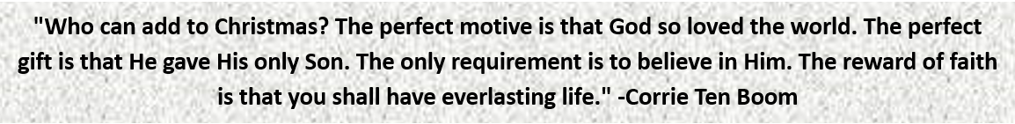

Sermon summary contributed by Phoebe Leong
Prayer pointers contributed by Adeliyn Lim

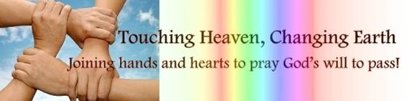
SERMON: Advent II
Pray:
- We will continue to be amazed at the miracle of Christ’s coming to give us salvation.
- We will constantly keep in mind the fulfilment of scripture in His coming, as well as the symbolism of the Magi’s gifts to the life of Jesus – that He is royal (gold), He is divine (incense) and He came to die for the sins of the world (myrrh).
- We will share our stories of how coming of Christ had impacted us.
On coming to the house, they saw the child with his mother Mary, and they bowed down and worshiped him. Then they opened their treasures and presented him with gifts of gold, frankincense and myrrh. (Matthew 2:11)

MINISTRIES & EVENTS: Cell Group Outreach
Many DUMC cell groups will be conducting Christmas parties in December with the purpose to share the Good News with pre-believers.
Pray:
- Cell group members will keep in mind the cell group’s mandate to evangelize.
- Pre-believers and backslidden Christians will be receptive to the Gospel message.
- The outreach programme will inspire pre-believers to want to know God in a deeper and more meaningful manner.
Here I am! I stand at the door and knock. If anyone hears my voice and opens the door, I will come in and eat with that person, and they with me. (Revelations 3:20)
MALAYSIA MY NATION: Land Rights of the Orang Asli
The Temiar community in Kelantan had put up a blockade to prevent logging activities and desecration of claimed ancestral lands. 54 Orang Asli had since been arrested for setting up the blockades. (Source: MalaysiaKini)
Pray:
- State and Federal governments to take charge and resolve the decades-long dispute; and they will honour land rights of the Orang Asli tribes across Malaysia.
- Orang Asli be allowed direct involvement and control on programmes and matters currently held and run by the Department of Orang Asli Affairs (JHEOA)
- Education will be prioritised for all schooling-age children.
- Wisdom and courage to the elder generation to stand firm and stand their ground in order to safeguard their lands.
- Churches and ministries to provide tangible support to this community.
Ahab said to Naboth, “Let me have your vineyard to use for a vegetable garden, since it is close to my palace. In exchange I will give you a better vineyard or, if you prefer, I will pay you whatever it is worth.” But Naboth replied, “The Lord forbid that I should give you the inheritance of my ancestors.” (1 Kings 21:2-3)

- A TRANSFORMED WORLD: Hoaxes and Fake News
A sharp increase in popularity of social media networks (primarily Facebook and WhatsApp) has created a predatory market seeking to profitably exploit the large reach of those networks by spreading fake news and outlandish rumours. Many of such publications gain readers by targeting religious and political affiliations, deliberately skewing the readers’ perspective - leading to real life actions such as the march against Ahok in Jakarta and the ‘Pizzagate’ controversy in America.
Pray:
- Readers of news will practice discernment and seek the truth for themselves; not blindly consuming and sharing sensational untruths.
- People to be more responsible on social media (such as Facebook, Snapchat, Twitter, etc.) when sharing any form of information.
- People will learn to be quick to listen, slow to respond/retaliate in anger, and take time to validate before sharing any information.
- Christians especially, to be agents of truth – validate news before sharing, and correcting in love.
Set a guard over my mouth, Lord; keep watch over the door of my lips. Do not let my heart be drawn to what is evil so that I take part in wicked deeds along with those who are evildoers; do not let me eat their delicacies. Let a righteous man strike me—that is a kindness; let him rebuke me—that is oil on my head. My head will not refuse it, for my prayer will still be against the deeds of evildoers. (Psalm 141: 3-5)

