FORWARD2017
STEP OUT: Towards Christlikeness (Matthew 28:18-20)
Senior Pastor Chris Kam

Then Jesus came to them and said, “All authority in heaven and on earth has been given to me. Therefore go and make disciples of all nations, baptizing them in the name of the Father and of the Son and of the Holy Spirit, and teaching them to obey everything I have commanded you. And surely I am with you always, to the very end of the age.” (Matthew 28:18-20)

Introduction

Mahatma Gandhi once said that “I like your Christ. I do not like your Christians. Your Christians are so unlike your Christ. The only thing that ever kept me from being a Christian was Christians.” What a sad thing it is, that Christians are the ones who made others turn away from the God’s saving grace.
Therefore I urge you to imitate me. (1 Corinthians 4:16)
Follow my example, as I follow the example of Christ. (1 Corinthians 11:1)
The challenge for the church in this ten year journey with Pastor Chris at the helm is: Christlikeness. The vision for DUMC is to be a church who will disciple other to be like Christ. But for us to do so, we must first be disciples (imitators) of Christ.

Big Idea: Love GOD, Serve People, Make Disciples toward Christlikeness

3 steps for us to make disciples:

Sink It In – Called to Live in Christ
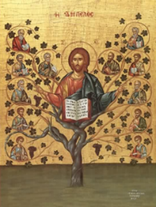
“…baptizing them in the name of the Father and of the Son and of the Holy Spirit…” (Matthew 28:19b)
Being baptised conveys the message that a person wants to be a part of God, choosing for the “old life” to die and have a “new life” in relationship with God.
“I am the vine; you are the branches. If you remain in me and I in you, you will bear much fruit; apart from me you can do nothing.” (John 15:5)
Choosing life with God is to allow God to remove our humanly self-centeredness and be transformed inside out – to change the nature of us who were born sinners, and live that the way Christ has shown us to live.
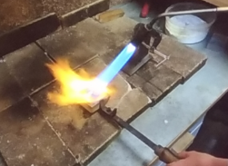
When we choose to let God transform us, He will make us pure like how a silversmith refines the black silver ore. A silversmith uses a high-heat blowtorch to burn away the impurities in the silver but keeps his eyes on the silver ore at all times as overheated silver has an affinity for absorbing oxygen which make it unworkable. He knows that the silver is ready when it produces a mirror-like quality, reflecting his face, signifying that the silver is ready to be poured out.

Likewise, God will burn away our impurities through many trials but never taxing us to the point of breaking; until He sees His face in us.

Live It Out – Equipped to Live Like Christ
“…teaching them to obey everything I have commanded you.” (Matthew 28:20a)
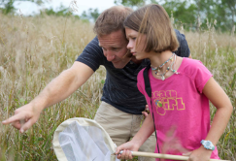
Discipleship is helping someone move from their present condition to the goal of Christlikeness. The effort of knowing what it meant to be a Christian was more likely to be an experience of observing other Christians rather than going to a bible study. Like children, the learning process towards becoming a Christian is more caught than taught. Therefore let us be more intentional in growing each other and growing those around us. Show them what it means to be a Christian – an imitator of Christ.

Pass It On – Sent to Live for Christ (STEP OUT)
“Therefore go and make disciples of all nations, baptizing them in the name of the Father and of the Son and of the Holy Spirit, and teaching them to obey everything I have commanded you. And surely I am with you always, to the very end of the age.” (Matthew 28:19-20)
Making disciples is a thing God has called us to do. It is about passing on what it means to a follower / an imitator of Christ to the next generation. Our NextGen are leading and disciplining the next generation among friends in their age group by using their life as a witness, being a friend and ultimately making disciples of Christ.

Conclusion
Let’s have a heart for the people. Let us bring someone to Christlikeness through our lives. Let us be a church of intentional discipleship from generation to generation.
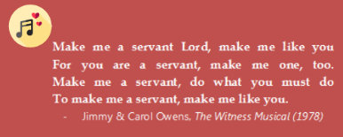

Sermon summary contributed by Adeliyn Lim
Prayer points contributed by Loong

SERMON: FORWARD2017 - Step Out: Towards Christlikeness
Pray:
- We are Christians will be willing to be put in the Potter’s Hands to be moulded and shaped into the vessel He wants us to be.
- We will always be humble and teachable.
- We will be conscious and deliberate in our Christian walk.
- We will live out the live that God intended for us to live.
- We will pass on our values and beliefs to other Christians.
Follow my example, as I follow the example of Christ. (1 Corinthians 11:1)

MINISTRIES & EVENTS: Volunteers
The many ministries in the church are supported by many volunteers. They serve faithfully. We need more volunteers.
Pray:
- The volunteers will continue to serve faithfully out of love both to God and their fellow men.
- We will appreciate the volunteers for giving their time and even money in serving.
- We will be more considerate and understanding.
- When we do give feedback, it will be constructing and out of love.
- More of us will be willing to step out from our own comfort zone and join the ranks of the many volunteers in the various ministries.
- The church administration will have a program to efficiently manage and channel the resources to various ministries.
- Both volunteers and those being served will display Christlikeness.
Each of you should use whatever gift you have received to serve others, as faithful stewards of God’s grace in its various forms. (1 Peter 4:10)
MALAYSIA MY NATION: Drivers and Riders on the Road
Pray:
- Road users will pay attention while on the road and they will not be distracted by smartphones and other devices.
- They will be alert and not take their mind off the road.
- They will not drive / ride when they are not in the condition to do so.
- All road users will be considerate and courteous.
- Road users will obey traffic regulations to ensure safety for all.
- Christians on the road will demonstrate Christlikeness.
You are my hiding place; you will protect me from trouble and surround me with songs of deliverance. (Psalm 32:7)

A TRANSFORMED WORLD: Drought in Tamil Nadu, India
Dry spell in Tamil Nadu state of India has reportedly destroyed 50% of the crops. According to a notice issued by the National Human Rights Commission to the state government, as many as 106 farmers have died or committed suicide in the state due to crop failure. Drinking water is diminishing.

Pray:
- Rain will fall according to the climate pattern, which the farmers depend on.
- The Khrisna River Water Board will agree to send water from the Telugu Water Project to ensure enough water supply for the residents in the state.
- The government will monitor and manage the crisis diligently.
- The government will be able to provide assistance to the farmers to help them survive.
He provides rain for the earth; he sends water on the countryside. (Job 5:10)

