**Core Habits 2- Humility (Numbers 12:1-15)**

***Founding Senior Pastor Dato’ Dr Daniel Ho***

Miriam and Aaron began to talk against Moses because of his Cushite wife, for he had married a Cushite. “Has the Lord spoken only through Moses?” they asked. “Hasn’t he also spoken through us?” And the Lord heard this. (Now Moses was a very humble man, more humble than anyone else on the face of the earth.)

At once the Lord said to Moses, Aaron and Miriam, “Come out to the tent of meeting, all three of you.” So the three of them went out. Then the Lord came down in a pillar of cloud; he stood at the entrance to the tent and summoned Aaron and Miriam. When the two of them stepped forward, he said, “Listen to my words:

“When there is a prophet among you, I, the Lord, reveal myself to them in visions, I speak to them in dreams. But this is not true of my servant Moses; he is faithful in all my house. With him I speak face to face, clearly and not in riddles; he sees the form of the Lord. Why then were you not afraid to speak against my servant Moses?”

The anger of the Lord burned against them, and he left them. When the cloud lifted from above the tent, Miriam’s skin was leprous—it became as white as snow. Aaron turned toward her and saw that she had a defiling skin disease, and he said to Moses, “Please, my lord, I ask you not to hold against us the sin we have so foolishly committed. Do not let her be like a stillborn infant coming from its mother’s womb with its flesh half eaten away.” So Moses cried out to the Lord, “Please, God, heal her!” The Lord replied to Moses, “If her father had spit in her face, would she not have been in disgrace for seven days? Confine her outside the camp for seven days; after that she can be brought back.” So Miriam was confined outside the camp for seven days, and the people did not move on till she was brought back. (Numbers 12:1-21)

# Introduction

**Habits** are ingrained patterns of behaviour in us that we exhibit normally and naturally. The birth of habits start from the formation of thoughts, follow by words, then action, which gave birth to habits that reflects in our regular actions, produces character, and ultimately, our destiny.

**Thoughts 🡪 Words 🡪 Actions 🡪 Habits 🡪 Character 🡪 Destiny**

On another hand, **humility** is defined as being meek, lowly of heart, self-effacing and gentle. Being *meek* does not mean one is weak. A humble person (being meek) is no push over, and not to be easily taken granted of. A person who is *self*-*effacing* does not like to talk about him or herself.

Humility is reflected in the *posture* of the heart, *attitude* of the mind and the *action* of the person. Moses is a good example of humility in Numbers 12:9-15, where Moses remained meek and gracious albeit being challenged by Aaron and Miriam. He trusted that God would vindicate and even prayed for mercy for the challenger:

The anger of the Lord burned against them, and he left them. When the cloud lifted from above the tent, Miriam’s skin was leprous—it became as white as snow. Aaron turned toward her and saw that she had a defiling skin disease, and he said to Moses, “Please, my lord, I ask you not to hold against us the sin we have so foolishly committed. Do not let her be like a stillborn infant coming from its mother’s womb with its flesh half eaten away.” So Moses cried out to the Lord, “Please, God, heal her!” The Lord replied to Moses, “If her father had spit in her face, would she not have been in disgrace for seven days? Confine her outside the camp for seven days; after that she can be brought back.” So Miriam was confined outside the camp for seven days, and the people did not move on till she was brought back. (Numbers 12:9-15)

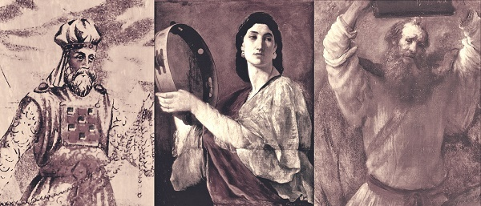

Nothing is too small and no job is too low for a humble person. A humble person is not interested in power and recognition. He is selfless, big-hearted and generous. Most of all, He trusts in God.

# Why is humility so important for us?

## It attracts the favour of God

In his distress he sought the favor of the Lord his God and humbled himself greatly before the God of his ancestors. And when he prayed to him, the Lord was moved by his entreaty and listened to his plea; so he brought him back to Jerusalem and to his kingdom. Then Manasseh knew that the Lord is God. (2 Chronicles 33:12-13)

“God opposes the proud but shows favor to the humble.” (1 Peter 5:5b)

## Causes God to hear our prayers

if my people, who are called by my name, will humble themselves and pray and seek my face and turn from their wicked ways, then I will hear from heaven, and I will forgive their sin and will heal their land. (2 Chronicles 7:14)

Humility attracts and draws His presence.

## Helps us to grow in wisdom, stature and in favour

When pride comes, then comes disgrace, but with humility comes wisdom (Proverbs 11:2)

And Jesus grew in wisdom and stature, and in favour with God and men (Luke 2:52)

# How can we grow in humility?

## Allow God to expose what is in our heart

Remember how the Lord your God led you all the way in the wilderness these forty years, to humble and test you in order to know what was in your heart, whether or not you would keep his commands. (Deuteronomy 8:2)

God is constantly moulding our character throughout our life.

## Through servanthood

For even the Son of Man did not come to be served, but to serve, and to give his life as a ransom for many.” (Mark 10:45)

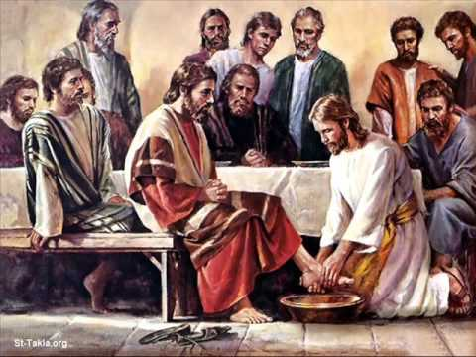When he had finished washing their feet, he put on his clothes and returned to his place. “Do you understand what I have done for you?” he asked them. “You call me ‘Teacher’ and ‘Lord,’ and rightly so, for that is what I am. Now that I, your Lord and Teacher, have washed your feet, you also should wash one another’s feet. I have set you an example that you should do as I have done for you. (John 13:12-15)

Pastor Daniel shared a story about a very humble president of a seminary college. Albeit being in a critical financial crisis, the college continued to perform well and produces good graduates. On one fateful day, a businessman came to the college and donated $50,000 to the president whom he had mistakenly thought as a hired painter when he approached him (the president who was painting the wall) for the direction to the president’s office.

The lower down we go to serve people the more God grows humility in us. We are also reminded of the importance to mix with the right people. If you want to soar high like an eagle, do not mix with the turkeys!

## Most of all, learn and model after Jesus

### What He says

Blessed are the meek, for they will inherit the earth. (Matthew 5:5)

“Come to me, all you who are weary and burdened, and I will give you rest. Take my yoke upon you and learn from me, for I am gentle and humble in heart, and you will find rest for your souls. (Matthew 11:28-29)

### How He relates

He relates to each one personally and treats everyone with dignity and respect:

**Blind Bartimaeus (Mark 10:47-49)**

When he heard that it was Jesus of Nazareth, he began to shout, “Jesus, Son of David, have mercy on me!” Many rebuked him and told him to be quiet, but he shouted all the more, “Son of David, have mercy on me!” Jesus stopped and said, “Call him.” So they called to the blind man, “Cheer up! On your feet! He’s calling you.”

**Zacchaeus (Luke 19:5,7)**

When Jesus reached the spot, he looked up and said to him, “Zacchaeus, come down immediately. I must stay at your house today.”

**Children (Luke 18:15-17)**

People were also bringing babies to Jesus for him to place his hands on them. When the disciples saw this, they rebuked them. But Jesus called the children to him and said, “Let the little children come to me, and do not hinder them, for the kingdom of God belongs to such as these. Truly I tell you, anyone who will not receive the kingdom of God like a little child will never enter it.”

**Other instances of how Jesus relates to others: Samaritan woman (John 4), Nicodemus (John 3 and Peter (John 21).**

### What He does

Who, being in very nature God, did not consider equality with God something to be used to his own advantage; rather, he made himself nothing by taking the very nature of a servant, being made in human likeness. And being found in appearance as a man, he humbled himself by becoming obedient to death— even death on a cross! (Philippians 2:6-8)

The greatest act of humility of all time was done on the cross by our Lord Jesus Christ, where He died for us. As sophisticated as it sounds, the way up is the way down!

For all those who exalt themselves will be humbled, and those who humble themselves will be exalted.” (Luke 14:11)

# Conclusion

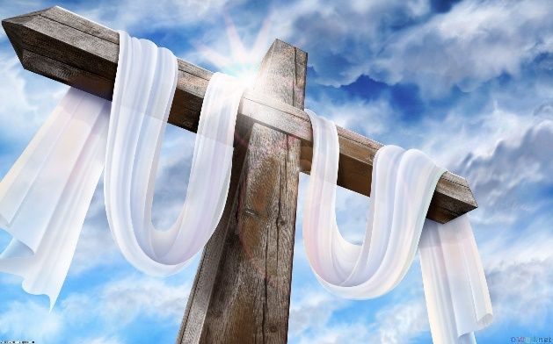It is important to wire our thoughts and words, which would result in our actions and the birth of our habits. All these, would mould our character and set our destiny.

Humility is very important for us because it attracts the favour of God, causes God to hear our prayers and helps to grow in wisdom, stature and in favour. We can grow in humility by allowing God to expose what is in our hearts, through serving others and most importantly, learn and model after Jesus. How? By looking at (and learning from) what He says, how He relates to others and what He does for you and I.

Sermon summary contributed by Chrisandra Wong

Prayer points contributed by Adeliyn Lim

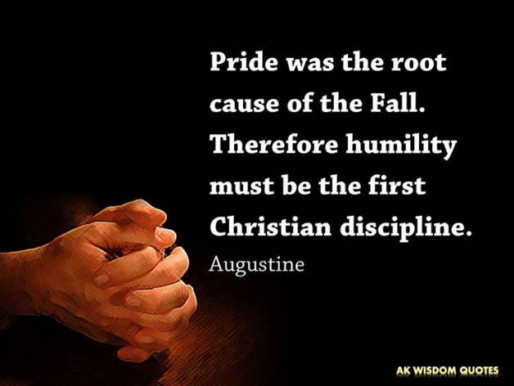

Description: /data/data/com.infraware.PolarisOfficeStdForTablet/files/.polaris_temp/image20.jpegSERMON: Core Habits - Humility

**Pray:**

* We will be more conscious of our thoughts, words and actions which develop the habits and personal characteristics we currently have.
* We will learn to continually examine ourselves and seek to be more humble in our lives.
* We will make it a habit and even a way of life to treat others with respect and dignity.
* We will continue developing our character and wisdom towards Christlikeness.

***For all those who exalt themselves will be humbled, and those who humble themselves will be exalted.” (Luke 14:11)***

Description: /data/data/com.infraware.PolarisOfficeStdForTablet/files/.polaris_temp/image22.jpeg**MINISTRIES & EVENTS: Prayer Meetings**

*There are two prayer meetings schedule in February: Church Prayer meeting on February 14 at Hall 1, 8pm and Crossfields Prayer Meeting on February 25 at Room 103, 8.30am. Let’s come together as a church to pray and intercede.*

**Pray:**

* That people will come to seek His presence and to intercede on behalf of the church, the peoples around them and our missionaries.
* The worship team and facilitating pastors will be prepared and strengthened to lead the sessions.
* The Holy Spirit to minister to the interceding group and the groups being prayed for.

***Sing to the Lord, all the earth; proclaim his salvation day after day.  (1 Chronicles 16:23)***

Description: /data/data/com.infraware.PolarisOfficeStdForTablet/files/.polaris_temp/image23.pngMALAYSIA MY NATION: Jobs and Economy

*Malaysia was long perceived as a safe and reliable destination for foreign investment. It was seen as investor friendly, politically stable, strict in its adherence to the rule of law and predictable when doing business. However, the culminations the recent 1MDB scandal, failing oil prices and international trade deals has made many foreign investors lose faith, leading to economic and job instability across Malaysia.*

**Pray:**

* God will convict and instil the fear of the Lord in the hearts of the current political masters.
* Foreign investors to not underwrite Malaysia too quickly and leave workers in a sudden upheaval.
* God will raise up God fearing leaders who will stand for truth and justice.

***God is our refuge and strength, an ever-present help in trouble. Therefore we will not fear, though the earth give way and the mountains fall into the heart of the sea, though its waters roar and foam and the mountains quake with their surging. (Psalms 46: 1-3)***

**A TRANSFORMED WORLD: Election for Jakarta Governor**

*The election for Jakarta governor will be held on February 15, where increased religious intolerance and vigilantism occurred partly due to the alleged criminal blasphemy of incumbent Jakarta Governor Basuki Tjahaja Purnama (better known as Ahok) – who is of Chinese descent and Christian. It is important to note that the grievances of the people extend beyond Ahok’s verbal transgressions and hinge on old racial prejudices and fears of Chinese-Indonesian political and economic dominance.*

*The Jakarta governor’s post is second most influential publicly elected office in the country after the presidency.*

**Pray:**

* Jakarta citizens will experience safe and peaceful elections.
* God's choice to be elected in the Jakarta gubernatorial election.
* The elected person will continue to allow freedom of religion and heal the ethnic divide in Indonesia.
* No corruption in the elections, or in the results that will be announced.

***I urge, then, first of all, that petitions, prayers, intercession and thanksgiving be made for all people— for kings and all those in authority, that we may live peaceful and quiet lives in all godliness and holiness. (1 Timothy 2:1-2)***