Core Habits: Pass it On and Fun (Exodus 12:21-28, Deuteronomy 16:14-15)
Pastor Mike Ngui

“Then Moses summoned all the elders of Israel and said to them, “Go at once and select the animals for your families and slaughter the Passover lamb. Take a bunch of hyssop, dip it into the blood in the basin and put some of the blood on the top and on both sides of the doorframe. None of you shall go out of the door of your house until morning. When the Lord goes through the land to strike down the Egyptians, he will see the blood on the top and sides of the doorframe and will pass over that doorway, and he will not permit the destroyer to enter your houses and strike you down. “Obey these instructions as a lasting ordinance for you and your descendants. When you enter the land that the Lord will give you as he promised, observe this ceremony. And when your children ask you, ‘What does this ceremony mean to you?’ then tell them, ‘It is the Passover sacrifice to the Lord, who passed over the houses of the Israelites in Egypt and spared our homes when he struck down the Egyptians.’” Then the people bowed down and worshiped. The Israelites did just what the Lord commanded Moses and Aaron.”
(Exodus 12:21-28)

“Be joyful at your festival—you, your sons and daughters, your male and female servants, and the Levites, the foreigners, the fatherless and the widows who live in your towns. For seven days celebrate the festival to the Lord your God at the place the Lord will choose. For the Lord your God will bless you in all your harvest and in all the work of your hands, and your joy will be complete.” (Deuteronomy 16:14-15)

Introduction
Tag-Line: Love God, Serve People, Make Disciples Towards Christ-likeness.
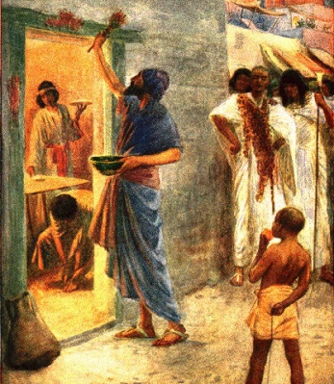
The Passover was a festival to commemorate the day that the Israelites were freed of slavery by the Egyptians. It celebrates the day the Lord’s grace and power reigned over the land and has since become a tradition for the nation. The people of Israel were told to PASS IT ON - the tradition – to their descendants and explain the significance of the celebration to them, so that they too, would learn about the grace of the Lord and His mighty works.

The BIG idea: PASS ON JOY!

Passing it on is not just about passing on one’s teachings and knowledge, it is also about passing on the great joy birthed from the memories and experiences of a tradition or culture.

“My people, hear my teaching; listen to the words of my mouth. I will open my mouth with a parable; I will utter hidden things, things from of old— things we have heard and known, things our ancestors have told us. We will not hide them from their descendants; we will tell the next generation the praiseworthy deeds of the Lord, his power, and the wonders he has done. He decreed statutes for Jacob and established the law in Israel, which he commanded our ancestors to teach their children, so the next generation would know them, even the children yet to be born, and they in turn would tell their children. Then they would put their trust in God and would not forget his deeds but would keep his commands. They would not be like their ancestors— a stubborn and rebellious generation, whose hearts were not loyal to God, whose spirits were not faithful to him.” (Psalm 78:1-8)

We cannot pass it on without the spirit of GENEROSITY

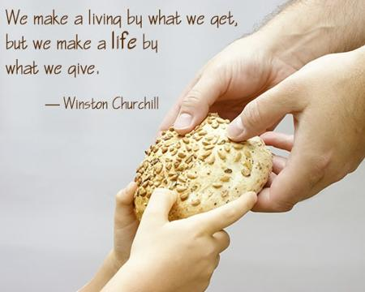
- We cannot pass on anything if we have a stingy heart.

Generosity is CONTAGIOUS. When you give with a heart of generosity, it places a mark on someone else’s heart, and it causes them to pass it on to others in their life. Generosity is not based on how much you have, but how much you are prepared to share. And there is ALWAYS something to share.

When you give out of your love for God, generosity is INEVITABLE. Pass on good advice, good experiences and good teachings, but do not forget to pass on the GOOD NEWS – that Christ has set us free!

“And the things you have heard me say in the presence of many witnesses entrust to reliable people who will also be qualified to teach others.” (2 Timothy 2:2)

Elijah and the widow at Zarephath
“Some time later the brook dried up because there had been no rain in the land. Then the word of the Lord came to him: “Go at once to Zarephath in the region of Sidon and stay there. I have directed a widow there to supply you with food.” So he went to Zarephath. When he came to the town gate, a widow was there gathering sticks. He called to her and asked, “Would you bring me a little water in a jar so I may have a drink?” As she was going to get it, he called, “And bring me, please, a piece of bread.” “As surely as the Lord your God lives,” she replied, “I don’t have any bread—only a handful of flour in a jar and a little olive oil in a jug. I am gathering a few sticks to take home and make a meal for myself and my son, that we may eat it—and die.”
Elijah said to her, “Don’t be afraid. Go home and do as you have said. But first make a small loaf of bread for me from what you have and bring it to me, and then make something for yourself and your son. For this is what the Lord, the God of Israel, says: ‘The jar of flour will not be used up and the jug of oil will not run dry until the day the Lord sends rain on the land.’” She went away and did as Elijah had told her. So there was food every day for Elijah and for the woman and her family. For the jar of flour was not used up and the jug of oil did not run dry, in keeping with the word of the Lord spoken by Elijah.” (1 Kings 17:7-16)

- The widow chose to bless Elijah with the little she had.

Discipleship is for EVERYONE

- A disciple = a learner

The Good News is NOT just for non believers or baby Christians. Everyone needs it. Everyone needs to be reminded of it – even us, as second or third generation Christians who may know the stories inside out. Everything we do should revolve around the Gospel. Everything we say should promote the love of Christ and the grace of our Lord. Passing on the Good News is NOT just about preaching to those who have yet to know Christ, but also to the Christians who are enslaved in their faith.

- Everyone is called to discipleship
People will not know about the Good News until we tell them about it. Sharing what Christ has done for us is not a task dedicated to just the pastors and leaders of a church, but for EVERY MEMBER of the church.

Pass on the joy!
- No joy, no fun!

Fun is not just about having parties and dancing to loud music! Rather, it is about being joyful and loving what you are doing!

- Loving God can be fun!
- Miserable Christians do not advertise the Gospel of Jesus Christ well.
- God gives us His very best. He wants to give us joy from the fullness of His joy.

“Command those who are rich in this present world not to be arrogant nor to put their hope in wealth, which is so uncertain, but to put their hope in God, who richly provides us with everything for our enjoyment.” (1 Timothy 6:17)

Sermon summary contributed by Phoebe Leong
Prayer points contributed by Michelle Wong

SERMON: Core Habits 4 & 5: Pass It On and Fun
Pray:
- All the people of God will set aside time reading His Word daily and pass it on by sharing generously with others in their daily walk in life.
- God’s people must inculcate the spirit of generosity by passing on anything of value without putting our self’s interest first; which is the basis of Christian Giving.
- We must practise sharing the Good News - the Love that Christ Jesus gave us by leading in love by example through encouragement, teaching and sharing experiences.
- Leaders in church will remind the people to constantly pray to commune with God which is the hallmark of holy obedience - Joy .
For the Lord gives wisdom; from his mouth come knowledge and understanding. (Proverbs2:6)

MINISTRIES & EVENTS: W2W ESSENTIAL2017
17 & 18 March 2017
Pray:
- For more ladies to respond to ESSENTIAL2017 Registration.
- More men volunteers to respond to serve in the conference. Specific need of photographers.
- Smooth logistic arrangement, preparation & unity for the Task Force.
- Plenary & workshop speakers' preparation, health & safety.

“May the Lord direct your heart to the love of God and to the steadfastness of Christ”
(2 Thessalonians 3:5)

MALAYSIA MY NATION: Future of Malaysia
The People of God
Pray:
- For protection and wisdom upon the leaders who are working towards improvement in the running of the administration of the government.
- For reconciliation among all leaders irrespective of race or religion for the better good of the country in the near future.
- For God’s protection and deliverance upon the leadership of the churches from all evil attacks.
- God’s authority will prevail in all circumstances which arise in our country and we are thankful for all His grace and mercies
I urge, then, first of all, that petitions, prayers, intercession and thanksgiving be made for all people- for kings and all those in authority, that we may live peaceful and quiet lives in all godliness and holiness.(1 Timothy2 :1-2)

- A TRANSFORMED WORLD: Turkey
Pray:
- For God to protect the people in Turkey who are showing the Love of Christ to those in the darkness.
- God’s favour & protection upon His people in Turkey amidst time of unrest and strife for leadership.
- God’s authority to be upon the new leader of Turkey.
- God will keep Turkey open to religious tolerance and freedom.
For unto us a child is born, to us a son is given, and the government will be on his shoulders. And he will be called Wonderful Counsellor, Mighty God, Everlasting Father, Prince of Peace. (Isaiah 9:6)

