Back to Basics of Being a Born-Again Christian: The Unshakeable Faith in Jesus Christ and you (Hebrews 11:1-6; 12:1&2)
Pastor Gilbert Tan

Now faith is confidence in what we hope for and assurance about what we do not see. This is what the ancients were commended for. By faith we understand that the universe was formed at God’s command, so that what is seen was not made out of what was visible. By faith Abel brought God a better offering than Cain did. By faith he was commended as righteous, when God spoke well of his offerings. And by faith Abel still speaks, even though he is dead. By faith Enoch was taken from this life, so that he did not experience death: “He could not be found, because God had taken him away.” For before he was taken, he was commended as one who pleased God. And without faith it is impossible to please God, because anyone who comes to him must believe that he exists and that he rewards those who earnestly seek him. (Hebrews 11:1-6)
Therefore, since we are surrounded by such a great cloud of witnesses, let us throw off everything that hinders and the sin that so easily entangles. And let us run with perseverance the race marked out for us, fixing our eyes on Jesus, the pioneer and perfecter of faith. For the joy set before him he endured the cross, scorning its shame, and sat down at the right hand of the throne of God. (Hebrews 12:1-2)

Introduction

Social media has served as a powerful platform for us to reconnect with friends and family from all over the world. Thankful for that, we get to know how friends have progressed all these years. However, as much as we enjoy it, if we do not know how to manage it well, there is some negativity to it. For instance, influence is one stronghold it may have on us. For example, when we post something online, we are eagerly chasing over numbers of “likes”. Whether we like it or not, we may start conforming to the pattern of the cyber worldview, and begin to seek for opinions about ourselves and what others would think of us. For example, a 12-year-old girl posted a video online, asking strangers if she is ugly. We (should) have a community and we do not need to ask people for their opinions. God has a higher value of who we are, for each and every one of us. How do we view God, and how God view us?
The BIG idea: Faith is a posture of Confidence and Surrender

Faith unlocks the pleasure of God. In the eyes of God, confidence and surrender are what He desires in us. The two words, confidence and surrender, do not usually come together. In Hebrews 11:6a, it is clearly stated that “without faith it is impossible to please God”. Our Lord is not pleased by our achievement or other worldly recognition. He wants us, to surrender fully unto Him, and be fully confident that God is in charged. In the Amplified version of Hebrews 11:6,
But without faith it is impossible to [walk with God and] please Him, for whoever comes [near] to God must [necessarily] believe that God exists and that He rewards those who [earnestly and diligently] seek Him.
We walk with God and please Him through intimacy (comes near). As such, we must have a firm conviction (believe) that God sees us through our faith, and that we should maintain a faith-based commitment (earnestly and diligently) that is lifelong until we meet our Maker in Heaven. He desires intimacy with each and every one of us.

How do we grow in faith?
Therefore, since we are surrounded by such a great cloud of witnesses, let us throw off everything that hinders and the sin that so easily entangles. And let us run with perseverance the race marked out for us, fixing our eyes on Jesus, the pioneer and perfecter of faith. For the joy set before him he endured the cross, scorning its shame, and sat down at the right hand of the throne of God. (Hebrews 12:1-2)
Pastor Gilbert uses Facebook as a platform to inspire and to encourage. However, when he notices that he feels jealous over other people’s posts, he stopped posting because that is a sign of obsession. We should take time off social media when it is hindering us from building intimacy with God.

Faith may require waiting time. It could be one year, it could be ten years, or even more. Sometimes, prolonged answers build characters in us. While waiting, we can see God clearer. The question for discussion is, “How do we grow in faith?”

Look to Jesus

Hebrews 12:2—Fixing our eyes on Jesus, the pioneer and perfecter of our faith.

Ways we look or gaze at Jesus:

Gazing at His Words. The Word of God reveals His character.

Remember the story of the woman who was bleeding for 12 years? She went to Jesus just to touch the edge of his cloak, and got healed immediately.
And a woman was there who had been subject to bleeding for twelve years, but no one could heal her. She came up behind him and touched the edge of his cloak, and immediately her bleeding stopped. “Who touched me?” Jesus asked. When they all denied it, Peter said, “Master, the people are crowding and pressing against you.” But Jesus said, “Someone touched me; I know that power has gone out from me.” (Luke 8:43-‬46) ‬‬
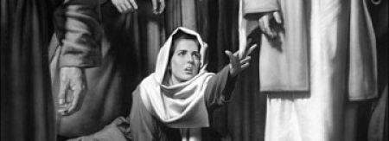‬
The same thing happens whenever we read the Word of God, they reveal the nature and character of God, and Who He is to us. The Word of God is powerful, and He knows it when we read His Word.

Worship God

Worshipping God means agreeing with what God said He is. When we sing, we are declaring the nature of God and who He is, and acknowledging His presence in our lives!

Worship and prayer goes hand in hand. Prayer is important. Let’s be encouraged to worship and pray to God together as a Cell Group, zone, church and country.

Christ is not just the author of our faith, he is also the perfecter of our faith, He started the process of moulding and shaping us, until He returns again as our bridegroom.

Look back and around us

Hebrews 12:1-- …Surrounded by such a great cloud of witnesses…

We must learn to share and declare of God’s faithfulness in our life. Such an act edifies others and helps in building up their faith.

Example 1
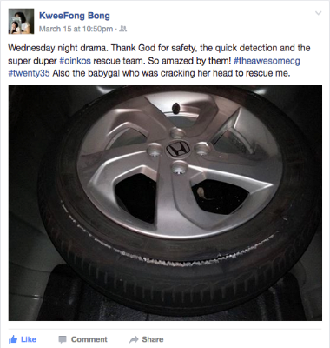
Cell group and community are very important to us. They support us like our own family members. For example, a church member recently expressed her heartfelt gratitude in social media when she had a flat tyre and how her cell members came to her rescue. Her post has many likes and concurring comments, sharing similar stories of how blessed one can be to be in the family of Christ. Now, if you are not in one already, join a CG!
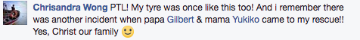

Example 2
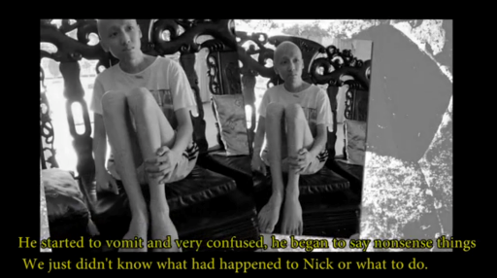
Nick was diagnosed with Leukaemia in 2012. He went through an extremely challenging journey and by God’s grace, came through the ordeal and had gone into remission in 2013. Throughout the progress, he was showered with great amount of support on Facebook and his church group. In 2014, he came to complete remission and was married to his fiancé who had stood by him throughout the ordeal. Today, he will soon become a father by this coming July. Nick gives all credit and glory to Jesus Christ alone. To find out more, go to www.papercranes.com.au/films-pre-wedding-film/last-year.

Heroes of faith in Bible
There are many other true and inspiring stories in the Bible for us to look back on, and how had the heroes of faith lived and obeyed God. Just to mention a few: Noah the drunkard, Rahab the prostitute, Sarah who played God, Joseph the coward and murderer and King David the adulterer and murderer. It is worth noticing that these heroes were all sinners with a colourful life, just like you and me.

Faith means saying ‘yes’ to God more often than saying ‘no’. Pastor Gilbert shared about the Walking Run event for the twenty35 community of young adults last month. It was on a Friday evening, and it rained the entire day. Since the event was carried our both indoor and outdoor, he got very discouraged with the weather. Traffic congestion and flash flood everywhere may be hindering people from coming, but they did not give up. They prayed and asked for God’s intervention. That evening, almost 200 people turned up. These people braved the traffic and rain just to be there!

Look forward to what God has called you to

Hebrews 12:1… let us run with perseverance the race marked out for us

The verse above suggests that we, as Christians, need to race / move forward into glorifying and magnifying Christ wherever God has placed us in. Ask God how can He use us to begin to share Christ to others. In all circumstances, love God, serve people and make disciples toward Christlikeness.

If we love God, we serve people. Serve people around us, those who are down and in need. Make ourselves available. In Luke 5, Simon Peter obeyed Jesus and let down his net for a catch. Astonished, he fell at Jesus’ knees and asked for forgiveness for his sinful nature. Simon was obedient and he simply obeyed Jesus. Easier said than done, but that is one way how we build on our faith. Moving forward requires risks, and interesting enough, faith is spelled R-I-S-K. It is purely obedience. When we obey, we begin the see the blessings of our Lord upon our lives. We need to be reminded that Christ is the Lord of our lives again.

What else has God called you to? Perhaps, it is calling to work full time for God? Whatever it may be the calling that may be testing our level of obedience unto Him, we sure need a revelation of who Christ is.

Conclusion
Faith is the posture of confidence and surrender. In the process of growing in faith, we need to look to Jesus through gazing at His Words for the Word of God reveals His character and worship God; Look back and around us; and Look forward to what God has called you to. Some of us have never heard of Jesus. Christ is who He said He is. He is indeed the Son of God and He died for us on the cross.

Sermon summary contributed by Chrisandra Wong.
Prayer points contributed by Phoebe Leong.

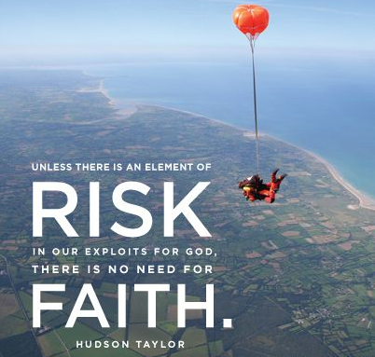

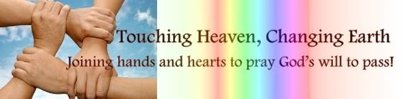

SERMON: The Unshakeable Faith in Jesus Christ and You
Pray:
- To meditate on Hebrews 11:6 as we learn about what it means to walk with God in intimacy and to see Him earnestly and diligently and encounter a firm conviction in our faith.
- To understand truly what having firm, unshakeable faith in Christ means.
- To grow in faith further as we fix our eyes on Jesus, look around at our community, and as we look forward to the work the Lord has for us.
- To run with perseverance and commitment in our faith, and preach the Gospel and share the Good News to the world with boldness and courage.
Therefore, since we are surrounded by such a great cloud of witnesses, let us throw off everything that hinders and the sin that so easily entangles. And let us run with perseverance the race marked out for us, (Hebrews 12:1)

MINISTRIES & EVENTS: 3-Day Fast and Prayer
April 11 – 18. Members gather together as one body to fast and pray.
Pray:
- Perseverance and faith in our fasting and praying throughout the 3 days.
- The sessions will be powerful and significant with God ministering to everyone present.
- For clarity of mind and a sensitive spirit to hear what the Lord is saying.
- For a thirst and hunger to see God’s hand move amongst His people as we pray.
“Even now,” declares the LORD, “return to me with all your heart, with fasting and weeping and mourning.” (Joel 2:12)

MALAYSIA MY NATION: The Church in Malaysia
Pray:
- For Christians in the country to persevere through in strength and faith in the plans that God has for the country.
- For justice to be brought upon those who have done evil and for the righteous to stand firm in their principles and values.
- Believers to go forth in obedience to Him and to share their faith in their communities with boldness and courage.
- For us, as Christians, to live righteous and holy lives, apart from those who have yet to know the Lord. So that we are able to shine His light and glorify His name.
"How good and pleasant it is when God’s people live together in unity!" (Psalm 133:1)

A TRANSFORMED WORLD: North Korea
Pray:
- For the minority sum of believers in the country to not lose hope and to continue being faithful to the Lord even in a time as this.
- For the Lord’s hand of protection over the Christians and those who are being imprisoned for their faith.
- For the nation to soon break free from the rigid ways of the regime and for the people to be free of oppression and suffering.
- For wisdom for the leaders in the nation and for conviction in their hearts to do what is right for the country.
"being strengthened with all power according to his glorious might so that you may have great endurance and patience, and giving joyful thanks to the Father, who has qualified you to share in the inheritance of his holy people in the kingdom of light." (Colossians 1:11-12)

