They Have No More Wine (Matthew 2:1-12)
Senior Pastor Chris Kam
On the third day a wedding took place at Cana in Galilee. Jesus’ mother was there, and Jesus and his disciples had also been invited to the wedding. When the wine was gone, Jesus’ mother said to him, “They have no more wine.”
“Woman, why do you involve me?” Jesus replied. “My hour has not yet come.” His mother said to the servants, “Do whatever he tells you.” Nearby stood six stone water jars, the kind used by the Jews for ceremonial washing, each holding from twenty to thirty gallons. Jesus said to the servants, “Fill the jars with water”; so they filled them to the brim. Then he told them, “Now draw some out and take it to the master of the banquet.” They did so, and the master of the banquet tasted the water that had been turned into wine. He did not realize where it had come from, though the servants who had drawn the water knew. Then he called the bridegroom aside and said, “Everyone brings out the choice wine first and then the cheaper wine after the guests have had too much to drink; but you have saved the best till now.” (John 2:1-10)

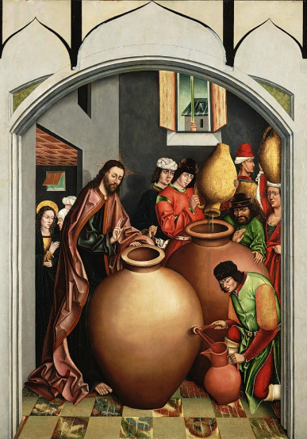
Introduction
Big Idea: Turning your water into wine, the ordinary to the extraordinary.
There are 35 recorded miracles of Jesus in the Bible. Turning water into wine in Cana was one of the first recorded miracle performed by Jesus.
Jesus did many other things as well. If every one of them were written down, I suppose that even the whole world would not have room for the books that would be written. (John 21:25)

Mother of Jesus
The Jewish wedding lasts 7 days. It was a happy time. When they have no more wine, Mary turned to Jesus.
An angel appeared to a teenage Mary and to her that her baby would be the saviour of the world.
But Mary treasured up all these things and pondered them in her heart. (Luke 2:19)

When Jesus was 12, Joseph and Mary lost Jesus during a pilgrimage in Jerusalem. They found him discussing theology and the laws at the learned teachers at the temple.
Then he went down to Nazareth with them and was obedient to them. But his mother treasured all these things in her heart. (Luke 2:51)

Mary must be thinking constantly about what was in store for Jesus. We do not know whether this is the reason she turned to Jesus during the wedding
In the time of Jesus, wine (in moderation) is a sign of joy and God's blessing. However, drunkenness is a sin. Diluted wine was often taken because there was no treated water. Adding some alcohol to the water is more hygienic way of drinking.
In this feast, they had no more wine. It meant no more joy or blessing.
No matter how well we plan our lives, our wine can still run out. It is important to notice that not everyone looks forward to Christmas as we are coming to the end of the year. Some of us are concerned over the political and economic situations of the nation. Some are worried about the declining national currency. Some are lonely and not with their family and friends. Some are overcome with sadness because this could be the first Christmas they have without their loved ones who have passed on. Some of us are worried about our loved ones, our health, our wealth and our jobs. As a church, we need to look out for these people whose wine is gone from their lives.
Jesus responded that his time has not come. In the NLT, we read “that’s not our problem.” Jesus was not being rude calling Mary dear woman. It was a common term of endearment at that time.
Mary ignored Jesus and told servants "to do whatever he tells you".
Do whatever Jesus tells you when the wine of your life is all gone.
We need to involve God in our lives. Many turn to God when wine is gone in their lives. Why do we wait until our wine is gone before we look for God? Much of what God tells you to do is in the Bible.
The heart of sin is not what we do wrong but the independence from God. We want to do our own things and run our own lives.

Manner of Jesus
Nearby stood six stone water jars, the kind used by the Jews for ceremonial washing, each holding from twenty to thirty gallons. Jesus said to the servants, “Fill the jars with water”; so they filled them to the brim. Then he told them, “Now draw some out and take it to the master of the banquet.” They did so, and the master of the banquet tasted the water that had been turned into wine. He did not realize where it had come from, though the servants who had drawn the water knew. Then he called the bridegroom aside. (John 2:6-9)

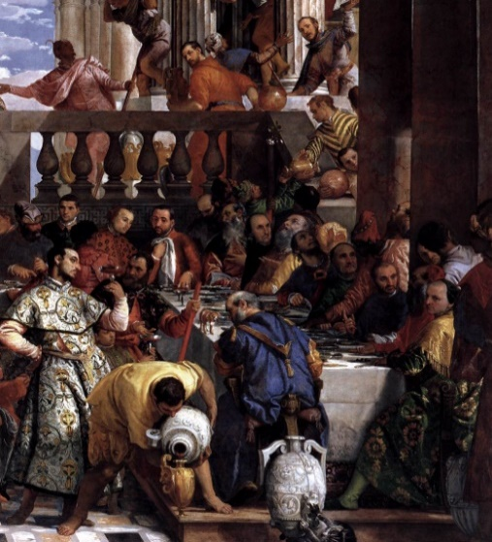
We are in this life journey of filling jars of our life with things that do not give us joy or blessing, for example, with wealth, pleasure, career, etc. And when it is filled to brim, we realise it is only water.
We need to turn to Jesus to turn the water into wine to be things that give us blessing and joy.
The servants must have been wondering what was Jesus thinking. Yet, they obeyed.
We believe the miracle happened because the servants did not question when asked to bring the jars of water to the master of the banquet.
Many of us live by sight. We want to have miracles before we follow Jesus. But Jesus tell us to do what he tells us first then miracles will happen. We are saved by faith not by works.
If you want the water to turn into wine, you need to do what He tells you.

Miracles of Jesus
You have saved the best till now. (John 2:10b)

The best wine presented earlier in the wedding feast turned out to be not the best. This water that Jesus turned into wine was even better than the best.
We may have plans for our life that we think is the best for us. We need to surrender what we think is best for our lives. This is a risk to take when we take a step of faith.
There is something better than what we think as the best in our life.
What is your life like right now? Has your wine run out? Would you allow Jesus and take a step of faith to start walking towards Jesus? God will fill the empty jars and if filled with water, God will turn this water into wine (joy and blessing). God uses ordinary people to do extraordinary things.
Interestingly, the Bible mentioned it as a sign. This is because every miracle is a sign that points towards Jesus. We are not looking at the miracle but at the miracle giver. Our focus is on Jesus. Make sure Jesus is there in your life.
God can completely transform hearts and give us a God perspective on life.
In hindsight, she would have been amazed. When you look back, accepting Christ is the best decision.
Sermon summary contributed by Zhenli and Loong.
Prayer pointers contributed by Michelle.

SERMON: They Have No More Wine
Pray:
- We as people of God will set aside time to read His Word daily and treasure them in our daily walk in life.
- We will remember that only Jesus can deliver us from our sinful ways as no matter what we plan, our ways are not His Ways.
- We must come to Him, surrender all that we want to do & receive by faith by seeking God’s Will for us.
- We will look to Jesus in all circumstances as He is the only one that can transform all hearts.
“May the Lord direct your heart to the love of God and to the steadfastness of Christ.” (2Thessalonians 3:5)

MINISTRIES & EVENTS: Essential 2017: Metamorphosis
A W2W Conference will be held on 17 &18 MARCH 2017 at the Dream Centre.
Pray:
- God will convict the hearts of the women to have the desire to seek Him and His purpose for them.
- God will inspire the volunteers both men and women to be bold and step up to be involved in the W2W Women Conference.
- God will enable the men to bless this event by encouraging their wives, sisters, mothers and daughters to sign up for the event.
- Many from the church and from outside the church will sign up for the conference.
- God will instil the spirit of team unity & humility, compassion & love for a special encounter with the Lord through fasting and prayer for those involved in facilitating the conference.
For the Lord gives wisdom; from his mouth come knowledge and understanding. (Proverbs2:6)

MALAYSIA MY NATION: CHURCHES IN MALAYSIA
Pray:
- God will put the right spirit within the hearts of Christian leaders within the various denominations to unite as one.
- People of God will work together to bring non-believers to Christ.
- People of God will pray for the leadership of the churches to work towards gathering their resources to aid those churches in need in their various ministries.
I urge, then, first of all, that petitions, prayers, intercession and thanksgiving be made for all people- for kings and all those in authority, that we may live peaceful and quiet lives in all godliness and holiness. (1 Timothy2 :1-2)

- A TRANSFORMED WORLD: Terrorism in Europe
Pray:
- For God to protect the people in Europe who are showing the Love of Christ to those from the darkness.
- God’s strength, comfort& protection upon those who have lost loved ones due to the violence.
- People of God will have the ability to counter the terrorism through alertness and unity.
- God to open the eyes of those who live in darkness to see the light through dreams, visions and hearing from the Holy Spirit.
But you Lord, are a shield around me, my glory the One who lifts my head high. (Psalm 3:3)

