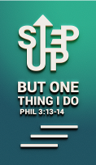
The Purifying Work of the Holy Spirit (1 Peter 1:13-16)
Be Holy
Pastor Jeffrey Rachmat

Therefore gird up the loins of your mind, be sober, and rest your hope fully upon the grace that is to be brought to you at the revelation of Jesus Christ; as obedient children, not conforming yourselves to the former lusts, as in your ignorance; but as He who called you is holy, you also be holy in all your conduct, because it is written, “Be holy, for I am holy.” (1 Peter 1:13-16 NKJV)

Introduction
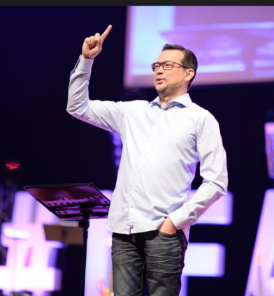
We live in a very interesting and challenging time. Decades ago, what was considered as taboo is now considered normal. People keep pushing the norm in the name of freedom. With the help of Internet and technology, many things can be found easily and may be in our homes even without realising it. For example, online shopping, movies, even pornography and transgenderism.

We will see more of these phenomena in the days to come. How can we live in this world without losing our faith and convictions? We cannot detach ourselves from this world. In fact, Jesus wants us to go into the world and preach the gospel.

What is holiness?
To be holy means to be separated. Why does God want us to be holy? Does he know anything about our world today or does he know something we do not know? We live our lives from the inside out, and not from the outside in. The separation begins from the inside. Holiness begins in our hearts and minds. Separation means that we are in the world but not of the world.

Why holiness?
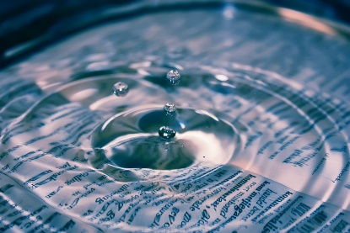
All of us love cleanliness. Where do those thoughts come from? From whom do we receive a longing to be clean? It is from God because we are created in his image and in his likeness. God is holy and clean. To be holy should be normal for Christians. We are God’s creation and God knows best how we should function. He knows how we can raise our maximum potential and live to the best of our capacity. Every commandment of every law that God gives us was not for His benefit, but for our benefit because He is our loving father. For instance, forgiveness frees us from the person that hurt us. Unforgiveness is like drinking poison but hoping the other person will die. Another example is when restricted areas are marked out, it is to guard your freedom. Commandments are to keep our freedom and secure our future, so we can enjoy His blessings continuously.
God wants you to be holy because you are at your very best when you are pure and holy. We do not see the vision God has for us when we do not live holy as He wants us to be. When you are pure and holy, your value will increase. People will start to treat you with honour and respect.

How to keep the Devil away
But when the Pharisees heard this, they said, “It is only by Beelzebul, the prince of demons, that this fellow drives out demons.” (Matthew 12:24)

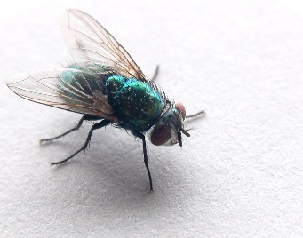
Beelzebul was mentioned – Prince of the Devils. The name means “the Lord of Dung” or “the Lord of Flies”. How to stop the flies from coming to your house? 2 options: (1) Buy fly repellent (2) clean your house. Many Christians would use the first option – they go to war with the devil. Nothing wrong with that but again you have options. Your decisions have consequences. The problem with this approach is if your house is dirty, it does not matter how many times you kill the flies, they will keep coming back. You need to clean your house, that is your life and mind. You need to live in purity and holiness to keep the Devil away from you. That is the second and more permanent option.

Sin versus holiness
In contrary, who is the one who tells you to disobey God and His word; to ignore God’s commands and go ahead and sin? The devil loves it when you sin, to sabotage your potential and decrease your value. Sin means missing your mark. Sin is like dirt or dust that covers your true beauty, pollutes your mind, and keeps you from being your best. You cannot be creative in God. Sin disrupts God’s plan for you. Sin pulls you away from God and leads you into the dark. Sin unlocks death. If you bring sin into your relationships, you activate death into that relationship.

“Not conforming yourselves to the former lusts, as in your ignorance” (1 Peter 1:14)
If we give in to lust, sin enters our lives and we become unholy.

Praise be to the God and Father of our Lord Jesus Christ, who has blessed us in the heavenly realms with every spiritual blessing in Christ. For he chose us in him before the creation of the world to be holy and blameless in his sight. (Ephesians 1:3-4)

God wants us to be holy because we are His. Our bodies are His temple and He wants to bless us in Christ Jesus.

How to be holy?

What should I do?
Repent therefore and be converted, that your sins may be blotted out, so that times of refreshing may come from the presence of the Lord. (Acts 3:19 NKJV)
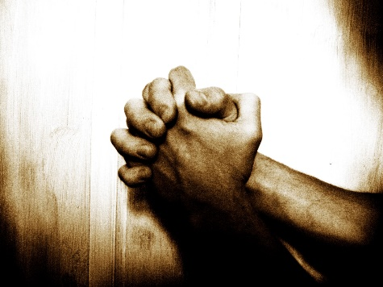
If we confess our sins, He is faithful and just to forgive us our sins and to cleanse us from all unrighteousness. (1 John 1:9 NKJV)

He wants to cleanse and refresh us so we can have better lives.

How we make the holiness in our lives
Now that you have purified yourselves by obeying the truth so that you have sincere love for each other, love one another deeply, from the heart. (1 Peter 1:22 NIV)

Every time you obey God’s word, you are purifying yourself. The Holy Spirit will always lead you towards holiness and purity. When you are pure and holy, you will function at your very best with the presence of God in you.

Conclusion
We need to change the way we think about holiness. Commandments are for our benefit and to reach our maximum potential, glorifying Jesus and be blessings for others because God is our loving Father who loves us so much that He wants us to win in life.
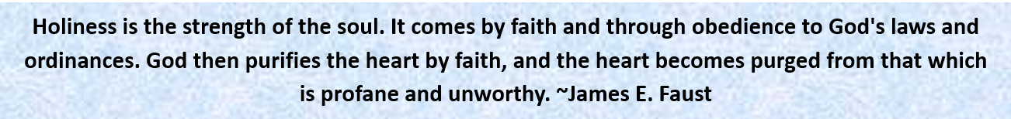
Sermon summary (04/06/2016) contributed by Zhenli.
There being 2 different sermons, there are no prayer pointers.

