The Rule Breakers
Pastor Joey Bonifacio

And God spoke all these words: “I am the Lord your God, who brought you out of Egypt, out of the land of slavery. “You shall have no other gods before me. “You shall not make for yourself an image in the form of anything in heaven above or on the earth beneath or in the waters below. You shall not bow down to them or worship them; for I, the Lord your God, am a jealous God, punishing the children for the sin of the parents to the third and fourth generation of those who hate me, but showing love to a thousand generations of those who love me and keep my commandments. (Exodus 20:1-6)
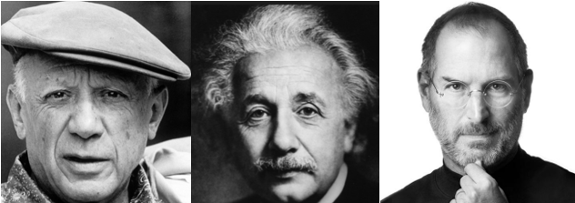
Pablo Picasso said “Learn the rules like a pro so you can break them like an artist.” Albert Einstein broke many laws of physics. More recently, Steve Jobs change our world by breaking a lot of rules.
There are two important reasons why these men are very successful. It is not so much as they are rule breakers but rather they know which rules needed to be broken. There are some rules that are not foundational lasting rules and they are really manmade tentative rules that are not the basis for the future. As great rule breakers as they are, they are successful because of the depth of knowledge they have about certain rules that should not and cannot be broken.
You are remembered by the rules that you break.
Great men can break rules because they understand certain rules can be broken but there are other rules that can never be broken.
The greatest rule breaker is Jesus, who kept on breaking the rules and traditions of the Jews. “Do not think that I have come to abolish the law or the Prophets; I have not come to abolish them but to fulfil them.”
And God spoke all these words: “I am the Lord your God, who brought you out of Egypt, out of the land of slavery. (Deuteronomy 20:1-2)

God Cannot Be Made
“You shall not make for yourself an image in the form of anything in heaven above or on the earth beneath or in the waters below. (Deuteronomy 20:4)
Moses brought the Israelites out of Egypt, the land with many gods. They do not know how to live with a God. Moses told them there are rules they must follow. First of all, there is only one God. He then further said they cannot make idols. God cannot be made. We cannot carve a god out of our imagination. Egypt has hundreds of gods shaped out from stones, metals and precious metals. These are gods that wanted to enslave them. They sacrificed to the gods. When they do this, they are literally worshipping demons.
Tony Chan, ex-feng shui master accepted Christ.
Tony’s driver gave him a Bible. That led to Tony’s subsequent acceptance of Jesus. If we think we cannot be used by God, we are too self-centred to be used by God.
Thomas Jefferson, the third president of the US did not believe in miracles. He cut off the miracles in the Bible. When God tells us to go to church, to tithe, we do.
We cannot shape or limit God according to our wish.

God cannot be replaced
You shall not bow down to them or worship them (Deuteronomy 20:5a)
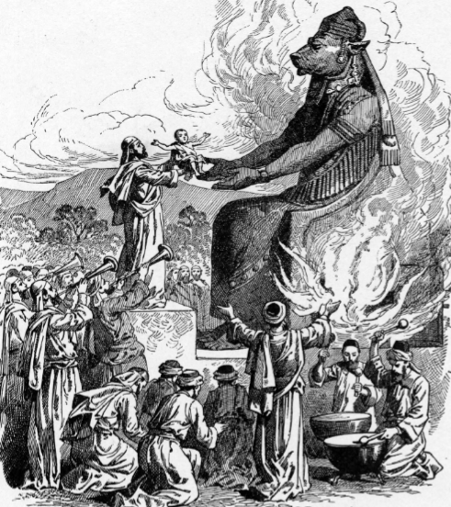
The Pharisees replaced laws with rules and traditions. The laws are there to reveal God. They do not replace God. The law is lightbulb we switched on to see God. But they are not to replace God. We do not worship the law. The law is there to remind us that we cannot make it without God. The law dims us when we try to live up the law. The law is there to make us draw near to God.
The problem with the Pharisees was they started to worship the lightbulb. Jesus came to tell them he did not come to abolish the law but to fulfil them. It is no longer you shall not murder / steal but instead you shall not murder / steal because of Jesus.
You study the Scriptures diligently because you think that in them you have eternal life. These are
the very Scriptures that testify about me (John 5:39)

Sometimes we can turn a good thing into an idol. The Bible can be an idol if we think we know the Bible very well and that we can quote it. It is not wrong to love our family but it cannot go before God. If we are going to be the person that God wants us to be, we must remember that there is no other God and we cannot make our own God.

God’s laws are about God’s Love
God’s laws are never about rule but instead God’s love.
You shall not bow down to them or worship them; for I, the Lord your God, am a jealous God, punishing the children for the sin of the parents to the third and fourth generation of those who hate me. (Deuteronomy 20:5)

Jealousy is a strong word. God told us do not fear and yet He told us to fear God. There is a godly fear.
You are still worldly. For since there is jealousy and quarrelling among you, are you not worldly? Are you not acting like mere humans? (1 Corinthians 3:3)

Let us behave decently, as in the daytime, not in carousing and drunkenness, not in sexual immorality and debauchery, not in dissension and jealousy. (Romans 13:13)

Jealousy is at the same level as sexual immorality and debauchery.
I am jealous for you with a godly jealousy. I promised you to one husband, to Christ, so that I might present you as a pure virgin to him. (2 Cor 11:2)
There is a godly jealousy. That’s what we can’t just do rules. Jealous is love and anger at the same time whether it’s godly jealousy or ungodly jealousy. It comes with priority. There is nothing wrong with working hard or ministry. If we love someone and give our best, and the person does not reciprocate, then we get angry.
There is also fidelity and intimacy. We have heard of a jealous lover who kills the lover.
There was a huge rave parties in the Philippines recently where 5 teenagers were found dead. The autopsy revealed a substance they took contained lethal elements. The parents more likely that not wished their children did not go out instead of calling them foolish. They just wanted them back.

God wants us to make Him our priority everyday just like He has made us His priority every day.

but showing love to a thousand generations of those who love me and keep my commandments (Exodus 20:6)

We often stop at verse 5. In verse 6, God promised to visit the future generations. God wants us to experience His steadfast love.
Sermon summary compiled by Loong.
There being 2 different sermons, there are no prayer pointers.

