What has the #Twenty35 got to do with me? (Matthew 5:14-16)
Deputy Senior Pastor Chris Kam

I am writing to you, dear children, because your sins have been forgiven on account of his name. I am writing to you, fathers, because you know him who is from the beginning. I am writing to you, young men, because you have overcome the evil one. I write to you, dear children, because you know the Father. I write to you, fathers, because you know him who is from the beginning. I write to you, young men, because you are strong, and the word of God lives in you, and you have overcome the evil one. (1 John 2:12-14)

Introduction
A recap of the FORWARD2016 series:
- Step Up - Casting a 10-year vision. We want to build our church not just for ourselves but for future generations.
- Our role in the nation – why is the church the hope of the nation.
- Why are we a cell Church and why we need to be in a cell group?
- What can we do in our community? Acts of kindness. Changing the spiritual atmosphere.
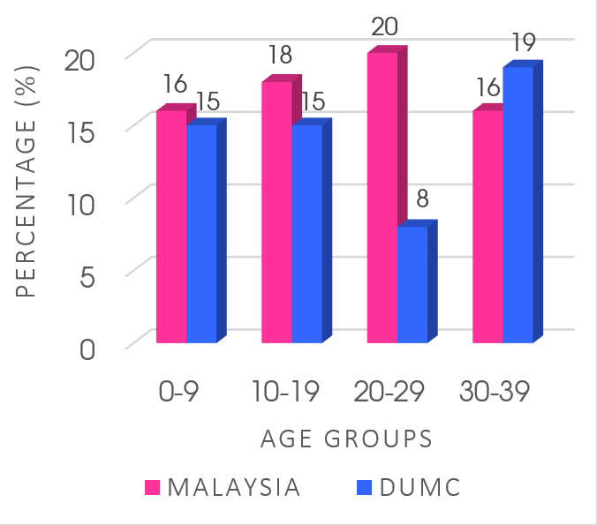
There are 54% of the Malaysian population under 30. In DUMC, the percentage is only 38%. We need another 700 members below 30 to make it on par with the national population. If we don’t take this seriously, we may lost one generation.

#Twenty35 is s strategy statement. It is a discipleship strategy. It is not to focus on a specific age group at the exclusion of others. Every age group is important in this strategy.

The big idea: Who is discipling you and who are you discipling?
Those above 50 are gold mines. However, if we don’t mine, the gold remains where it is.

Even though you have ten thousand guardians in Christ, you do not have many fathers, for in Christ Jesus I became your father through the gospel. Therefore I urge you to imitate me. (1 Corinthians 4:15-17)

What’s a guardian? A servant or slave tutor who supervises the child and has no intimate relationship. That’s what the church in Corinth has become and that’s what many churches of today has become. The problem starts with the home when parents do not disciple their children in the way of the Lord and they leave it to the church to do that, which only has a window of 2 or 3 hours a week. And if we don’t watch it, in just one generation, we can lose it all. That’s what happened in the Joshua generation after Moses. We need to let the young people to begin to know we love them. Do not just give them “the look”. Sit down with them and talk to them.

I write to you, young men, because you are strong, and the word of God lives in you, and you have overcome the evil one. (1 John 2:14)

1 John 2:12-14 sets the path of spiritual development for everyone to grow from a child to a father. The fathers in our midst know the heart of God intimately and live out a life desiring the pleasure of God. He models the same to his children. We believe this fathering and discipling mandate is first given to biological fathers and then to other older men and women in partnership within the Church to disciple the younger ones.
Very often, a church breaks the members into silos of different age groups. We want to break down the silos. We need to think multi-generational in the church.

What will keep our #Twenty35 in the church?
- Encounter with God.
- Feel they belong – not just among their peers but influential older ones.
- Have a sense of purpose. There is no greater purpose than the Gospel of Jesus Christ.

3 mental images of #Twenty35:
- Strong
- The Word of God lives in them.
- They have overcome the evil one.

You are Strong
First, he is strong. We often link strength to just a physical attribute but we know being strong are equally, if not more vital in being spiritually, emotionally, socially and mentally strong. This person is steady, firm, immovable and sure. He is not so affected by struggles, calamities or even persecutions. In fact, these will make him even stronger. He does not merely ask why to the circumstances of life, but what he can learn from them so that he is better the next round and offers himself to counsel and help others in similar situations. Weak men will abandon ship or leave at the first sign of trouble, but this man confronts it and seeks a solution for it.
So allow our children to go through some sufferings and hardship. Do not be too eager to lend a helping hand. That may rob them the opportunity to grow in life.
They grow strong by learning to serve and give. Parents need to set an example to them about loving and serving people. If we are half-hearted in loving God and serving people, they will pick that up too. Do they see us as parents excited about church? The power of influence and modelling.

The Word of God lives in you
Our children from the Children Church know the Bible well. But we want not just knowledge in the head but in the heart experientially as well. The word “lives” holds the idea to “remain”, “abide” or “dwell”. There is a power of the Holy Spirit that seems to work through his life and it is evident for everyone to see. Help him not only know the Word of God but encounter the God of the Word.
They have learnt to feed themselves. What if we are transferred to a place of work, or place of studies, where there are no dynamic churches, no hype, no wow factor. Would we still be able to survive as a Christian, or you will continue to thrive because your intimacy is with the Lord. Can we worship with all our heart in a conservative church? Can we thrive in an environment where we may even preach better the preacher there?
The real test of their faith is when all that are comfortable to them are taken away. When parents are not around. Do they have a positive experience of God and church?

You have overcome the evil one
The third mark has to do with overcoming the evil one. The devil trips us in two ways. He is called the accuser (Revelation 12:10) and the tempter (1 Thessalonians 3:5). He accuses us of our past sins that have already been forgiven and we could easily succumb if the Word of God does not live in us. Many live defeated lives rather victorious one. If he can’t accuse us of our past sins, he will then tempt us towards possible future sins. In both cases, we live under his domination when he succeeds. The #Twenty35 young man however will overcome both the accuser and the tempter.
And all these happens not because the #Twenty35 could do it on their own but because there are people around them, whether their parents or mentors / disciplers who can walk the journey with them. #Twenty35, learn to stand on the shoulders of giants. There are no self-made man.
How does this pan out?
First, go to cell groups. We have no relationships sitting in rows. We build relationships sitting in a circle. There are also many great gold mines like the Pre-Marital Counselling, Women2Women, Men Alive!, Marriage Ministry, Faith@Work, NextGen, Children Church, and many other ministries in general.
When that happens, v15 kicks in. They become lovers of God and not lovers of the world.
Do not love the world or anything in the world. If anyone loves the world, the love of the Father is not in him. For everything in the world—the cravings of sinful man, the lust of his eyes and the boasting of what he has and does—comes not from the Father but from the world. The world and its desires pass away, but the man who does the will of God lives forever. (1 John 2:15-17)

The young people are a danger and threat to the evil one.
Pastor Chris is of the opinion, especially for our children, that they have no reasons why they cannot do better than us. The opportunities accorded them now, in terms of education, equipping, training and exposure, are way better than our times at their age. We need to move the faith of our children from second hand to first hand. A legion of such spiritual young warriors will advance the kingdom in a supernatural and miraculous way. We need to believe in the next generation. Each generation is here for the next. We need to be intentional and craft the heart of God for our children and their children in generations to come. Keep that mental image in your mind.
Who is discipling you and who are you discipling?
What is the Holy Spirit saying to you?

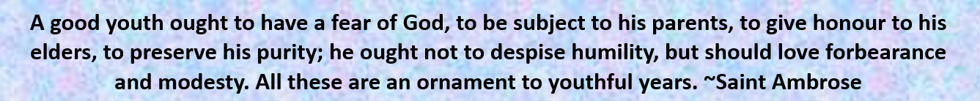

Sermon summary contributed by Ngui Yuen Loong
Prayer points contributed by May Ng

SERMON: Forward 2016: What has the #Twenty35 got to do with you?
Pray:
- Awareness that #Twenty35 affects all of us regardless of age.
- Each one has a role to play in #Twenty35 and not just those within the 20-35 age group.
- Every individual in Christ to find the need to have a mentor and to mentor.
- Encouragement to raise the next generation as leaders in Christ.
- Boldness and purposefulness in Christ.
- Reliance on a community of fellow Christians for mutual encouragement and spiritual maturity.
And the things you have heard me say in the presence of many witnesses entrust to reliable people who will also be qualified to teach others. (2 Timothy 2:2)
MINISTRIES & EVENTS: W2W Moments
W2W will be continuing their studies on a book by Beth Moore.
Pray:
- God to raise women of all generations to fulfil their God-given destiny.
- Peace and joy in the studying of His Word.
- God to speak to the participants for the respective seasons in their lives.
- Lasting fellowship among the participants.
- Women to be called as leaders in Christ in their vocation be it in the marketplace, ministry, or home.
In the same way, the women are to be worthy of respect, not malicious talkers but temperate and trustworthy in everything. (1 Timothy 3:11)

MALAYSIA MY NATION: Chinese New Year Celebrations
Chinese all over the world, including in Malaysia, will be celebrating Chinese New Year come 8 February 2016.
Pray:
- Peace and harmony to prevail in the celebrations.
- Journey mercies to all travelling during the festive season.
- Touching of lives by the Holy Spirit that the fear of the Lord is the basis for righteous living.
- Breaking of bondages from fear and superstition surrounding the celebrations.
- Touching of lives that the Lord is the Source and Provider of all good things.
Serve the Lord with fear and celebrate his rule with trembling. (Psalm 2:11)
- A TRANSFORMED WORLD: Zika VIrus
A rare tropical virus has been spreading rapidly through Latin America prompting health officials to warn pregnant women of the risks to their babies. The virus has been linked by some officials in Brazil to surging cases of microcephaly - a brain defect that leads to reduced head size in infants. However, the virus itself is not thought to be fatal and often comes with no symptoms at all.
Pray:
- All to put their trust in the Lord for protection from the virus.
- Serious co-operation from authorities worldwide to curb the spread of the virus.
- Wisdom for health workers to administer the appropriate treatment to patients.
- Binding and breaking of all foul spirits at work in the spread of this virus.
You will not fear the terror of night, nor the arrow that flies by day, nor the pestilence that stalks in the darkness, nor the plague that destroys at midday. (Psalm 91:5, 6)

