A Mother’s Highest Calling (Luke 1:26-38)
Stella Kam

In the sixth month of Elizabeth’s pregnancy, God sent the angel Gabriel to Nazareth, a town in Galilee, to a virgin pledged to be married to a man named Joseph, a descendant of David. The virgin’s name was Mary. The angel went to her and said, “Greetings, you who are highly favored! The Lord is with you.”
Mary was greatly troubled at his words and wondered what kind of greeting this might be. But the angel said to her, “Do not be afraid, Mary; you have found favor with God. You will conceive and give birth to a son, and you are to call him Jesus. He will be great and will be called the Son of the Most High. The Lord God will give him the throne of his father David, and he will reign over Jacob’s descendants forever; his kingdom will never end.”
“How will this be,” Mary asked the angel, “since I am a virgin?”
The angel answered, “The Holy Spirit will come on you, and the power of the Most High will overshadow you. So the holy one to be born will be called the Son of God. Even Elizabeth your relative is going to have a child in her old age, and she who was said to be unable to conceive is in her sixth month. For no word from God will ever fail.”
“I am the Lord’s servant,” Mary answered. “May your word to me be fulfilled.” Then the angel left her. (Luke 1:26-38)

Introduction

What is the character of God that best resonates with you? The list may be long, but base on the following three characteristics, who would we choose to reflect the following characteristics, our fathers, or our mothers?

- Loving
- Faithful
- Sacrificial

We find that both men (fathers) and women (mothers) actually reflect these characteristics of God. Rightly so, because we are all made in the image of God. As long as we are influencing somebody, we are reflecting the image and characteristics of God.

BIG IDEA: Mothers, never forget that you are a reflection of God to your children.

It is the highest calling of God in influencing others, and we can respond to this calling through Character, Call and Commission.

Character
In the sixth month of Elizabeth’s pregnancy, God sent the angel Gabriel to Nazareth, a town in Galilee, to a virgin pledged to be married to a man named Joseph,a descendant of David. The virgin’s name was Mary.The angel went to her and said, “Greetings, you who are highly favored! The Lord is with you.” Mary was greatly troubled at his words and wondered what kind of greeting this might be. But the angel said to her, “Do not be afraid, Mary; you have found favor with God. (Luke 1:26-30)

What does it mean to find favour with God? What does it mean to be said to be highly favoured? There was also another person in the Bible that was said to be highly favoured by God, and it actually described what it means:

But Noah found favor in the eyes of the Lord. This is the account of Noah and his family. Noah was a righteous man, blameless among the people of his time, and he walked faithfully with God. (Genesis 6:8-9)
A person who is found favoured by God is one that is righteous, blameless in the eyes of people and walks faithfully with God (have a relationship with God). So, this is how Mary was. Mary was a principled person (she did not fornicate) and also the Lord’s servant (obedient to God and knows God). She was willing to throw her reputation away so that the Lord’s will could be done. Ultimately, character is very important in responding to God’s highest calling.

Since character is so important, motherhood starts when a person is born. Character inculcated in us through the values that we have, and is shown by the decisions that we make. It is what we exposed ourselves to. It is something that we grow into or form over the time, just like a pearl. A natural pearl is not made overnight, but based on every situation it faces. In all circumstances at all stages of our lives, we make decisions. The trend of answers to our decisions determine the values that we have.

Value is something that we hold deep inside, something that we truly believe in. The words (that represent our feelings) that oozes out during the most unexpected situations demonstrates our true value. Those feelings that we have will come out in our behaviour, and it would be manifested during times when we least expect it. Over time, when we continuously demonstrate these values, people will see that as our character.

Values Feelings Behaviour Character

We cannot teach character to our children. It is caught rather than taught. Our children catch our character through our responses during the most unexpected situation, where we are left with not much time to think or reflect. As such, one cannot impart to your children what you do not have. And we cannot outsource this to the children’s church or next gen.

Is it too late for any mother or influencer to change their character? The answer is no, it is never too late to change and values can be change. Values are not something that we are born with. Values are taught and caught. Therefore, we catch good values by surrounding ourselves with things that are of Biblical values: Be together with likeminded Christians while not forgetting the pre-believers, join a cell group, read materials and watch TV programmes that inculcate good values, etc. These create an environment to which we will catch good values. What good values are you catching today that enables you to become a better mother (influencer) to your children (mentee)?

Question: What kind of values do I want to model to my children?

Call
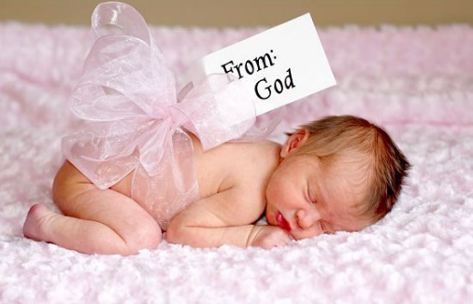
The call to motherhood is a natural instinct to many mothers. The moment parents know that the mother is pregnant, the instinct prevails though all the preparation for the arrival of the baby till he/she graduates from the best education possible, not forgetting other areas that revolves around the child.
We need to realise that our children are not ours. They belong to God.
You will conceive and give birth to a son, and you are to call him Jesus. He will be great and will be called the Son of the Most High. The Lord God will give him the throne of his father David, and he will reign over Jacob’s descendants forever; his kingdom will never end.” (Luke 1:31-33)

Just as how Jesus was given to Mary, our children were given to us by God, for a purpose. Every single child is different and has a different purpose and plan by God. Have you asked God for the purpose of your child?

Ask/Seek to know
“What do you want of this child, God?”
Just as how God told Mary the purpose He had for Jesus, He also would like us to know His purpose for our children.

Dedicate
Dedicating our children back to God is an indication that we are in partnership with Him as God entrusts us with the children.

On the eighth day, when it was time to circumcise the child, he was named Jesus, the name the angel had given him before he was conceived. (Luke 2:21)

When the time came for the purification rites required by the Law of Moses, Joseph and Mary took him to Jerusalem to present him to the Lord (as it is written in the Law of the Lord, “Every firstborn male is to be consecrated to the Lord”), and to offer a sacrifice in keeping with what is said in the Law of the Lord: “a pair of doves or two young pigeons.” (Luke 2:22-24)

Prepare
Aside from asking God of the purpose He has for the child and dedicating the child back to Him, we need to prepare the child in growing holistically.

And the child grew and became strong; he was filled with wisdom, and the grace of God was on him. (Luke 2:40)

And Jesus grew in wisdom and stature, and in favor with God and man. (Luke 2:52)

The above verses indicate that Jesus experienced a holistic growth physically (strong), mentally (wisdom), spiritually (grace of God), emotionally and socially. A few questions for parents to ponder upon:

- How do we help our children to be first generation Christian who fall in love with God themselves?
- How do we ground our children in their faith that they may be strong in the Word of God so that they can actually stand in these last days?
- How do we help our children to build good character that they will embrace Godly biblical values for themselves?
How do we prepare them for their call? After we have gone through the whole journey of preparation, it is time to commission them.
Question: What does God want your children to be?

Commission
When we let go, we commission them. From there, they will learn to be independent through doing housework, cooking, managing their finance, etc. All these would help them to grow to their full potential. In preparation to commission them, we observe and witness the work of God in them for their purpose in life. Parents, when you are finally able to commission them and let them go, it speaks thousands of words, including your ability to do the job that God had entrusted you to. It is then time to say that “It is finished, and I am now entrusting my child back to God who would continue to take them on their journey.” It all shows that you have done your part and a good job as a parent. We should always remember God’s call.

Luke 2:16-19 (Shepherds)
So they hurried off and found Mary and Joseph, and the baby, who was lying in the manger. When they had seen him, they spread the word concerning what had been told them about this child, and all who heard it were amazed at what the shepherds said to them. But Mary treasured up all these things and pondered them in her heart.

Luke 2:28-33 (Prophecy over Jesus)
Simeon took him in his arms and praised God, saying: “Sovereign Lord, as you have promised, you may now dismiss your servant in peace. For my eyes have seen your salvation, which you have prepared in the sight of all nations: a light for revelation to the Gentiles, and the glory of your people Israel.” The child’s father and mother marveled at what was said about him.

Luke 2:51 (Jesus was 12 years old in the temple)
Then he went down to Nazareth with them and was obedient to them. But his mother treasured all these things in her heart.

Conclusion

Being a mother, a parent or an influencer, is the highest calling to be a right reflection of God to our children or those whose life are being influenced by us. This call is to build our character and to know what God has in mind for us and to be able to commission the people that have been entrusted to us.

All our children are in the midst of completing their race in life. We are here to build character and impart it to our children so that they will also be children of Godly character. This call, calls for preparation to commission our children into God’s purpose in their journey of life and that they are running the right race of life. When it is time for them to be independent and to grow up, we are called to commission them on the race that God had given them, ensuring that they run that race well, and for us to be cheering them along the way, encouraging them, so that they finish well.

We would like to plead with all those who are influencing children and building the next generation, to all do our part and gather as a church and family, to make sure that every single child run the race and finish well, and we would be all at the finishing line, saying, “Yes, Yes, Yes!
*

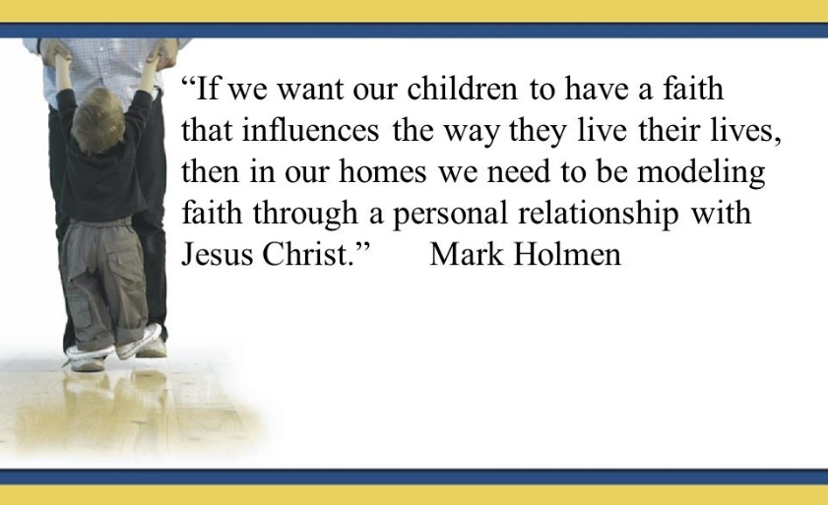

Sermon summary contributed by Chrisandra Wong.
Prayer points contributed by Phoebe Leong.

SERMON: Mother’s Day Celebration – A Mother’s Highest Calling
Pray:
- That no matter how tough and difficult the journey of motherhood becomes, the mothers will remember their calling and persevere through.
- That they adhere to their calling to motherhood not just for the sake of it, but in obedience to God.
- That they draw strength from God and walk faithfully with Him.
- That we as their family will help our mothers in every way we can.
“But the angel said to her, “do not be afraid, Mary; you have found favour with God.” (Luke 1:30)

MINISTRIES & EVENTS: Syok Saturday
As a continuation of the 20-35 event, DUMC is holding Syok Saturday on 20th May 2017, for an evening of fellowship and fun.
Pray:
- For everything, from the planning to the execution, to run smoothly.
- For the logistics, that the team will be able to achieve its target number.
- That God’s presence will be there, even as the people get to know one another and have fun.
- For safety and security throughout the event, that no accidents or mishaps will occur during the event.
I will also make you a light for the Gentiles, that my salvation may reach to the ends of the earth.” (Isaiah 49:6b)

MALAYSIA MY NATION: MACC launch Anti-Corruption Revolution Movement
The Malaysian Anti-Corruption Commission (MACC) wants the public to make corruption their number one enemy and hopes to do this with the launch of the Anti-Corruption Revolution Movement or Gerah. The Gerah campaign will be held on the first Monday of every month and will see MACC officers going to the ground to bring about aggressive and drastic changes among Malaysians.
Pray:
- MACC officers themselves will make corruption their number one enemy and will be able to carry out their duties free of any outside influences.
- Wisdom to those in charge to manage this initiative well and achieve their goals.
- The rakyat will also take corruption seriously and play their part in the fight against corruption.
- God's hand and protection upon everyone who is fighting against corruption.
- God will bring truth and justice into this land.
"Woe to those who call evil good and good evil, who put darkness for light and light for darkness, who put bitter for sweet and sweet for bitter. “ (Isaiah 5:20)

A TRANSFORMED WORLD: Riot in Venezuela
Opponents of President Nicolas Maduro in Venezuela are protesting in the streets in Caracas. Major casualties have been minimized over the past few weeks, but the political unrest, caused by anti-government protestors is still affecting many people with violent behaviours in the streets.
Pray:
- For God to intercede in the country even in a time like this, and for Him to bring peace and unity among the people in the land.
- For the softening of hearts of the protestors in their violent ways and to open their eyes to peace and love.
- For the authorities to handle the situation with wisdom and righteousness, that they will know how to bring the protests to an end without affecting anymore people.
- For God to give the president a heart for the people and not a heart of greed.
Consider the blameless, observe the upright; a future awaits those who seek peace. (Psalms 37:37)

