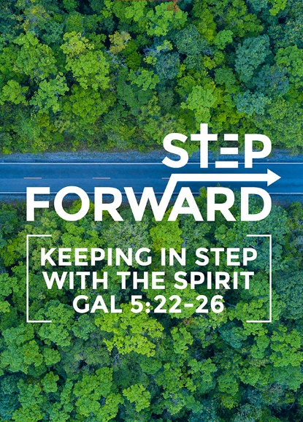
Running and Continuing the Race
(Hebrews 12:1-3)
Founding Senior Pastor Dato’ Dr Daniel Ho
Therefore, since we are surrounded by such a great cloud of witnesses, let us throw off everything that hinders and the sin that so easily entangles. And let us run with perseverance the race marked out for us, fixing our eyes on Jesus, the pioneer and perfecter of faith. For the joy set before him he endured the cross, scorning its shame, and sat down at the right hand of the throne of God. Consider him who endured such opposition from sinners, so that you will not grow weary and lose heart. (Hebrews 12:1-3)

Introduction

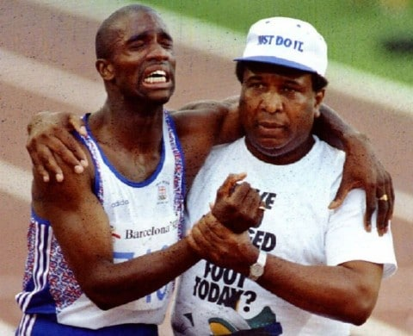
Derek Anthony Redmond is a British athlete who held the British record for the 400 metres sprint, and won gold medals in the 4x400 metres relay at the World Championships and European Championships. At the 1992 Olympic Games in Barcelona, he tore his hamstring in the 400 metres semi-final. Struggling and limping, Derek was determined to continue the race. His father, Jim Redmond, came running from the stands to his side, helping him as he limped toward the finish line. Derek managed to complete a full lap of the track as the crowd gave him a standing ovation.

We need encouragement to give/receive

From saints of old

The apostles and prophets are cheering us on. They cheer us on through the Bible. When we read the letters and books of the prophets and apostles, we are encouraged and inspired.

From one another

We can encourage each other. We are so privileged and blessed to be able to receive good teachings and trainings week after week from the pastors and leaders of the church. Every week, we meet not only in church, but also in cell group, where we have the opportunity to fellowship and share our lives with one another, and to encourage each other.

Entanglements to overcome

Let us throw off everything that hinders and the sin that so easily entangles. (Hebrews 12:1b)

The common entanglements the church usually talks about are money, sex and power. However, the other entanglements we need to guard against are as follows:

Bad attitudes

- A bad attitude of having seen it, done it, and thinking that there is nothing else to learn.
- Being distant and aloof, cut off from people.
- To treat others without dignity and respect.
- Complaining, whining and fault-finding.

We must guard against bad attitudes for they will entangle us and hinder us in our race of life.

Bad experiences

Sometimes when we have been hurt by fellow Christians, we refuse to go to church or cell group. We need to put God in the centre, and to make time to fellowship with others. Do not allow past hurts to prevent you from moving on in your Christian life.

Even with our spouses, we fight over small things sometimes. When it comes to arguments, we need to look at the bigger picture so we will see that some things are just not worth fighting for.

Do not break relationships because of greed. Do not be proud if you have become rich. Do not idolize the wealth and possessions that you have, which can imprison us in idolatry and break family relationships. We are to learn to give, share and bless. Realize that the wealth does not own us, we own them. The wealth does not belong to us; they belong to God, and we are to steward it well.

Bondages/Baggage

We need to remove all forms of addictions to pornography, smoking, gambling, and etc. from our lives. We need to cut off its roots.

It is important not to carry any bondages / baggage as we journey through life, for they can be a source of hindrance to us from running the race well.

Bondages and baggage can also come from broken and difficult backgrounds such as broken, struggling and dysfunctional families. If you come from a bad background, do not get upset with God, thinking that He is unfair. Coming from good families do not mean that we will finish well. Likewise, coming from bad families do not mean we will not finish well.

Example to follow

Who is it that we follow? We made it through 40 years because of God’s goodness and grace, not because of ourselves.

Look to Jesus

If you want to make a difference and an impact, go back to your home town or home country and plant a church there. This is because a church will grow to outlast you.

If you are hurt, angry or bitter. Look to Jesus to heal, restore and forgive you. God is always at work through the Holy Spirit.

Follow Jesus in:

- Clarity of vision – When Jesus went to the cross, He did not look just to the cross, but He looked beyond that. Jesus looked beyond the pain and the shame to the glory and purpose ahead.

VISION

Building God’s community and making known His glory

MISSION

- To evangelise the Klang Valley and to send missionaries to unreached people groups worldwide.

- To disciple every believer into maturity in Christ and to be effective in the service of God.

- To advocate community engagement in our nation, bringing God’s love and justice to a needy society.

- Conviction regarding the cause
- Courage in the journey

Values to uphold

Authenticity
Commit to always be authentic, genuine and honest, with nothing to hide. If we do wrong, we confess our sins, bring it to light and receive forgiveness.

Humility
Cultivate a culture of grace and humility.

Generosity
Generosity with not just money, but time, resources and other things. It is a blessing and a privilege to give.

Gratitude
We need to be grateful for all that God has done. God is good, all the time, and we need to remember that and thank Him.

DNA to live out

Evangelism
- The church must never ever forget that the heart of what we do is to share Jesus.
- If we are all to lead one person to Christ, the church will double.
- We have the greatest message in the world. If we share and lead a person to Christ, we make an eternal and everlasting difference in that person’s life.
- Many people are lost in a Christ-less eternity, and we have the only answer to rescue them.

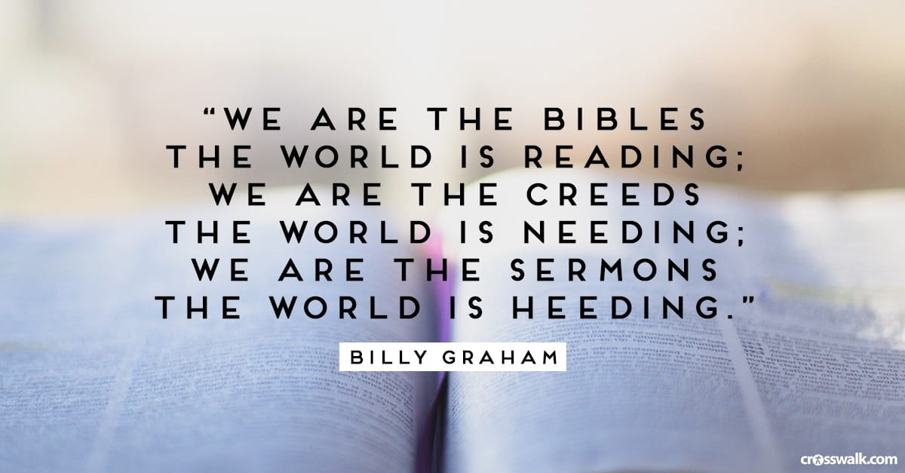
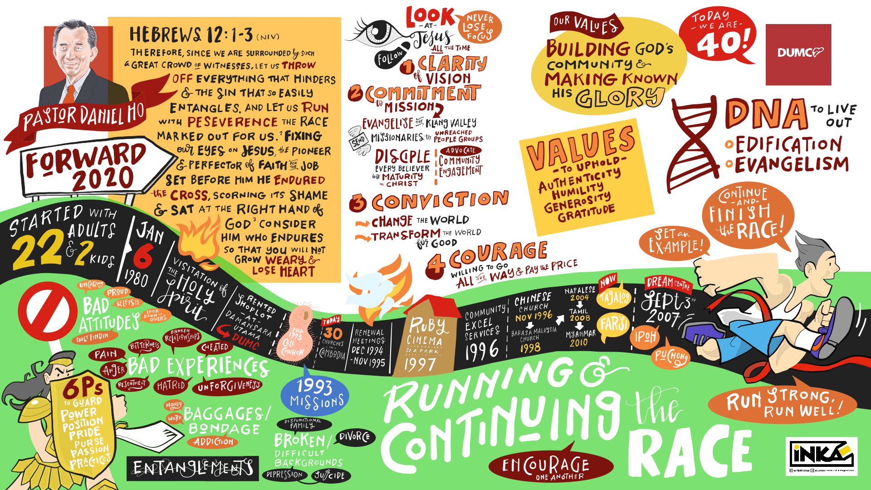

Sermon summary contributed by Anthea Tan
Graphic recording by Chan Wai

