- WORKS (30 minutes)

- Testimonies Through Reflections

- Journaling
- Get hold of the Bible Reading Plan from:
Youversion – OwnIt365 Plan
and begin an exciting journey in the discovery of the Lord’s personal word to you.
- Request one of your members to share a journal entry. Pair up members to share with, and pray for one another.
- Think creatively and keep one another accountable as per the Leader’s Meeting in July, as per what was modelled using WhatsApp or any equivalent way.
- If there are any good testimonies, ask your members to write out their testimonies and submit to the church: general@dumc.my.
- Looking Ahead

  - Church Prayer Altar (to strongly encourage in the month of August)
Every Saturday | 7.00 -9.00am | Room 101 & 102
Let us come and seek the face of God. Prayer precedes everything.
During the preaching series on prayer, i.e. ‘Breathe’, strongly encourage this!

  - The Marriage Course
12 August – 30 September 2018 | 3.00 – 5.30 pm | Hall 3
“Building a healthy marriage that lasts a lifetime.”
Register at bit.ly/marriage_course
For more information, visit dumc.my/familylife

  - Crossfields 2018

Crossfields Prayer Meeting
4 August 2018 | 9.00 – 11.00 am | Room 103
Breakfast @ 8.15 a.m.

Explore Missions and get equipped by attending this training requirement:
Missions Candidate Preparation Program I (MCPP1)
11 & 12 August 2018 | Weekend Away | Empress Hotel (Sepang)

Mission trips into the harvest field, coming up:
Sarawak Iban | 22 to 28 August 2018
Sarawak Penan | 18 to 22 August 2018
Thailand | 2 to 9 September 2018
Cambodia | 20 to 27 September 2018

Contact Eunice Tan at eunice.tan@dumc.my

- WORD (60 minutes)
Prayer Series – Breathe
Why Pray? (The Lord's Prayer) (Matt. 6:5-15)
By Pr Chris Kam

- Read the scripture passage.
- Do a THREE-MINUTE SUMMARY of the sermon highlighting the KEY POINTS. Do not preach the whole sermon again, as majority of your members would have heard the sermon already. Allocate more time for sharing in the cell through the application questions below.
- Sermon Resource at: http://www.dumc.my/resources/sermons/

Let’s read the passage from Matt. 6:5-15. Let’s go one round and everybody reads one verse.

Pastor Chris Kam, continued the series on prayer, titled “Why Pray?"
The BIG Idea of the sermon is: To pray is to know the heart of God.

Three reasons why we should pray:
1) Prayer is personal (Builds relationship)
2) Prayer is peace
3) Prayer is power (Brings result)

The Lord's prayer can be divided into 5 platforms: God’s Honour, God’s Kingdom, God’s Provision, God’s Forgiveness & God’s Power.

The focus this week is to pray on the 1st platform: God's Honour (Matt. 5:9 Our Father in heaven, hallowed be your name …)

Let’s now spend time on the ‘Activity Sheet’ or ponder over these questions below:

Reflection & Application Questions:

- Memorise the Lord's prayer for the next few weeks during Prayer Series.
- In what ways do you struggle with your personal prayer? How would you like your prayer life to be like? Pray and encourage the person to approach God personally & sincerely.
- Do you have a prayer request regarding a situation in your life that needs the peace and the power of breakthrough from God? What is God saying in this situation you are in?
- Share a testimony on an answered prayer in CG & have someone in CG collate and send to Zone Pastor.
Note to Word leader:
As you are preparing for this session, this is a great time to pray that the Holy Spirit will guide you to use the questions efficaciously. You can select, modify or entirely create your own questions, according to the needs of your CG.
WORD Activity Sheet (for Printing)
The BIG IDEA: To pray is to know the heart of God

- My prayer life relationship
Which picture best portrays your experience with prayer? In what ways does this picture represent your prayer life?
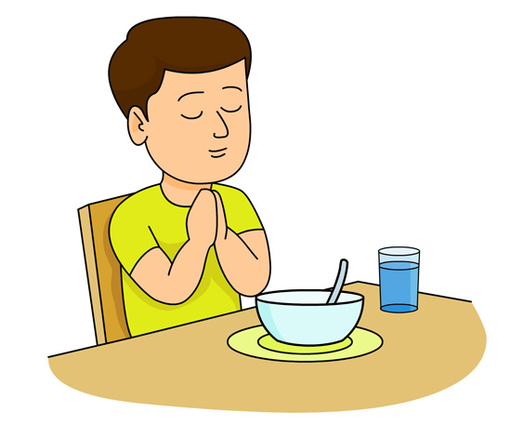

Read Matt: 6:5-9 & fill in the blanks:
"O___ F_________ in Heaven, hallowed be Your Name..." (Matt. 6:9)

- Effects of my prayer life relationship
Looking at the flow chart above, what is built from a growing relationship (prayer life relationship) is wonderfully limitless! What are some of the other things that you imagine can be built?
- P e _ c _ (Phil. 4:6-7; John 16:33)
- R _ s _ l t (Js 5:15; Exo. 32:14)
- ______________________________________________________________________

First Platform: HONOUR (Matt. 6:9)
What are some examples of how we can honour (i.e. respect, admire and give tribute to God) in words as we pray to Him? What can we say to honour God?
- Example: "God, You are a good, good Father."
- ______________________________________________________________________
- ______________________________________________________________________

Sharing a testimony on an answered prayer is also a way of honouring God for what He has done. How has God answered your prayer?

_______________________________________________________________________________

_______________________________________________________________________________

