CONTENTS

Worship
Word
Works
Upcoming:
Preaching Schedule
Event Highlights
Equip courses

WORSHIP (Praise and Prayer)

- Prayer Focus

      - Malaysia: SPM Examinations (13 Nov – 13 Dec)
Pray:
- Wisdom for teachers and students alike and clarity of minds in preparing and sitting for the examinations.
- Minimal disruption of the examination schedule from rain or floods.

      - The Adopted Unreached People Group: Newari & Tamang(Nepal)
PRAY- Newari & Tamang
- May God raise up intercessors and prayer teams for spiritual breakthrough in Nepal
- The Church and believers – a triumphant Nepalese church with pastors bold in sharing Christ with their own people, and for God to raise more leaders among them.
- God will enable them to generate income to meet their needs.
- Better education for the children and youths to help them advance in their lives as they grow older.

Mission Team (6-16 Dec)
- Pray for for Vera Tay (Leader), Jing Wai (Asst. Leader), Ngiik Yan, Joyie Soh, Wai Khum & Eunice Wong:
- The presence of God to go before them and for divine appointments; for team unity and their obedience to the Lord; wisdom, boldness and sensitivity to evangelise the Newari and Tamang people.
- God’s powerful encounter with the people and for their openness and receptivity.
- For good partnership with the local pastors and churches to advance the work of God in Atonement Church, Dhadingbesi and Maidi.
- For journey mercies, protection and good health for them and their loved ones at home
2. Penans of Sarawak
Pray – Penans
- For more teachers to offer their skills and knowledge to them in order to help them improve their livelihood and standard of living, and also give them access to the Good News.
- The Penans will gain access to all the benefits of being Malaysians by being granted birth and identity documents.
- Penan believers – for their hearts’ preparation and desire to draw closer to God; for greater and lasting spiritual strengthening and life transformation.

Mission Team (December)
Pray for Pr Eddy Marson Yasir (Leader), Liew Siew Eng (Asst. Leader), Rose Jayasooria, Elizabeth Lee, Edith Lim, Cray Maxwell, Voon Pei Shih & Song Boon Lee:
- For God’s divine revelation and guidance and alignment of their hearts with His greater plan in their ministry to the Penans; for the two preChristmas celebrations with the Penan community.
- For their preaching, teaching, sharing, evangelising and visitation – for a double portion of God’s strength, wisdom, power, miracles and healing; their perfect health and proficiency in the Malay language.
- For safety and journey mercies; God’s presence and protection over the team and their loved ones at home.

WORD (60 minutes)

Advent 1:God is Light
(John 1:14, 8:12; Heb 1:1-3)
Chris Kam, Senior Pastor
Big Idea: Are You a Good Photograph In The Light Of Christ

- Read the scripture passage.
- Do a THREE-MINUTE SUMMARY of the sermon highlighting the KEY POINTS. Do not preach the whole sermon again, as majority of your members would have heard the sermon already. Allocate more time for sharing in the cell through the application questions below.
- Sermon Resource at: http://www.dumc.my/resources/sermons/

Reflection & Application Questions:

- Often in life, we do not like what we see in the mirror. We wish to change something about our body. We are never too satisfied with how we look. We all desire to go under the spotlight - the worldly spotlight - to be honoured, accepted, recognized. If this applies to you how do you get out of this situation?

- We are like photographic paper. We are sensitive to light. It is a matter of what light we are sensitive to - the world’s spotlight, or the spotlight of Christ / God. Our image depends on that the light. How then do we become a good Photograph?

- “… Whoever follows me will never walk in darkness, but will have the light of life.” (John 8:12b) following this scripture what practical steps can we take to be exposed to this light continuously

- What kind of characteristics does a person have once transformed by the light to Christlikeness ? Give some examples

Note to Word leader:
As you are preparing for this session, this is a great time to pray that the Holy Spirit will guide you to use the questions efficaciously. You can select, modify or entirely create your own questions, according to the needs of your CG, especially if you feel that there are too many questions than required for the allocated time.

WORKS (Ministry and Bearing Witness)

Share your personal testimonies of God’s goodness and transformation to pre-believing family and friends this week.

- Christmas Party (renamed from Home-E)
We've got a fun line up for our Christmas Party programme! Cell groups have the option to invite friends to the CG Christmas Party or to participate in the Urban Food Sharing event. Cells to inform your pastors if you are interested in the Urban Food Sharing. For the CG Christmas Party, you may choose between Basic or Basic Plus. More information at dumc.my/christmas2018

- Share Your Story (Your Story, His Glory)
- Whether your story is about how you came to know Christ, of illness healed, an act of kindness in your times of need, or of how you served people or how people have served you, give glory to God. Share your story so that more people will be encouraged and God's love is known.
- If there are any good testimonies, ask your members to write out their testimonies and submit to the church: http://dumc.my/connect/individual-care/share-your-story/

- Personal: Bible Reading and Journaling
- Subscribe to the Bible Reading Plan from: YouVersion – OwnIt365 One Story Plan.
- Request one of your members to share a journal entry. Pair up members to share with, and pray for one another.

- Scripture Memory
Every cell meeting, do get your cell members to recite the following together:
- Ephesians 5:15-16 (Theme verse for 2018)
- Ephesians 4:1-2
¹As a prisoner for the Lord, then, I urge you to live a life worthy of the calling you have received. ² Be completely humble and gentle; be patient, bearing with one another in love.
- Matthew 6:9-13
9 “This, then, is how you should pray:
“‘Our Father in heaven,
hallowed be your name,
10 your kingdom come,
your will be done,
on earth as it is in heaven.
11 Give us today our daily bread.
12 And forgive us our debts,
as we also have forgiven our debtors.
13 And lead us not into temptation,[a]
but deliver us from the evil one.
(For Yours is the kingdom and the power and the glory forever. Amen)

- CrossFields

Short Term Mission Trips
*Crossing into the harvest field with the message of the Cross
Nepal | 6-16 Dec 2018
Sarawak Iban | 8-14 Dec 2018
For more info, contact Eunice Tan @ 03 7958 7388 or eunice.tan@dumc.my

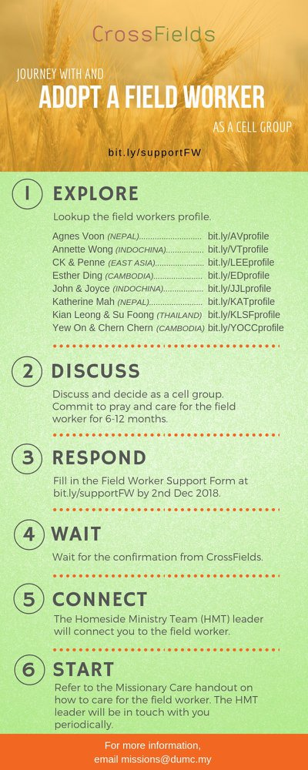
As a cell group explore this as a commitment to support missions through prayer and encouragement.

When we support them in this way, we join them in the work of the Lord in these nations to reach out to people groups whom the Lord loves and who have yet to hear & receive the Gospel into their lives.

- CMS: Steps to Fill in the Salvation Form
- Select “More”
- “Form”
- Select “Form Lit” box
- Look for “Salvation Form”
- Fill in form of new salvation by “Change Respondent”
- Must have “E-mail” and “Mobile Phone”

UPCOMING

PREACHING SCHEDULE

Dec 8&9 | Advent 2-God is Love | Rev. Irvin Rutherford

Go to: http://www.dumc.my/resources/sermons/ for the latest info.

EVENT HIGHLIGHTS

  - Church Prayer Altar
Every Saturday | 7.00 -9.00am | Room 101 & 102
Let us come and seek the face of God. Prayer precedes everything.

  - Christmas is coming!

Light of the World, Christmas Day Celebration

25 Dec | 8.30am / 11.30am | Auditorium

Advent season is near. Join us at our weekly Christmas Celebrations beginning 1, 2 Dec. First Devotional available at Info Counter.

dumc.my/christmas2018 for more info.

  - DUMC CHRISTMAS CELEBRATIONS
Chinese | 25 Dec | 9.00am & 11.15am | Hall 1
BM | 23 Dec |10.00am | Hall 4
Myanmar | 25 Dec |11.30pm | Hall 1
Tamil | 23 Dec |7.30pm | Hall 1
Nepalese | 9 Dec | 2.00pm | Hall 4

EQUIP COURSES

Watch out for our exciting announcements for 2019!

