CONTENTS

Worship
Word
Works
Upcoming:
Preaching Schedule
Event Highlights
Equip courses

WORSHIP (Praise and Prayer)

- Prayer

Fourth Weekend of ADVENT
Opening Prayer: Everlasting Father, all the world bows down before You. Teach us to embrace Your will in all things, in times of prosperity and in times of adversity. May we constantly fix our gaze to do Your will. We ask this through our Lord Jesus Christ, Your Son, who lives and reigns with You and the Holy Spirit, one God, forever and ever. Amen.
A Prayer of Encouragement
Father, we thank you for this year. You have been our shield, fortress and provider and have been ever present with us. Renew our faith in You and never let us waver from our path to Your Kingdom. By Your grace, we are Your children and overcomers. Father, we pray for the people around us who need Your encouragement because of all that they are facing right now. Fill them with hope, with Your presence, and with Your supernatural strength. Let the rain of Your presence fall upon them to refresh and renew their faith.
Father, we lift up the Church in our nation and everyone who calls upon Your Name. We ask You to empower us with Your love and anointing, and be our pillar of strength. We are nothing without You but we are everything when we stand with You and in You. Let there be a unity amongst us that only You can give, but one that we must pursue. Father, I thank You for the grace You have given to us. We give You this day, this week and the rest of 2018. We need Your favour, wisdom and strength to finish well. Give us courage to do all that we need to do, as we serve You and Your purpose with passion. Thank You for Your amazing love and grace. You are our all. We exalt You, we worship You and adore You. We thank You for the miracles that You have prepared for us, and for our answered prayers. Amen.

WORD (60 minutes)

Advent IV:God is Life: A Sacred Christmas
(John 1:1-9; 10:10)
Pr Alex Tan
Big Idea: Life is not always Perfect but Life in the Son is always full life.

- Read the scripture passage.
- Do a THREE-MINUTE SUMMARY of the sermon highlighting the KEY POINTS. Do not preach the whole sermon again, as majority of your members would have heard the sermon already. Allocate more time for sharing in the cell through the application questions below.
- Sermon Resource at: http://www.dumc.my/resources/sermons/

Reflection & Application Questions:

- Christmas is not Christmas until it happens in your heart. Have we allowed Christ into our hearts?

- During this Christmas period we are reminded about the story of Mary and Joseph difficult journey to Bethlehem. Life’s Journey can be filled with various difficulties .How do we deal with this? Reflecting on the difficult time Mary and Joseph had when Baby Jesus was about to be born.

- Do we trust God to provide for our needs completely and receive the providence humbly like Mary and Joseph had?

Note to Word leader:
As you are preparing for this session, this is a great time to pray that the Holy Spirit will guide you to use the questions efficaciously. You can select, modify or entirely create your own questions, according to the needs of your CG, especially if you feel that there are too many questions than required for the allocated time.

WORKS (Ministry and Bearing Witness)

Share your personal testimonies of God’s goodness and transformation to pre-believing family and friends this week.

- Christmas Party (renamed from Home-E)
We've got a fun line up for our Christmas Party programme! Cell groups have the option to invite friends to the CG Christmas Party or to participate in the Urban Food Sharing event. Cells to inform your pastors if you are interested in the Urban Food Sharing. For the CG Christmas Party, you may choose between Basic and Basic Plus. More information at dumc.my/christmas2018

- Share Your Story (Your Story, His Glory)
- Whether your story is about how you came to know Christ, of illness healed, an act of kindness in your times of need, or of how you served people or how people have served you, give glory to God. Share your story so that more people will be encouraged and God's love is known.
- If there are any good testimonies, ask your members to write out their testimonies and submit to the church: http://dumc.my/connect/individual-care/share-your-story/

- Personal: Bible Reading and Journaling
- Subscribe to the Bible Reading Plan from: YouVersion – OwnIt365 One Story Plan.
- Request one of your members to share a journal entry. Pair up members to share with, and pray for one another.

- Scripture Memory
Every cell meeting, do get your cell members to recite the following together:
- Ephesians 5:15-16 (Theme verse for 2018)
- Ephesians 4:1-2
¹As a prisoner for the Lord, then, I urge you to live a life worthy of the calling you have received. ² Be completely humble and gentle; be patient, bearing with one another in love.
- Matthew 6:9-13
9 “This, then, is how you should pray:
“‘Our Father in heaven,
hallowed be your name,
10 your kingdom come,
your will be done,
on earth as it is in heaven.
11 Give us today our daily bread.
12 And forgive us our debts,
as we also have forgiven our debtors.
13 And lead us not into temptation,[a]
but deliver us from the evil one.
(For Yours is the kingdom and the power and the glory forever. Amen)

- CrossFields

CROSSFIELDS 2019
“Crossing into the harvest field with the message of the Cross”
Myanmar | 8-15 Mar
Cambodia | 21-29 Mar
Sabah | 21-24 Mar
Sarawak Iban | 21-29 Mar
MCPP1 | 23-24 Mar | Empress Hotel Sepang Contact Eunice at 03 79587388 or eunice.tan@dumc.my
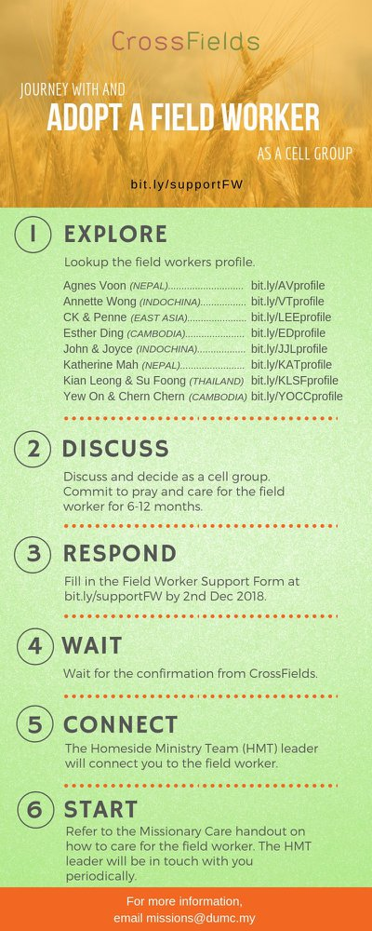
As a cell group explore this as a commitment to support missions through prayer and encouragement.

When we support them in this way, we join them in the work of the Lord in these nations to reach out to people groups whom the Lord loves and who have yet to hear & receive the Gospel into their lives.

- CMS: Steps to Fill in the Salvation Form
- Select “More”
- “Form”
- Select “Form Lit” box
- Look for “Salvation Form”
- Fill in form of new salvation by “Change Respondent”
- Must have “E-mail” and “Mobile Phone”

UPCOMING

PREACHING SCHEDULE

Dec 25 Dec | Light of The World | Sr Pr Chris Kam

Go to: http://www.dumc.my/resources/sermons/ for the latest info.

EVENT HIGHLIGHTS

  - Church Prayer Altar
Every Saturday | 7.00 -9.00am | Room 101 & 102
Let us come and seek the face of God. Prayer precedes everything.

  - PARENT SUPPORT PARENT (PSP)
Topic: Raising Kingdom Kids 12 & 26 Jan, 9 & 23 Feb, 9 & 23 Mar 2019
Time: 3.00pm-4.30pm
Venue: Cafe Function Room, Dream Centre
Sign up at bit.ly/psp_parenting

  - W2W MOMENTS BEGINS FEB 2019!
Moments are a platform for ladies from all walks of life to come together for a time of mutual encouragement and fellowship through Bible Study.
Every 3rd Sat | 8.30am-11.00am | Hall 3 Alternate Tues | 9.00am-11.30am | SS15, Rm109, DUMC@Puchong Alternate Wed | 9.00am-11.30am | Ara D’sara & BU4
Register at bit.ly/moments2019
EQUIP COURSES

a. BASIC CHRISTIANITY 101 (Basic Doctrine I) Saturdays • 12 & 19 Jan | 8.30am-1.00pm

b. DUMC 101 Saturday | 26 Jan | 8.30am-1.00pm

c. BAPTISM & MEMBERSHIP ENCOUNTER WEEKEND Saturday & Sunday (stay-in) • 16-17 Feb

d. CHRISTIAN LIVING 101 (My New Life) Sundays | 9 Feb-30 Mar | 8.00am-9.30am

e. BIBLE 101 (Understanding the Bible) Saturdays | 2 & 9 Feb | 8.30am-1.00pm

F. BE STILL AND KNOW THAT I AM GOD (A Spiritual Retreat) 22-24 Feb | Fraser’s Hill Register: bit.ly/DUMCRetreat_22Feb2018

g. EXPLICIT GOSPEL (W/ MATT CHANDLER) Sundays | 24 Feb-7 Apr | 8.00am-9.30am | Hall 3

h. HEBREWS PART 1 (REPEAT) Sundays | 24 Feb-14 Apr | 8.00am-9.30am | Hall 2

