CONTENTS

Worship
Word
Works
Upcoming:
Preaching Schedule
Event Highlights
Equip courses

WORSHIP (Praise and Prayer)

- Malaysia-Harmony Among The People
Pray for:
- Better understanding and communication among the communities.
- Engagement of young people to promote non-discrimination and protection for minority groups.
- Firm action by the Government against extremist groups who incite racial and religious tensions.

- DUMC Anniversary & Gift Weekend (12/13 January 2019)

As DUMC celebrates 39 years of God’s faithfulness, let us thank Him for:
- His grace and favour bestowed upon us.
- His wonderful provision for us and our families and His church.

Pray for God’s people, and that the Holy Spirit will:
- Envision and enable us to give towards a vision in which many lives will be blessed and transformed through the work of individuals and organisations both locally and globally.
- Teach us to trust Him to release to us the resources which will enable us to give to this vision.
- Prepare and stir our hearts to give willingly, sacrificially, cheerfully and generously

WORD (60 minutes)

FORWARD: Stepping forward with the Spirit
(Gal 5: 22-26)
Chris Kam, Senior Pastor

Big Idea: Stepping Forward in preparation for something bigger than yourself

- Read the scripture passage.
- Do a THREE-MINUTE SUMMARY of the sermon highlighting the KEY POINTS. Do not preach the whole sermon again, as majority of your members would have heard the sermon already. Allocate more time for sharing in the cell through the application questions below.
- Sermon Resource at: http://www.dumc.my/resources/sermons/

Reflection & Application Questions:

Stepping forward with Jesus
- What does it mean by keeping in step with the spirit? Are you following the Holy Spirit’s step or your own? Share an area of your life that you sense the Holy Spirit is working on for your spiritual growth.

Stepping forward with your heart
- Verse 24 says that those who belong to Christ Jesus have crucified their flesh with its passions and desires. What is preventing you to give your whole heart to God in order to experience the fullness of a Christian life?

Stepping forward with someone
- How can the CG step forward together this year to build God’s kingdom? Discuss and plan for something that can impact the community around you as a CG.

Note to Word leader:
As you are preparing for this session, this is a great time to pray that the Holy Spirit will guide you to use the questions efficaciously. You can select, modify or entirely create your own questions, according to the needs of your CG, especially if you feel that there are too many questions than required for the allocated time.

Note to Cell Groups that have children during meeting:
We recognize several cell groups in DUMC may have 5 or more children joining them during Cell Group meetings. We would like to get them engaged as well during the session therefore we are suggesting for CGs to use Manna Pad and assign someone in rotation to facilitate them after worship. Here is the link to the Manna Pad materials http://dumc.my/resources/downloads/

WORKS (Ministry and Bearing Witness)

Cell leaders to ask these two important questions or share with one another during Works session in every CG meeting.

    - Who have I met, praying for and sharing Christ with?
    - What is the Holy Spirit saying about the community I am in?

- Share Your Story (Your Story, His Glory)
- Whether your story is about how you came to know Christ, of illness healed, an act of kindness in your times of need, or of how you served people or how people have served you, give glory to God. Share your story so that more people will be encouraged and God's love is known.
- If there are any good testimonies, ask your members to write out their testimonies and submit to the church: http://dumc.my/connect/individual-care/share-your-story/

- Personal: Bible Reading and Journaling
- Subscribe to the Bible Reading Plan from: YouVersion – OwnIt365 New Testament (NT)+ Plan.
- Request one of your members to share a journal entry. Pair up members to share with, and pray for one another.

- Scripture Memory

Every cell meeting, do get your cell members to recite the following together:

Galatians 5:22-26 (Theme verse for 2019)

²² But the fruit of the Spirit is love, joy, peace, forbearance, kindness, goodness, faithfulness, ²³ gentleness and self-control. Against such things there is no law. ²⁴ Those who belong to Christ Jesus have crucified the flesh with its passions and desires. ²⁵ Since we live by the Spirit, let us keep in step with the Spirit. ²⁶ Let us not become conceited, provoking and envying each other.

- CrossFields

“Crossing into the harvest field with the message of the Cross”
Myanmar | 8-15 Mar
Cambodia | 21-29 Mar
Sabah | 21-24 Mar
Sarawak Iban | 21-29 Mar

MCPP1 | 23-24 Mar | Empress Hotel Sepang Contact Eunice at 03 79587388 or eunice.tan@dumc.my

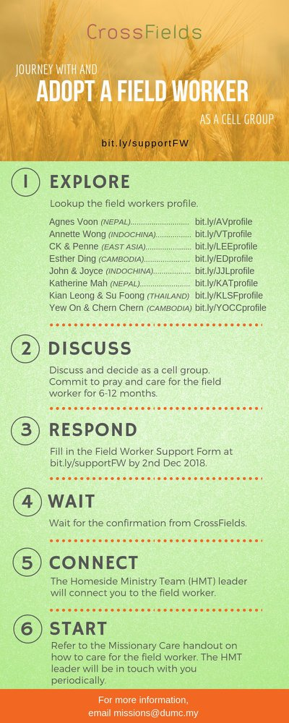
As a cell group explore this as a commitment to support missions through prayer and encouragement.

When we support them in this way, we join them in the work of the Lord in these nations to reach out to people groups whom the Lord loves and who have yet to hear & receive the Gospel into their lives.

- CMS: Steps to Fill in the Salvation Form
- Select “More”
- “Form”
- Select “Form Lit” box
- Look for “Salvation Form”
- Fill in form of new salvation by “Change Respondent”
- Must have “E-mail” and “Mobile Phone”

UPCOMING

PREACHING SCHEDULE

Jan 5&6 | Stepping Forward With The Spirit | Sr Pr Chris Kam
Jan 12&13 | Stepping Forward In Community | Sr Pr Chris Kam
Jan 19&20 | Stepping Forward In Leadership | Sr Pr Chris Kam
Jan 26&27 | Stepping Forward In Societal Transformation | Pr Dato’ Daniel Ho

Go to: http://www.dumc.my/resources/sermons/ for the latest info.

EVENT HIGHLIGHTS

  - Church Prayer Altar
Every Saturday | 7.00 -9.00am | Room 101 & 102
Let us come and seek the face of God. Prayer precedes everything.

  - PARENT SUPPORT PARENT (PSP)
Topic: Raising Kingdom Kids 12 & 26 Jan, 9 & 23 Feb, 9 & 23 Mar 2019
Time: 3.00pm-4.30pm
Venue: Cafe Function Room, Dream Centre
Sign up at bit.ly/psp_parenting

  - W2W MOMENTS BEGINS FEB 2019!
Moments are a platform for ladies from all walks of life to come together for a time of mutual encouragement and fellowship through Bible Study.
Every 3rd Sat | 8.30am-11.00am | Hall 3 Alternate Tues | 9.00am-11.30am | SS15, Rm109, DUMC@Puchong Alternate Wed | 9.00am-11.30am | Ara D’sara & BU4
Register at bit.ly/moments2019

  - ANNIVERSARY AND GIFT WEEKEND 2019
“Celebrating 39 years of God’s faithfulness to DUMC” 12 & 13 Jan 2019 | Dream Centre
Come prepared to sow into His Kingdom.

  - FORWARD 2019 COMBINED COMMUNION CELEBRATIONS
5 Jan 2019 | 11.45pm-2.00am | Auditorium
6 Jan 2019 | 9.00am-11.00am | Auditorium
6 Jan 2019 | 11.30am-1.30pm | Auditorium

  - WANT TO JOIN THE DUMC FAMILY?
Here are the steps:
> Join a Cell Group (You can get help at our CG Kiosk)
> Attend Basic Christianity 101 > Attend DUMC 101
> Join an Encounter Weekend
> Baptism & Membership Interview Sign up at the Info Counter or online at dumc.my/equip

EQUIP COURSES

BASIC CHRISTIANITY 101 (Basic Doctrine I)

Saturdays • 12 & 19 Jan | 8.30am-1.00pm

DUMC 101

Saturday | 26 Jan | 8.30am-1.00pm

BAPTISM & MEMBERSHIP ENCOUNTER WEEKEND

Saturday & Sunday (stay-in) • 16-17 Feb

CHRISTIAN LIVING 101 (My New Life)

Sundays | 9 Feb-30 Mar | 8.00am-9.30am

BIBLE 101 (Understanding the Bible)

Saturdays | 2 & 9 Feb | 8.30am-1.00pm

EXPLICIT GOSPEL (W/ MATT CHANDLER)

Sundays | 24 Feb-7 Apr | 8.00am-9.30am | Hall 3

HEBREWS PART 1 (REPEAT)

Sundays | 24 Feb-14 Apr | 8.00am-9.30am | Hall 2

