CONTENTS

Worship
Word
Works
Upcoming:
Preaching Schedule
Event Highlights
Equip courses

WORSHIP (Praise and Prayer)

- Malaysia: Church
Pray:
- That Christians will be salt and light in this world, living authentic holy lives that manifest Jesus’ love and compassion.
- For Christian leaders to be godly, humble and loving towards one another.

- International: Micronesia
Capital City: Palikir.
Government: Constitutional Government in Free Association with the United States. Population: 104,196.
Major People Groups: Chuukese/ Mortlockese 49.3%, Pohnpeian 29.8%, Kosraean 6.3%, Yapese 5.7%, Yap outer islanders 5.1%, Polynesian 1.6%, Asian 1.4%, Other 0.8%. Religions: Christian 96.65%, Ethno 1.4%, Non 0.85%;
Language: English.
GDP Per Capita: $3,400.
Literacy Rate: 94.2%. UNREACHED: 4%

The Federated States of Micronesia are a group of Islands north of Papua New Guinea in the Pacific Ocean. Comprised of 607 islands, the archipelago contains mountainous islands, coral atolls, and volcanic outcroppings. Ethnicity, village, class, kinship, and religion are much stronger identifiers in day-to-day activity than the Micronesian identity, yet there is still a sense of “unity among diversity” that draws them together.

Pray for:
- People who worship at the altar of materialism to be humbled with the knowledge of their spiritual poverty.
- The truth of Christ to free those in bondage to magic and cults.
- More oral Christian resources to be available to the non-literate.

WORD (60 minutes)

FORWARD 4: Stepping Forward In Societal Transformation
(Daniel 6:1-12, 19-28)
Dato’ Dr Daniel Ho, Founding Senior Pastor

- Read the scripture passage.
- Do a THREE-MINUTE SUMMARY of the sermon highlighting the KEY POINTS. Do not preach the whole sermon again, as majority of your members would have heard the sermon already. Allocate more time for sharing in the cell through the application questions below.
- Sermon Resource at: http://www.dumc.my/resources/sermons/

Reflection & Application Questions:

      - Share the kind of character, courage and cost, if any, you have shown and/or experienced in your workplace, home, community or place of study. What has been the consequence to you and the people around you? What changes have you seen and how is God real in all these?

      - Have you been told to keep your faith private or do you have a tendency to keep your faith private? How did you or can you overcome this to ensure that you are bearing witness and living out your faith publicly? What are you doing and the commitments and prayers you are making, individually or as a group, to increasingly see a transformation of your workplace or place of study, your home and as well as in the community and society? Gather to share and pray regularly among your colleagues, friends or classmates, for example, regarding influence and impact.

Note to Word leader:
As you are preparing for this session, this is a great time to pray that the Holy Spirit will guide you to use the questions efficaciously. You can select, modify or entirely create your own questions, according to the needs of your CG, especially if you feel that there are too many questions than required for the allocated time.

Note to Cell Groups that have children during meeting:
We recognize several cell groups in DUMC may have 5 or more children joining them during Cell Group meetings. We would like to get them engaged as well during the session therefore we are suggesting for CGs to use Manna Pad and assign someone in rotation to facilitate them after worship. Here is the link to the Manna Pad materials http://dumc.my/resources/downloads/

WORKS (Ministry and Bearing Witness)

Cell leaders to ask these two important questions or share with one another during Works session in every CG meeting.

    - Who have I met, praying for and sharing Christ with?
    - What is the Holy Spirit saying about the community I am in?

- Share Your Story (Your Story, His Glory)
- Whether your story is about how you came to know Christ, of illness healed, an act of kindness in your times of need, or of how you served people or how people have served you, give glory to God. Share your story so that more people will be encouraged and God's love is known.
- If there are any good testimonies, ask your members to write out their testimonies and submit to the church: http://dumc.my/connect/individual-care/share-your-story/

- Personal: Bible Reading and Journaling
- Subscribe to the Bible Reading Plan from: YouVersion – OwnIt365 New Testament (NT)+ Plan.
- Request one of your members to share a journal entry. Pair up members to share with, and pray for one another.

- Scripture Memory

Every cell meeting, do get your cell members to recite the following together:

Galatians 5:22-26 (Theme verse for 2019)

²² But the fruit of the Spirit is love, joy, peace, forbearance, kindness, goodness, faithfulness, ²³ gentleness and self-control. Against such things there is no law. ²⁴ Those who belong to Christ Jesus have crucified the flesh with its passions and desires. ²⁵ Since we live by the Spirit, let us keep in step with the Spirit. ²⁶ Let us not become conceited, provoking and envying each other.

- CrossFields

“Crossing into the harvest field with the message of the Cross”
Myanmar | 8-15 Mar
Cambodia | 21-29 Mar
Sabah | 21-24 Mar
Sarawak Iban | 21-29 Mar

MCPP1 | 23-24 Mar | Empress Hotel Sepang Contact Eunice at 03 79587388 or eunice.tan@dumc.my

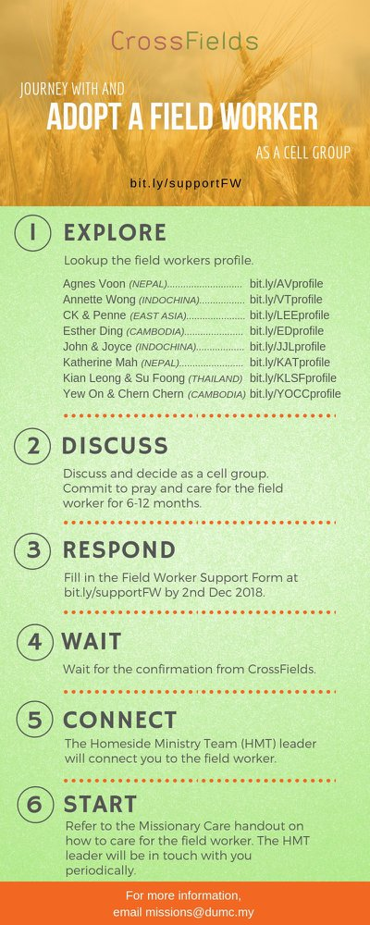

- CMS: Steps to Fill in the Salvation Form
- Select “More”
- “Form”
- Select “Form Lit” box
- Look for “Salvation Form”
- Fill in form of new salvation by “Change Respondent”
- Must have “E-mail” and “Mobile Phone”

UPCOMING

PREACHING SCHEDULE

Feb 3 | Open Topic | Pr Gilbert Tan
Feb 9&10 | Open Topic | Pr Alex Tan
Feb 16&17 | Studies in the Book of Galatians 1 | Sr Pr Chris Kam
Feb 23&24 | Studies in the Book of Galatians 2 | Pr Dato’ Kee Sue Sing

Go to: http://www.dumc.my/resources/sermons/ for the latest info.

EVENT HIGHLIGHTS

  - Church Prayer Altar
Every Saturday | 7.00 -9.00am | Room 101 & 102
Let us come and seek the face of God. Prayer precedes everything.

  - PARENT SUPPORT PARENT (PSP)
Topic: Raising Kingdom Kids 9 & 23 Feb, 9 & 23 Mar 2019
Time: 3.00pm-4.30pm
Venue: Cafe Function Room, Dream Centre
Sign up at bit.ly/psp_parenting

  - W2W MOMENTS BEGINS FEB 2019!
Moments are a platform for ladies from all walks of life to come together for a time of mutual encouragement and fellowship through Bible Study.
Every 3rd Sat | 8.30am-11.00am | Hall 3, DC
Alternate Tues | 9.00am-11.30am | SS15 & Room 109, DC
Alternate Wed | 9.00am-11.30am | Ara D’sara & BU4
Register at bit.ly/moments2019

  - WANT TO JOIN THE DUMC FAMILY?
Here are the steps:
> Join a Cell Group (You can get help at our CG Kiosk)
> Attend Basic Christianity 101 > Attend DUMC 101
> Join an Encounter Weekend
> Baptism & Membership Interview Sign up at the Info Counter or online at dumc.my/equip

EQUIP COURSES

BAPTISM & MEMBERSHIP ENCOUNTER WEEKEND

Saturday & Sunday (stay-in) • 16-17 Feb

CHRISTIAN LIVING 101 (My New Life)

Sundays | 9 Feb-30 Mar | 8.00am-9.30am

BIBLE 101 (Understanding the Bible)

Saturdays | 2 & 9 Feb | 8.30am-1.00pm

EXPLICIT GOSPEL (W/ MATT CHANDLER)

Sundays | 24 Feb-7 Apr | 8.00am-9.30am | Hall 3

HEBREWS PART 1 (REPEAT)

Sundays | 24 Feb-14 Apr | 8.00am-9.30am | Hall 2

ANNOUNCEMENT

NO SATURDAY CELEBRATION AND CHILDREN’S CHURCH NEXT WEEK
Due to the Chinese New Year break, there will be only one Celebration next week at 10.00am on Sunday 3 Feb 2019.
There will also be no Children’s Church on 2 and 9 Feb 2019.

