CONTENTS

Worship
Word
Works
Upcoming:
Preaching Schedule
Event Highlights
Equip courses

WORSHIP (Praise and Prayer)

- Malaysia: Women & Girls

Pray:
- That all our women and girls will be protected, nurtured, educated and have access to all rights and opportunities so that they can fully contribute economically, socially, and spiritually to Malaysia and the world.

- International: Gambia
Ninety percent of the population in Gambia is Muslim, but there is some religious freedom and tolerance. Christians, mostly Protestants, make up 5% of the population. Discipleship and leadership training are needed in order for believers to effectively reach those living in isolated areas and to motivate believers to witness to their fellow Gambians.

Pray for:
- Continued freedom to spread the Gospel.
- Unhampered and accurate translation work for many Gambian languages with no Bible.
- Missionaries to be prepared to leave urban Gambia to travel upriver to unreached tribes.

WORD (60 minutes)

Studies in the Book of Galatians III
The Blessings of a Child of God
(Galatians 4: 1-20; Reading Gal: 4:1-7 & 17-20)
Senior Pastor Chris Kam

Big Idea: I am a Child of God

- Read the scripture passage.
- Do a THREE-MINUTE SUMMARY of the sermon highlighting the KEY POINTS (God’s Provision, Our Portion; Eternal Purpose). Do not preach the whole sermon again, as majority of your members would have heard the sermon already. Allocate more time for sharing in the cell through the application questions below.
- Sermon Resource at: http://www.dumc.my/resources/sermons/

Reflection & Application Questions:

      - What is the most significant thing that the Holy Spirit spoke to you about through the sermon?

      - What does Gal 4:5 meant to you, where Apostle Paul says that you “might receive adoption to sonship”? What does it mean for you now to have God as your Heavenly Father and to call him “Abba, Father” (literally Daddy)? Was it easy for you to do that? Why or why not?

      - In what ways do you think you are falling back into legalism if you try to do enough to please God, as opposed to doing that as a response to His love? Share examples of how you have been guilt-ridden to be performance-driven with God or times when you feel God loves you less.

      - What did Paul mean when he wrote, “until Christ is formed in you”? Relate that to being more and more Christlike in our lives. What does that mean to you? What is the role of the Holy Spirit in this? Share some testimonies of the transforming work of Christ in your life.

Note to Word leader:
As you are preparing for this session, this is a great time to pray that the Holy Spirit will guide you to use the questions efficaciously. You can select, modify or entirely create your own questions, according to the needs of your CG, especially if you feel that there are too many questions than required for the allocated time.

Note to CGs experimenting on Men’s MAG during Word time:

            - What circumstances in your life make it difficult for you to see yourself as a son of God?

            - How does it feel to realise that God chose you? Does this change your perception of self worth as a man? Do you struggle with issues of self-doubt?

            - How can you grow in Christlikeness as you live from day to day? What are some things you must change in your marriage/family/job/ministry as a man of God?

Note to CGs experimenting on Women MAG during Word time:

- Ponder over the claim “I am a child/daughter of God? I am adopted.” Then share what does this mean to you personally.

- What fears are/were you a slave to? How does the truth of your daughter-ship free you from these fears?

- What is one thing the Holy Spirit has been nudging you to change in your marriage/family/job/ministry as a daughter of God?

Note to Cell Groups that have children during meeting:
We recognize several cell groups in DUMC may have 5 or more children joining them during Cell Group meetings. We would like to get them engaged as well during the session therefore we are suggesting for CGs to use Manna Pad and assign someone in rotation to facilitate them after worship. Here is the link to the Manna Pad materials http://dumc.my/resources/downloads/

WORKS (Ministry and Bearing Witness)

Cell leaders to ask these two important questions or share with one another during Works session in every CG meeting.

    - Who have I met, praying for and sharing Christ with?
    - What is the Holy Spirit saying about the community I am in?

- Share Your Story (Your Story, His Glory)
- Whether your story is about how you came to know Christ, illness healed, an act of kindness in your times of need, or of how you served people or how people have served you, give glory to God. Share your story so that people will be encouraged and God's love is known.
- If there are any good testimonies, ask your members to write out their testimonies and submit to the church: http://dumc.my/connect/individual-care/share-your-story/

- Personal: Bible Reading and Journaling
- Subscribe to the Bible Reading Plan from: YouVersion – OwnIt365 New Testament (NT)+ Plan.
- Request one of your members to share a journal entry. Pair up members to share with, and pray for one another.

- Scripture Memory

Every cell meeting, do get your cell members to recite the following together:

Galatians 5:25 (Theme verse for 2019)
Since we live by the Spirit, let us keep in step with the Spirit.

Galatians 2:20 (added from March 2019)
I have been crucified with Christ and I no longer live, but Christ lives in me. The life I now live in the body, I live by faith in the Son of God, who loved me and gave himself for me.

- CrossFields

“Crossing into the harvest field with the message of the Cross”
Myanmar | 8-15 Mar
Cambodia | 21-29 Mar
Sabah | 21-24 Mar
Sarawak Iban | 21-29 Mar

MCPP1 | 23-24 Mar | Empress Hotel Sepang Contact Eunice at 03 79587388 or eunice.tan@dumc.my

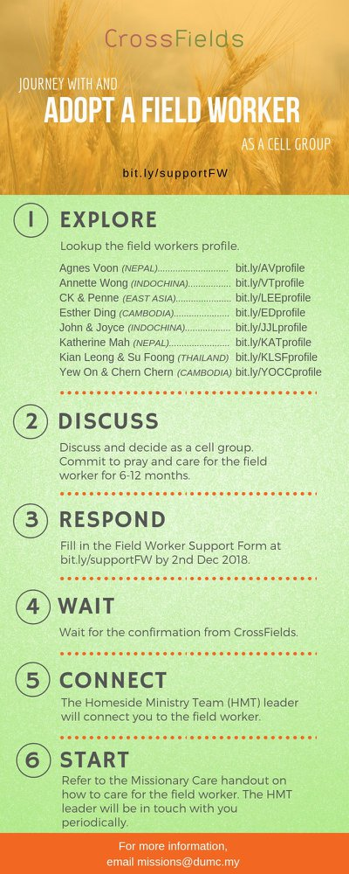

- CMS: Steps to Fill in the Salvation Form
- Select “More”
- “Form”
- Select “Form Lit” box
- Look for “Salvation Form”
- Fill in form of new salvation by “Change Respondent”
- Must have “E-mail” and “Mobile Phone”

UPCOMING

PREACHING SCHEDULE

Mar 02&03 | Studies in the Book of Galatians 3 | Sr Pr. Chris Kam
Mar 09&10 | Studies in the Book of Galatians 4 | Pr. Mike Ngui
Mar 16&17 | Studies in the Book of Galatians 5 | Sr Pr. Chris Kam
Mar 23&24 | Essential Women’s Conference Weekend | Stella Hoh

Go to: http://www.dumc.my/resources/sermons/ for the latest info.

EVENT HIGHLIGHTS

  - Church Prayer Altar
Every Saturday | 7.00 -9.00am | Room 101 & 102
Let us come and seek the face of God. Prayer precedes everything.

  - WANT TO JOIN THE DUMC FAMILY?
Here are the steps:
> Join a Cell Group (You can get help at our CG Kiosk)
> Attend Basic Christianity 101 > Attend DUMC 101
> Join an Encounter Weekend
> Baptism & Membership Interview Sign up at the Info Counter or online at dumc.my/equip

EQUIP COURSES 2019

EXPLICIT GOSPEL (W/ MATT CHANDLER)

Sundays | 24 Feb-7 Apr | 8.00am-9.30am | Hall 3

HEBREWS PART 1 (REPEAT)

Sundays | 24 Feb-14 Apr | 8.00am-9.30am | Hall 2

        - UNDERSTANDING THE BIBLE (101)

Saturdays | 2 Mar – 9 Mar | 8.30am-1.00pm | Room 108

ANNOUNCEMENT

