CONTENTS

Worship
Word
Works
Upcoming:
Preaching Schedule
Event Highlights
Equip courses

WORSHIP (Praise and Prayer)

- Malaysia: Race & Religion
The National Patriots Association (Patriot) has called on all parties to abandon race-based politics, saying that racism and racial politicking have crossed into the “danger zone.” (9 Mar 2019)
Pray:
- For religious freedom to be upheld and racial acceptance to be practised by all segments of society.
- For restoration of trust and the rebuilding of bridges among the races and religions.
- Against those who incite or stoke animosity using race and religion, and for the dismantling of race-based politics.

- International: Gaza Strip and West Bank
These areas west of Syria and Jordan are some of the most contested and contentious lands on earth. The West Bank, formerly Judea and Samaria, is landlocked between Israel and Jordan and contains the northwest quarter of the Dead Sea. The Gaza Strip, located between Egypt and Israel, borders the Mediterranean Sea and has historically been a prime location for trade. It contains the city of Jericho, one of the oldest cities in the world.

Pray for:
- The Prince of Peace to bring about meaningful reconciliation between Jewish and Arab leaders.
- Christian leaders to boldly live out the gospel in the midst of the constant conflict.
- Demonstrations of love and concern for Palestinian exiles.

WORD (60 minutes)

W2W Weekend
I have a Dream
(Proverbs 29:18, 31:10-31)
Stella Hoh

Big Idea: Don’t settle for just your dreams. Go for God’s!

- Read the scripture passage.
- Do a THREE-MINUTE SUMMARY of the sermon highlighting the KEY POINTS (My role, God’s dream; My limitation, God’s empowerment; God’s dream, Our dream). Do not preach the whole sermon again, as majority of your members would have heard the sermon already. Allocate more time for sharing in the cell through the application questions below.
- Sermon Resource at: http://www.dumc.my/resources/sermons/

Reflection & Application Questions:

      - What is the most significant thing that the Holy Spirit spoke to you about through this sermon?

      - What is one dream you have, where God is prompting you to embrace His dream and dream bigger? What is holding you back? What support do you need?

      - Have you ever dampened/broken someone’s dream (or seen it done to somebody else)? Is there someone in your life who is chasing God’s dream, whom you can be a supporter/encourager? What will you do?

      - Do you have a broken dream? How can the CG help to heal or support you?

MAG (Mentoring & Accountability Group) Reflection & Application Questions:

For Men:

      - Share one dream that you have always had since you were a child.
      - What do you think God's dream is for you as a man of God? Ask the Holy Spirit to reveal to you.
      - Are you aware of dreams that women close to you have? Have you shown Disinterest, Dominance or Discouragement towards their dreams? How can you help them achieve these dreams?

For Women:

- What is a dream you have that has not been fulfilled?
- Is there a dream you have that the Holy Spirit is prompting you to dream bigger; and dream His dream?
- a) Have you had a broken dream? How can we as sisters-in-Christ support/help
you?
OR
b) Who is someone in your life that you can take an interest in/encourage their
God given dream? What will you do?

Note to Word leader:
As you are preparing for this session, this is a great time to pray that the Holy Spirit will guide you to use the questions efficaciously. You can select, modify or entirely create your own questions, according to the needs of your CG, especially if you feel that there are too many questions than required for the allocated time.

Note to Cell Groups that have children during meeting:
We recognise several cell groups in DUMC may have 5 or more children joining them during Cell Group meetings. We would like to get them engaged as well during the session therefore we are suggesting for CGs to use Manna Pad and assign someone in rotation to facilitate them after worship. Here is the link to the Manna Pad materials http://dumc.my/resources/downloads/

WORKS (Ministry and Bearing Witness)

Cell leaders to ask these two important questions or share with one another during Works session in every CG meeting.

    - Who have I met, praying for and sharing Christ with?
    - What is the Holy Spirit saying about the community I am in?

- Share Your Story (Your Story, His Glory)
- Whether your story is about how you came to know Christ, illness healed, an act of kindness in your times of need, or of how you served people or how people have served you, give glory to God. Share your story so that people will be encouraged and God's love is known.
- If there are any good testimonies, ask your members to write out their testimonies and submit to the church: http://dumc.my/connect/individual-care/share-your-story/

- Personal: Bible Reading and Journaling
- Subscribe to the Bible Reading Plan app: YouVersion – OwnIt365 New Testament (NT)+ Plan.
- Request one of your members to share a journal entry. Pair up members to share with, and pray for one another.

- Scripture Memory
Every cell meeting, do get your cell members to recite the following together:

Galatians 5:25 (Theme verse for 2019)
Since we live by the Spirit, let us keep in step with the Spirit.

Galatians 2:20 (added from March 2019)
I have been crucified with Christ and I no longer live, but Christ lives in me. The life I now live in the body, I live by faith in the Son of God, who loved me and gave himself for me.

- CrossFields
“Crossing into the harvest field with the message of the Cross”

Sarawak Iban | 19-22 Apr; 17-20 May
Nepal | 25 Apr-5 May
Sarawak Penan | 25-31 May
MCPP1 | 23-24 Mar | Empress Hotel Sepang

Website: dumc.my/missions Mission Trip dates: bit.ly/CF2019cal

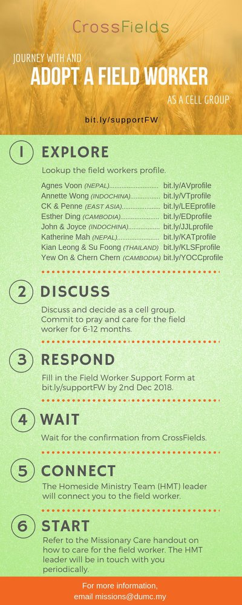

- CMS: Steps to Fill in the Salvation Form
- Select “More”
- “Form”
- Select “Form Lit” box
- Look for “Salvation Form”
- Fill in form of new salvation by “Change Respondent”
- Must have “E-mail” and “Mobile Phone”

UPCOMING

PREACHING SCHEDULE

Mar 30&31 | The Christian’s Duty | Sr Pr Chris Kam
Apr 6&7 | Sowing and Reaping | Pr Mike Ngui

Go to: http://www.dumc.my/resources/sermons/ for the latest info.

EVENT HIGHLIGHTS

  - Tuesday Night Encounters (NEW!)
Every 3rd Tuesday of every month | 8.30 -10.00pm | Auditorium
A night focusing on prayer, healing and deliverance
For more information, contact: forerunners@dumc.my

  - Church Prayer Altar
Every Saturday | 7.00 -9.00am | Room 101 & 102
Let us come and seek the face of God. Prayer precedes everything.

  - WANT TO JOIN THE DUMC FAMILY?
Here are the steps:
> Join a Cell Group (You can get help at our CG Kiosk)
> Attend Basic Christianity 101 > Attend DUMC 101
> Join an Encounter Weekend
> Baptism & Membership Interview Sign up at the Info Counter or online at dumc.my/equip

EQUIP COURSES 2019

CHRISTIAN LEADERSHIP 201

Saturdays | 13 & 20 Apr | 8.30am-1.00pm

        - PRAYER 101 (The Lord’s Prayer)

Sundays | 14 Apr – 2 Jun | 8.00am-9.30am | (excluding 21 Apr & 19 May)

MINISTRY 201 (Finding Your Fit)

Saturday | 13 Apr | 8.30am-1.00pm

MINISTRY 202 (Moving in the Gifts of the Holy Spirit)

Saturdays | 27 Apr & 4 May | 8.30am-1.00pm

DUMC 101 (Membership Requirement)

Saturday | 4 May | 8.30am-1.00pm

ANNOUNCEMENT

