CONTENTS

Worship
Word
Works
Upcoming:
Preaching Schedule
Event Highlights
Equip courses

WORSHIP (Praise and Prayer)

- Malaysia: Labour Day(1 May)
Pray for:
There will be greater emphasis on human capital, and for the emergence of a diligent, disciplined and honest workforce.
• Workers will strive for effectiveness and efficiency in their work.
• Employers will always have the interests and welfare of their workers foremost in their minds.
• For co-operation, harmony and unity between management and staff, employers and employees.

- International: Sri Lanka-Easter Sunday Bombings

On the morning of 21 April 2019, while Christians in Sri Lanka were celebrating Easter Sunday, churches and hotels were bombed in four cities (Kochchikade, Negombo, Batticaloa, and Colombo). The latest casualty figures are 359 dead and 500 injured from the eight bombings. Some arrests have been made. Pray that the church will demonstrate the holy love of God, personally and corporately showing love to all, including our enemies, but also act with maturity and firmness in insisting that the authorities carry out a thorough investigation and punish the wrongdoers.
Pray:
• For God’s comfort and strength for the families and loved ones of the victims.
• Comfort and relief too for the injured, and for their speedy recovery.
• God will not allow extremists to use these incidents to cause unrest in the country.
• That the perpetrators will be speedily brought to justice.

WORD (60 minutes)

Called To The Marketplace
(Colossians 3:22-4:1; Philippians 2:12-16)
Dato’Dr Daniel Ho,Founding Senior Pastor

Big Idea: We are called to the marketplace.

- Read the scripture passage.
- Do a THREE-MINUTE SUMMARY of the sermon highlighting the KEY POINTS (The Task, The Test, The Trust). Do not preach the whole sermon, as majority of your members would have heard the sermon already. Allocate more time for sharing in the cell through the application questions below.
- Sermon Resource at: http://www.dumc.my/resources/sermons/

Reflection & Application Questions:

      - What is the most significant thing that the Holy Spirit spoke to you about through this sermon?

      - What are the challenges of your workplace and in what ways have you served well and not so well in your workplace? In what ways and areas you would like to improve on? How can others help and pray?

      - Being the greatest mission field, how are you bearing witness and sharing Christ with your colleagues in your workplace? What have you succeeded in and not succeeded in? What are your plans and goals and how can your members pray with you?

Note to Word leader:
As you are preparing for this session, this is a great time to pray that the Holy Spirit will guide you to use the questions efficaciously. You can select, modify or entirely create your own questions, according to the needs of your CG, especially if you feel that there are too many questions than required for the allocated time.

Note to Cell Groups that have children during meeting:
We recognize several cell groups in DUMC may have 5 or more children joining them during Cell Group meetings. We would like to get them engaged as well during the session therefore we are suggesting for CGs to use Manna Pad and assign someone in rotation to facilitate them after worship. Here is the link to the Manna Pad materials http://dumc.my/resources/downloads/

WORKS (Ministry and Bearing Witness)

Cell leaders to ask these two important questions or share with one another during Works session in every CG meeting.

    - Who have I met, praying for and sharing Christ with?
    - What is the Holy Spirit saying about the community I am in?

- Share Your Story (Your Story, His Glory)
- Whether your story is about how you came to know Christ, illness healed, an act of kindness in your times of need, or of how you served people or how people have served you, give glory to God. Share your story so that people will be encouraged and God's love is known.
- If there are any good testimonies, ask your members to write out their testimonies and submit to the church: http://dumc.my/connect/individual-care/share-your-story/

- Personal: Bible Reading and Journaling
- Subscribe to the Bible Reading Plan app: YouVersion – OwnIt365 New Testament (NT)+ Plan.
- Request one of your members to share a journal entry. Pair up members to share with, and pray for one another.

- Scripture Memory
Every cell meeting, do get your cell members to recite the following together:

Galatians 5:25 (Theme verse for 2019)
Since we live by the Spirit, let us keep in step with the Spirit.

Galatians 2:20 (added from March 2019)
I have been crucified with Christ and I no longer live, but Christ lives in me. The life I now live in the body, I live by faith in the Son of God, who loved me and gave himself for me.

- CrossFields
“Crossing into the harvest field with the message of the Cross”

Sarawak Iban | 17-20 May
Sarawak Penan | 25-31 May
Thailand | 1-7 Jun
Vietnam | 14-18 Jun
MCPP1| 20-21 Jul | Empress Hotel (Sepang)

Website: dumc.my/missions Mission Trip dates: bit.ly/CF2019cal

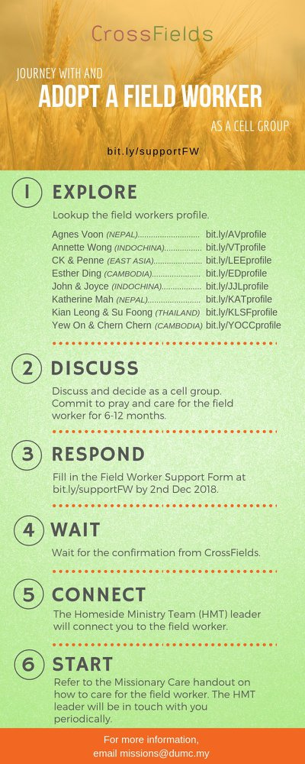

- CMS: Steps to Fill in the Salvation Form
- Select “More”
- “Form”
- Select “Form Lit” box
- Look for “Salvation Form”
- Fill in form of new salvation by “Change Respondent”
- Must have “E-mail” and “Mobile Phone”

UPCOMING

PREACHING SCHEDULE

May 4&5 2019 | Calling In The Marketplace 2 | Eileen Wong

Go to: http://www.dumc.my/resources/sermons/ for the latest info.

EVENT HIGHLIGHTS

  - Join The Celebrations in DUMC@Puchong at 10am Every Sunday
Bring your friends and family members living around the Puchong area. Look for DUMC@Puchong on Waze or Google Maps. (Please park at IOI Business Park Level B2)

  - Tuesday Night Encounters (NEW!)
Every 3rd Tuesday of every month | 8.30 -10.00pm | Auditorium
A night focusing on prayer, healing and deliverance
For more information, contact: forerunners@dumc.my

  - Church Prayer Altar
Every Saturday | 7.00 -9.00am | Room 101 & 102
Let us come and seek the face of God. Prayer precedes everything.

  - WANT TO JOIN THE DUMC FAMILY?
Here are the steps:
> Join a Cell Group (You can get help at our CG Kiosk)
> Attend Basic Christianity 101
> Attend DUMC 101
> Join an Encounter Weekend
> Baptism & Membership Interview Sign up at the Info Counter or online at dumc.my/equip

  - SEMINAR ON THE KINGDOM OF GOD BY PASTOR NEAL PATTERSON
Come for an impactful and enlightening time.
Part 1 | 9 May (Thu) | 7.30pm-10.00pm | Hall 4
Part 2 | 11 May (Sat) | 8.30am-12.30pm | Hall 4
Register at bit.ly/DUMC2019KOG Enquiries to equip@dumc.my

- PARENTS SUPPORT PARENTS
Topic: Parenting Together (New Series)
Dates | 27/4, 11/5, 25/5, 15/6, 29/6
Time | 3.00pm-4.30pm
Venue | Café Function Room
Admission free!

EQUIP COURSES 2019

DUMC 101 (Membership Requirement)

Saturday | 4 May | 8.30am-1.00pm

BASIC CHRISTIANITY 201

Saturdays | 11 & 18 May | 8.30am-1.00pm

c. BMEW (Membership Requirement)
Weekend Away | 18 & 19 May

d. BIBLE 101
Saturdays | 25 May & 1 Jun | 8.30am-1.00pm

e. BIBLE STUDY –
ANNOUNCEMENT
HEBREWS PT 2
Sundays | 12 May-21 Jul | 8.00am-9.45am (Exc 16 Jun)

