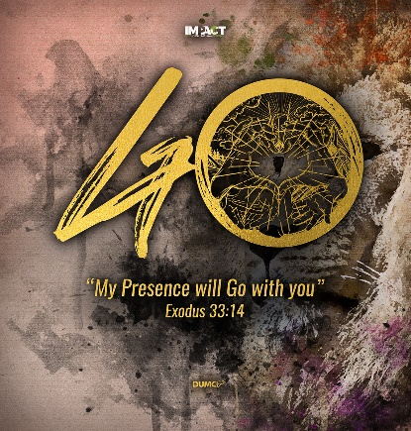
We are not in control, GOD is
(Luke 9:10-17)
Senior Pastor Chris Kam

Late in the afternoon the Twelve came to him and said, “Send the crowd away so they can go to the surrounding villages and countryside and find food and lodging, because we are in a remote place here.”

He replied, “You give them something to eat.”

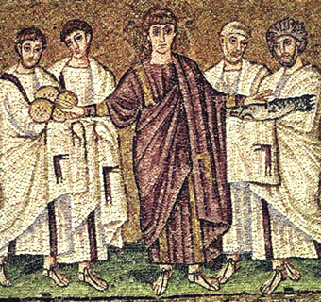
They answered, “We have only five loaves of bread and two fish—unless we go and buy food for all this crowd.” (About five thousand men were there.)

But he said to his disciples, “Have them sit down in groups of about fifty each.”
(Luke 9:12-14)

Introduction

We should still be connected even when we are not able to come together physically, including in our virtual cell groups. We are still one in spirit and present in spirit.

And let us consider how we may spur one another on toward love and good deeds, 25 not giving up meeting together, as some are in the habit of doing, but encouraging one another—and all the more as you see the Day approaching. (Hebrews 10:24-25)

For though I am absent from you in body, I am present with you in spirit and delight to see how disciplined you are and how firm your faith in Christ is. (Colossians 2:5)

Our country has suffered a double whammy, both politically and due to the COVID-19 virus. Many people have been suffering due to the virus, with deaths occurring in our country. There are also economic repercussions. Businesses are affected, travel plans disrupted and conferences cancelled.
We are what we believe. We may be angry or frustrated or anxious during this period. This is the time that we are tested about what we believe in – about God and His sovereignty. We are often tested in the worst of times and through this testing, who we are really shows. It can bring the best out of us or the worst out of us.

How do we, as Christian disciples, respond in a Christlike manner?

The future is determined by God. The future is not determined by circumstances or by man.
BIG IDEA: I am not in control, God is.

Our Call
But our citizenship is in heaven. And we eagerly await a Savior from there, the Lord Jesus Christ, who, by the power that enables him to bring everything under his control, will transform our lowly bodies so that they will be like his glorious body. (Philippians 3:20-21)

How do we hold a healthy tension between being a citizen of heaven and a citizen of our nation? We need to be responsible and take the necessary precautions. We still need to trust in God’s protection. We are called to be the salt and light. We are not Malaysian by accident but by a sovereign act of God.

From one man he made all the nations, that they should inhabit the whole earth; and he marked out their appointed times in history and the boundaries of their lands. (Acts 17:26)

We are here because God has put us here. Our call, while we are here, is to be the salt and light while the world is panicking. We have a hotline where people can seek help during these difficult times. We need to be reaching out to impact the poor, needy, outcasts, underprivileged and refugees. Rather than hoarding food, we need to be giving. We need to look at the needs around us, even after the movement control order. There are people in need even among the middle-income group.

Our Challenge
As Christians, this challenge will increase over time. Things on Earth are not going to get better on their own. We need Jesus for things to get better.

Then he said to them: “Nation will rise against nation, and kingdom against kingdom. There will be great earthquakes, famines and pestilences in various places, and fearful events and great signs from heaven. (Luke 21:10-11)

This pandemic is a pestilence. The Challenges will be ahead of us but how do we respond? Jesus tells us we should not be surprised by all this because we are pilgrims on this earth and heaven will be our ultimate home.

Late in the afternoon the Twelve came to him and said, “Send the crowd away so they can go to the surrounding villages and countryside and find food and lodging, because we are in a remote place here.” He replied, “You give them something to eat.” They answered, “We have only five loaves of bread and two fish—unless we go and buy food for all this crowd.” (About five thousand men were there.) But he said to his disciples, “Have them sit down in groups of about fifty each.” (Luke 9:12-14)

The disciples were concerned because of the 5000 men who were there, not including the women and children.

He replied, “You give them something to eat.” They answered, “We have only five loaves of bread and two fish—unless we go and buy food for all this crowd.” (Luke 9:13)

Jesus asked them to give something to eat. They replied that they only had 5 loaves and 2 fishes. Jesus was telling the disciples to do something they cannot do. 5 loaves and 2 fishes does not equate to 5000 men. It is an impossible sum. The disciples had no choice but to realise that they cannot do this and to turn to Jesus. Jesus sat the people down in groups of 50 because a miracle was going to happen. They gave thanks and started to distribute the food. There was more than enough to eat. In the eyes of the disciples, they realised that this is a miracle of immense proportions.

When we look at things around us, we realise that it is an impossible sum. There are many issues in our lives. It is important for us to turn and look to Jesus and ask what Jesus would have us do. Even as we see Jesus doing what He is doing, we have confidence.

Our Confidence

We are definitely not in control of many situations. These are impossible sums. Our confidence is in looking to Jesus. He will only do a miracle in our lives if we surrender the little that we have. When we turn our eyes towards Him, He will do the rest.

He replied, “Because you have so little faith. Truly I tell you, if you have faith as small as a mustard seed, you can say to this mountain, ‘Move from here to there,’ and it will move. Nothing will be impossible for you.” (Matthew 17:20)

If we have the faith of a small mustard seed, we can move mountains. It is not our faith that really counts. It is the object of faith that is most important – Jesus. We must know in whom we believe in. Jesus is in control and we can turn to Him.

The number 5 represents human weakness and limitations in the light of God’s covenant and grace. Man is insufficient in himself. 5+2 adds up to 7, symbolising the completion and perfection of God which comes into our lives.

We are never adequate or sufficient in ourselves until we surrender to the Lord Jesus Christ.

Conclusion

As we look at the situation around us, God is saying to us to turn our eyes to Him. With all that is going on in our lives, we are not in control but God is in control. We need to shine the glory of God even in the midst of uncertainties. We need to stand for what is right in serving the community. We need to come out the other end of the movement control order (MCO) as a better person and allow God to build deeper into our lives.
Sermon summary contributed by Zhenli

