Apostles’ Creed V: Empty Tomb to Highest Throne
Philippians 2:5-11
Pastor Mike Ngui

In your relationships with one another, have the same mindset as Christ Jesus: Who, being in very nature God, did not consider equality with God something to be used to his own advantage; rather, he made himself nothing by taking the very nature of a servant, being made in human likeness. And being found in appearance as a man, he humbled himself by becoming obedient to death—even death on a cross! Therefore God exalted him to the highest place and gave him the name that is above every name, that at the name of Jesus every knee should bow, in heaven and on earth and under the earth, and every tongue acknowledge that Jesus Christ is Lord, to the glory of God the Father. (Philippians 2:5-11)

THE APOSTLES’ CREED
I Believe in God, the Father Almighty,
Creator of heaven and earth,
I Believe in Jesus Christ, His Only Son, our Lord,
who was conceived by the Holy Spirit,
born of the Virgin Mary,
suffered under Pontius Pilate,
was crucified, died, and was buried;
the third day He rose again from the dead.
He ascended into heaven,
is seated at the right hand of the Father,
and will come again to judge the living and the dead.
I Believe in The Holy Spirit,
the holy catholic* church,
the communion of saints,
the forgiveness of sins,
the resurrection of the body,
and the life everlasting.
Amen.
BIG IDEA: Jesus our Lord is the Lord and our returning King.

Introduction
In this last sermon of the Apostles’ Creed, the message is on the Resurrection, Ascension and the Return of Christ. They explain why should Jesus be our Lord and what elevated his position to be our Lord.
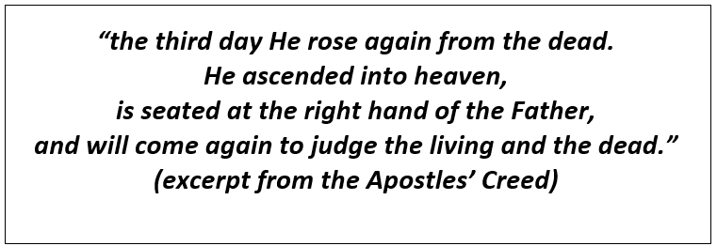

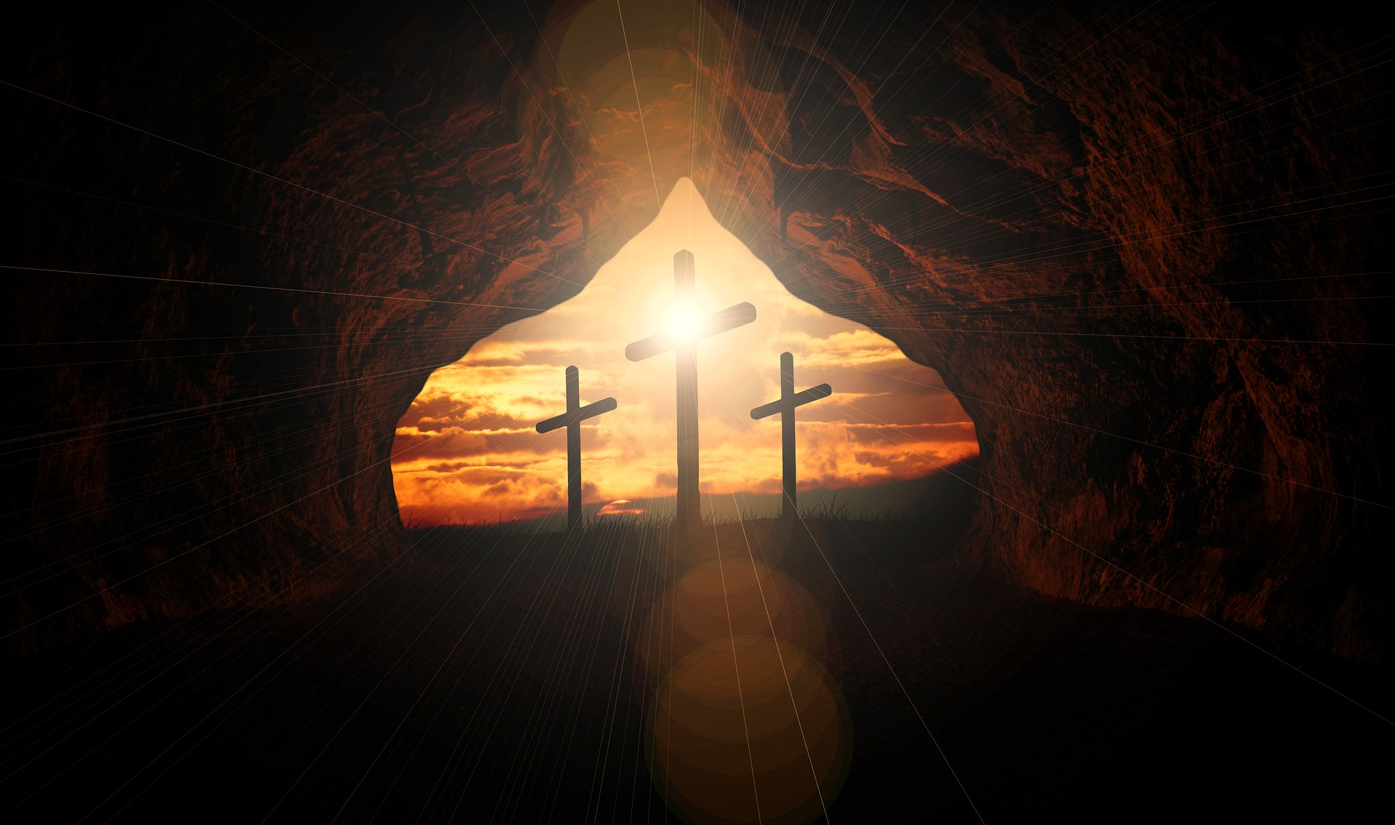
The Resurrection: Jesus rose from the dead
“the third day He rose from the dead”

The promise of resurrection
The promise of resurrection was fulfilled when Jesus was resurrected. It is a promise that was not just for Martha and Mary, but for us too. For when Jesus rose from the dead, we too can be raised.

“Jesus said to her, “I am the resurrection and the life. The one who believes in me will live, even though they die; and whoever lives by believing in me will never die. Do you believe this?” (John 11:25,26)

“By his power God raised the Lord from the dead, and he will raise us also.” (1 Corinthians 6:14)

The proof of Jesus’ claims
The resurrection of Jesus proved that Jesus is the Son of God, the Messiah. It is also proof that we will be delivered.

“…concerning his Son, who was descended from David according to the flesh and was declared to be the Son of God in power according to the Spirit of holiness by his resurrection from the dead, Jesus Christ our Lord.” (Romans 1:3,4)

“God has raised this Jesus to life, and we are all witnesses of it… ‘Therefore let all Israel be assured of this: God has made this Jesus, whom you crucified, both Lord and Messiah.” (Acts 2:32, 36)

The product in our salvation
Jesus was delivered on Good Friday and raised on Easter Sunday. If Jesus had not been raised, there is no resurrection, and there will be no forgiveness or justification. When Jesus rose from the dead, it shows that God accepted the sacrifice. The resurrection was everything.

“He was delivered over to death for our sins and was raised to life for our justification. (Romans 4:25)

“And if Christ has not been raised, your faith is futile; you are still in your sins.” (1 Corinthians 15:17)

What does resurrection mean for us then?
When Christ rose from the dead, we have been raised with him, and something changed. We changed. Therefore, set our minds and hearts to focus on God. We now live, as we are people belonging to God. Relocate the centre of our life. Do not continue to live in the old ways, but as a new creation in Christ.

“Since, then, you have been raised with Christ, set your hearts on things above, where Christ is, seated at the right hand of God. Set your minds on things above, not on earthly things.”
(Colossians 3:1,2)

Upon a life I did not live,
upon a death I did not die,
I risk my whole eternity
on the resurrection.
- C.H. Spurgeon

The Ascension: Jesus at the Father’s right hand
“He ascended into heaven,
is seated at the right hand of the Father”

Jesus ascended to send the Holy Spirit
Jesus ascended to send the Holy Spirit to us. The Holy Spirit comes to be with us and in us, to give us power, love and self-discipline. The Holy Spirit comes to empower us and show us God’s love.

“But very truly I tell you, it is for your good that I am going away. Unless I go away, the Advocate will not come to you; but if I go, I will send him to you.” (John 16:7)

“For the Spirit God gave us does not make us timid, but gives us power, love and self-discipline.” (2 Timothy 1:7)

Jesus ascended to intercede for us
Jesus intercedes for us. He is the most empathetic high priest that we have. He is with us all the time, so we do not go to the Father alone.

“but because Jesus lives forever, he has a permanent priesthood. Therefore he is able to save completely those who come to God through him, because he always lives to intercede for them.”
(Hebrews 7:24, 25)

Jesus ascended the throne as Lord
Jesus ascended not as a crucified man or a saviour, but as Lord. All the time when Jesus walked the earth, he did so as a lowly man. He lowered and humbled himself so low, that when God raised him, He raised him to the highest, as Lord.

“Therefore God exalted him to the highest place and gave him the name that is above every name, that at the name of Jesus every knee should bow, in heaven and on earth and under the earth, and every tongue acknowledge that Jesus Christ is Lord, to the glory of God the Father.” (Philippians 2:9-11)

What does ascension mean for us then?
When Jesus ascended, he ascended as our Lord, who intervenes for us, ever-backing and empowering us through the Holy Spirit. All these, so we can live in this world as his royal emissaries.

The Return: Jesus will be back
“and will come again to judge the living and the dead.”

“For whenever you eat this bread and drink this cup, you proclaim the Lord’s death until he comes.”
(1 Corinthians 11:26)

Jesus will return for us
Jesus will return for us, to bring us home to the Father. When Jesus comes, there will be enormous glorious change.

“And if I go and prepare a place for you, I will come back and take you to be with me that you also may be where I am.” (John 14:3)

“But our citizenship is in heaven. And we eagerly await a Saviour from there, the Lord Jesus Christ, who, by the power that enables him to bring everything under his control, will transform our lowly bodies so that they will be like his glorious body.” (Philippians 3:20,21)

Thus, we eagerly await the return of our saviour, who will bring restoration.

The crux of the whole matter is this: our wonderful, created world will be restored to its rightful Owner. I for one look forward to that day. I want to live here when Jesus Christ owns and rules the world. Until that hour, there will be conflict, distress and war among the nations. We will hear of suffering and terror and fear and failure.
But the God who has promised a better world is the God who cannot lie. He will shake loose Satan’s hold on this world and its society and systems. Our heavenly Father will put this world into the hands that were once nailed to a cross for our race of proud and alienated sinners.
It is a fact. Jesus Christ is returning to earth.
-A.W. Tozer

Jesus will return as King of Kings, Lord of Lords
Jesus will come as Lord. He will no longer come in a lowly manner, being treated unjustly, oppressed and made to suffer. Instead, He will return triumphantly as Lord.

“… the Lamb will triumph over them because he is Lord of lords and King of kings …”
(Revelation 17:14)

“On his robe and on his thigh, he has this name written: KING OF KINGS AND LORD OF LORDS.”
(Revelation 19:16)

Thou art coming to a King
Large petitions with thee bring;
For His grace and power are such
None can ever ask too much.
-John Newton

We know that our Jesus is King, so let our request not be small! Do not be afraid to ask from our Lord.

“Let us then approach God’s throne of grace with confidence, so that we may receive mercy and find grace to help us in our time of need.” (Hebrews 4:16)

Let us be reassured that He will return. Anticipate the return of Jesus Christ, our Lord.

Looking for the train to arrive is one thing but looking for someone we love to come on that train is another matter. With regard to our Lord's return, we emphasize preparation without expectation. Of course, all too generally nothing is said of His return at all. Bringing in the Kingdom is preached, but not bringing back the King.
- Vance Havner

What does His return mean for us then?
Jesus will return as the King of Kings and the Lord or Lords. He will return victoriously and gloriously, to bring restoration and to take us home to our Father. The Apostles’ Creed also reminds us that Jesus will come to judge as well.

Conclusion
Jesus’s empty tomb to the highest throne reflects the significance of His resurrection, ascension and return. Therefore, take heed:
- To live our lives as those raised with Jesus
- To refocus our lives from a perspective of Jesus
- Jesus is there to petition for us and empower us to live in this world as His royal emissaries
- Our King is coming back, and we should anticipate His return
- Before He judges, He offers mercy, so come to Him

In short, the Lordship of Jesus is not an academic matter but is intensely practical. Therefore, ponder deeply of what it means that Jesus Christ is Lord of our lives.

Sermon summary contributed by Adeline Ting.

