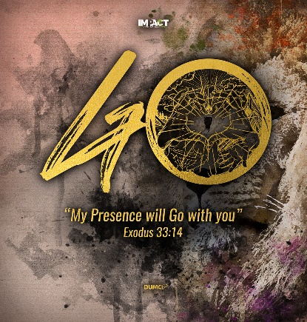
Church Gathered & Scattered: The Shifts of the Holy Spirit
2 Major Shifts for the Church
Joshua 3:1-5
Senior Pastor Chris Kam

Introduction
The early church was birthed in Acts 2 on Pentecost, with about 500 or more disciples. By the end of Acts 2, 3,000 or more believers were added to their gathering; by Acts 4, or about 2 years later, there were about 5,000 men, not counting women and children, which could double or triple that number. By Acts 8 or about 4 years later, the church was persecuted and scattered.

On that day a great persecution broke out against the church in Jerusalem, and all except the apostles were scattered throughout Judea and Samaria. (Acts 8:1)

Those who had been scattered preached the word wherever they went. (Acts 8:4)

The scattering was for the preaching of the gospel and the extension of God’s kingdom. If the church has not been renewed and revived with the constant emphasis of the Great Commission to go and make disciples of all nations, God will often scatter the church through persecutions, hardships and even pandemics.

Not all difficulties are necessarily bad and can even be allowed by God for His greater purpose for the gospel to be preached to the ends of the earth, and then He will come again.

The agent of change is the Holy Spirit. The church of Jesus Christ needs a big shaking to see the needs around us. What is the prophetic voice of God in this pandemic?

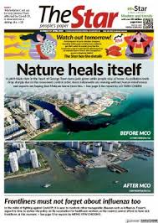
In a recent report in The Star, it was reported that a pitch-black river in Georgetown, Penang turned jade green, while people stayed at home. Pollution levels have dropped sharply due to the movement control order and rivers nationwide are reviving without human interference.

There is a prophetic declaration that there is much self-correction and re-alignment of ourselves because the way we use the Earth’s resources is unsustainable.

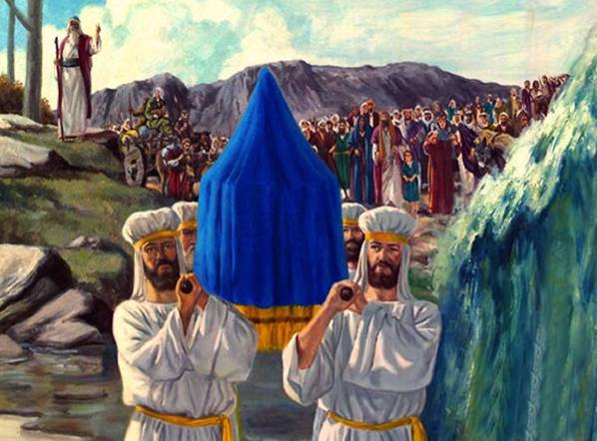
Early in the morning Joshua and all the Israelites set out from Shittim and went to the Jordan, where they camped before crossing over. After three days the officers went throughout the camp, giving orders to the people: “When you see the ark of the covenant of the Lord your God, and the Levitical priests carrying it, you are to move out from your positions and follow it. Then you will know which way to go, since you have never been this way before. But keep a distance of about two thousand cubits between you and the ark; do not go near it.” Joshua told the people, “Consecrate yourselves, for tomorrow the Lord will do amazing things among you.” (Joshua 3:1-5) (emphasis, SP’s)

There are three movements here: ‘move out from your positions’, ‘will know which way to go’ and ‘keep a distance’.

Joshua and the people

Move Out
… you are to move out from your positions and follow it (Joshua 3:3)

The Israelites have been moving around in circles now for 40 years. We are not meant to live to move around in circles, not getting anywhere. There is no holy discontent or desire to move out of the circle, in which case God will shake us. God reminded us in 2019 to come out of our comfort zone and embrace a new spirit. God is challenging us again to go beyond the four walls of the church. He also reminded us to sow generously for we will reap bountifully and make disciples of all nations.

Move To

Then you will know which way to go, since you have never been this way before (Joshua 3:4)

BIG IDEA: Never been this way before

God is challenging us to have a dream so big that unless God is there, we are bound to fail.

In the study of the book of Jonah, when God says ‘go’, don’t say ‘no’.

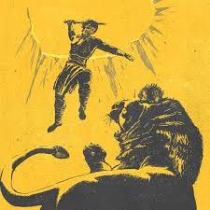
In ‘chasing the lion’, think of something you have never tried, do something you have never done, and go somewhere you have never been.

This is another season for us to step up, step out, step in and step forward.

Move Ahead
But keep a distance of about two thousand cubits between you and the ark; do not go near it. (Joshua 3:4)

This does not mean we are to move ahead of God. Follow the ark and the presence of God, do not go your way.

We thank God that we live in the new covenant today, that we are able to go into the presence of God with freedom because we are saved by the blood of Jesus, we do not need the ark today because the presence of God through the Holy Spirit is upon the body of believers through the church. God’s presence goes with us. We involve the Holy Spirit everyday. God is going to use the entire body of Christ to be the agent of the gospel for the world where every member, you and I, plays an important part.

God chose the lowly things of this world and the despised things—and the things that are not—to nullify the things that are, so that no one may boast before him. (1 Corinthians 1:28-29)

There are no superman or superwoman in the body of Christ. There are no super apostles, prophets, evangelists, teachers, pastors etc – their role is to equip the body of Christ to do the work of the ministry, and the power of the church today is everyone doing his/her part as the Holy Spirit directs him/her to serve wherever they are. If our spiritual diet is based on hearing from other people, we miss out on the greatest gift of the personal teacher and tutor, Who is the Holy Spirit. Make time to read His Word.

A favourite phrase used everywhere now is ‘the new normal’. In some sense, it is the scattering of the church through digital means.

This is a season of reflection, recalibration and reinvention.

Reinvention is not to invent something that is already existing, but to remake, revive and to repurpose. The reality is, we cannot ‘do’ church the way we are used to for the next 12-24 months, or until a vaccine for Covid-19 has been found.

Two Major Shifts for the Church

A Shift from Physical to Digital Presence
We are not saying there are no more physical church, but the inclusion of a digital platform.

End-to-end Congregational Worship
How do we do the entire celebration from start to end, like right now? It was very unnerving replicating the physical celebration on a virtual platform, but DUMC was able to pull it off because we have been live-streaming already seven years now. However, DUMC’s monthly church giving has not ‘suffered; for the month of April when services were fully online, the giving for that month was more than when the church was meeting physically in January/February. We now have people tuning in from different parts of the world. The average screen views for all of DUMC’s six congregations were about 8,000 – 9,000 thereabouts; if this was to be translated to the actual people watching, there could be about 15,000 people or more behind the screens. In the Myanmar congregation, there is an average screen view of about 4,000; meaning there could be about 8,000 to 10,000 people watching behind the screen. They are drawing new people from their diaspora from around the world. They have also gotten over 50 people to join their online cell group meetings from overseas.

Equipping
Post-MCO, we will see a combination of online and physical class training, as people are now adapting to a new way of learning.

Cell Groups
Our cell group meetings have been taken to a new level. We are able to do anything now, even to eat together virtually. MCO has not stopped us from being a cell group. From last week’s cell statistics, we have at least 110 new visitors joining our English cell groups. It is an interesting phenomenon that new people are willing to join cell groups online. The life of DUMC is not about how many screen views for the online church celebrations, but whether our members are attending cell groups weekly, as this is the only way we know that they are connected to the church. Cell attendance record is very, very important to our Senior Pastor. If you are not part of a cell group, please join one as soon as possible. We may even need to meet in cell groups for our online celebrations; we do not have to watch alone; we can now come together as a cell group and ‘attend’ church celebration together.

Church Meetings
DUMC has a Saturday prayer altar, with about 150 regular attendees, 7am to 9am. All DUMC’s meetings are done virtually right now. DUMC has also brought in their overseas missionaries to attend online meetings now.

A Shift in “Less of” and “More of”

Needing less for self, and more for the marginalised
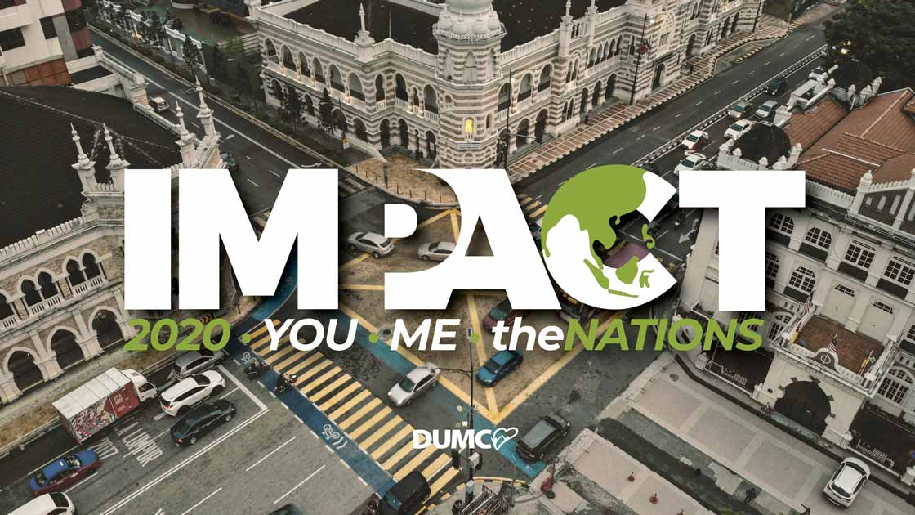
It has forced us to evaluate our lifestyle that we do not need a lot in life. Maybe it is because we spend a lot of time at home, there is no need to accumulate a lot to impress anybody. We open our eyes to see the ‘invisible’ society in our midst - the urban poor, the B40 group, the refugees, the asylum seekers, and migrant workers. They have very different struggles – their struggle is to put food on the table, putting a roof over their heads, which many of us have taken for granted in our lives. We must uplift their plight through economic empowerment, job creation, social enterprising and even our corporate network.

IMPACT 2020 is not a series of events that we are embarking on as a checklist to tick off; it is a lifestyle. IMPACT 2020 is now rebranded as IMPACT NOW. We must live simply so that others can simply live.

Needing less focus on numbers, and more on engagement
It is forcing us not to think of programmes to attract large crowds; it is helping us to think about engaging more intentionally and meaningfully in our relationships with one another and our friends. The most power strategy of evangelism is not big evangelistic meetings, but individual members sharing our lives and the gospel, influencing our friends one by one.

Needing less timewasters, and more on efficacy
There is a difference between efficiency, effectiveness, and efficacy. Efficacy simply means right place, right time and requires wisdom. Because the MCO has made us bring everything that we do physically to a digital platform, it has also brought this question – why we do what we do. Can things be done more efficiently and effectively? Are there unnecessary things that we can do without? Things that we are comfortable with, do we really need them? Do we really need to print materials and cut down more trees? Like our weekly bulletin, we can download them online. Do we need to pass the offering bags around because giving is a matter of the heart? We can encourage people to give online or have a box for them to drop their offerings in.

Needing less conversations on buildings/institutions, and more on relationships/communities
It has forced us to prioritise and ask the hard questions – what is most core or fundamental about the mission of the church? If everything is stripped away, are we still obeying the Great Commandment and the Great Commission? Are we still doing missions and reaching out to our community? Are we still making an impact in the marketplace, even though we cannot meet? Are we still fulfilling what is basic and fundamental?

This is encapsulated in our tagline:

Love God, Serve People, Make Disciples towards Christlikeness
DUMC has just reviewed their budget, asking themselves what is absolutely necessary in view of what is going on. Do we want to direct our funds towards the poor and needy? DUMC has shaved off about 17% of their budget and can redirect these funds to the needy outside. The church staff have all taken a pay freeze that was due in March, as an act of solidarity in view of the current economic downturn. It has also accelerated the multi-site strategy to make the church smaller, flexible, and mobile. We are connected by small groups and can grow as big as God allows us to grow by remaining small at all times. A possible future theme could be: Growing smaller to be deeper and wider.

Small is Big. Less is More. Slow is Fast.
We need wisdom to understand this and that the church will be relevant for the community. It is hoped that we will not waste this MCO and the pandemic as God recalibrates us.

Overarching Shift
A shift from Superficial Faith to an Authentic Faith
We pray that this MCO and pandemic will reveal something about yourself - what you have and what you do not have. Let us be humble to allow God to change us.

Conclusion
Joshua told the people, “Consecrate yourselves, for tomorrow the Lord will do amazing things among you.” (Joshua 3:5)

Will you re-dedicate your lives to God, as you look ahead with hope and excitement with what is ahead of us? We look forward to our future glory but while we are here on earth, God has given us unimaginable opportunities as compared to maybe even a year ago. So, let us consecrate ourselves that God will use us in a fresh new way.

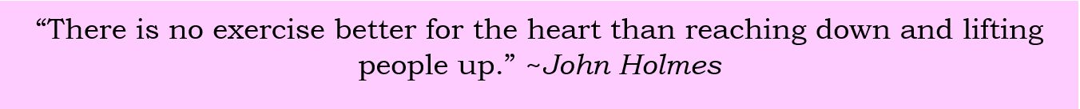

Sermon summary contributed by May.

