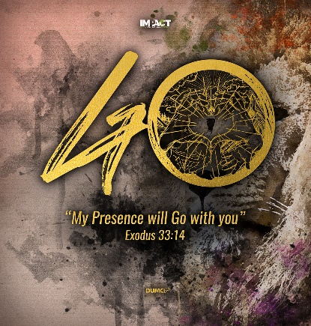
Apostles’ Creed VI: I Believe in the Holy Spirit (Ephesians 1:13-14, John 16:13-15, Acts 1:4-5, 8)
Senior Pastor Chris Kam
And you also were included in Christ when you heard the message of truth, the gospel of your salvation. When you believed, you were marked in him with a seal, the promised Holy Spirit, who is a deposit guaranteeing our inheritance until the redemption of those who are God’s possession—to the praise of his glory. (Ephesians 1:13-14)
But when he, the Spirit of truth, comes, he will guide you into all the truth. He will not speak on his own; he will speak only what he hears, and he will tell you what is yet to come. He will glorify me because it is from me that he will receive what he will make known to you. All that belongs to the Father is mine. That is why I said the Spirit will receive from me what he will make known to you.” (John 16:13-15)
On one occasion, while he was eating with them, he gave them this command: “Do not leave Jerusalem, but wait for the gift my Father promised, which you have heard me speak about. For John baptized with water, but in a few days you will be baptized with the Holy Spirit.”… But you will receive power when the Holy Spirit comes on you; and you will be my witnesses in Jerusalem, and in all Judea and Samaria, and to the ends of the earth.” (Acts 1:8)

This weekend, we celebrate Aldersgate Sunday. On 24th May 1738, John Wesley at the age of 35 had an experience when he said, “I felt my heart strangely warmed.” It was then that he had an encounter with the presence of the Holy Spirit and he felt assured of his salvation in Christ. This experience was a spark that ignited a transformation in his life. It led him to a life of fruitfulness and the founding of the Methodist movement in Britain and US, a significant mark in church history.

THE APOSTLES’ CREED
I Believe in God, the Father Almighty,
Creator of heaven and earth,
I Believe in Jesus Christ, His Only Son, our Lord,
who was conceived by the Holy Spirit,
born of the Virgin Mary,
suffered under Pontius Pilate,
was crucified, died, and was buried;
the third day He rose again from the dead.
He ascended into heaven,
is seated at the right hand of the Father,
and will come again to judge the living and the dead.
I Believe in The Holy Spirit,
the holy catholic church,
the communion of saints,
the forgiveness of sins,
the resurrection of the body,
and the life everlasting.
Amen.

Introduction
Overview of the Holy Spirit in Biblical History
God’s Spirit was present in creation. God the Father spoke, the Word was Jesus and the Holy Spirit created.
In the Old Testament, Holy Spirit’s presence was manifested by wind, cloud, storm, smoke or fire. He would rest on specific people for certain tasks that they are assigned to, empowering leaders like Moses, Joshua, the prophets, judges, kings and Israel elders.
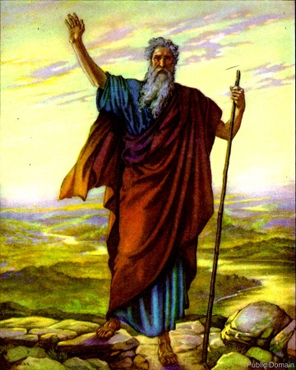
In the Exodus story:
But Moses replied, “Are you jealous for my sake? I wish that all the Lord’s people were prophets and that the Lord would put his Spirit on them!” (Numbers 11:29)
Here, was a prophetic call where Moses hoped that someday, all of God’s people will receive God’s spirit and prophesy in His power.
600 years later, Joel prophesized the same:
“And afterward, I will pour out my Spirit on all people. Your sons and daughters will prophesy, your old men will dream dreams, your young men will see visions. Even on my servants, both men and women, I will pour out my Spirit in those days.” (Joel 2:28-29)

In the days of Pentecost:
On one occasion, while he was eating with them, he gave them this command: “Do not leave Jerusalem, but wait for the gift my Father promised, which you have heard me speak about. For John baptized with water, but in a few days you will be baptized with the Holy Spirit.” (Acts 1:4-5)

But you will receive power when the Holy Spirit comes on you; and you will be my witnesses in Jerusalem, and in all Judea and Samaria, and to the ends of the earth.” (Acts 1:8)
And then it happened. Holy Spirit fell upon the disciples and the tongues of fire rested on them. They began to speak in foreign languages which they do not understand and people were amazed.
“…as the Spirit enabled them” (Acts 2:4)

The work of the Holy Spirt now is to pull people together and unite them in Christ.
31st May 2020 will be the commemoration and celebration of Pentecost Sunday – the receiving of the Holy Spirit. It was the followers of Jesus who were the recipients of God’s promised gift of the spirit. It wasn’t the religious leaders or people in high places. In fact, the disciples were an unimpressive group of people.

… they were unschooled, ordinary men … (Acts 4:13) … meaning, like you and me.

The disciples then went on to shake and shaped the entire world. Thereafter, the Holy Spirit keeps filling the apostles and the believers – Jews or Gentiles, Greek or Roman, slaves or free, male or female. Everyone, without distinction, were filled with the Holy Spirit.

In the grand plan of Salvation, God the Father orchestrated the plan, God the Son redeems and God the Spirit calls people to faith and repentance in Jesus and seals them in redemption.

And you also were included in Christ when you heard the message of truth, the gospel of your salvation. When you believed, you were marked in him with a seal, the promised Holy Spirit, who is a deposit guaranteeing our inheritance until the redemption of those who are God’s possession—to the praise of his glory. (Ephesians 1:13-14)

Today, God the Father is in heaven. Jesus is sitting at God’s right hand and the Holy Spirit is here, working in the hearts of people. The Holy Spirit empowers believers to missional living – saving, justifying, regenerating us with a new life, sanctifying us towards Christlikeness and unites us with Christ as well as with others to become one body called the church. He also equips us to be spiritual people to be living supernaturally in an earthly existence with the hope for our future glory until Jesus comes again!

However, the Holy Spirit has become a topic of theological conflict and debate. Rather than being a source of spiritual renewal and unity, he has become a ‘spooky mystical force’, only called out to fulfil our wants. Over time, He has been neglected and absent in the minds of many Christians and he has been retreated from the focus of theology, worship and spirituality. These people have adopted a trinity of God consisting of the Father, the Son and the Holy Bible. They may have a form of spirituality and religiosity but lack power in their walk with God.
BIG IDEA: The Holy Spirit is God’s presence in us, actively and powerfully working in our lives today.

The Holy Spirit is a person
The Holy Spirit is not an “it”, he is not impersonal force or power. He portrays 3 attributes of personality.

In the mind
And he who searches our hearts knows the mind of the Spirit, because the Spirit intercedes for God’s people in accordance with the will of God. (Romans 8:27)

In the emotion
And do not grieve the Holy Spirit of God, with whom you were sealed for the day of redemption. (Ephesians 4:30)

At that time Jesus, full of joy through the Holy Spirit … (Luke 10:21)

In the Will
All these are the work of one and the same Spirit, and he distributes them to each one, just as he determines. (1 Corinthians 12:11)

Holy Spirit is divine
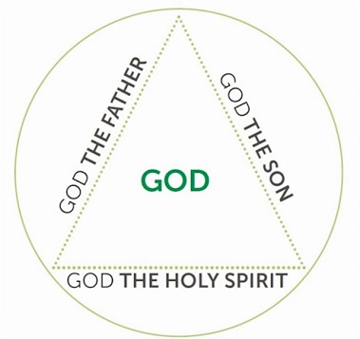
If we do not believe that the Holy Spirit as a divine person, then we rob Him of thw worship, faith, love and surrender that are due to Him. He is holy, and can be grieved when we sin. We need to treat the Holy Spirit with reverence and awe.
Therefore go and make disciples of all nations, baptizing them in the name of the Father and of the Son and of the Holy Spirit … (Matthew 28:19)

The Holy Spirit is the third person of the trinity – co-equal in power, substance and glory though the Holy Spirit voluntarily subordinates himself to God the Father and God the Son.
We need to hold the trinity in symmetry and balance in the understanding of who God is. We must not be lopsided and over / under emphasize what is revealed in Scripture. We need to have the same kind of adoration with God the Father, the Son and the Holy Spirit.

The Holy Spirit is actively as work today
But very truly I tell you, it is for your good that I am going away. Unless I go away, the Advocate will not come to you; but if I go, I will send him to you. (John 16:7)
We can have access into the presence of God. He lives in the body of Christ called the church, and He lives in us. The Holy Spirit is in our hearts.
He is active in 3 things:

Divine creation
The Spirit of God has made me; the breath of the Almighty gives me life. (Job 33:4)
The Holy Spirit sustains and regenerates us into a new person in Christ. He unites the people of God into one body, with Christ as the head. The Holy Spirit gives us skills, intellect and artistry. He is the creative side of God. He can provide us with designs and ideas that are unique.

Divine revelation
No one comes to the Father except through what has been revealed to him or her. The Holy Spirit draws them to the Father. He convicts people of their sin, judgement and the need for righteousness.
He enlightens our minds and sanctifies us to be more Christlike.

… these are the things God has revealed to us by his Spirit. The Spirit searches all things, even the deep things of God. (1 Corinthians 2:10)
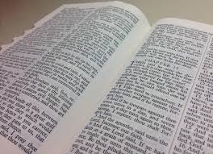
All Scripture is God-breathed and is useful for teaching, rebuking, correcting and training in righteousness, so that the servant of God may be thoroughly equipped for every good work. (2 Timothy 3:16-17)

The Bible guards us against any counterfeit voice, because the Holy Spirit will never contradict the book He wrote. The more we know the bible, the more familiar we are familiar to the voice of the Holy Spirit.

Divine empowerment
In the Old Testament, the Holy Spirit empowered specific individuals for ministries that serve God’s purpose.
In the New Testament, through the new covenant that we are living in, the Holy Spirit is poured out on all believers. The Holy Spirit empowers the church with the office of apostles, prophets, evangelists, pastors, and teachers. Their roles are to equip the saints (all of us) for the works of ministry.
The Holy Spirit will equip us with suitable gifts in order for us to fulfill what God has directed us to do for His kingdom. Without the Holy Spirit, we would be exhausted. With Him, we can experience the change and holiness that we long for.

Implications
- Keep surrendering daily to the Spirit’ control
Do not pray for “more of you, Holy Spirit,” because God has given all. It is about us living a life of repentance, yielding more to Him so that He can have more of us. We have to pray and ask for forgiveness when we have sinned because sin can be hindrance in our lives to God.
- Keep obeying
We need to obedient to what we have read from the Word of God and heard from His voice.
We need to put what we have known into practice so that we can change the way we live our lives. Start small, then move towards bigger things.
- Keep in step
Since we live by the Spirit, let us keep in step with the Spirit. (Galatians 5:25)

Do not go ahead of Him. Be conscious and intentional in walking with God. Get Him involved in your life. Do not neglect Him. It is not about us asking Him to join us in what we want to do or after we have made plans. Rather, ask Him from the beginning what He is doing and partner Him there.

The Holy Spirit is in the business of drawing people to Christ. He is with anyone, anywhere, at any time. He already knows our needs or the conditions of our hearts even before we tell Him. When we pray, we are expressing a desire and it may also open up our hearts to Him and what He wants to do in our lives.
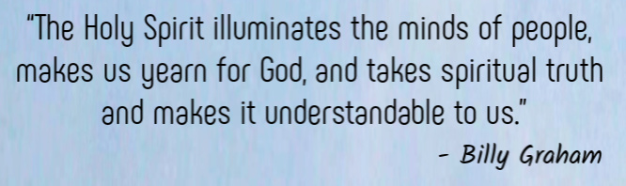

Sermon summary contributed by Wendy ML Tan

