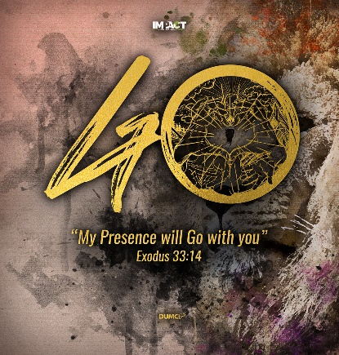
Pentecost: A Mighty Visitation from Heaven
Pastor Dato' Dr Daniel Ho
‘In the last days, God says, I will pour out my Spirit on all people. Your sons and daughters will prophesy, your young men will see visions, your old men will dream dreams. Even on my servants, both men and women, I will pour out my Spirit in those days, and they will prophesy. I will show wonders in the heavens above and signs on the earth below, blood and fire and billows of smoke. The sun will be turned to darkness and the moon to blood before the coming of the great and glorious day of the Lord. And everyone who calls on the name of the Lord will be saved.’ (Acts 2:17-21)

Introduction
The world is shook by the coronavirus pandemic. Jobs are lost. Companies closed. However, there is an event that is more important and more significant than COVID 19. It has influenced and impacted more people. It is the Pentecost. Pentecost was prophesied 800 years before it happened.

The Trinity of God consists of the Father, the Son and the Holy Spirit. They may have a form of spirituality and religiosity but lack power in their walk with God.
BIG IDEA: The Holy Spirit.

Prophetic occasion (Acts 1:4, 5)
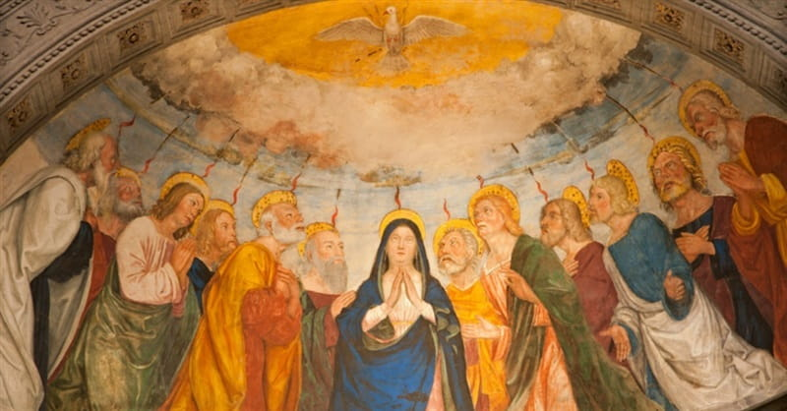
On one occasion, while he was eating with them, he gave them this command: “Do not leave Jerusalem, but wait for the gift my Father promised, which you have heard me speak about. For John baptized with water, but in a few days you will be baptized with the Holy Spirit.” (Acts 1:4, 5)

That occasion will be so unusual and radical that these disciples will never be the same again

It is to do with the coming of the Holy Spirit (Acts 1:8).

And do not grieve the Holy Spirit of God, with whom you were sealed for the day of redemption. (Ephesians 4:30)

Evan Roberts brought a great spiritual awakening to Wales in the Welsh Revival. He spent three months during which he received a 4-hour visitation from the Lord every day.

He has this to say, “I believe the world is upon the threshold of a great revival, and I pray that I may be allowed to help bring this about. I beseech all those who confess Christ to ask Him today, upon their knees, if He has not some work for them to do now. He will lead them all as He has led us. He will make them pillars of smoke by day and pillars of fire by night to guide all men to Him.”

But they are to wait for 10 days before the visitation of the Holy Spirit. Once the holy spirit come in us, our lives will never be the same again.

I believe God is preparing us for something amazing to come
Evan Roberts was awakened by the Holy Spirit every morning at 1:00 am for three months . God was preparing for him. He prayed God that will bring 100,000 souls to Christ. He said
We should come to God and do the same. Evan Roberts was 26 he burst into the scene.

Pentecost outpouring (Acts 2:1-4)
When the day of Pentecost came, they were all together in one place. Suddenly a sound like the blowing of a violent wind came from heaven and filled the whole house where they were sitting. They saw what seemed to be tongues of fire that separated and came to rest on each of them. All of them were filled with the Holy Spirit and began to speak in other tongues as the Spirit enabled them. (Acts 2:1-4)

Holy Spirit was poured out and the believers spoke in tongues (Acts 2:5, 6)
Now there were staying in Jerusalem God-fearing Jews from every nation under heaven. When they heard this sound, a crowd came together in bewilderment, because each one heard their own language being spoken. (Acts 2:5, 6)
There were people from many nations gathered in Jerusalem. They heard about His presence, power and the mighty acts He is going to perform in their own native tongue.

Under the anointing of the Holy Spirit Peter preached with incredible power (Acts 2:37-41)
When the people heard this, they were cut to the heart and said to Peter and the other apostles, “Brothers, what shall we do?” Peter replied, “Repent and be baptized, every one of you, in the name of Jesus Christ for the forgiveness of your sins. And you will receive the gift of the Holy Spirit. The promise is for you and your children and for all who are far off—for all whom the Lord our God will call.” With many other words he warned them; and he pleaded with them, “Save yourselves from this corrupt generation.” Those who accepted his message were baptized, and about three thousand were added to their number that day. (Acts 2:37-41)

It is to do with the coming of the Holy Spirit (Acts 1:8)

And do not grieve the Holy Spirit of God, with whom you were sealed for the day of redemption. (Ephesians 4:30)

Many thought they were drunk but Peter explained and challenged them. 3000 were added on that day. During the Welsh revival, David Lloyd George, who was the Welsh MP and lather the British PM said that “It (Welsh revival) is certainly the most remarkable spiritual movement this generation has witnessed. It seems to be rocking Welsh life like a great earthquake.”
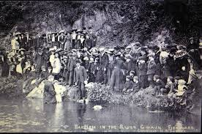
In 1904 to 1905 the Welsh revival changed the landscape of Wales. No one drank in pubs anymore. There were not interested to go to cinemas and football games anymore. The coal miners changed their own vulgar language and spoke politely even to donkeys. They had to retrain the donkeys. From Wales, it spread all across the world. The famous Azusa Revival in California that spawned the Pentecost Movement can be traced to the Welsh revival.

The Pentecost outcome (Acts 4)

Great Unity (Acts 4:32a)
All the believers were one in heart and mind. No one claimed that any of their possessions was their own, but they shared everything they had. (Acts 4:32)

There was oneness and resonance in everything that they do. The elders of DUMC has always been in unity since DUMC started.

Great Sharing (Acts 4:32b)
All the believers were one in heart and mind. No one claimed that any of their possessions was their own, but they shared everything they had. (Acts 4:32)

We must share beyond the church especially since COVID 19. The B40 and immigrants are really suffering for food. DUMC has been a blessing in providing food and paying rental to those in the B40 group.

Great Power (Acts 4:33a)
With great power the apostles continued to testify to the resurrection of the Lord Jesus. And God’s grace was so powerfully at work in them all (Acts 4:33)
Miracles, signs, and wonders were prominent in the early church. Healing. deliverance, conversion and salvation marked the early church and we pray they will will continue to mark of the churches today.

Much Grace (Acts 4:33b)
With great power the apostles continued to testify to the resurrection of the Lord Jesus. And God’s grace was so powerfully at work in them all (Acts 4:33)
Unusual favour was upon the people of God. They experience favour from all peoples of the world, even those not in the faith. As much as we bless others, we will in turn enjoy much grace and favours from God in a wonderful manner.

Great Increase (Acts 6:7; Acts 8:4)
So the word of God spread. The number of disciples in Jerusalem increased rapidly, and a large number of priests became obedient to the faith. (Acts 6:7)
The priests who practised Judaism began to accept Christ and follow Jesus. With this pandemic, we must reorder and prioritize our lives by putting God first.
Those who had been scattered preached the word wherever they went. (Acts 8:4)
Since Stephen was martyred, the people were scattered but they continued preaching the word of God. We should reach out, share the good news and be a good witness to others. As we do this together, Malaysia will never be the same again.

Great Joy (Acts 8:8)
So there was great joy in that city. (Acts 8:8)
Philip preached the gospel in Samaria. It rocked the city of Samaria and there was joy. As the gospel penetrated, people will encounter God and have great joy and grace of God.

Testimony
Tan Boon was the longest admitted patient in Sungai Buloh hospital. He was in septic shock and was in coma for 16 days. The family had strong support from the church. Upon that, all the organs failed and they put a tube at his neck. During a zoom prayer Zechariah 3:3-4 was released.
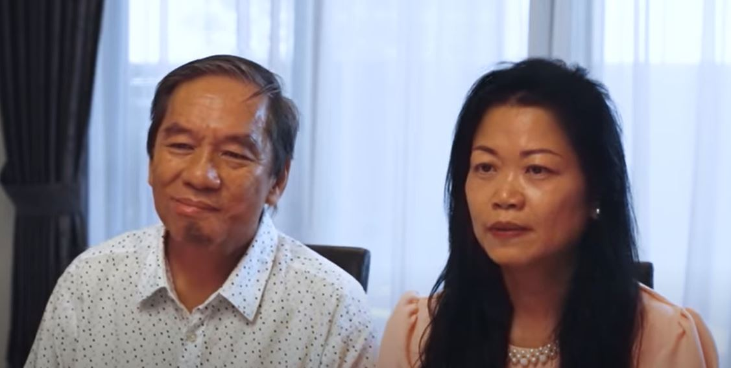
Now Joshua was dressed in filthy clothes as he stood before the angel. The angel said to those who were standing before him, “Take off his filthy clothes.” Then he said to Joshua, “See, I have taken away your sin, and I will put fine garments on you.” (Zechariah 3:3-4)
On 02 April 2020, Tan Boon recovered and was responding. During the coma Tan Boon had a vision about a train which passed through the furnace like Daniel. On the next day, the ventilator was removed and he was recovering. The ventilators affected his speech and food intake. He continued to recover. On 17 April 2020, he spoke to his wife. In 01 May 2020, he got back his IPhone and IPad. God snatched him from the face of death. The Bangsar cell prayed daily for more than 50 days continuously. Nothing is impossible with God.
Tan Boon learned that money is not everything in life. God’s word gives life to all hopelessness. God has given him a second chance on life. Tan boon wants to make his life count for Jesus.

Conclusion
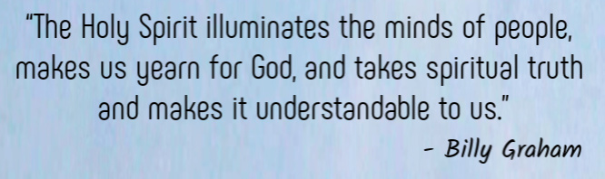
May God continue to rise your faith to a new level. May we continue to pray and desire to revival in our city.

Sermon summary contributed by Abbey Thangiah

