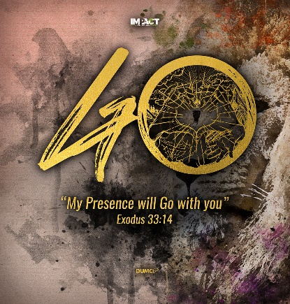
Apostles’ Creed VII: The Church
Ephesians 3:7-11
1 Peter 2:9
Pastor Mike Ngui

I became a servant of this gospel by the gift of God’s grace given me through the working of his power. Although I am less than the least of all the Lord’s people, this grace was given me: to preach to the Gentiles the boundless riches of Christ, and to make plain to everyone the administration of this mystery, which for ages past was kept hidden in God, who created all things. His intent was that now, through the church, the manifold wisdom of God should be made known to the rulers and authorities in the heavenly realms, according to his eternal purpose that he accomplished in Christ Jesus our Lord. (Ephesians 3:7-11)

But you are a chosen people, a royal priesthood, a holy nation, God’s special possession, that you may declare the praises of him who called you out of darkness into his wonderful light. (1 Peter 2:9)

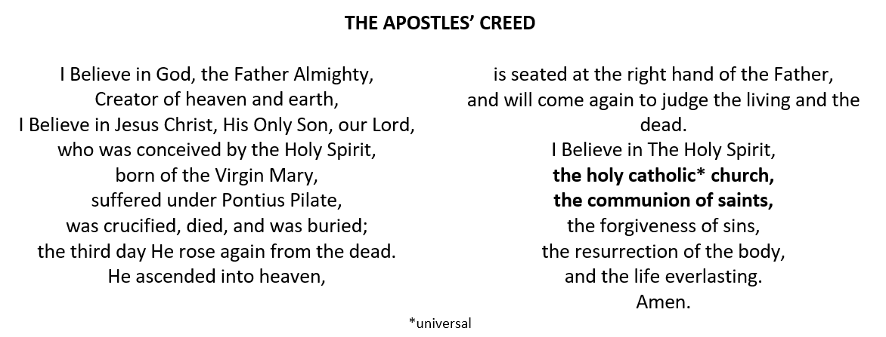
BIG IDEA:
Church: God’s gym, to become Christlike.

Introduction
The Church, in the Apostles’ Creed, is Holy, global, and universal through ages, and is also local and in the present. As such, the Church is instrumental and central in God’s plans.

No one can have God for his Father, who does not have the Church for his mother. - St Cyprian

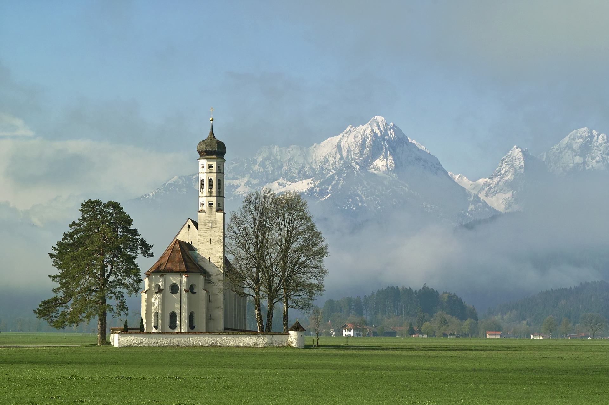
The Church is Holy
“I believe in … the holy catholic Church”

The new humanity beginning with Christ
The Church is where the new humanity begins, and this humanity begins with Christ. We, as the new humanity, is to be holy and Christlike.

Consequently, you are no longer foreigners and strangers, but fellow citizens with God’s people and also members of his household, built on the foundation of the apostles and prophets, with Christ Jesus himself as the chief cornerstone. In him the whole building is joined together and rises to become a holy temple in the Lord. And in him you too are being built together to become a dwelling in which God lives by his Spirit. (Ephesians 2: 19-22)

Therefore, if anyone is in Christ, the new creation has come: the old has gone, the new is here!
(2 Corinthians 5:17)

For if a man is in Christ he becomes a new person altogether—the past is finished and gone, everything has become fresh and new. (J B Phillips)

A people similar yet radically different
As a normal human being, we can all get sick and tired. We share similar needs, struggles and pains as well. Yet in this all, we are radically different as God’s chosen people.

But you are a chosen people, a royal priesthood, a holy nation, God’s special possession, that you may declare the praises of him who called you out of darkness into his wonderful light.
(1 Peter 2:9)

We have been set apart, with a purpose to magnify God. We are no longer the people we once were. We now have a new path of life, with a difference in attitude and orientation.

no longer a slave, but God’s child … also an heir (Galatians 4:7)

no longer live as the Gentiles do, in the futility of their thinking (Ephesians 4:17)

steal no longer, but must work .. to share (Ephesians 4:28)

With a new attitude and orientation, there will be implications in the choices we make and how we treat others (moral implications). These are evidence of our new humanity.
Therefore, as God’s chosen people, holy and dearly loved, clothe yourselves with compassion, kindness, humility, gentleness and patience. Bear with each other and forgive one another if any of you has a grievance against someone. Forgive as the Lord forgave you. And over all these virtues put on love, which binds them all together in perfect unity. (Colossians 3:12-14)

A people with a purpose beyond themselves
Clothed with new humanity, we are people with a purpose and mission to make things different. The difference that we bring is a beautiful difference that attracts people.

The glory of the gospel is that when the church is absolutely different from the world, she invariably attracts it. (Martyn Lloyd-Jones)

The Church is global, universal through the ages
“I believe in … the holy catholic Church”
catholic ~ universal

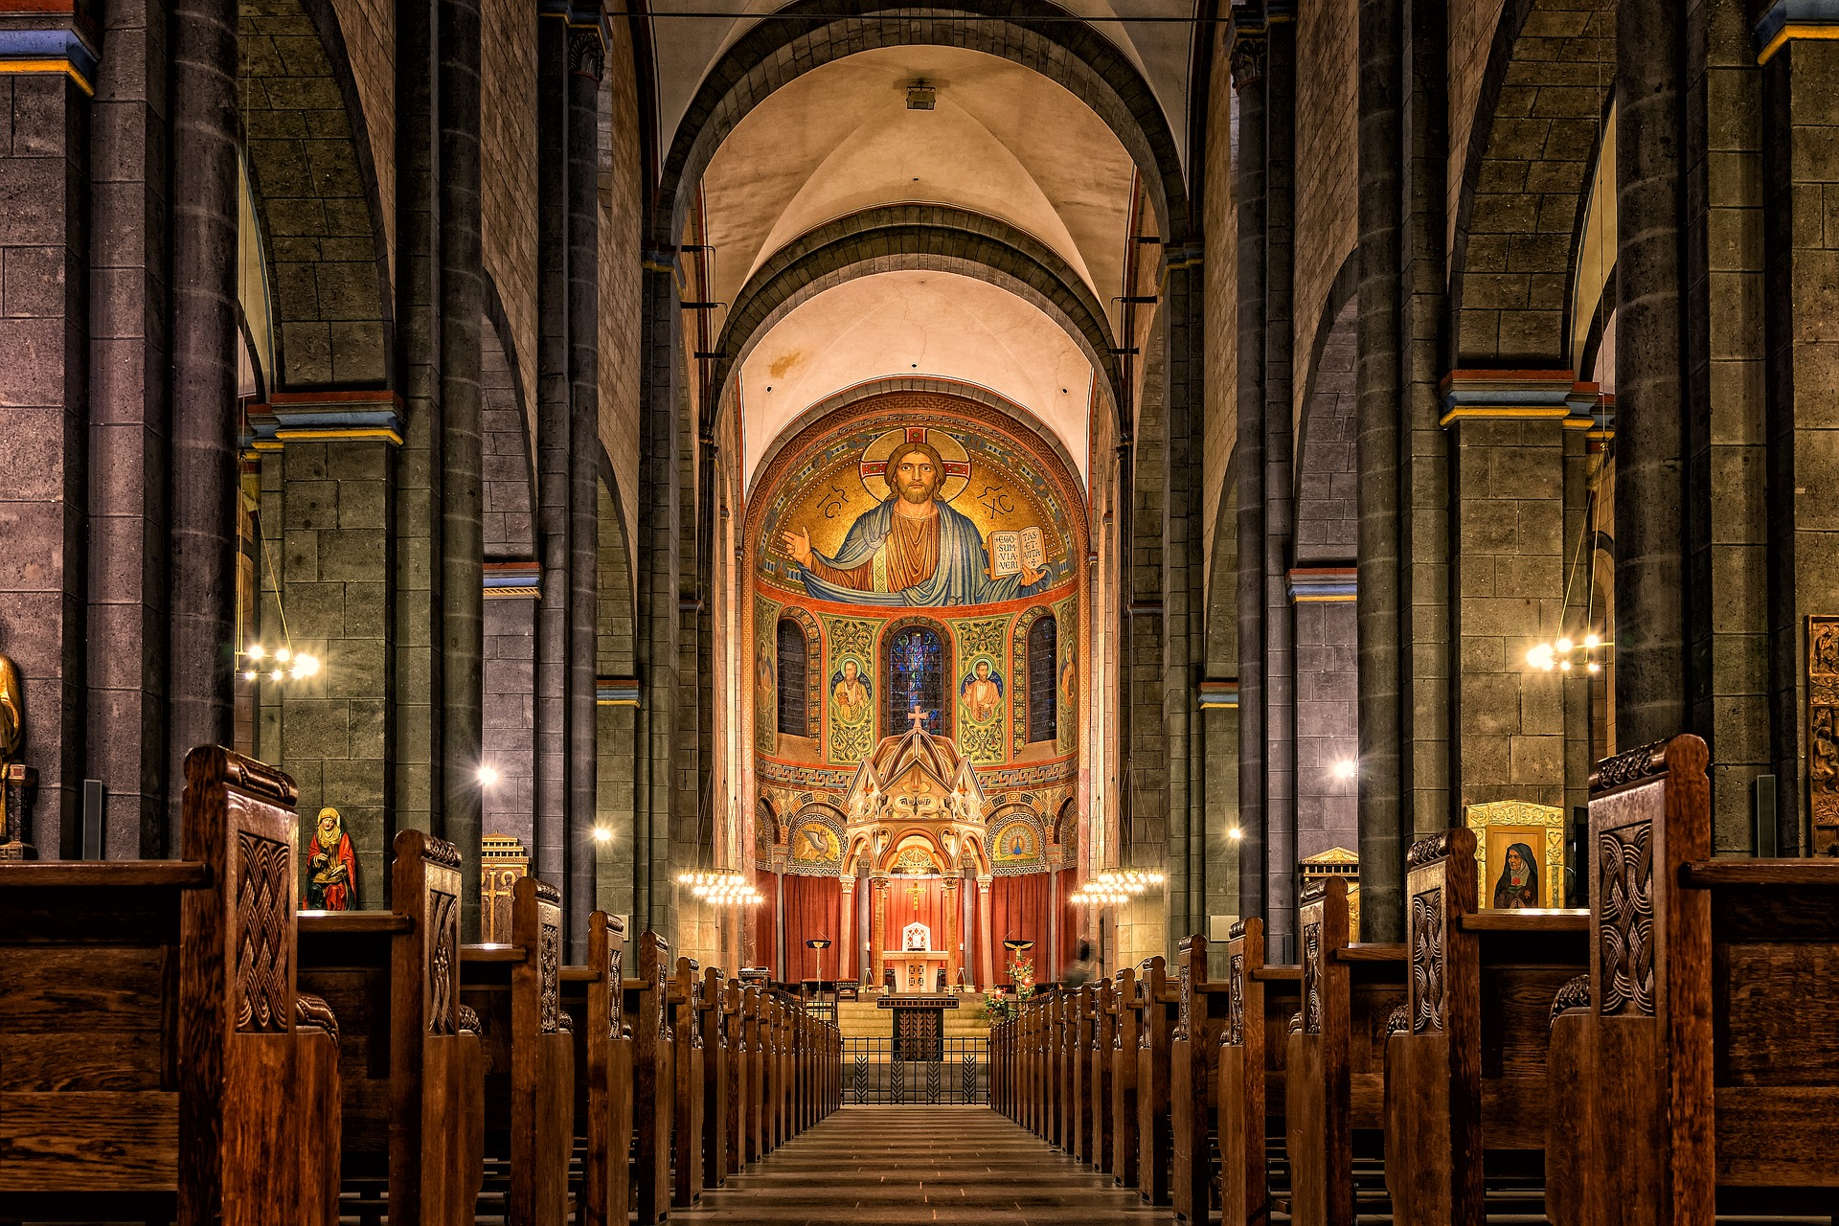
A body corporate, around the world, across the ages
History will reveal that the Church can exist in many different regions (Judea, Galilee, Samaria) and gathered in many homes, yet it is still a single Church. And Jesus is the head of this Church that spans over centuries and will remain a global church until Jesus returns.

Then the church throughout Judea, Galilee and Samaria enjoyed a time of peace and was strengthened. Living in the fear of the Lord and encouraged by the Holy Spirit, it increased in numbers. (Acts 9:31)

And God placed all things under his feet and appointed him to be head over everything for the church, which is his body, the fullness of him who fills everything in every way. (Ephesians 1:22-23)

Now to him who is able to do immeasurably more than all we ask or imagine, according to his power that is at work within us, to him be glory in the church and in Christ Jesus throughout all generations, for ever and ever! Amen. (Ephesians 3:20,21)

A body with a diversity of understanding
There is only one Church, yet there are many denominations. But it is the same God that is moving powerfully amongst His people. God does not discriminate. Peter in Acts 11, described how God poured out His spirit to the Gentiles. Paul and Barnabas in Acts 15, have reported that God did not discriminate between Gentiles, and has given them the Holy Spirit.

A body in diverse settings
God expects us to work with one another to comprehend His work. We need to understand our differences, to help each other understand God better. Churches from different denominations, have different beliefs and their own understanding. Paul and Barnabas were sent to Antioch (Acts 15) to report on the conversion of Gentiles. They wanted to know what to do with the Gentile Christians and each has their own understanding. What is critical is that the difference in understanding should not overshadow our unity.
one of you says, ‘I follow Paul’; another, ‘I follow Apollos’; another, ‘I follow Cephas’; still another, ‘I follow Christ.’ Is Christ divided? (1 Cor 1:12,13a)

The Church is also local and in the present
“I believe in … the communion of saints”

The only church that we can experience is the local church, not the global church.

The local church is the Church in ‘flesh and blood’
The local church is where we experience and engage with one another. Our relationships with one another and each other, revolves around unity, love and humility. In our local church:
- We accept one another (Romans 15:7)
- We bear with and forgive one another (Colossians 3:13)
- We bear one another’s burdens (Galatians 6:2)
- We do not complain against one another (James 4:11, 5:9)

Community living is one that builds us to be more Christlike. As we become involved and engaged with the local church community, it teaches us how to live with one another. Tim Keller addressed community living to the millennial.

You are the generation most afraid of real community because it inevitably limits freedom and choice. Get over your fear. - Tim Keller

Through living with the community (church), we learn the limits to our freedom and choice. We are not free to hurt others, harbor wrath or ill feelings, complain about others, or to push our opinion through at the expense of others. We learn to become more Christlike towards one another.

The local church is God’s gym for building the Body of Christ
The end goal for the body of Christ is to have the maturity in Christ Jesus. We can develop this maturity within our local church and in our cell groups, as we live with one another, we bear with one another, and we journey on with one another.

So Christ himself gave the apostles, the prophets, the evangelists, the pastors and teachers, to equip his people for works of service, so that the body of Christ may be built up until we all reach unity in the faith and in the knowledge of the Son of God and become mature, attaining to the whole measure of the fullness of Christ. (Ephesians 4:11-13)

Therefore, be a part of the local church, to engage in the learning relationships so that we can be transformed. The Church and cell group can be messy at times due to the dynamics of the human society, but living with one another and bearing with one another, is where we “workout” to be more Christlike. This is also where we get the opportunity to put all our bible study, quiet time and prayers into action/practice. They help make us to be more Christ-like.
I became a servant of this gospel by the gift of God’s grace given me through the working of his power. Although I am less than the least of all the Lord’s people, this grace was given me: to preach to the Gentiles the boundless riches of Christ, and to make plain to everyone the administration of this mystery, which for ages past was kept hidden in God, who created all things. His intent was that now, through the church, the manifold wisdom of God should be made known to the rulers and authorities in the heavenly realms, according to his eternal purpose that he accomplished in Christ Jesus our Lord. (Ephesians 3:7-11)

Conclusion
In short, the church, as a gym, is not a comfortable place. It is where we workout, meet resistance, and push ourselves to go beyond so that we can be better. The local church is the place for Christ followers to be “muscle-building” to become more Christlike. And through our local church, show that reconciliation is possible by the way we live.

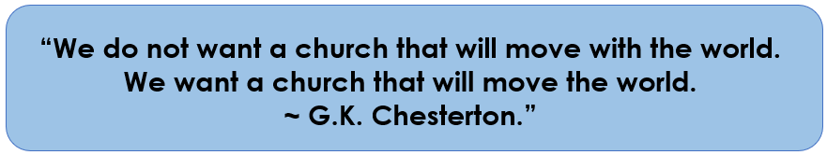

Sermon summary contributed by Adeline Ting.

