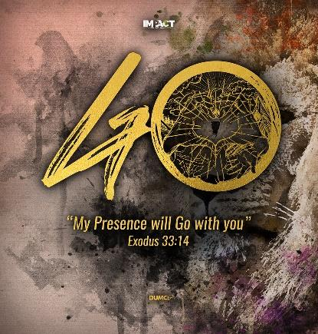
Impacting Family: Turning hearts of the fathers to their children
(Malachi 4: 5-6)
Jason Wong

See, I will send the prophet Elijah to you before that great and dreadful day of the Lord comes. He will turn the hearts of the parents to their children, and the hearts of the children to their parents; or else I will come and strike the land with total destruction. (Malachi 4:5-6)

Introduction
Children are important to God. They are precious in His eyes. Each child has a destiny, a calling, and a purpose. Parents are entrusted by God to nurture their children, to speak life into their children and call out their destiny. Sadly, parents sometimes fail to value their children as how God intended. Their worth is based on their achievements-exam marks and grades. As a result, families become materially rich, but relationally poor.

This relationship reflects the brokenness in the family. A broken family can have many subsequent implications, with children bearing the consequences. And, the root of this issue is the absence of the father (fatherlessness). The hearts of fathers are turned away from their children. Without a father (father figure, spiritual father), some of the children grow up to become the last, the lost and the least, with repercussions to families, communities and nation. Fatherlessness is a pressing issue that needs God’s intervention. God refers us to Elijah on lessons to become effective fathers.

Elijah and Elisha – imparting double portion to the next generation

2 Kings 2:9
Elisha has asked to inherit a double portion of Elijah’s spirit. This not only means Elisha will have double the blessing, but also that the blessings will be passed to him (next-generation) as inheritance. This is a significant understanding, that when blessings and good things from fathers are passed to their children, they are double the portion! Their children will be empowered and equipped with greater blessings in all that they do. With double blessings, amazing work can be done, which may lead to transformed nations.

But, sadly, generations after generations, there are fathers that abandon and abuse their children. The abuse, abandonment, wickedness and wrongful ways, passes to the next generation in double portions as well. The children grow up to become much worse than their fathers, leading to poor morality and social decadence.

Therefore, fathers need to be aware of what is passed on and inherited by their children. Fathers can either bless or curse their children and the generations thereafter.

Elijah and the widow and her son – father the fatherless

1 Kings 17:1-24
God commanded Elijah to travel to Zarephath, where he met a widow. Elijah not only stayed and provided for the widow and her son, but also resurrected the son when he was physically dead. God, in His mercy, sent Elijah to father the fatherless. Elijah came to not only resurrect the physical body of the widow’s son, but to also resurrect his destiny and purpose.

This is a profound message to all. God does not forget children without fathers. They can be guided by father figures or spiritual fathers onto the right path. By having father figures or spiritual fathers, the fatherless are protected and valued, align with God’s purpose for each child.

Elijah, Ahab and Jezebel– confronting spiritual authorities of the land

1 Kings 16:31-34, 18:15-18
Elijah confronted Ahab on his wickedness as a ruler and his weakness in dealing with his wife Jezebel. Jezebel worshipped Baal, and influenced Ahab to turn from God. Their ways were deeply faulted and Elijah was the only one bold enough to confront them.

Men, as head of the family, must wilfully honour God by honouring their marriage and family. They need to protect their family from negative influences and poor judgements. How is your marriage altar? And your family altar?

Elijah and the twelve stones– rebuilding broken altars

1 Kings 18:30-31
Elijah took twelve stones, each representing the tribes from Jacob, rebuilding the altar in the name of the Lord. Similarly, fathers can rebuild altars that have been broken (i.e. marriage altar, family altar), to protect the family and make things right. Fathers do not have to go through this alone. When earthly fathers pray, the heavenly Father will move. He will give the earthly fathers abundant love and forgiveness. All that is received shall be given and passed on to the next generation.

Conclusion
It is clear that God’s desire is for children to be protected, valued, and nurtured to fulfil their destiny. And, God has intended to achieve this through fathers in families. Fathers (including spiritual fathers) have a big role in bringing up children and their family. They are spiritual authorities on earth, heads of their family who can change their children’s lives. And this they can do by turning their hearts towards their children and to look to God, our Heavenly Father who never fails us.

Sermon summary contributed by Adeline Ting.

