Missions Weekend – 29.4%: Without the Bread of Life (Matthew 21:12-13)
Beram Kumar

Jesus entered the temple courts and drove out all who were buying and selling there. He overturned the tables of the money changers and the benches of those selling doves. “It is written,” he said to them, “‘My house will be called a house of prayer,’ but you are making it ‘a den of robbers.’” (Matthew 21:12-13)

Introduction

The Scripture passage for the sermon reveals a side of Jesus we never would have imagined He could be. Jesus was upset not because the people were buying and trading, but he was upset because they had missed something important. They had forgotten the reason for which the house of God had been set up. God has said that His house will be a house of prayer for the nations, but the people were so busy buying and trading in the temple courts that they had forgotten this. They had forgotten why God has blessed them.

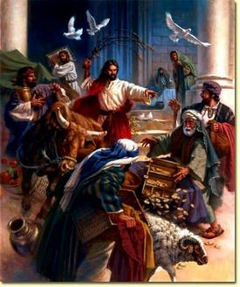
The buying and selling took place in the large outer court of the Gentiles, which covered several acres. The Court of the Gentiles was used by Gentiles to worship (King Solomon also opened the Temple to non-Jews). The Gentiles saw that the Jewish pilgrims coming to the Passover needed animals that met the Jewish ritual requirements for sacrifice, therefore Gentile vendors set up their animal pens and money tables in the court of the Gentiles.

Their intentions for buying and trading animals may be to meet the Jewish ritual requirements for sacrifice, to fulfil the Jewish religious rituals. However, they were so busy even with their own religious rituals that they had forgotten the true purpose of the outer court of the temple, which was meant for the prayer for the nations. Jesus was angry because there was no place for prayer for the nations in the house of God. It is so easy to get caught up and tangled up in so many things that we forget God, including being caught up in religious rituals!

At the time when people built the tower of Babel, they thought they could find God, but in actual fact it is God who finds us. The whole story of the Bible was about God reaching out to us and seeking us out. The people created religion by thinking they could find God. Therefore, God scattered them into different languages and different places all over the earth. We call it judgement, but it is actually God’s compassion. From one nation, God raised up Abraham. He chose one so that He can bless the other nations through that one. God’s purpose in choosing Israel was so that they can be a blessing to the nations. However, they enjoyed their status so much that they forgot why they are chosen – to bless others.

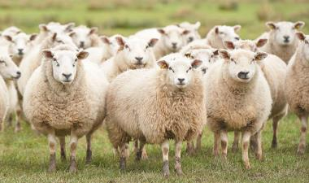
- Facts about Sheep

They do not know how to stop eating.
Sheep can eat and eat continuously until they become round. They stumble and their legs goes up. The weight of their eating can press against the lungs, and they can suffocate and die.

They can be driven or led
A butcher drives a sheep from behind with a stick, hitting it to get it moving. A shepherd leads the sheep from the front.

The Covenant

God had blessed Israel many times. But the blessings have overtaken the Bless-er. The story of the Old Testament was a cycle of God blessing Israel, Israel forgetting God, they were led into captive, they cry out to God, God saves them and blesses them again, but they forget Him again, they were taken into captive, God saves them and blesses them again and the cycle goes on.

The Israelites were chosen to be a great nation. They were saved, rescued, and blessed, because of the covenant God made with Abraham. That is the first part of the covenant. The second part of the covenant was so that through them, the nations will be blessed. They had to be reminded that when they are blessed and well fed and taken care of, they are not to forget God, or the second part of the covenant. God didn’t choose them because they were special or the most beautiful. God chose them because of the covenant He had made.

He says, “Be still, and know that I am God; I will be exalted among the nations, I will be exalted in the earth.” (Psalm 46:10)

We are familiar with the first part of the verse in Psalm 46:10. However, it is the second part we do not give much attention to. We like to pick the part of Scripture which we like, which is beneficial to us, and ignore the part that requires us to play our part in obedience to God.

There is a beautiful story of redemption in the book of Hosea. Hosea redeemed Gomer, who was a prostitute. He took her in, married her and took care of her. However, it was not long before she ran away into the arms of strange men. She had become too familiar with Hosea’s love. God has redeemed us and took us in as His, yet we turn away from Him because we too have become familiar with His love and His blessings.

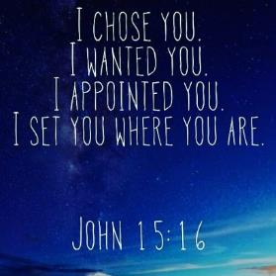
The covenant in the old has not changed, God will bless us and make us into a great nation, so that we can be a blessing to others. The covenant is the same covenant in the old that has been transferred to the new for the church. The covenant has not changed, the terms and conditions are still the same.

God did not love Israel above all the other nations. He loved all the other nations as much as he loved Israel, but he has chosen Israel for a special purpose. Likewise, He does not love us above the others, He loved the others as much as He loved us, but He has chosen us for a special purpose.

Places we thought impossible for the Gospel to reach are experiencing rapid growth in churches. Church growth in order of speed - Iran, Afghanistan, China and India.

The Story of Trouble

Pastor Beram shared a story about the time when he was in Indonesia on a mission trip, and God led him to reach out to a group of people in a village that was notorious for being very resistant to the Gospel, even to the point of murder. A boy was assigned to join his team, which he calls “Trouble”. Trouble was called as such because there is always trouble with him around.

Before the team was released to enter the village, they were told to walk around in the streets and pray silently in their hearts for God to bless the people in the village. At the end of the day, when everyone was supposed to gather at the rendezvous point after their trip around the village, they waited a long time for one team to return, and it was the team with Trouble in it.

Finally, two hours later when the team returned, Trouble ran up to them and shouted something about miracles happening. After the leaders had spoken with the team, they found out what happened. When Trouble and his team was asked by the village headman to explain who they were, Trouble blurted out that they were Christians. Realizing his blunder, Trouble babbled on, and finally he asked the village headman what they can do for him. The village headman told them he had a stroke, and Trouble offered to pray for him. While praying, the village headman suddenly shouted that he had been healed, and called out the other villages who were sick to be prayed for as well! Many miracles and healings took place in the village that day, and many in the village came to put their faith in Christ.

If God can use Trouble, He can use anyone. He can use you.

Conclusion

It’s not about you and me, it’s about God. It’s about His purpose, His desire, His plan, to be fulfilled on earth and in heaven.
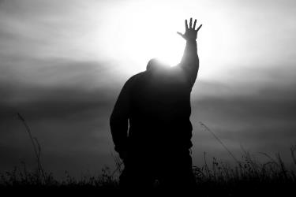
We are given the call to the Great Commission – God is not a butcher driving us, He is a shepherd leading us. If we honestly say “I want to be faithful to the covenant, I want to be a blessing to the nations.” God is able, if we say yes to Him, He will show us how and make a way, even when we do not know how. We just need to be willing.

There are no preconditions – God might not be asking you to be a missionary or send you to a remote place across the globe, but all you need to do is to be willing to answer the call to the Great Commission, the call to obedience, to give your life to Jesus.

Let go of the stuff that is causing you to stagger and stumble in your faith. For you are not totally in, and you are not totally out. You are being driven by the butcher. Leave the butcher and follow the shepherd.

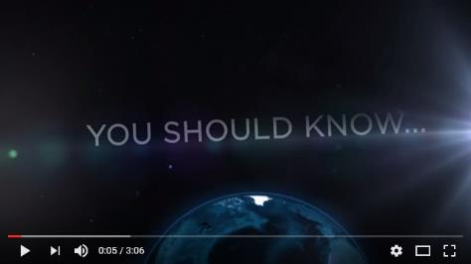
Click on the image to watch the YouTube video “You Should Know” – Missions to Unreached Peoples.

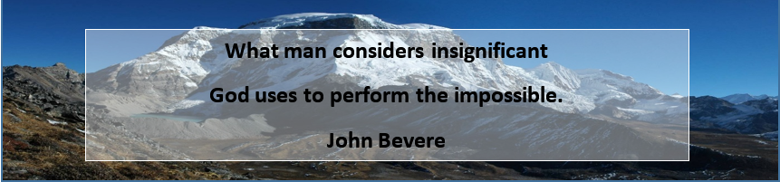
Sermon summary contributed by Anthea.
Prayer points contributed by Abbey.

Special #ServePeople announcement
DUMC has started the #ServePeople initiative, please visit the following website to get more information.
http://dumc.my/servepeople/

Be sure to get the 30-day #ServePeople Guide.
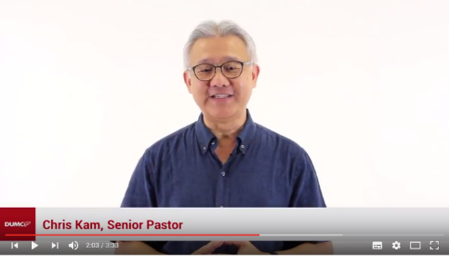
Click the image on the left to see the video.

SERMON: 29.4% Without the bread of life.
Pray:
- We will not be driven by the butcher but be drawn to the shepherd.
- We will not take Gods love for granted.
- God will open the way when we accept his call.
- God will prepare the hearts of the unbelievers and perform miracles through us.
- God will use us to be a blessing to the nations.
Jesus entered the temple courts and drove out all who were buying and selling there. He overturned the tables of the money changers and the benches of those selling doves. “It is written,” he said to them, “‘My house will be called a house of prayer,’ but you are making it ‘a den of robbers (Matthew 21:12-13)

MINISTRIES & EVENTS: Short Term Mission Trips
Vietnam July 20 – July 25
Myanmar August 25 – September 1
Sarawak Iban August 26 – September 3
Sarawak Penan August 27 – September 1

Pray:
- God will prepare the hearts of those who are ready to go.
- Spiritual covering for all the organizers and attendees of the event.
- God will raise the interest for the people on missions.
- For good time of fellowship and renewed passion for missions during the event.
“For this is what the Lord has commanded us: “‘I have made you a light for the Gentiles, that you may bring salvation to the ends of the earth (Acts 13:47)

Malaysia My Nation: Multi Cultural Malaysia
Several incidents have revealed some cracks in the harmonious living in Malaysia.
Pray:
- Politicians will not use multi culturalism just to win elections but put in real efforts to promote peaceful living among all Malaysia.
- We will not be discouraged but will do our part to make Malaysia a better place.
- God will use us as vessels to promote unity.
- Malaysians will not leave Malaysia because of racial reasons but be the example.
"How good and pleasant it is when God’s people live together in unity!" (Psalm 133:1)

A TRANSFORMED WORLD: Nigeria
ABUJA / LAGOS(Reuters) - Boko Haram militants have released 82 schoolgirls out of a group of more than 200 whom they kidnapped from the north-eastern town of Chibok in April 2014 in exchange for prisoners, the presidency said on Saturday. Switzerland and the International Committee of the Red Cross helped secure the 82 girls in "lengthy negotiations", the presidency said on its Twitter account. President Muhammadu Buhari will receive the girls on Sunday in the capital Abuja, it said, without saying how many Boko Haram suspects had been exchanged or disclosing other details.
Pray:
- Praise God for the released children.
- Protection for the schoolgirls who are still held captive.
- God will intervene miraculously and show his compassion on the schoolgirls and their family involved.
- Churches will play their role in the ongoing rescue efforts.
So do not fear, for I am with you; do not be dismayed, for I am your God. I will strengthen you and help you; I will uphold you with my righteous right hand. (Isaiah 41:10

