Following Christ = Making Disciples: The Demands of Discipleship
Pastor Alex Tan

Then Jesus said to his disciples, “Whoever wants to be my disciple must deny themselves and take up their cross and follow me. For whoever wants to save their life will lose it, but whoever loses their life for me will find it. (Matthew 16:24-25)
What is more, I consider everything a loss because of the surpassing worth of knowing Christ Jesus my Lord, for whose sake I have lost all things. I consider them garbage that I may gain Christ.
(Philippians 3:8)

Introduction
In scripture, Jesus sets down conditions to be fulfilled if “You’re truly my disciple” (John 13:34,35 and John 8:31) and “You cannot be my disciple” (Luke 14:26-27, 33). The conditions for “You’re truly my disciple” are straightforward to fulfil, but the conditions why someone cannot be a disciple unless they renounce everything is tricky and frankly hard to swallow. This begs the question: If Jesus were the Senior Pastor of this church today, would you still be here? Because the answer we give reveals the distance we now have towards discipleship in Christ.
The Big Idea:
The demands of discipleship are outrageous and outstanding.

Outrageous price
Becoming a Christian is akin to transitioning from a teenager into an adult. In our youth we are carefree and can do what we wanted, when we want to. As an adult, there are boundaries, responsibilities and constraints placed upon us. So it is with being a Christian – there are demands that come with being a Christian.
Just like how we cannot become a well-adjusted adult unless we truly “grow up” and confront what it means to be responsible for ourselves; If we do not confront and accept the cost of becoming a Christian, then we will not be able to grow into the fullness of a Christian life.

Matthew 16:24-25 reminds us that sacrifice is an essential part of what it means to be a follower of Christ. We must be prepared to pay a heavy price in following Christ. Jesus continues: “What good will it be for someone to gain the whole world, yet forfeit their soul?” (Matthew 16:26) This tells us to be mindful of the cares of God, and not be focused only on worldly cares.

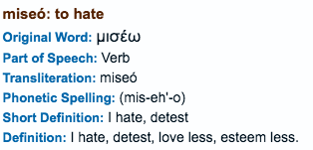
To put the outrageous price into perspective, the word in Greek “μισέω” that is translated as “hate” in Luke 14:26, is more accurately rendered as “to love less”. Therefore the passage does not exhort Christians to hate their family (which would contradict Jesus’ call to love one another); rather, it calls on us to love God more, because Jesus is of higher worth.

Outstanding prize
Why was Paul preoccupied with Christ, to the exclusion of all other things? How is sacrifice the better way? The problem we face in evaluating his statement is, we cannot make a judgement on whether it is worth following Christ unless we understand what we are receiving from Christ.

If there is one thing that all men have in common, it is that we are all on a journey towards death, and that we will encounter suffering in our journey.
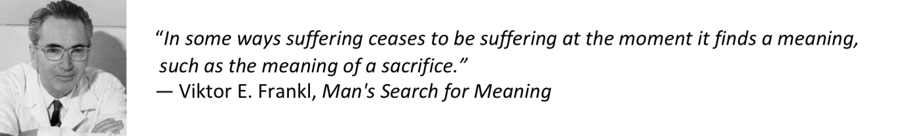
In light of this, it is worth considering the cost of following Christ – allowing Jesus to fill our life with meaning beyond what the world can make available to us. As Frank Viola says in his book Jesus Manifesto, “Being Jesus for the world does not mean that Christ has come to obliterate you. It rather means that Christ has come to complete you and to live His resurrection life through you.”

Conclusion
Let’s take time to reconsider what being a Christian or a follower of Christ means: to comprehend the outrageous price that is asked of us, then to appraise the outstanding prize of worth in this life, and the extension of what is to come in the future.
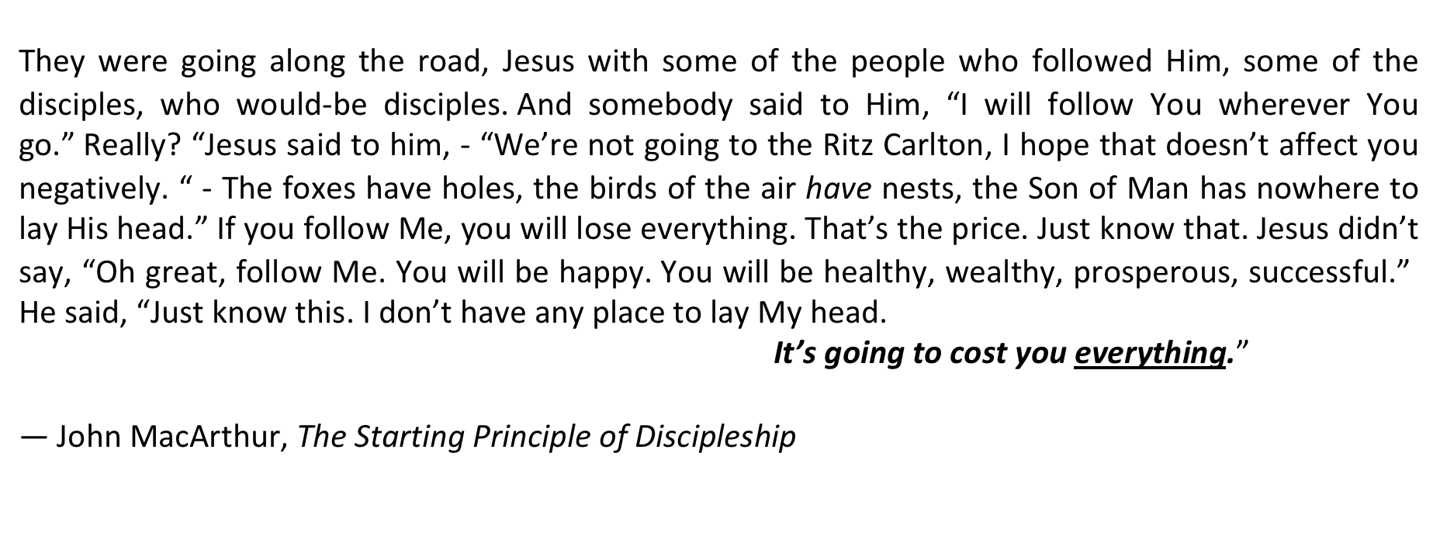

Our all-surpassing worth is in Christ – are we willing to pay the price to get the prize?

Sermon summary contributed by Adeliyn.
Prayer points contributed by Wendy ML.

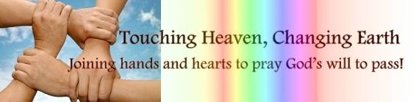

SERMON: Following Christ = Making Disciples: The Demands of Discipleship
Pray:
- We would love one another and abide in God’s words as we seek to be a true disciple of Christ.
- That we would learn to love God more than anything or anyone else in this world, by putting Christ first and make Him our all.
- That while we have our gifts and talents to achieve our dreams or ambitions, and when we become fruitful and more powerful, we will still remember who we are in Christ
- In our journey of life, we will learn to value the worth in denying ourselves, and allowing Christ to fill us.
- That we would appreciate, understand and seal in the demands of discipleship which comprises both the Outrageous Price and Outstanding Prize.
Then Jesus told his disciples, “If anyone would come after me, let him deny himself and take up his cross and follow me. For whoever would save his life will lose it, but whoever loses his life for my sake will find it.” (Matthew 16:24-25)

MINISTRIES & EVENTS: New Mummies Family Day
DUMC’s New Mummies Ministry is a community for both new mummies and mummies of young children. The ministry will be hosting a Family Day outing on 10 June 2017 at the Kepong Metropolitan Park.
Pray:
- Parents with young children will eagerly sign up for the event.
- There will be a good time of fellowship and bonding among the parents and children as they connect with one another and build friendships during the picnic, games and sports activities.
- God’s presence, love and faithfulness can be felt among all who attend.
- The weather will be pleasant and that there will be no glitches in all the activities planned for that morning.
Children are a heritage from the Lord, offspring a reward from him. Like arrows in the hands of a warrior are children born in one’s youth. Blessed is the man whose quiver is full of them. They will not be put to shame when they contend with their opponents in court. (Psalms 127:3-5)

MALAYSIA MY NATION: 14th General Election
There is a possibility that the 14th General Elections will be held soon.
Pray:
- More eligible citizens, especially the youth and young adults will heed the need and call to register as voters before the pending elections.
- As Christians, we would in time to come, play our role in either voting for the right candidates that will govern our district, state or nation or volunteering as polling / counting agents.
- Voters will intentionally make time and effort to avail on the election day.
- Voters will vote without any intimidations or coercion.
- There will be dedicated and non-corrupted candidates who will stand for the next general elections.
- Any corruption or scandals will be exposed so as not to jeopardize the proceedings of the elections.
When the righteous thrive, the people rejoice; when the wicked rule, the people groan. (Proverbs 29:2)

- A TRANSFORMED WORLD: Terrorist Attacks
Recently, a suicide bombing took place right after a concert in Manchester, UK, killing 22 - including teenagers and a child. Also, Islamic State militants took over Marawi City in Central Mindanao, Philippines - where dozens have been killed during clashes.
Pray:
- For God’s comfort and love among the families and friends who have lost their loved ones in the attacks.
- God’s people will reach out compassionately to the community around them, by giving a helping hand to those in need, be it in monetary terms, in kind or by a simple gesture of praying for one another.
- The relevant government and authorities may have the wisdom to handle the crises and deal with the terrorists efficiently and not be consumed by fear, failure nor fatality.
- The militants will encounter God and be convicted to lay down their weapons and stop the attacks on innocent people, especially the children.
- Christians will stand strong in their faith and persevere through this season of their lives.
Blessed are the peacemakers, for they will be called children of God. Blessed are those who are persecuted because of righteousness, for theirs is the kingdom of heaven. (Matthew 5:9-10)

