Listen 4: We All Can Build the Church
Senior Pastor Chris Kam
Now about the gifts of the Spirit, brothers and sisters, I do not want you to be uninformed. You know that when you were pagans, somehow or other you were influenced and led astray to mute idols. Therefore I want you to know that no one who is speaking by the Spirit of God says, “Jesus be cursed,” and no one can say, “Jesus is Lord,” except by the Holy Spirit. There are different kinds of gifts, but the same Spirit distributes them. There are different kinds of service, but the same Lord. 6 There are different kinds of working, but in all of them and in everyone it is the same God at work.
Now to each one the manifestation of the Spirit is given for the common good. To one there is given through the Spirit a message of wisdom, to another a message of knowledge by means of the same Spirit, to another faith by the same Spirit, to another gifts of healing by that one Spirit, to another miraculous powers, to another prophecy, to another distinguishing between spirits, to another speaking in different kinds of tongues, and to still another the interpretation of tongues. All these are the work of one and the same Spirit, and he distributes them to each one, just as he determines. Just as a body, though one, has many parts, but all its many parts form one body, so it is with Christ. For we were all baptized by one Spirit so as to form one body—whether Jews or Gentiles, slave or free—and we were all given the one Spirit to drink. Even so the body is not made up of one part but of many.
Now if the foot should say, “Because I am not a hand, I do not belong to the body,” it would not for that reason stop being part of the body. And if the ear should say, “Because I am not an eye, I do not belong to the body,” it would not for that reason stop being part of the body. If the whole body were an eye, where would the sense of hearing be? If the whole body were an ear, where would the sense of smell be? But in fact God has placed the parts in the body, every one of them, just as he wanted them to be. If they were all one part, where would the body be? As it is, there are many parts, but one body.
The eye cannot say to the hand, “I don’t need you!” And the head cannot say to the feet, “I don’t need you!” On the contrary, those parts of the body that seem to be weaker are indispensable, and the parts that we think are less honorable we treat with special honor. And the parts that are unpresentable are treated with special modesty, while our presentable parts need no special treatment. But God has put the body together, giving greater honor to the parts that lacked it, so that there should be no division in the body, but that its parts should have equal concern for each other. If one part suffers, every part suffers with it; if one part is honored, every part rejoices with it.
Now you are the body of Christ, and each one of you is a part of it. And God has placed in the church first of all apostles, second prophets, third teachers, then miracles, then gifts of healing, of helping, of guidance, and of different kinds of tongues. Are all apostles? Are all prophets? Are all teachers? Do all work miracles? Do all have gifts of healing? Do all speak in tongues? Do all interpret? Now eagerly desire the greater gifts. (1 Corinthians 12:1-31)

Introduction
To wrap up the the Listen series, Pastor Chris talked about the many spiritual gifts written by apostle Paul to the Corinthian church in 1 Corinthians 12. This was during the time where the church was facing many problems with the behaviour and practices of the people. One of the many problems was that the people were using their spiritual gifts for their own benefit - they were using it to make money and profit for themselves. This was when Paul decided to write a letter to the Corinthians, telling them how to live and reminding them about the purposes of their spiritual gifts. He reminds them that the foundation of how we live must be love, and that we ought to build one another up through love. Our spiritual gifts enable and empower us to do that; and that is how we are going to build up the church of Jesus Christ.
THE BIG IDEA: We All Can Build the Church

It is FREE
- How do we know this?
Charisma – Spiritual Gifts
If we break it down, the word ‘Charis’ refers to ‘Grace’, and the word ‘Ma’ refers to ‘Gift’. Therefore, Charisma would literally mean ‘Grace Gift’. The word ‘Grace’ alone means to be given ‘unmerited favour’, or ‘something you do not deserve’. Therefore, to say that something is both a ‘grace’ and a ‘gift’ is a double emphasis of something that really is FREE!
- So why is it free?
It is simply because God loves us. He wants to bless us and empower us with these gifts of His! However, we must EAGERLY desire it (1 Corinthians 14:1). These gifts are offered by God, but they only truly become ours when we eagerly ask for it and RECIEVE it from God.
- The story of Simon the Sorcerer
“When Simon saw that the Spirit was given at the laying on of the apostles’ hands, he offered them money and said, “Give me also this ability so that everyone on whom I lay my hands may receive the Holy Spirit.” Peter answered: “May your money perish with you, because you thought you could buy the gift of God with money! You have no part or share in this ministry, because your heart is not right before God.” (Acts 8:18-21)
In this passage, the Bible tells us that Simon the Sorcerer witnessed the great miracles Peter and the disciples were doing, and took interest in the spiritual gifts they had. So much so, that he tried to buy these gifts from Peter! Seeing the ignorance of the sorcerer, Peter rebuked him for trying to buy the Holy Spirit with money. Scripture tells us that we cannot buy these gifts with treasures and valuables, nor can we buy them with good deeds. There is absolutely nothing we can or cannot do to deserve the gifts of the Holy Spirit. God just chooses to give us these gifts because He simply loves us and wants us to have it. These gifts are free for us, but they were bought with an extremely high price – with is the life of Jesus Christ. It is because of Him that we have access to these gifts, and even access to our Father.
“There are different kinds of gifts, but the same Spirit distributes them. There are different kinds of service, but the same Lord. There are different kinds of working, but in all of them and in everyone it is the same God at work.” (1 Corinthians 12:4-6 NIV)
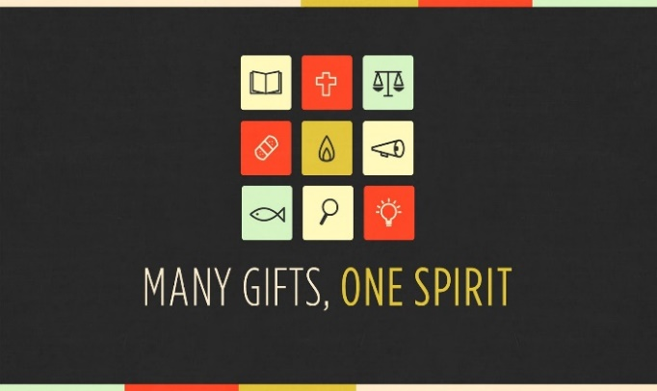
- The Giver – The Holy Trinity
The Holy Spirit distributes these gifts to us, and God gives us these gifts through the Holy Spirit.
- Energema
“Now there are varieties of gifts, but the same Spirit; and there are varieties of service, but the same Lord; and there are varieties of activities, but it is the same God who empowers them all in everyone.” (1 Corinthians 12:4-6 ESV Version)
In some versions, the word ‘workings’ is translated to ‘activities’ instead. When translated into Greek, the word ‘activities’ refer to energy. Pastor Chris encourages us to plug in our spiritual gifts into our ministry, and incorporate them in our serving. When this happens, we get our powerful results and we truly marvel at the great works of the Lord.

It is for ALL
- The gifts of the Spirit is for everyone.
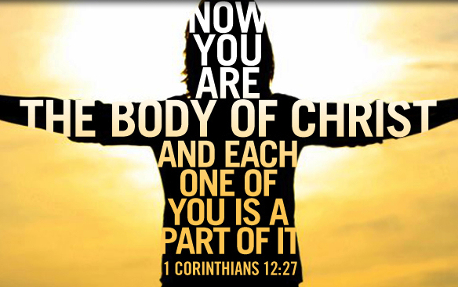
“But in fact God has placed the parts in the body, every one of them, just as he wanted them to be.” (1 Corinthians 12:18)
God never misses out anyone one of us. The gifts of the Spirit are given to every single person who recognizes God as Lord. It is not reserved for those who are smarter, nor is it kept from those who are less capable. No one is deprived of God’s gifts, neither is anyone more deserving of them than another person.
Everyone is as important in the ministry of God. Scripture says that the body cannot function without any of its parts. It needs the hands as much as it needs the legs; it needs the kidneys as much as it needs the brain. Similarly, the Church needs its members as much as it needs its pastors. It needs its workers as much as it needs its leaders. No one is short of the grace and love of God, and no one is short of the free gifts of God.
Pastor Chris also reminds us that we should not come to church with a ‘consumer mindset’ – to have everything revolve around you. We are easily strayed away to the attitude of having everything at our advantage; to have everything be of benefit to you. (‘what is in it for me?’; ‘how does this benefit me?’ etc.) Our spiritual gifts are given to us to empower ourselves as a person, but it is also to empower us in our ministry. These gifts are given to us to serve others and His kingdom. Pastor challenges us to pray for our cell groups before going for it this week, asking God for someone we can pray for and how He can use us in our cell groups. This is how we can exercise our gifts.
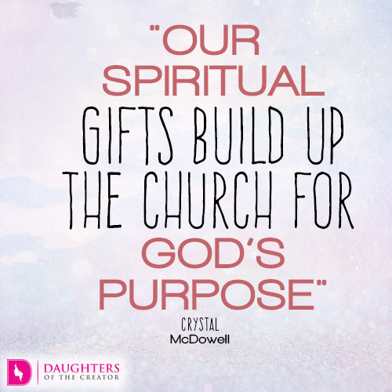

It is used to BUILD UP
“Now to each one the manifestation of the Spirit is given for the common good.” (1 Corinthians 12:7)
- The gifts of the Spirit is to be used for the common, greater good of His people.
To build others up, we must exercise our spiritual gifts. Paul says that the giving of these gifts to us is for us to build others in our community up. It is for us to encourage those who need strength, and for us to walk with those around us in wisdom and truth.

Conclusion
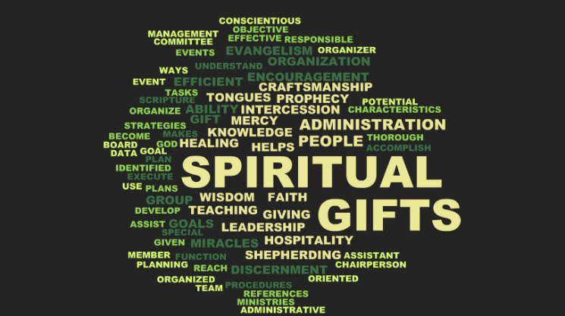
Paul starts of the letter by urging the Corinthians not be ignorant of the gifts of the Spirit. We need to be clear of the purposes of these spiritual gifts, and how we are to use them. We are called to His ministry and to do His work with the great aid of the Holy Spirit. Often times, it is taken for granted, and we begin to doubt ourselves and our capability to do His work. We begin having the mindset of a consumerism Christian – only coming to church every weekend for routine’s sake. We choose to remain where we are, and we become stagnant in our faith, choosing not to do anything more than just to be a church goer.
Do we realize the power of the Holy Spirit in us? Are we ignorant of what the Holy Spirit has to offer us? Let’s challenge ourselves today to take a step closer to God, and be more intentional and in plugging in our spiritual gifts in our ministry.

What is the Holy Spirit saying to you today?
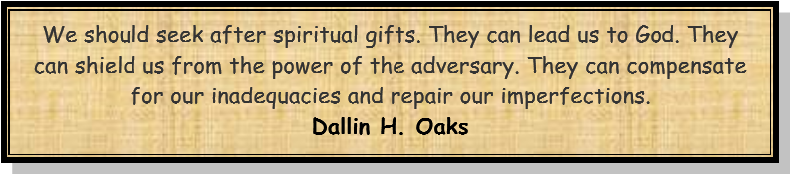
Sermon summary contributed by Pheobe Leong.
Prayer Points by Michelle Wong

- SERMON: We All Can Build the Church
Pray
- God's people will desire to receive the gifts of the Spirit.
- We will intentionally set aside ourselves to meet the needs of others for spiritual growth.
- People of God will place importance in serving others through His spiritual gifts.
- We will allow the Holy Spirit to use us in spreading God’s revelation through sharing what we hear by prophesying to others so that they may be build up in their spirit.
"And in him you too are being built together to become a dwelling in which God lives by his Spirit.” (Ephesians2:22)

MINISTRIES & EVENTS: MISSIONS VOLUNTEERS:
CES and WOL Russian-Malaysian fellowship
2 - 6 AUGUST 2017
Pray:
- God will convict the hearts of all believers to rise up to the call to serve in the Free Mobile Medical Clinics.
- God will inspire more people of God to step up and register for this ministry.
- God will enable His people to be united and build up one another through His calling for this ministry.
- God will bless the leaders in charge with wisdom, knowledge and understanding to do His Will.
For the Lord gives wisdom; from his mouth come knowledge and understanding. (Proverbs2:6)

MALAYSIA MY NATION: Future of Malaysia - GE14
All Malaysians
Pray:
- People of God will pray for protection and wisdom upon those involve in GE14 to be convicted with honesty and trustworthiness in counting and recording the votes.
- All eligible to be voters will be convicted in their hearts to step up and register themselves and those registered to ensure that their voting stations and names are still in the website.
- God’s protection and deliverance upon the Election Commission to play their role fairly and justly.
- God’s peace, authority and protection on all voters will prevail in the coming GE14 and we are thankful for all His grace and mercies.
I urge, then, first of all, that petitions, prayers, intercession and thanksgiving be made for all people- for kings and all those in authority, that we may live peaceful and quiet lives in all godliness and holiness.(1 Timothy2 :1-2)

- A TRANSFORMED WORLD: India
Pray:
- God's protection on Christian leaders who are boldly seeking to plant and grow churches.
- God’s strength, comfort & protection upon Christians who are assisting in micro-financing for new believers to do business.
- Protection and providence for the agencies providing micro-financing for their special clients.
- God to give gifts of translation to the local believers involve in Bible translation.
But you Lord, are a shield around me, my glory the One who lifts my head high. (Psalm 3:3)

