Boundaries: Choose Life
Brother Terry Yeow

Now what I am commanding you today is not too difficult for you or beyond your reach. It is not up in heaven, so that you have to ask, “Who will ascend into heaven to get it and proclaim it to us so we may obey it?” Nor is it beyond the sea, so that you have to ask, “Who will cross the sea to get it and proclaim it to us so we may obey it?” 14 No, the word is very near you; it is in your mouth and in your heart so you may obey it.
See, I set before you today life and prosperity, death and destruction. For I command you today to love the Lord your God, to walk in obedience to him, and to keep his commands, decrees and laws; then you will live and increase, and the Lord your God will bless you in the land you are entering to possess. But if your heart turns away and you are not obedient, and if you are drawn away to bow down to other gods and worship them, I declare to you this day that you will certainly be destroyed. You will not live long in the land you are crossing the Jordan to enter and possess.
This day I call the heavens and the earth as witnesses against you that I have set before you life and death, blessings and curses. Now choose life, so that you and your children may live and that you may love the Lord your God, listen to his voice, and hold fast to him. For the Lord is your life, and he will give you many years in the land he swore to give to your fathers, Abraham, Isaac and Jacob.
(Deuteronomy 30:11-20)

Introduction
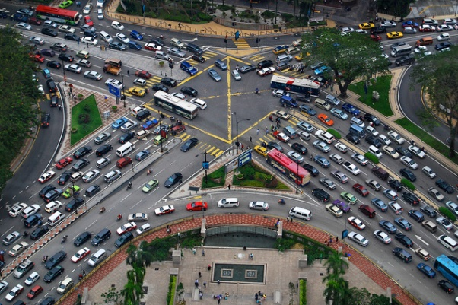
Moses was approaching the end of his life and he was reminding the Israelites to walk right with God. Moses has lead two million God’s chosen people out of slavery. They were in slavery who did not have an identity and was suddenly free. God provided laws for the society to function.

Three months ago the traffic lights in Section 14 was not functioning and thus there was a traffic jam. Terry found a gap and was rushing. He realised that all cars was heading the same direction and it caused a deadlock. It was chaos because the drivers did not follow the law and there were no boundaries.

Our idea of boundaries is that we are confined in a box. People believe that “God has set us free”. Boundaries are not like boxes but like guardrails that will lead us to our destiny and prevent us from falling.
The BIG Idea: Choose the boundaries that will lead to life.
God has destined us to life and prosperity. In Hebrew, it means to move forward favourably.
Why life?
The thief comes only to steal and kill and destroy; I have come that they may have life, and have it to the full. (John 10:10)

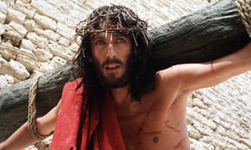
Why did Jesus die for us? Jesus died for our sins. Sin was the barrier that separated us from God. Jesus came so that He could reconcile us back to the Father. God worked miracle after miracle but the people continued disobeying.
The life of prosperity was to love God, have access to God and to move forward favourably.
Boundaries exist as guardrails so that we can live a life full of life and prosperity. It protects us from death and destruction.
Paul Gascoigne was the star footballer for England in the nineties. He was a person living his destiny to be the greatest footballer. But he was living a life of no boundaries. He was always seen in a bar after a match. He did whatever he wanted to do. Even the managers at that time claimed that he could be the greatest footballer the world had seen. Sadly, without any guardrails, he had mental illness, was depressed and was an addict to drugs and other substances. In the end, he could not fulfil his destiny.
There are three guidelines to finding your destiny.

Lordship
Who or What is in Charge of your Life? Will it cause obedience or disobedience to God?

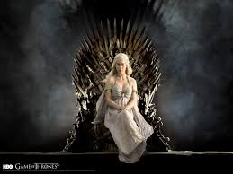
One of the first thing Moses does is to instruct Joshua to build an altar, cast in stone and inscribe God’s commandments in it. Why? To remind the Israelites to never to forget. Is Jesus sitting on the throne of your life? It easy to say yes but is that really the case. Are you sitting on the throne of your own life?

Terry graduated in software engineering and IT was the main career choice of that time. God had another plan instead and called him to serve young people. Since joining the team, he never looked back. Who is in charge of your life?

Accountability
How does it affect people around me?
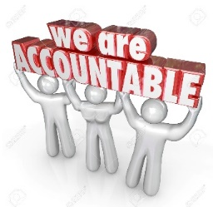
And let us consider how we may spur one another on toward love and good deeds, not giving up meeting together, as some are in the habit of doing, but encouraging one another and all the more as you see the Day approaching. (Hebrews 10:24-25)

Accountability is willing to be accountable to people other than yourself. It is spurring on one another. Nowadays, many believe that we are only accountable to our job and ourselves. This is a very bad belief system because the choices you make affect the people around us.

What is the difference between accountability and informability? Informability is merely informing people about what is happening in your life without accepting any input for encouragement or correction. For example a university student merely updated Terry on his relationship journey and status when he had already broke up with the girl.

Answering “How does it affect the people around me” will guide you towards the right decision.

Cause and Effect
Will this ultimately lead me to freedom or bondage?

This day I call the heavens and earth as witnesses against you that I have set before you life and death, blessings and curses. (Deuteronomy 30:11)

There is a natural consequence to our actions. Nature will witness against your actions. We are free of making the choices but not free from the consequences. God’s choice for us is freedom. The final question we must ask ourselves. Will this ultimately lead to freedom or bondage?

Conclusion
How do we apply these three questions in our life?

These three questions can be applied across the board in any area of our lives.

- Should I go to a party?
- Is this in obedience or disobedience to God? Will I be forced to do something I do want that will be disobedient?
- How does it affect the people around me?
- Will this ultimately lead me to freedom or bondage? Are there any details I know about the party that will cause me to stumble?

- Relationship? When Terry met his wife, he went through all these questions.
- Is this in obedience or disobedience to God? Upon talking to his partner, she encouraged him to obey God.
- How does it affect the people around me? His friends in church were surprised why this relationship did not start sooner. This was his sign.
- Will this ultimately lead me to freedom or bondage? This relationship will surely lead to freedom in Christ as it is heading the right direction. Terry is happily married in with one daughter.

- How do we choose our friends? Terry had a friend who approached him in university.
- Is this in obedience or disobedience to God? He sensed God asking him to be friends with this friend despite of his known habits.
- How does it affect the people around me? He noticed this friend opening to him about issues. Although his church friends were surprised he continued to be friends.
- Will this ultimately lead me to freedom or bondage? One day, this friend approached Terry and asked him why he travels every week from Nilai to his hometown. He took the chance to talk about his family and serving in his church. This friendship actually caused Terry to open up to his friend about God and church. It was certainly heading towards the right direction.

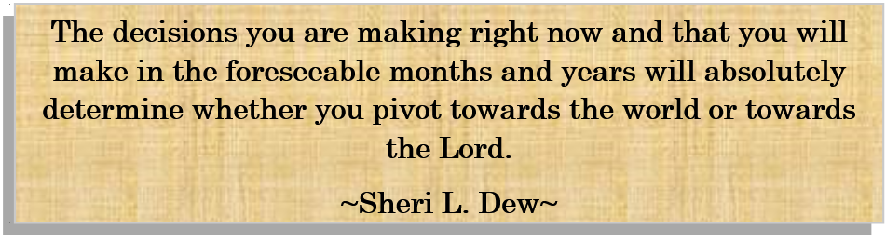
Sermon summary contributed by Abbey Thangiah
Prayer pointers contributed by Wendy ML

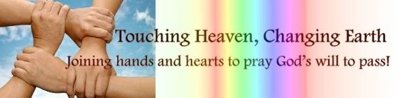

SERMON: Love One Another - Choose Life
Pray:
- We will understand that without boundaries, rules or laws in our society or our lives, there will be chaos.
- We will learn to set boundaries for ourselves that will lead us to have life (reconciliation with God) and prosperity (moving forward favourably).
- What we choose to do will be in obedience to God’s will for us.
- We will be open to being accountable with someone else because the actions and decisions that we do may affect the people around us.
- We will remember that there will be consequences in the choices we make and therefore we should choose to have freedom instead of bondage.
Don’t you know that when you offer yourselves to someone as obedient slaves, you are slaves of the one you obey—whether you are slaves to sin, which leads to death, or to obedience, which leads to righteousness? (Romans 6:16)

MINISTRIES & EVENTS: TRAC Children’s Ministry Conference 2017
DUMC will be hosting this conference from 31st Aug to 2nd Sept. The theme of this conference is Encounter, Equipped and Empowered - To Disciple the Next Generation.
Pray:
- Children’s Ministry volunteers, workers and teachers from various churches nationwide will sign up for the conference.
- For journey mercies and good health for the all the speakers including Pastor Bill Wilson of Metro World Child as well as the organizing committee, workshop moderators, servers, and others.
- For clarity and smoothness in everything, including the planning, execution and logistics.
- That the attendees will be filled with the Holy Spirit as they prepare their hearts to listen and be inspired to reach out, build bridges and live out the Gospel among the children in the community around them.
- All who attend will be blessed and encouraged by the presence of God and the network of fellow like-minded volunteers and partners in this ministry.
Train up a child in the way he should go; even when he is old he will not depart from it (Proverbs 22:6)

MALAYSIA MY NATION: 40-Day Fast & Pray
This year’s theme: Hope in God. (7 Aug to 15 Sept 2017). The launch will be held at DUMC on 6th Aug 2017.
Pray:
- The people of God in our country will heed the call to fast and pray fervently for a period of 40 days, placing their hope in God for breakthroughs for the country and for themselves.
- Believers will humbly and earnestly seek God’s face and voice to discover the plans and visions that He has for the nation and His people.
- Believers will stand united and spur one another on as they persevere through this 40-day challenge.
- Believers who fast will put aside their lunch money as a contribution towards the charity collection which will bless the rural church work, discipleship focused initiative and the read through the bible initiative.
May your unfailing love be with us, Lord, even as we put our hope in you. (Psalms 33:22)

- A TRANSFORMED WORLD: Forest fires raging in Indonesia
Indonesia’s National Disaster Mitigation Agency (BNPB) announced that five provinces -Riau, Jambi, South Sumatra, West Kalimantan and South Kalimantan are on emergency alert for the spread of forest fires in peat lands.
Pray:
- The relevant government and environmental agencies in Indonesia would be well prepared and able to tackle any potential forest fires.
- Firefighters will be well equipped and have the strength and courage to carry out their duties
- Culprits of intentional land burning will be caught and convicted.
- The smoke and smog from the forest fires will not spread and cause a blanket of haze to loom over neighbouring states and countries.
- The current dry season will pass by quickly, that there will be cooler weather with rainfall soon so that the air quality will also improve.
Then I will give you your rains in their season, and the land shall yield its increase, and the trees of the field shall yield their fruit. (Leviticus 26:4)

