Pass It On: Part 1
Reverend Tony Yeo

He said to them, “This is what I told you while I was still with you: Everything must be fulfilled that is written about me in the Law of Moses, the Prophets and the Psalms.”
Then he opened their minds so they could understand the Scriptures. He told them, “This is what is written: The Messiah will suffer and rise from the dead on the third day, and repentance for the forgiveness of sins will be preached in his name to all nations, beginning at Jerusalem. You are witnesses of these things. I am going to send you what my Father has promised; but stay in the city until you have been clothed with power from on high.” (Luke 24:44-49)

Introduction
Pastor Tony Yeo has been a pastor for nearly 30 years. Knowing the average response of people upon knowing his profession, he often tells people that he works for a global enterprise, which has outlets in every nation of the world. The enterprise builds hospitals, schools, colleges and universities. It also prepares young couples for life-long marriages; prevent marriage and families from crisis; do all sorts of conferences; helps people from the womb to the tomb, and if ends up in tomb, it sends them to heaven. The enterprise majors in only one thing, that is radical life change. The name of the global enterprise is called Christianity.

You and I are part of this global enterprise! Having said that, it is part of the DUMC’s core habits that we should Pass It On! It is Jesus who said that we must pass it on. In Luke 24:44-49, Jesus talked about the four irreducible minimums to Pass it On:

MASTER Worth Following – Understanding the Lordship of Jesus (Luke 24:44-45)
In Luke 24:44-49, Jesus gave His final mandate to the church before He ascended to heaven.
Jesus passed on to His disciples and to us today. Everything that said in the bible from old to New Testament, every part of the Holy Scripture points to someone, Jesus! Jesus wants to anchor and ground the faith of the disciples. Before Jesus left He reminded His disciples that everything that is written, from Old Testament to Psalm, everything was about “me”.

He said to them, “This is what I told you while I was still with you: Everything must be fulfilled that is written about me in the Law of Moses, the Prophets and the Psalms.” Then he opened their minds so they could understand the Scriptures. (Luke 24:44-45)

No matter how long we have been a Christian, we must always go back to scriptures. To have a MASTER worth following we must come back to the Word which always points us to Jesus Christ. We may be faced with many doubts and crossroads in life, in order to make a wise decision that God wants us to make, we must always come back to the Holy Scripture. The Bible must master our life, to allow it to constantly bring us back to the realm that this God is worthy of our lives. There always has to be a master worth following, no other than Jesus Christ.

We grow to be A PEOPLE OF THE BOOK to master our lives.
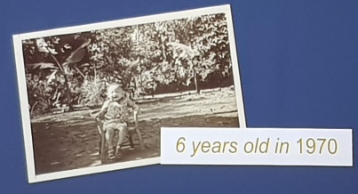
Pastor Tony Yeo shared that his father died from heart attack when he was only six years old. At that time, his mother was pregnant with his brother, the seventh child of the family. Other relatives abandoned the family due to the fear of financial burden that the family of seven might bring. It was also a superstitious belief that when a man died while the wife is pregnant, the woman is a wicked one.
The night after the funeral of the father, while preparing to check in to the hospital to deliver her seventh child, his mother opened up the closet and a Bible fell down on the floor. It was opened on Psalm 23.
The Lord is my shepherd, I lack nothing. (Psalm 23:1)

That was how his mother got to know about our Saviour Lord Jesus Christ. Their kind neighbour brought them to church and the kids to Sunday School. Pastor Tony Yeo loved going to church as there were songs to sing and games to play. Once day, at the age of 8 years old, a Sunday School teacher taught them that God does not want to only be a saviour, but to be your heavenly father. Immediately, pastor Tony Yeo broke down in tears, feeling the emptiness and absence of his earthly father. On that day, he gave his life to Jesus and has been actively involved in church. He was very passionate about Jesus and kept pursuing Him till this day.

At the age of 15, he answered an altar call and told God that he was willing to give his life to be a missionary. But deep inside him, he knew that wherever God leads, he will follow; and what God feeds, he will swallow. Pastor Tony knows that his identity is determined by WHOSE he is and not WHO he is.

FAITH Worth Having – Understanding the Heart of the Gospel (Luke 24:46)
“…Christ should suffer and rise again from the dead.” (Luke 24:46)
Transformation precedes multiplication. God wants to change us from the inside out. Pastor Tony’s son now calls himself Timothy Isaac Yeo because God asked him if he was willing to be His Isaac, to be a living offering to Christ. Timothy responded, taking a leap of faith. Without the knowledge of his father, he applied for a scholarship to a seminary in Chicago, USA. God honoured his step of faith and he got a 5 year scholarship for his studies to go into fully time ministry.

Our calling, is to disciple our children and not to be the best Uber driver to them. Parents nowadays are too anxious in sending our children to tuition classes and other enrichment programmes. The next generation should have faith worth having and that they would embrace God for themselves.

It is time for a change.

A CAUSE Worth Pursuing – Understanding the Kingdom and Missions (Luke 24:47)
“repentance for the forgiveness of sins proclaimed in His name to all the nations...” (Luke 24:47)
Our great commission as Christians is to make disciples of all nations. There was once when Pastor Tony was in a church in Bangkok, as he was waiting in the senior pastor’s office, he saw this big white globe at the centre of the office. Curious, he asked why was it there and he was told that the globe served as a reminder that Jesus died for the whole nation (world), not just for Bangkok and his church.

John Wesley said, “I look on all the world as my parish; thus far I mean, that, in whatever part of it I am, I judge it meet, right, and my bounden duty, to declare unto all that are willing to hear, the glad tidings of salvation.”

Such is Jesus’ incredible love to the nations of the world.

When Pastor Tony was young he only wanted to be a missionary. After his course in the seminary, he served eight years as a pastor. Then he was ready to go. At that time, his wife had just experienced a second miscarriage. God spoke to him, and knowing that he was ready to go, but willing to stay, God told him that he was not testing his readiness to go, but willingness to stay. God wanted him to stay and disciple. To make many more Tony Yeos as compared to just one if he is to go for Mission Trip. He obeyed and stayed.

A LIFE Worth Living – Understanding the Redemptive Nature of Discipleship (Luke 24:48-49)
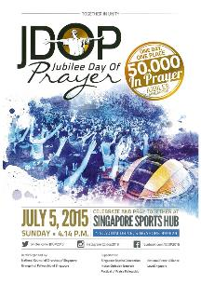
This life is worth living because is it daily empowered not by of our devotion and dedication but because of the Holy Spirit who lives in us.
“I am sending the promise of my Father upon you. But stay in the city until you are clothed with power from on high.” (Luke 24:49)

Life as a Christian is not a difficult life, but rather an impossible life. We are struggling everyday with the pride of our lives, the lust of the eyes and flesh, etc. That is why God left “someone” with us, that is the Holy Spirit that lives in us. The Holy Spirit is our guide and counsellor in life, and the steward of every spiritual gifts and talents in us. The Holy Spirit takes control of every part of our lives. The Holy Spirit is God Himself.
Two years ago, Pastor Tony was compelled by the Holy Spirit to gather 50,000 Christians from all denominations and all churches in Singapore to pray for Jubilee year of Singapore. By God’s grace, 51,000 showed up including Prime Minister Lee Hsien Loong, President Tony Tan and his wife, Mary Tan, as well as Defence Minister Ng Eng Hen. Christians came together as one people, once heart and one voice, unitedly praying for the nation. As Christians, we must shine for Jesus, be the salt and light in the world.
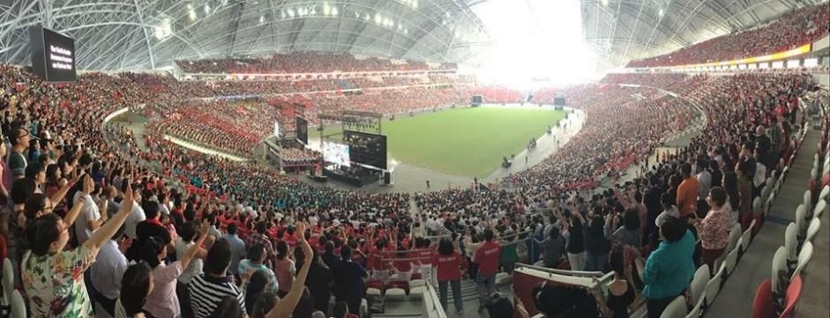

CONCLUSION

Pass it on!

- MASTER Worth Following- his name is called Jesus.
- FAITH Worth Having- because Jesus is alive! The power that raised Jesus from death is the work in our lives. Nothing is impossible with God.
- A CAUSE Worth Pursuing- Pursue the nations of the world.
- A LIFE Worth Living- When it’s impossible, lean and depend on the Holy Spirit. This is the life that God wants us to live.

Pastor Tony ended the message with a testimony that he encountered three months ago. After preaching one Sunday, he completely lost his voice. He was having other commitments within short period, but he had no voice! Just before he left Singapore, God said to him:

BE STILL and know that I am God. (Psalm 46:10)

He told God that he needed deliverance and not direction. He came to a lounge at the airport and the name of the lounge is Still. He knew that he should let go and allow God to take control of the situation. He still had no voice and his wife had to take over for him during the senior pastor and wife retreat. On the day of conference where he was supposed to preach, for the first time after 7 days of complete voice lost, he got his voice back! People cried and prayed for him, it was a modern day miracle.

When we are at work, we really work. When we really pray, God is at work.

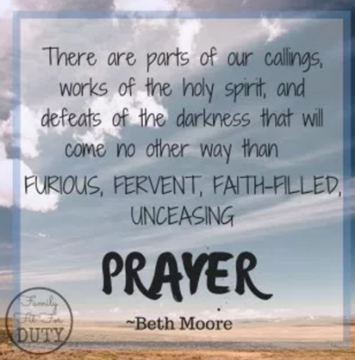

Sermon summary contributed by Chrisandra Wong.
Prayer points contributed by Prudence Tay.

SERMON: Pass IT On
Pray:
- We will begin to spend quality time with God and His Word.
- God will grant us understanding of His Word.
- We will grow our faith to greater heights.
- We will be open to the promptings of the Holy Spirit, who is in us, and be obedient as He leads.
- God will put into our hearts a passion to Pass On our faith, especially to those around us and our lives will be one that reflects and points the way to God.
You are witnesses of these things. I am going to send you what my Father has promised; but stay in the city until you have been clothed with power from on high.” (Luke 24:48-49)

MINISTRIES and EVENTS: Mission Candidate Preparation Program 1 (MCPP1)
7 – 8 October 2017
Pray:
- Members will attend this training to prepare themselves to go for at least one short term mission trip.
- God’s anointing upon the trainers and facilitators to impart passion and knowledge to the participants.
- God to speak to the participants and stir their hearts for His passion for the lost.
- The participants will sign up to go for one mission trip.
for, “Everyone who calls on the name of the Lord will be saved.” How, then, can they call on the one they have not believed in? And how can they believe in the one of whom they have not heard? And how can they hear without someone preaching to them? (Romans 10:13-14)

MALAYSIA MY NATION: Violence Among the Young
In recent years we have seem a rise of violent behaviour especially among the youth and young people. There were the cases of the brutal abuses of a navel cadet and a student which lead to their deaths. More recently, was the group of 7 youths, aged between 11 to 18, who planned and executed a fire in a boarding school because the boarding school students mocked them.
Pray:
- All adults who are responsible for you people will take a serious look at themselves and their behaviour and correct any violent behaviour in themselves. That they will be a good example of how to behaviour calmly and in control.
- Parents and teachers alike will have wisdom on how to curb and discipline misbehaviour and violence of children under their authority.
- The church will play a part in helping to teach the young people to be respectful and to behaviour in the right manner.
- Christian students and teachers will be an influence in the schools they are in, to promote good values and behaviour.
Discipline your child, and he will give you rest; he will bring you happiness. (Proverbs 29:17)
- A TRANSFORMED WORLD: Puerto Rico Crack in Dam
Puerto Rico is facing renewed danger in the wake of Hurricane Maria, as the Guajataca Dam fails under the strain of weather damage and heavy rainfall. The government has called the situation "extremely dangerous", and the struggling dam is reportedly causing flash flooding in the island's northwest corner.
Pray:
- Calm, and order as people in the affected areas are being evacuated.
- Word of the evacuation will reach those living in the more remote areas and they will be safely evacuated.
- Wisdom upon the authorities on how to handle this situation and to put the safety of the people first.
- Other nations will enable teams to assist Puerto Rico in time of this crisis.
- May the God of peace bring peace to the people as they go through this time of loss and uncertainty.
Be gracious to me, O God, be gracious to me, For my soul takes refuge in You; And in the shadow of Your wings I will take refuge Until destruction passes by. (Psalm 57:1)

