I Love My Church: Where the Rubber Meets the Road
Ephesians 5:25 - 32
Pastor Mike Ngui

Why do we need church in the first place? God is in us. We can also pay our tithes online. What is the point of church when we do not like the people in them? We need to be in church because that is where the rubber meets the road. There is no point having a million-dollar car with the fastest engine system if there are no tyres. The tyre needs to meet the road for the car to unleash its power. This is where the idea of Christianity turns reality when we attend church. Pastor Mike is currently studying Greek. After months of practice and studies, he has to sit for a three-hour exam. This is when the rubber meets the road.

The BIG IDEA
The Local Church is where the rubber meets the road

I Love the Church because Jesus Loves His Church

Husbands, love your wives, just as Christ loved the church and gave himself up for her to make her holy, cleansing her by the washing with water through the word, and to present her to himself as a radiant church, without stain or wrinkle or any other blemish, but holy and blameless. (Ephesians 5:25 -27)

This verse is famous in weddings but equally applicable in the church contexts. The verse is not only applicable for the church in Ephesus but to all churches. Christ died for the church, Christ is preparing the church to be without blemish for the Lord’s coming. He held nothing back and was willing to give his life. Therefore, the church is a work in progress. Just like a lifelong marriage, the church is there to bring out the best of you.
Phones have workout app nowadays. It counts your calories and have pre-programmed workouts for everyone to follow. You can change the voice, intensity and the time of workout to suit your needs. Unless you start working out, the app is useless in itself. You can sit on the couch and comment how awesome the app is but you will never lose weight. You must work out.
We have reduced following Christ to only doing what he says but do not yield.

I Love this Church because Jesus loves this church.
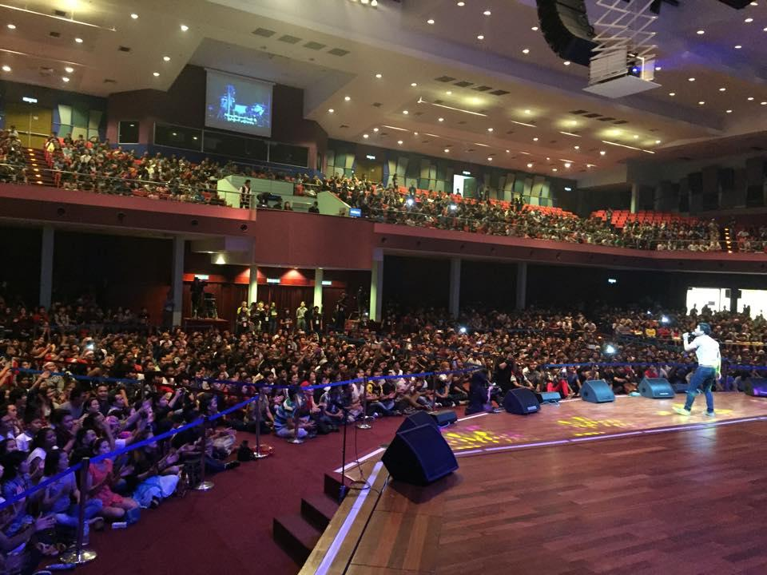
We love this church (DUMC or any church you are part of). Every Saturday and Sunday, DUMC has 6 services of different languages. Every week, we meet for cell group. You are part of the church. DUMC is not a building. The C also does not stand for Club or Charity.
We need to connect to the local church to be a part of the community. This puts our faith in Christ into action. We need to put the app into practice.

Commit to the Local Church Because it is the New Testament Pattern

A New Testament Church
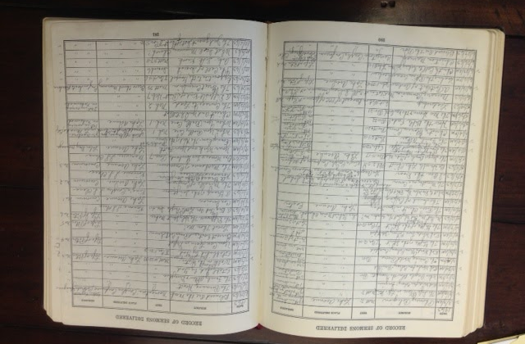
No widow may be put on the list of widows unless she is over sixty, has been faithful to her husband (1 Timothy 5:9)

Although ‘membership’ is not mentioned in the bible, few passages in the bible will show that membership is actually practiced in the New Testament. In 1 Timothy 5:9, we can see that there was a ‘list of widows’. The church kept records of people’s identity, age and membership to identify who needs help from the church.

Those who accepted his message were baptized, and about three thousand were added to their number that day. (Acts 2:41)

The church takes record of people. This is why the book of Acts could give an accurate number of the people who were added to the kingdom.
When Apollos wanted to go to Achaia, the brothers and sisters encouraged him and wrote to the disciples there to welcome him. When he arrived, he was a great help to those who by grace had believed. (Acts 18:27)

People in the church were aware who belongs in which church. When Apollos wanted to visit, he wrote to them and was welcomed by everyone in that church. This allowed the believers in Achaia to identify a fellow believer and welcomed him to the family.

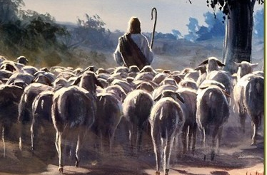
NT Church Leadership

Be shepherds of God’s flock that is under your care, watching over them—not because you must, but because you are willing, as God wants you to be; not pursuing dishonest gain, but eager to serve; not lording it over those entrusted to you, but being examples to the flock. (1 Peter 5: 2,3)

Leaders of the Church are called to care for their flock. How can someone care for the flock if they cannot identify who the flock is and what their needs are? That’s why it is important to be a part of this congregation.

NT Church Discipline
For in him you have been enriched in every way—with all kinds of speech and with all knowledge. What I mean is this: One of you says, “I follow Paul”; another, “I follow Apollos”; another, “I follow Cephas”; still another, “I follow Christ.” Is Christ divided? Was Paul crucified for you? Were you baptized in the name of Paul? (1 Corinthians 5: 2, 12-13)

When there are members causing confusion, this will divide the church. Where there are cases of church members behaving badly. The only option is to move them out of the fellowship.

NT Church Exhortations
And let us consider how we may spur one another on toward love and good deeds, not giving up meeting together, as some are in the habit of doing, but encouraging one another—and all the more as you see the Day approaching. (Hebrews 10:24-25)

The church is a place where we encourage one another to gather and support each other. This allows us to commit and work with each other. We need to be committed to be a part of the work in progress.

Conclusion
Whoever does not love does not know God, because God is love. Whoever claims to love God yet hates a brother or sister is a liar. For whoever does not love their brother and sister, whom they have seen, cannot love God, whom they have not seen. (1 John 4:8,20)

The local church is where rubber meets the road. It is an example of God’s love. The membership is not a piece of paper but the attitude of membership is more important. Let us commit to work together in the local church and grow together.
Are we members in paper or are we members at heart?

Sermon summary contributed by Abbey Thangiah.
Prayer pointers contributed by Michelle Chuah.

SERMON: I Love My Church: Where the Rubber Meets the Road

Pray
- God's people will renew their commitment to Christ with a heart of commitment towards their local Church and its Mission.
- We will intentionally live out our commitment to Love God, Serve People and Make Disciples through active participation in Church.
- People of God will turn from their own ways and be prepared to submit to the leadership of the Church by contributing to its growth.
- We will be the living body of Christ in our congregation and not be outsiders.

“For we were all baptized by one Spirit so as to form one body – whether Jews or Gentiles, slave or free – and we were all given the one Spirit to drink Even so the body is not made up of one part but of many.” (I Corinthians 12:13-14)

MINISTRIES & EVENTS: 3-Day Fast & Prayer
10 - 12 OCTOBER 2017
Pray:
- God will convict the hearts of all believers to seek God through prayer and pray for our nation.
- God will inspire more people of God to step up to fast and hear from Him.
- God will enable His leaders to encourage the Church to come forth to pray.
- God will bless the leaders in charge with wisdom, knowledge and understanding to do His Will.
‘Therefore I tell you, whatever you ask for in prayer, believe that you have received it, and it will be yours.’ (Mark 11:24)

MALAYSIA MY NATION : Johor – People of Kluang, Mersing & Kota Tinggi

Pray:
- People of God have wisdom to pray for their own oikos in Johor.
- People of God to step out in boldness and wisdom to bear witness to Jesus of His Love and compassion in their localities.
- God’s strength and protection upon His persecuted believers with perseverance to endure.
- God will reveal Himself to pre-believers and persecutors in dreams, visions, signs and miracles
‘The Spirit of the Lord is on me, because he has anointed me to preach good news to the poor. He has sent me to proclaim freedom for the prisoners and recovery of sight for the blind, to release the oppressed, to proclaim the year of the Lord’s favour.’ (Luke 4: 18-19)

- A TRANSFORMED WORLD: Persecution of churches
Pray:
- God's protection, strength and grace on leaders & people of underground house churches who are boldly seeking to share the gospel and grow churches.
- God’s hand on the government to ease restrictions on church planting as a restoration and healing process for the nation.
- Persecutors to have a change of heart – compassion, and experience the Love of Christ.
‘What answer shall be given to the envoys of that nation? The Lord has established Zion, and in her his afflicted people will find refuge.’(Isaiah 14:32)

