I Love My Church: It’s About Me
Senior Pastor Chris Kam

“I am writing to you, dear children,
because your sins have been forgiven on account of his name.
I am writing to you, fathers,
because you know him who is from the beginning.
I am writing to you, young men,
because you have overcome the evil one.
I write to you, dear children,
because you know the Father.
I write to you, fathers,
because you know him who is from the beginning.
I write to you, young men,
because you are strong,
and the word of God lives in you,
and you have overcome the evil one.” (1 John 2:12-14)

Introduction

In the previous sermon of the “I Love My Church” series, Pastor Chris talked to us about living as consumeristic Christians in the church, and that the local church exists not only for us, but for a purpose bigger than ourselves. This week, he shares with us about a rather paradoxical concept – that the church is not only about us, but at the same time, it is also all about us.

He begins by posing this question: Are you in the pursuit of happiness? Have you ever wanted to have an ever-increasing amount of happiness and fulfillment in your life? In our society today, everything we see, do and think directs us to the end goal of being happy. Consumeristic advertisements portray nothing but the good life, and how having just the right things can lead to fulfilment and happiness. Pastor Chris calls this obsession. He goes on to say that unknowingly, we often become obsessed in pursuing happiness and satisfaction in our lives. And often, we forget this – that we do not live our lives to get. When we live our lives to give, that’s where we find that we are able to receive so much more. This is a paradox.

THE BIG IDEA

I need you to help me grow and mature towards Christlikeness.

It’s about ME towards MATURITY
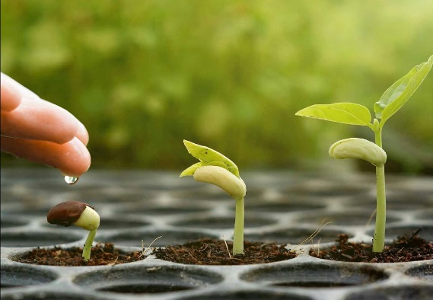
Just like young children, who struggle with the concept of egocentric thinking – the inability to think from a second person’s point of view, or the inability to understand that not everything is about them, we also wrestle with this thinking. We often come to church, or be part of a community as a consumeristic Christian, thinking that the community exists for our purposes, and therefore, should fulfill all our needs. Just like children, who have yet to mature in their nature, some of us, as baby Christians have also yet to mature in this aspect. However, again, as children have their parents and guardians to help them, we as Christians also have spiritual parents and great communities that God has put us in to walk with us and guide us through things like that. We need people who can help us mature towards Christlikeness. God is not in the business of making us happy; He is in the business of making us holy. We need to understand that the church and the community cannot just revolve around us, and we cannot just be stuck on the mindset of being consumeristic Christians. We need to let our spiritual parents and guardians groom us into maturity.

It’s about US towards MINISTRY

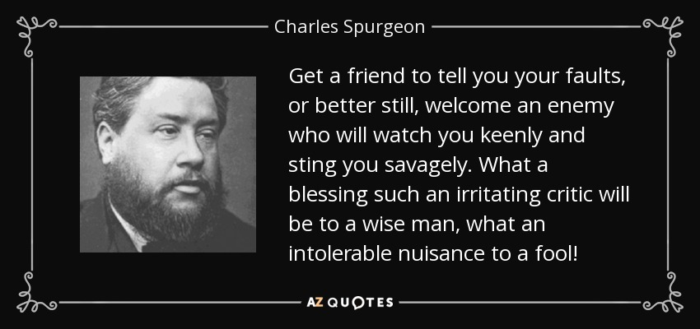
As it is with a married couple, it is the same as the people in the church. One of the struggles that a married couple will face in the early stage of their marriage is the understanding that it is not about them as individual people anymore, but it is about them as a couple. Everything they do, say and think reflects them as a couple – as two people who have become one. It cannot revolve around them as separate people. Even through fights and disagreements, the couple must look at the relationship as a whole, and they must have the opinion and feelings of each other in mind. Even when they see the ugly side of one another, it is about whether they choose to stay and continue loving one another. Similarly, with the church, we need to understand that when it comes to the ministry of the church, it cannot just revolve around us as individuals anymore, it must be about the ministry as a whole. As the couple chooses to stay strong throughout the relationship, we must also choose to stand strong in ministry, even when we face setbacks or stumble across people we don’t like and can’t agree with – Because there will be people we cannot see eye to eye with. But it’s whether we choose to let God use moments like these to mold us towards love, or walk away and find fulfilment and happiness somewhere else. The word of God tells us to be strong – in our attitude, and in our character.

“I write to you, young men, because you are strong, and the word of God lives in you, and you have overcome the evil one.” (1 John 2:14)

It’s about OTHERS towards MULTIPLICATION

Again, Pastor uses the analogy of a married life. Just as a married couple struggles with the understanding that after having kids, it is not just about them as husband and wife anymore, but their life now has to revolve around their kids – what they want and what they need. Pastor shares with us his understanding of why God gives us children – to humble ourselves. God gives a husband and wife children to teach them how to die to themselves – to teach them how to put themselves second instead of first, to cater to someone else’s needs before their own. Similarly, in the church, God is teaching us to understand this – that our needs are met when we meet the needs of others.

Conclusion
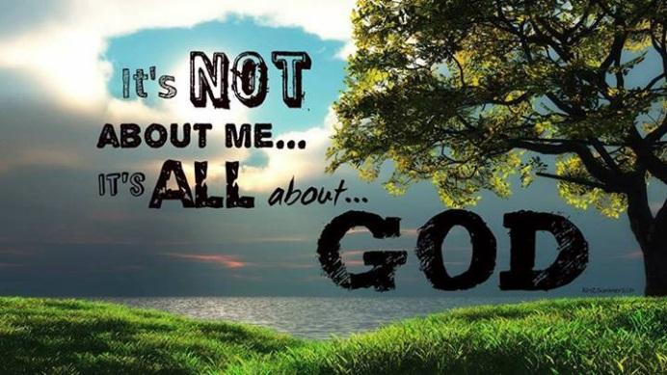
It is not about us, but it is also about us. As Christians, we need to remember that as God is molding us towards holiness, he has also placed us in communities to teach us that it is not all about us. We are in a society that tells us to pursue happiness in all the right things and all the right places, but it is in giving to others, living selflessly and putting others before ourselves that we find the greatest joy and fulfillment. Just as a young couple has pre-marital counsellors to guide them through their marriage, as do we need a community to help us through our lives as a Christian, to help us grow and mature towards Christlikeness. At the end of the day, it is not about us, but ultimately about HIM.

Sermon summary contributed by Phoebe Leong.
Prayer pointers contributed by Michelle Wong.

SERMON: I LOVE MY CHURCH: It’s About Me
Pray:
- All the people of God will recognise the need to grow and mature in Christ-likeness .
- God’s people will intentionally respond to God’s call to die to self and draw near to Him to devote ourselves to others.
- We must turn to God and set our heart and mind to allow God to use us to serve His purpose.
- People of God will be sensitive to God’s heart and be led by the Holy Spirit to reach out to touch those in need through sharing His Love.
It is more blessed to give than to receive. (Acts 20:35)

MINISTRIES & EVENTS: W2W Encounter Weekend Getaway
17 - 19 November 2017

Pray:
- Holy Spirit will prepare the hearts and well-being of the speakers to deliver His message to the women participants.
- God will convict the hearts of the women He has called to come receive the message from Christ.
- God’s empowerment and wisdom upon the volunteers and the team members as they prepare for the event.
- Cooperation, unity and smooth collaboration between volunteers and team members and church leaders in the preparation for the event.
“May the Lord direct your heart to the love of God and to the steadfastness of Christ”
(2 Thessalonians 3:5)

MALAYSIA MY NATION: Malaysia - Parliamentary Seating
23 – 30 November 2017

Pray:
- People of God will pray for wisdom upon all the members of Parliament to be convicted in their hearts to vote correctly, courageously and without fear or favour on good laws to be passed.
- All members will be convicted in their hearts to vote for the right laws to be passed and the necessary changes be made to existing laws so that it is fair and just for all Malaysians.
- God’s protection and authority upon the Speaker for each seating to enable smooth running of each seating to take place.
- God’s authority will prevail in all preparations for the coming Parliamentary seating in our country and we are thankful for all His grace and mercies.
I urge, then, first of all, that petitions, prayers, intercession and thanksgiving be made for all people- for kings and all those in authority, that we may live peaceful and quiet lives in all godliness and holiness. (1 Timothy2 :1-2)

- A TRANSFORMED WORLD: Cambodia - Church
Pray:
- For God to protect His people in Cambodia who are showing the Love of Christ to those from the darkness.
- God’s people will be convicted to unite and have a kingdom mindset amidst time of restoration of the land.
- God will raise up People of God as leaders with quality, commitment and depth who will find more resources in building up the nation.
- The Church in Cambodia will wean itself off foreign aid and become self-reliant.

And my God will meet all your needs according to the riches of His glory in Christ Jesus.
(Philippians 4:19)

