Missions Weekend: Simplicity and Difficulty
Joseph Gordon

If you declare with your mouth, “Jesus is Lord,” and believe in your heart that God raised him from the dead, you will be saved. For it is with your heart that you believe and are justified, and it is with your mouth that you profess your faith and are saved. For “Everyone who calls on the name of the Lord will be saved.”

How, then, can they call on the one they have not believed in? And how can they believe in the one of whom they have not heard? And how can they hear without someone preaching to them? And how can anyone preach unless they are sent? As it is written: “How beautiful are the feet of those who bring good news!” (Romans 10:9-10 & 13-15)

Introduction
The church partakes of the Holy Communion so they can remember Jesus, what He has done, and how He gave His life for everyone. That is the essence of missions, which is to remember what Jesus has done and to tell the world about it. Whenever we partake or celebrate the Holy Communion, the breaking of the bread and the drinking of the cup, we are celebrating missions.

The Institution of the Lord’s Supper
For I received from the Lord that which I also delivered to you: that the Lord Jesus on the same night in which He was betrayed took bread; and when He had given thanks, He broke it and said, “Take, eat; this is My body which is broken for you; do this in remembrance of Me.” In the same manner He also took the cup after supper, saying, “This cup is the new covenant in My blood. This do, as often as you drink it, in remembrance of Me.” For as often as you eat this bread and drink this cup, you proclaim the Lord’s death till He comes. (1 Corinthians 11:23-26)

Whenever we break the bread and partake of it, we need to remember that Jesus died for us. Jesus paid the price by giving His life for our sake, and because of what He has done, we have salvation and eternal life, and we have a community and a family of believers to whom we belong to.

However, we need to remember that Jesus did not die just for you and me, He died for everyone else as well. If we think only of ourselves, we miss the true purpose of communion.

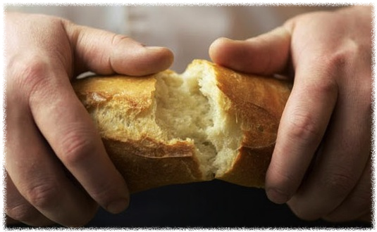
In the Old Testament, the breaking of bread symbolises a covenant that is made. When Jesus sat with the disciples and broke the bread during the Last Supper, He is in effect saying, “I am giving my life for the salvation of many, bringing hope to the world. Will you join me?”

Jesus took the bread and said that it represented His body. The bread is a common, ordinary thing. People eat bread every day. Jesus has a knack of taking common, ordinary things and giving it meaning. Anything in the hands of Jesus becomes sacred. He takes something that which is common and ordinary and makes it sacred, He gives it significance. That is what Jesus can do for us as well. He takes common, ordinary people and gives them meaning and significance.

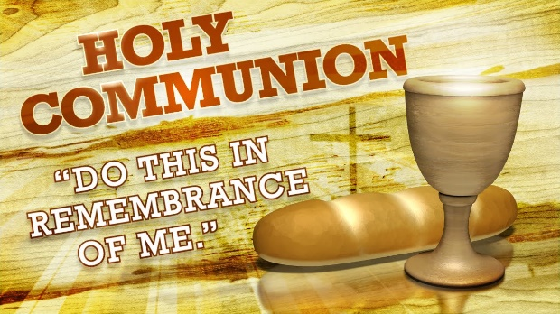
All disciples, except for James, died a martyr death. They were willing to give their lives for the Gospel because they wanted to stay true to the covenant that was made at the Last Supper. They broke the bread daily so that they could remember Jesus. They knew that it can be easy to forget, to get caught up in life, in work, family and daily living. It can be easy to forget and to get caught up in the pursuits of life and our own ambitions. We need to remember that Jesus did not die so that we can live in a nicer house, or drive a nicer car.

If we partake of the bread and drink of the cup thinking only of ourselves, we are not partaking and drinking in a way that is worthy of the Lord Jesus, who never once thought only of Himself, but thought of others always.

The Reminder of the Great Commission
Therefore go and make disciples of all nations, baptizing them in the name of the Father, and of the Son, and of the Holy Spirit, and teaching them to obey all that I have commanded you. And surely I am with you always, to the very end of the age.” (Matthew 28:19-20)

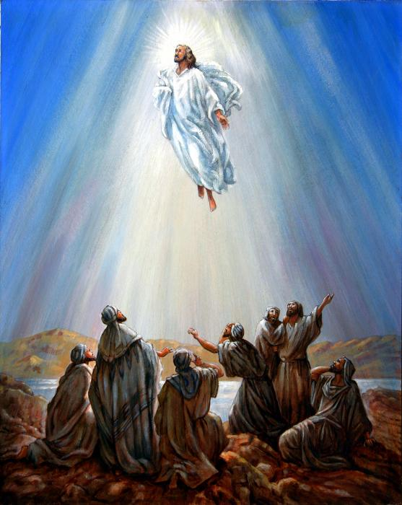
In the book of Acts, after Jesus died and rose from the dead, He met with the disciples for a last time, reminding them to wait in Jerusalem for the gift the Father has promised, which is the gift of the Holy Spirit. Soon after, Jesus was taken up into heaven before the disciples.

After he said this, he was taken up before their very eyes, and a cloud hid him from their sight. They were looking intently up into the sky as he was going, when suddenly two men dressed in white stood beside them. “Men of Galilee,” they said, “why do you stand here looking into the sky? This same Jesus, who has been taken from you into heaven, will come back in the same way you have seen him go into heaven.” (Acts 1:9-11)

The disciples were standing at the same spot where Jesus had left them, still staring up into the sky, and God had to send two angels to remind them that Jesus was coming back, and of what Jesus had called them to do. Two thousand years later, believers are still looking up into heaven, asking the same question, wondering when He is coming back, instead of doing what God has called them to do.

Remember what Jesus has done for you, and for everyone else. Remember how He gave His life for you and for others. When you remember Jesus, people live. When you forget, people die.

We need to remember that:

Jesus died for me
This deals with our personal relationship with Jesus. We need to search our lives and see if there is any sin in us which we need to confess and repent of.

Jesus died for us
This deals with the relationship we have with other believers in the church. We need to examine and see if we have offended anyone in any way, if we are holding onto offense against someone or some people in the family of believers. Then we need to go and make things right with them, to remember that Jesus loves them and He has died for them too.

Jesus died for them
This deals with the responsibility we have as believers to the rest of the world. We need to see the bigger picture of salvation, and not think only of ourselves and look out only for our own interests. Yes, Jesus gave His life for you and me so that we can enjoy the benefits of salvation and eternal life, but we need to remember that He gave His life for the whole world too! Everyone has the right to salvation and eternal life.

Conclusion
The question we need to ask ourselves is this:
“Am I using all that God has given me to make Jesus famous? Am I living my life in such a manner as to make His name famous?”
“What is it that is keeping me from living out God’s plan for my life? Is it something I fear, or something which I love? What is it that is keeping me from fulfilling the calling God has given me?”
As long as we hold onto these things, we will never be able to enter the fullness of the life God wants us to live. We will never be able to take hold of the purposes of God, as long as we hold onto our own purposes. We will never be able to follow His plans as long as we hold onto our own plans.
Ask the Lord to give you the strength to let go. Release these things to Jesus, and live your life for one purpose, which is to make His name famous to the ends of the earth. Offer your life to God, to do whatever needs to be done. Surrender your life to God, to His will, His purposes, to His way.
We need to remember why Jesus died. We need to remember why He gave His life.

Sermon summary contributed by Anthea Tan
Prayer pointers contributed by Prudence Tay

SERMON: Simplicity and Difficulty
- We will remember that Jesus died for the whole world.
- Jesus will open our eyes and heart to see the needs of people around us.
- We will answer the call of Jesus and share the Gospel to those who need it.
- We will step out in faith and obey Jesus to do His work and not live in our own world of comfort.
How, then, can they call on the one they have not believed in? And how can they believe in the one of whom they have not heard? And how can they hear without someone preaching to them? And how can anyone preach unless they are sent? As it is written: “How beautiful are the feet of those who bring good news!” (Romans 10: 13-15)

MINISTRIES & EVENTS: Baptism & Membership Encounter Weekend
11 – 12 November 2017
Pray:
- Journey mercies as the participant, helpers and facilitators travel.
- The participants will have an encounter with God and grow closer to Him.
- The facilitators will be open to the guidance of the Holy Spirit during this weekend.
- After the weekend the participants will continue to grow and to be obedient to God.
Whoever believes and is baptized will be saved, but whoever does not believe will be condemned. (Mark 16:16)

MALAYSIA MY NATION: Penang-Heavy rains and flooding
Much of Penang has been hit by typhoon-like winds and incessant heavy rain. Over 2,000 people have been evacuated from several flood-hit areas since early Sunday morning. The army has been called in to assist in evacuations and rescue efforts. So far 4 people have been reported dead. The Meteorological Department has issued a “red” alert warning of continuous heavy rainfall across the northwest island state and Kedah on the mainland.
Pray:
- People will be vigilant of the rising flood waters and get to safety.
- The relevant authorities and the army will work together to rescue those trapped by the flood waters.
- People, especially God’s people, to arise during this time of need and offer help to those in need.
- God’s protection upon all who are involved in rescue work.
- The rains and winds will subside and that the flood waters will begin to recede.
- The Penang government will take measures to prevent this type of flooding due to prolong heavy rains from happening again.
The Lord does whatever pleases him, in the heavens and on the earth, in the seas and all their depths. He makes clouds rise from the ends of the earth; he sends lightning with the rain and brings out the wind from his storehouses. (Psalms 135:6, 7)

- A TRANSFORMED WORLD: Australia – Refugee centre in Papua New Guinea
Papua New Guinea’s High Court ruled last year that the refugee camp, Manus Island centre, was illegal and the camp was scheduled to close on Oct. 31. The detainees in the camp have defied attempts to close the camp, saying they fear violent reprisals from the local community if they are moved to other “transit centres”. The 600 men in the camp have no water and power after utilities to the camp were cut off on Wednesday, Nov 2.
Pray:
- Aid will be provided to the men in the camp.
- The men will agree to move to the “transit centres” and that these centres will have adequate facilities to meet the needs of the men.
- The relevant authorities will speed up the process of resettling the men and these men will accept the decision of the country they will be going to.
- Wisdom to the Australian government as they seek to deter more refugees from arriving at their shores and how to handle those that do arrive.
- The crisis of war in the countries these refugees come from will be resolved and that the people will not need to leave their country in the first place.
There will always be poor people in the land. Therefore I command you to be openhanded toward your fellow Israelites who are poor and needy in your land. (Deuteronomy 15:11)

