Beautiful King: From Obedience to Faithfulness
(Isaiah 7:14; Matthew 1:22-23; Luke 1:26-38)
Senior Pastor Chris Kam

Therefore the Lord himself will give you a sign: The virgin will conceive and give birth to a son, and will call him Immanuel. (Isaiah 7:14)

All this took place to fulfill what the Lord had said through the prophet: “The virgin will conceive and give birth to a son, and they will call him Immanuel” (which means “God with us”). (Matthew 1: 22:23)

In the sixth month of Elizabeth’s pregnancy, God sent the angel Gabriel to Nazareth, a town in Galilee, to a virgin pledged to be married to a man named Joseph, a descendant of David. The virgin’s name was Mary. The angel went to her and said, “Greetings, you who are highly favored! The Lord is with you.” Mary was greatly troubled at his words and wondered what kind of greeting this might be. But the angel said to her, “Do not be afraid, Mary; you have found favor with God. You will conceive and give birth to a son, and you are to call him Jesus. He will be great and will be called the Son of the Most High. The Lord God will give him the throne of his father David, and he will reign over Jacob’s descendants forever; his kingdom will never end.” “How will this be,” Mary asked the angel, “since I am a virgin?” The angel answered, “The Holy Spirit will come on you, and the power of the Most High will overshadow you. So the holy one to be born will be called the Son of God. Even Elizabeth your relative is going to have a child in her old age, and she who was said to be unable to conceive is in her sixth month. For no word from God will ever fail.” “I am the Lord’s servant,” Mary answered. “May your word to me be fulfilled.” Then the angel left her. (Luke 1: 26-38)

Introduction
In those days, being “betrothed to” meant that the couple are married to one another but will only live together after the wedding feast has been conducted. Being told that they were to be parents without consummating their marriage must have been a big blow to them, especially in a time where “sins” like fornication and adultery could mean death. Yet, this young couple obeyed, and Jesus Christ came into our world.
BIG IDEA: God chooses and uses ordinary people to do His extraordinary things. Our obedience can change the course of history.

Our takeaway are these three important lessons:

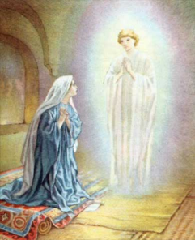
Our Permission Not Needed
“I am the Lord’s servant,” Mary answered. “May your word to me be fulfilled.” Then the angel left her. (Luke 1:38)
When Joseph woke up, he did what the angel of the Lord had commanded him and took Mary home as his wife. (Matthew 1:24)
God did not ask Mary or Joseph for their permission to bring Jesus into the world. He simply sent an angel to tell them His plan and will for their lives. That was it!
God’s plan may not be revealed to us by the same means as how Mary and Joseph got their message. Yet we will ultimately end up where we should be through the many circumstances in our lives, not just by our own planning. You will know if you are not at the centre of God’s will for your life. God gives you the choice to obey or to disobey – but you cannot run away forever.
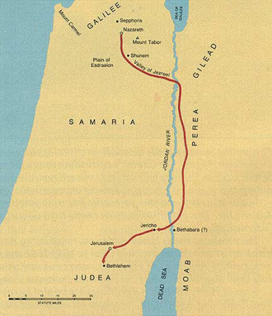
Learn to trust that His ways are higher than your way, and that His way, will lead you to miracles and blessings.

His Plan May Not Be Easy
Life was certainly not easy for Mary, Joseph and Jesus! While Mary was pregnant, Caesar Augustus issued a decree that a census to be taken throughout the Roman world (Luke 2:1). Everyone had to travel back to their hometown to register! Joseph and a heavily pregnant Mary had to travel from Nazareth to Bethlehem – a distance of about 120 kilometres, with some uphill portions at the elevation of 4000 feet (1.2 kilometres). They had to even take the long way round because Jews never journeyed through Samaria. The journey is estimated to have taken four to five days on foot.
Upon arrival, they had no place to stay. Jesus was born and was placed in a manger. When Jesus was between newly-born and two years old, this young family had to flee to Egypt due to Herod’s persecution - the killing of babies up to 2 years old as he heard of the news of a king being born. While Jesus was between thirteen to thirty years old, Joseph passed away. This meant that Mary became a single mother and Jesus, the head of the household.
The Bible never once said that obeying meant that it was going to be easy. God’s main purpose is not for us to be happy, healthy and wealthy; rather, His purpose is to make us Holy. His promise to you and me, is that no matter what the circumstances or how we feel, He “will never leave you nor forsake you” (Deuteronomy 31:6; Joshua 1:5; Hebrews 13:5)

His Plan Through You Becomes a Blessing
And the child grew and became strong; he was filled with wisdom, and the grace of God was on him. (Luke 2:40)
Put yourself in Mary’s shoes: being a mother and witnessing everything Jesus went through – watched him grow and learn His father’s trade (carpentry) and became strong physically; listened to Him speaking and debating wisely with friends, family and religious teachers; observed how people favoured Him; watched Him die on the cross and heard Him commissioning His disciple to be her son in His place; interacting with Him again when He returned to life; looking at Him as He ascended to heaven and having the promise of His coming again.
Mary had been through many things in her life by obeying God. Forever she is acknowledged as the Blessed Virgin. We too can be a blessing to others, if we obey and allow God to use us for His sovereign plan.

In Closing…
“For I know the plans I have for you,” declares the Lord, “plans to prosper you and not to harm you, plans to give you hope and a future. (Jeremiah 29:11)
Pastor Chris shared Fanny Crosby’s (1820 – 1915) story. At six weeks old, she contracted flu and developed an eye infection. Mustard poultice was prescribed, which may have caused her permanent blindness. She grew up rooted in the Word (having memorized the Bible), and became "Queen of Gospel Song Writers" with almost 9000 hymns to her name – one of which is “Blessed Assurance”. For someone who is so blessed with music, mission and a heart for God, one might have asked why such a thing happened to her. Her reply to such a question was “If I had a choice, I would still choose to remain blind...for when I die, the first face I will ever see will be the face of my blessed Saviour. It seemed intended by the blessed providence of God that I should be blind all my life, and I thank him for the dispensation.”
As we go through life, let us change the way we look at life. God chooses the ordinary to make the extraordinary. Let us choose to obey and make it our story, our song.
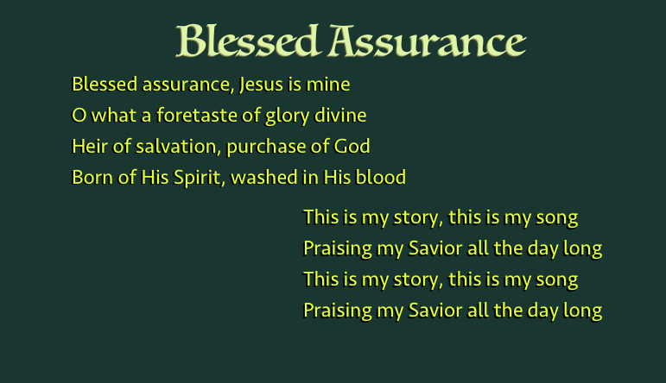
Sermon summary contributed by Adeliyn
Prayer points contributed by Michelle

SERMON: Beautiful King - From Obedience to Faithfulness
Pray:
- God's people will remember to be obedient to His Will with a heart of commitment towards Him.
- We will intentionally obey and carry out God's plan with perseverance and remain faithful by trusting Him.
- We will be a blessing to those whom He has directed us to by obeying His instructions.
- We will be faithful to His plan as He will not forsake us but make us Holy.
“For I know the plans I have for you," declares the Lord ,"plans to prosper you and not to harm you, plans to give you hope and a future.+” (Jeremiah 29:11)

MINISTRIES & EVENTS: CROSSFIELDS 2018 - Sarawak (Iban)
24 - 30 MARCH 2018
Pray:
- God will convict the hearts of all believers to join Crossfields in reaching out to the unreached people.
- God will inspire more people of God to step up to go forth with faith to share His Good News with the breakthrough in language through translation.
- God will enable His leaders to train and equip those called to serve effectively in the mission field in Sarawak.
- God will bless the leaders in charge with wisdom, knowledge and understanding to do His Will.
‘The Spirit of the Lord is on me, because he has anointed me to preach good news to the poor. He has sent me to proclaim freedom for the prisoners and recovery of sight for the blind, to release the oppressed, to proclaim the year of the Lord’s favour.’ (Luke 4: 18-19)

MALAYSIA MY NATION: CHURCHES IN MALAYSIA
UNITY OF THE NATION
Pray:
- People of God will have wisdom to pray for their own oikos in Malaysia.
- Church leaders will step out in boldness and wisdom to bear witness of unity among God's people in their localities.
- God’s strength and wisdom upon church leaders to unite to pray for our nation in preparation for GE14.
- God will reveal Himself to leaders in every rank and file in Malaysia in dreams and visions of their purpose for Malaysia.
‘Therefore I tell you, whatever you ask for in prayer, believe that you have received it, and it will be yours.’ (Mark 11:24)

- A TRANSFORMED WORLD: Pakistan
Pray:
- God's protection, strength and grace on leaders and people of underground house churches who are boldly seeking to share the gospel and grow the churches.
- God’s hand on the government to ease restrictions on church planting as a restoration and healing process for the nation.
- Persecutors to have a change of heart – compassion, and experience the Love of Christ.
- God's healing and restoration upon the victims and families of the Bethel Church incident in Pakistan.
‘What answer shall be given to the envoys of that nation? The Lord has established Zion, and in her his afflicted people will find refuge.’(Isaiah 14:32)

