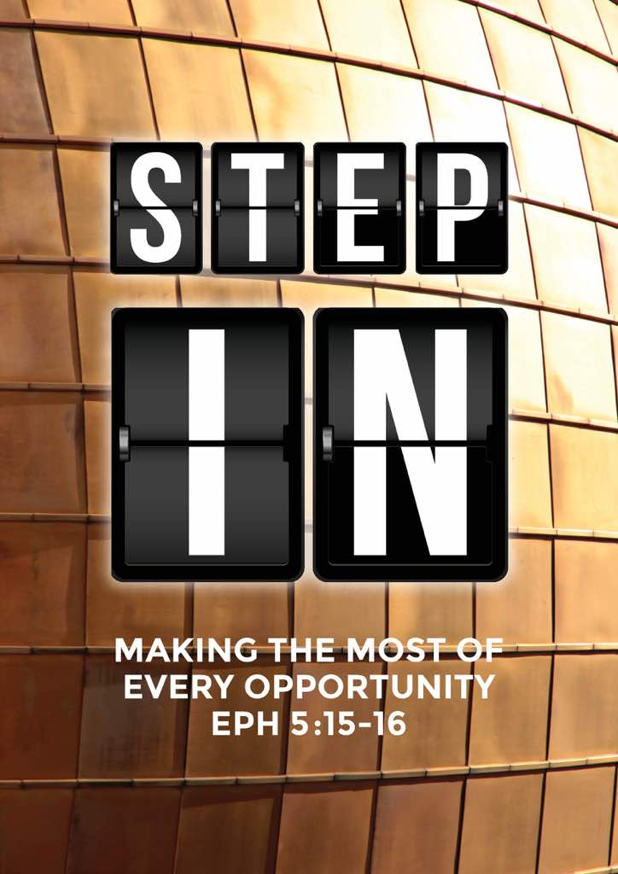
Forward2018: Step In – Making the Most of Every Opportunity (Ephesians 5:15-20; Colossians 4:2-6)
Senior Pastor Chris Kam

Be very careful, then, how you live—not as unwise but as wise, making the most of every opportunity, because the days are evil. Therefore do not be foolish, but understand what the Lord’s will is. Do not get drunk on wine, which leads to debauchery. Instead, be filled with the Spirit, speaking to one another with psalms, hymns, and songs from the Spirit. Sing and make music from your heart to the Lord, always giving thanks to God the Father for everything, in the name of our Lord Jesus Christ. (Ephesians 5:15-20)

Devote yourselves to prayer, being watchful and thankful. And pray for us, too, that God may open a door for our message, so that we may proclaim the mystery of Christ, for which I am in chains. Pray that I may proclaim it clearly, as I should. Be wise in the way you act toward outsiders; make the most of every opportunity. Let your conversation be always full of grace, seasoned with salt, so that you may know how to answer everyone. (Colossians 4:2-6)

Introduction

When Pastor Chris stepped into the role of Senior Pastor about 3 years ago, he shared with us a 5-year vision. In the first year, as he stepped up into the new role, we were challenged as a church to Step Up as well. In the 2nd year we were challenged to Step Out, and did many amazing things as a church. This year we are challenged to Step In, to be open to opportunity calls from the Spirit and to continuously pray as always for the Spirit to lead us. Next year we will Step Forward – Pastor Chris admits that he does not know what this means at this point in time, but we can be assured that it will be a powerful year for the church.

As we move forward into the new year to Step In, there are three things we need to be reminded of:

Be Very Careful
“Be very careful, then, how you live…” (Ephesians 5:15)
Paul said this in reference to Ephesians 5:14 (Wake up, sleeper, rise from the dead, and Christ will shine on you.”) He is reminding the Church of Ephesus – and the Church today! – to not be caught sleeping. We who have chosen to follow Christ are called to be the children of Light. Just as our parents ask us to be careful when we go out because they love us and do not want us to get hurt, Paul is reminding us to be careful that we do not lose our way and fall asleep in the faith.

How are we careless? In our fallen flesh nature, we do not always pay attention to what we do. We live in the present with no conscious vision for the future. The truth is that it is not that we do not know. It is that we fail to have the discipline to pay attention to the One Thing.

Note that this warning is not from Paul only. In fact, the reminder comes from the days of the Old Testament! Joshua’s final address to the people was to remind the Israelites to be careful to love the Lord. But as evident in the Old Testament, God’s Chosen fall away time and again. It just took one generation for the people to forget God.

“But be very careful to keep the commandment and the law that Moses the servant of the Lord gave you: to love the Lord your God, to walk in obedience to him, to keep his commands, to hold fast to him and to serve him with all your heart and with all your soul.” (Joshua 22:5)

“The Lord has driven out before you great and powerful nations; to this day no one has been able to withstand you. One of you routs a thousand, because the Lord your God fights for you, just as he promised. So be very careful to love the Lord your God.” (Joshua 23: 9-11)

Throughout the Bible, God is reminding us to love Him because He knows that we have the tendency to forget to love Him. How then do we Love Him? It is through obeying His commandments. Jesus Himself said, “If you love me, keep my commands.” (John 14:15) The Great Commission was for all disciples of Jesus to teach others to obey everything that Jesus has taught and commanded them to do (Matthew 28: 18-20) As we are reminded to be careful to love the Lord, be reminded that we Love Him by obeying His Word.

In this, we have to watch our:

Heart
Above all else, guard your heart, for everything you do flows from it. (Proverbs 4:23)

Some Christians are so hurt that they cannot serve. They refuse to leave their hurts at the cross, to the point where they get easily offended by everything. To get out of this cycle of keeping the hurt and getting hurt over and over again, we need to forgive and leave our hurts to the Lord. We need to be careful with relationships, whether in marriage, family or friendships. We also need to be careful with our words as careless words hurt the heart, and the wounds of the heart are the hardest to heal.

Attitude
Some Christians are selfish and are careless about serving. For them, God is about blessings and have no care about everything else. Christians cannot have this attitude as this contradicts what is taught in the Word. We have to think about the people around us.

Time
Be alert and of sober mind. Your enemy the devil prowls around like a roaring lion looking for someone to devour. (1 Peter 5:8)

Although Satan has been defeated by Jesus’ death on the Cross for the sins of the world, we still need to be careful. As Christ-followers in a fallen world, we are in a spiritual war by default. The Devil’s strategy is to:
- Quietly steal your attention from God – many of us do not realize that we are so preoccupied that we have no time for God’s work, some even to the point that they forget about God!
- Attack you like a lion and besiege you for your attention and time.
We have to aware of his tactics and not allow a foothold in your life. He cannot touch you if we are careful to love the Lord. We also need to careful in our lives before stepping into another’s life, going into it with the full power of God.

Be Wise
“Be very careful, then, how you live—not as unwise but as wise…” (Ephesians 5:15)
What is wisdom? It is something that comes from God. Foolishness is the absence of God in your life. To live wisely is to live God’s will for your life. For this to happen, we need to know 3 things about God’s will.

His Sovereign Will
Know and acknowledge that the Lord is in charge, even if we don’t understand everything about it. Jesus dying on the cross for the sins of the world was His sovereign will. The human mind cannot fully understand His sovereign will, but we can take comfort that no matter what, He is God.

His Revealed Will
We may not understand what drives God’s will, but He has revealed His will by “writing” the Bible through its many authors. This is the reason why we need to spend time reading the Bible. The Living Word will reveal the will for our life, church and what is happening in the world. We should not be asking God if we should marry a non-believer as the Bible clearly tells us not to do so.

That is why the Bible is known as the acronym for Basic Instructions Before Leaving Earth.

His Individual Will
For we are God’s handiwork, created in Christ Jesus to do good works, which God prepared in advance for us to do. (Ephesians 2:10)

Just as He has made us different, God has a personalized individual plan for each of us! We can model after the lives of heroes of faith, but we should never want to live that person’s life. God already knows what His plans are for each and every one of our lives: the problem is that we never found out!

We need to commit to spend time in quiet time to pray, read His Word and listen when the Holy Spirit speaks.

Be Mindful of Every Opportunity
Be very careful, then, how you live—not as unwise but as wise, making the most of every opportunity (Ephesians 5:15)
Know that we do not need to go out hunting for an opportunity. All we need is to be in tune with God, and each of us will be directed to the opportunities.

In the same way, let your light shine before others, that they may see your good deeds and glorify your Father in heaven. (Matthew 5:16)
Opportunities for good deeds abound. Know that the receiver of good deeds will point back to the Father.

Be wise in the way you act toward outsiders; make the most of every opportunity. (Colossians 4:5)
What we need is to allow ourselves to be led by the Holy Spirit. Again you do not have to look for opportunities. All we need to do is to let the Spirit lead you, and act on the opportunity.

Closing words
Pastor Chris had shared with us many times before that when we wake up we should say “Good morning Holy Spirit!” first thing in the morning instead of reaching for our smartphones or doing the chores of the day. He shared that perhaps it is time for us to end the day with saying “Good night Holy Spirit”. All this is about consciously living with and in the Holy Spirit. After all, Step In is about having the Holy Spirit leading our lives.

An upcoming Church-wide opportunity is DUMC Anniversary Gift Weekend on the 13-14 January – where each of us are given the opportunity to pray and share the cost of the many organization involved in missions, education and theological works in effort to further God’s Kingdom. There are many opportunities around us in the Malaysian diaspora as we have many scattered people – Myanmar, Nepali, Filipino, Iranian currently as part of our congregation. Malaysia is also the local mission field where many of our neighbours and colleagues do not know Christ. Furthermore, Malaysia aims to be a Global Education Destination. It is estimated that the number of foreign students will triple by 2020. We need to be prepared to serve these students in the love of the Lord. There are also 2 – 6 million migrant workers (legal and illegal) working here in Malaysia.

In fact we are blessed by the Myanmar Ministry. They come into Malaysia as migrant workers, yet they have showed great faith through their training. Right now the Myanmar congregation in DUMC is one of the biggest congregations in the world, rival only by the church in Myanmar, and at the current rate, it may become the biggest Myanmar Christian congregation in the whole world. Hundreds have given up their jobs to join the 13-week long TSOD (The School of Discipleship), trusting that God will provide them with finances during the course, and jobs after finishing the course. Some after successfully passing interviews by the pastor, have answered the call to continue the 13-week long TSOL (The School of Leadership), trusting God fully for all their needs. The graduates of TSOL are now challenged to full-time work back home in Myanmar.

Most of the opportunities continue to be available in our own communities. Last year, the church participated in the Homecoming Christmas Party hosted by Cell Groups as part of the Step Out challenge. Many had joined us by invitation and a number had come to Christ (numbers below). We need to continue to follow and disciple these persons.
 | Invited Guests | Came to Christ
English | 1883 | 68
Vernacular (Bahasa, Chinese, Tamil, Nepali) | 262 | 27
Myanmar | 17763 | 6371

In short, we need to continue to equip ourselves to Step Up to the call, Step Out in Faith, and call on God’s strength to Step In into the opportunities as the Holy Spirit leads us.

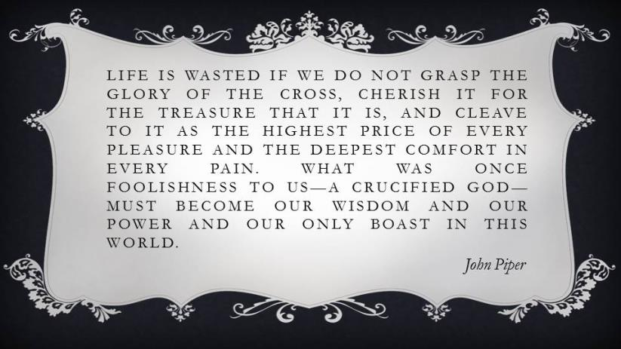

Sermon summary contributed Adeliyn.

