Forward2018: Step In – Discipling the Next Generation-Children’s Church (Deuteronomy 6:1-9)
Senior Pastor Chris Kam
Love the Lord Your God
These are the commands, decrees and laws the Lord your God directed me to teach you to observe in the land that you are crossing the Jordan to possess, so that you, your children and their children after them may fear the Lord your God as long as you live by keeping all his decrees and commands that I give you, and so that you may enjoy long life. Hear, Israel, and be careful to obey so that it may go well with you and that you may increase greatly in a land flowing with milk and honey, just as the Lord, the God of your ancestors, promised you. (Deuteronomy 6:1-3)

The Shema:
Hear, O Israel: The Lord our God, the Lord is one. Love the Lord your God with all your heart and with all your soul and with all your strength. These commandments that I give you today are to be on your hearts. Impress them on your children. Talk about them when you sit at home and when you walk along the road, when you lie down and when you get up. Tie them as symbols on your hands and bind them on your foreheads. Write them on the doorframes of your houses and on your gates. (Deuteronomy 6:4-9)

Introduction
Ephesians 5:15 reminds us of the first 3 of 5 sermons in the FORWARD2018, they are
- Ephesians 5:15 – Be very careful, be wise and be mindful of every opportunity.
- 2Corinthians 9:8 – The Presence of God is the Blessed Life.
- 2Corinthians 9:6-15 – Don’t be like the Dead Sea, Be a Blessing and Serve People.
Deuteronomy:
2…so that you, your children and their children after them may fear the Lord your God…. (Deuteronomy 6:2)
7 Impress them on your children.

BIG IDEA: It’s not about the things we can pass on to our children, but the time we can be with them.

There are 3 main areas of the heart we need to look into when we Step In to Discipling the Next Generation.

How do we pass it on to the children?

Inspiration of the Heart
“Hear, O Israel: The Lord our God, the Lord is one. Love the Lord your God with all your heart and with all your soul and with all your strength. (Deuteronomy 6:4-5)
- We must be inspired in our hearts by the Lord first before discipling our children and others.
- Be on ‘fire’ for Him which reveals the reality of our faith.
- Need to have encounters with God to be able to share with our children from our hearts.
The keyword is ‘all’. We need to love God with everything we have. Children need to see that we love God with our all.

In the future, when your sons ask you,” What is the meaning of the stipulations, decrees and laws the Lord our God has commanded you?” tell him: (Deuteronomy 6:20-21)

It takes a village to raise a child. Many a times we Asian parents and especially grandparents want to give their best to their children. As such many parents forsake being with their children to work harder to provide the best for them. But thank God who always provide mentors when needed. For example, Queen Esther had her uncle Mordecai as her mentor. We need to be there with them.

Integrity of the Heart
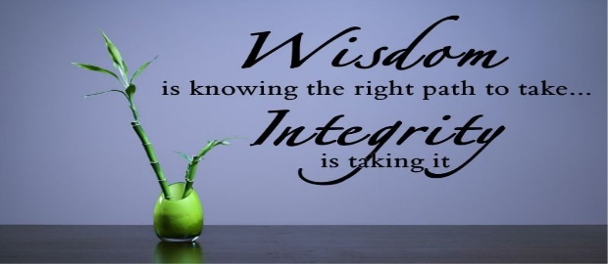
“These commandments that I give you today are to be on your hearts.” (Deuteronomy6:6)
The Jews literally practise wearing the Word of God on themselves using phylacteries for their prayers.
Tie them as symbols on your hands and bind them on your foreheads. (Deuteronomy6:8)
We as the people of God should:
- live out the commandments that God gave.
- be consistent in all we do
  - we cannot pretend about our faith.
  - what we preach must be seen and are real.
  - honour God.
  - love our neighbour (next generation) by taking.
- be responsibility in showing them that the church is also theirs through welcoming them in our celebration and discipling them.
Share our personal experience, our encounter with God and live Christian life wholeheartedly. This is something to tell the children.

Do we have our own stories? Have we grown in our Christian life? Do not just provide religious education but give them a God encounter.

Instruction of the Heart (Passing On)
“Impress them on your children. Talk about them when you sit at home and when you walk along the road, when you lie down and when you get up. Tie them as symbols on your hands and bind them on your foreheads. Write them on the doorframes of your houses and on the gates.” (Deuteronomy 6: 7-9)
DUMC do not practice parallel celebration for Children’s Church because we encourage children to be together with the adults during Celebration. We want to impress them to be familiar about attending church from young.
Figure 1- Mezuzot – God’s Words on the doorframe

Whatever we do or think must be according to God’s Words - everything we do in life: instructing, modelling, habitual deeds: such as attending church regularly, praying and reading His Word daily. In principle - what you do with your hands or think in your mind must always align with God’s word. Live by the ways of God.
Finally, parents are the primary educators of their children.
“Fathers, do not exasperate your children; instead, bring them up in the training and instruction of the Lord.” (Ephesians6:4)

If you do not grow in Christian life, the primary responsibility is your own.

The whole church becomes modelling to children. Children should be welcome in the church. Bring them up in the rhythm of church life.

Parents need to:
- be equipped to be able to bring up the children in the Ways of the Lord
- Instil the rhythm of Church life to the next generation -> must see this as part of their life
- Instil the importance of Holy Communion to the next generation
- share prayers for people and the need to be prayed for
- share the act of tithing as the way of giving thanks to God for his providence
- leave it as a legacy for them

CONCLUSION:
But it still takes a village to raise a child because:
- We are not fully equipped as parents.
- We do not have all the answers to our children’s questions.
- We need them to grow up loving God and loving their neighbours as themselves.
- They need to be a living part of the community of God.

Dedication Prayer by Parents:
Dear Lord, we bring our child before You. We sincerely dedicate this precious life to you. You have given this child to us and we accept this responsibility with humility, knowing that it is through You that we are empowered to be godly parents. Let our lives and marriage bring great blessing and security to the child.

Lord, write into his/her heart Your words of wisdom so that he / she may not depart from them when he / she
grows up. Give us Your wisdom to guide him / her in all Your ways. May he / she glorify Your Name all the days of his / her life.

In the Name of the Father, the Son and the Holy Spirit. Amen.

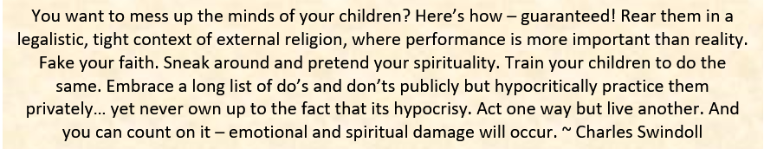

Sermon summary by Michelle Chuah

