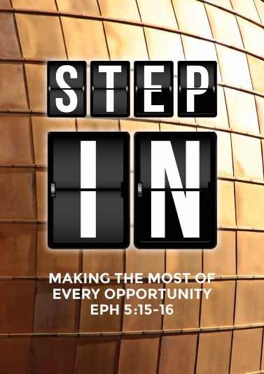
Pit Stop
(Psalm 46:1-11)
Brother Terry Yeow

God is our refuge and strength,
an ever-present help in trouble.
Therefore we will not fear, though the earth give way
and the mountains fall into the heart of the sea,
though its waters roar and foam
and the mountains quake with their surging.
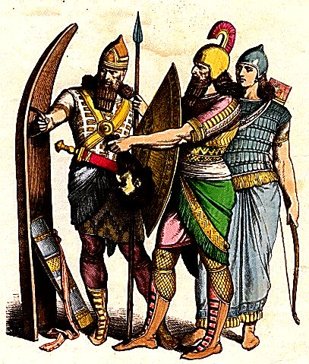
There is a river whose streams make glad the city of God,
the holy place where the Most High dwells.
God is within her, she will not fall;
God will help her at break of day.
Nations are in uproar, kingdoms fall;
he lifts his voice, the earth melts.
The Lord Almighty is with us;
the God of Jacob is our fortress.
Come and see what the Lord has done,
the desolations he has brought on the earth.
He makes wars cease
to the ends of the earth.
He breaks the bow and shatters the spear;
he burns the shields with fire.
He says, “Be still, and know that I am God;
I will be exalted among the nations,
I will be exalted in the earth.”
The Lord Almighty is with us;
the God of Jacob is our fortress.
(Psalm 46:1-11)

Introduction

Our goal in life should not be to finish the fastest but to finish the race.

The background to Psalm 46 is found in 2 Kings 18-19 where King Sennacherib and his Assyrian army were surrounding Jerusalem. They sent a delegation to mock King Hezekiah of Judah and God. King Hezekiah then prayed a prayer of desperation. In reply, God sent an angel at night to put 185,000 Assyrians to death while King Sennacherib himself was later murdered by his own sons.

From this story, we learn not to mock God and that our God can be trusted and has to be trusted at all times.

BIG IDEA
Be still in the midst of chaos.

He is our strength and refuge
God is our refuge and strength, an ever-present help in trouble. Therefore we will not fear, though the earth give way and the mountains fall into the heart of the sea (Psalm 46:1-2)

Where do we usually find our refuge and help? We can sometimes tend to rely on human strength and counsel. However, the realities are that:

- He will be our refuge in times of danger.
- He will be our strength when we are weak.
- He will be our ever-present help when we are lost and far away.

Our God is a great God
There is a river whose streams make glad the city of God, the holy place where the Most High dwells. (Psalm 46:4)

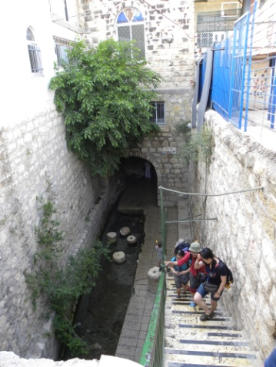
God brings comfort, security and hope. The river referred to in this verse is an underground river built by King Hezekiah. No army or weapon that is against Him and His people shall prosper.

God is within her, she will not fall; God will help her at break of day. Nations are in uproar, kingdoms fall; he lifts his voice, the earth melts. The Lord Almighty is with us; the God of Jacob is our fortress. Come and see what the Lord has done, the desolations he has brought on the earth. He makes wars cease to the ends of the earth. He breaks the bow and shatters the spear; he burns the shields with fire.
(Psalm 46:5-9)

We can take comfort that God is on our side.

Be still
He says, “Be still, and know that I am God; I will be exalted among the nations, I will be exalted in the earth.” (Psalm 46:10)

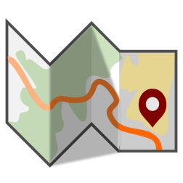
Being “still” is not being idle. The Hebrew word used is “rapha” which means to be weak, to let go and to surrender. What is the posture that we carry in a difficult situation? Do we surrender that situation to the Lord?

Conclusion
Trust the Lord as His plans are perfect. Surrender your plans and situations to Him as He is a great God.

For I know the plans I have for you,” declares the Lord, “plans to prosper you and not to harm you, plans to give you hope and a future. Then you will call on me and come and pray to me, and I will listen to you. You will seek me and find me when you seek me with all your heart. I will be found by you,” declares the Lord, “and will bring you back from captivity. I will gather you from all the nations and places where I have banished you,” declares the Lord, “and will bring you back to the place from which I carried you into exile.” (Jeremiah 29:11-14)

We need to seek God with all our hearts in order to find God and His plans for us.

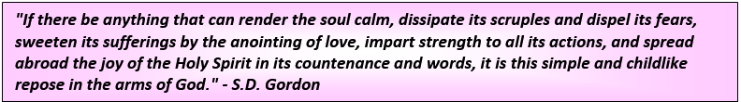

Sermon summary by Zhenli.

