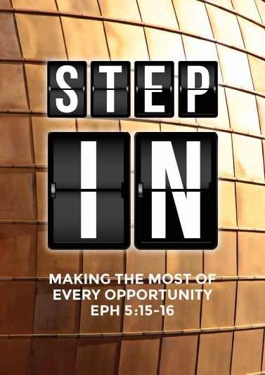
Prayer Series – Breathe II: Why Pray?
(The Lord’s Prayer)
Matthew 6:5-15
Senior Pastor Chris Kam

“And when you pray, do not be like the hypocrites, for they love to pray standing in the synagogues and on the street corners to be seen by others. Truly I tell you, they have received their reward in full. But when you pray, go into your room, close the door and pray to your Father, who is unseen. Then your Father, who sees what is done in secret, will reward you. And when you pray, do not keep on babbling like pagans, for they think they will be heard because of their many words. Do not be like them, for your Father knows what you need before you ask him.

“This, then, is how you should pray: “‘Our Father in heaven, hallowed be your name, your kingdom come, your will be done, on earth as it is in heaven. Give us today our daily bread. And forgive us our debts, as we also have forgiven our debtors. And lead us not into temptation, but deliver us from the evil one.’ For if you forgive other people when they sin against you, your heavenly Father will also forgive you. But if you do not forgive others their sins, your Father will not forgive your sins. (Matthew 6:5-15)
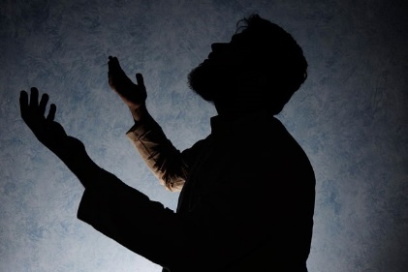

Introduction

Question 1: Rate your personal prayer life between 1 and 10. (1 - Not good; 10 – Very good)

Question 2: In what ways do you struggle with your personal prayer? How would you like your prayer life to be like?

There are 3 reasons for our struggle in prayer:
- Undisciplined – We have problem setting aside time to pray, but no problem doing other things, like watching our favorite show on TV.
- Not motivated – This is a matter of the heart and emotions. We pray but things do not seem to happen. We are not inspired to pray, because when we pray it seems like things do not happen.
- Do not understand – We need to be educated on why prayer is so important and necessary. You can be a Christian and live a prayer-less life for a long time, praying only when you have a need, thanking God for the food, praying for a parking lot.
We do not pray in order to be accepted by God. This is a wrong theology. God has already loved, forgiven and accepted us. We pray because prayer is like breathing for Christians.

“To be a Christian without prayer is no more possible than to be alive without breathing.” – Martin Luther

When we pray, we ourselves are changed. We will see a tremendous change of heart towards God and people. We will love God, serve people and make disciples.

People think they do not pray well because they do not pray the King James kind of prayer. One of the most effective prayers found in Bible is simply, “Lord, help me!”
Peter prayed that prayer and Jesus came and helped him.
But when he saw the wind, he was afraid and, beginning to sink, cried out, “Lord, save me!” (Matthew 14:30)

The disciples were caught sleeping when Jesus went away to pray. Jesus told them to watch and pray so they will not fall into temptation.
Then he returned to his disciples and found them sleeping. “Simon,” he said to Peter, “are you asleep? Couldn’t you keep watch for one hour? Watch and pray so that you will not fall into temptation. The spirit is willing, but the flesh is weak.” (Mark 14:37-38)

Our Father in heaven, hallowed be your name,
your kingdom come, your will be done, on earth as it is in heaven.
Give us today our daily bread.
And forgive us our debts, as we also have forgiven our debtors.
And lead us not into temptation, but deliver us from the evil one.
(for yours is the kingdom and the power and the glory forever. Amen.)
(Matthew 6:9-13)

The last line ‘for yours is the kingdom and the power and the glory forever. Amen.’ is not found in the NIV. It was deliberately added by someone as they copied the Scriptures to make the ending sound better.

Jesus reminded the people not to pray loudly and babble away like the hypocrites.
And when you pray, do not be like the hypocrites, for they love to pray standing in the synagogues and on the street corners to be seen by others. Truly I tell you, they have received their reward in full. But when you pray, go into your room, close the door and pray to your Father, who is unseen. Then your Father, who sees what is done in secret, will reward you. And when you pray, do not keep on babbling like pagans, for they think they will be heard because of their many words. Do not be like them, for your Father knows what you need before you ask him. (Matthew 6:5-8)

Posture and attitude in prayer:

- Pray secretly
There is nothing to show off about or to compare. Do not go around judging people, how long they pray and the way they pray and so on.

- Pray sincerely
Pray from the heart. There is no need to use bombastic words. Pray authentically. Pray sincerely and not superficially.

BIG IDEA To Pray is to Know the Heart of God.

3 Reasons to pray:

Prayer is Personal (Builds relationship)
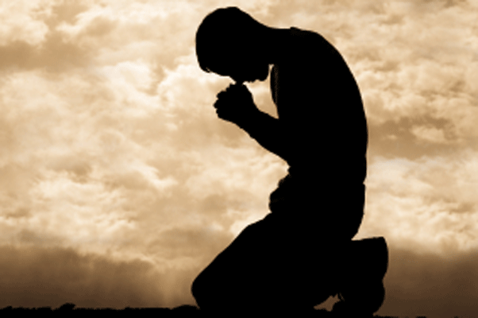
Abba means Daddy. This is how we can address God, as our Heavenly Father.

Question 3: Why do our prayers build intimacy and relationship with God in relation to Matthew 6:9?

Communication is very important in a relationship. Even in a marriage relationship, talking and communication is important to build intimacy in our marriage with our spouses. This is also the same in our relationship with God. This is how we grow closer to Him.

Prayer is not just about making ourselves heard, but also about hearing what God has to say. Communication in our relationship with God, like every other relationships, goes both ways too.

Prayer is not to change the plan or mind of God. We cannot change the heart and mind of God.

We need to know that even if our prayers are not answered, we know that God has heard our prayers and we grow closer to Him.
I love the Lord, for he heard my voice; he heard my cry for mercy. (Psalm 116:1)

The Lord is near to all who call on him, to all who call on him in truth. (Psalm 145:18)

We pray more when bad things happen in our lives. Sometimes God, in His love for us, will allow bad things to happen to us so we will pray and draw close to Him.
Let us then approach God’s throne of grace with confidence, so that we may receive mercy and find grace to help us in our time of need. (Hebrews 4:16)

Prayer is Peace
Do not be anxious about anything, but in every situation, by prayer and petition, with thanksgiving, present your requests to God. And the peace of God, which transcends all understanding, will guard your hearts and your minds in Christ Jesus. (Philippians 4:6-7)

I have told you these things, so that in me you may have peace. In this world you will have trouble. But take heart! I have overcome the world. (John 16:33)

This is a peace that transcends all understanding, a peace we do not understand. This is a peace that guards, protects and watch over our hearts and minds in Christ Jesus.

God does not promise we will get all that we ask for. But He promises to be with us all the way.

Prayer is Power (Brings result)
And the prayer offered in faith will make the sick person well; the Lord will raise them up. If they have sinned, they will be forgiven. Therefore confess your sins to each other and pray for each other so that you may be healed. The prayer of a righteous person is powerful and effective. Elijah was a human being, even as we are. He prayed earnestly that it would not rain, and it did not rain on the land for three and a half years. Again he prayed, and the heavens gave rain, and the earth produced its crops. (James 5:15-18)
Question 4: Do you have a prayer request regarding a situation in your life that needs the peace and the power of breakthrough from God? What is God saying in this situation you are in?

The objective of prayer is not to pray what we want, but to pray what God wants. As you mature in the Lord, you will realise that many prayers in the past are very selfish and self-centred. When we pray according to the heart of God, amazing things happen.

God does not change. But it is wrong thinking to think we have no power to change anything. God has relented due to prayer and did not bring on the disaster He planned.
Then the Lord relented and did not bring on his people the disaster he had threatened. (Exodus 32:14)

Conclusion

We can change certain things, but we cannot change the ultimate outcome of things. We know that God governs all things, but we do not know how God really works in the creation of the world. God will still achieve His purpose, He still has a sovereign plan. However, He still calls us to pray. He uses humans this way. There is no shortcut to knowing and understanding God’s heart.
In him we were also chosen, having been predestined according to the plan of him who works out everything in conformity with the purpose of his will. (Ephesians 1:11)
“Prayer is a mighty instrument, not for getting man’s will done in heaven, but for getting God’s will done in earth.” – Robert Law

You desire but do not have, so you kill. You covet but you cannot get what you want, so you quarrel and fight. You do not have because you do not ask God. When you ask, you do not receive, because you ask with wrong motives, that you may spend what you get on your pleasures. (James 4:2-3)

There are 5 platforms of prayer: Honour, Kingdom, Provision, Forgiveness and Power.

Our assignment is to learn the Lord’s prayer by heart in the next few weeks. As an assignment this week, start your prayer by honouring Him first.

Sermon summary by Anthea.

