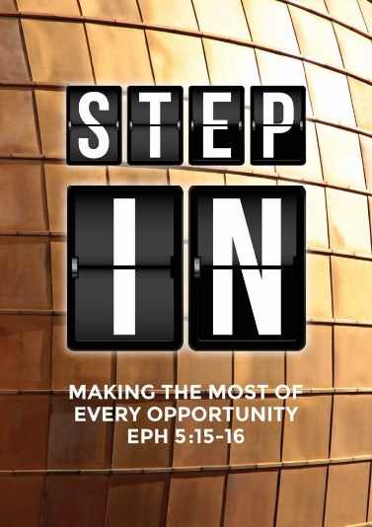
Prayer Series – Breathe III: God’s Kingdom
(The Lord’s Prayer)
Matthew 6:5-15
Senior Pastor Chris Kam

Our Father in heaven, hallowed be your name, your kingdom come, your will be done, on earth as it is in heaven. Give us today our daily bread. And forgive us our debts, as we also have forgiven our debtors. And lead us not into temptation, but deliver us from the evil one. (for yours is the kingdom and the power and the glory forever. Amen.)
(Matthew 6:9-13)

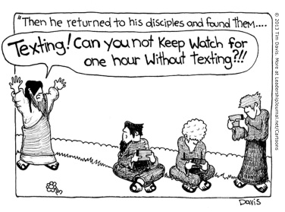
This is a modern interpretation of the story where Peter, James and John fell asleep for an hour, a reminder where all of us can be distracted.

Platform 2: God’s Kingdom

How can we pray ‘Your Kingdom come, Your will be done’?

After this, Jesus traveled about from one town and village to another, proclaiming the good news of the kingdom of God. (Luke 8:1)

Proclaiming the good news is central to the teaching of Jesus. The word ‘Kingdom’ comes up 123 times in the four gospels. Outside the gospels, the word ‘Kingdom’ comes up 27 times in the New Testament.

The purpose of God in creating the world is to establish His Kingdom reign. Because of the sin of Adam and Eve, the dominion over the world was transferred to Satan, although God still has dominion over the world. Christ has now come to reclaim the dominion through the Cross and through His Resurrection. Through the Holy Communion, we celebrate that Jesus has come to claim back the dominion over the world. When Jesus returns, He will have complete reign, when He creates a new heaven and a new earth.

Where the hearts of man are not surrendered to Jesus, that is the kingdom of darkness. The Kingdom of God is the reign of Christ in the lives of His Kingdom people with growth in spiritual breadth and depth.

BIG IDEA:
To Pray for His Kingdom to come is to extend the Heart of God to the World.

Your Kingdom Come (Transformation)

The kingdom of God transforms us individually

During the time of Jesus, many Jewish people misunderstand the Kingdom of God. They thought that the Kingdom of God is national in scope. They were under the rule of the Roman empire and were crying to God. They thought that the Messiah will come to deliver them from the evil Roman empire. The Jews were thinking in terms of political and military might. They got it wrong.

The Lord’s prayer reminds us that our hope is in Him. Our hope can only come when there is repentance of the heart.

In the study of church history, the decline of the church actually took place during the reign of the first Christian Roman emperor, Constantine. The answer does not come from political power. The answer comes the Kingdom of God.

Once, having been asked by the Pharisees when the kingdom of God would come, Jesus replied, “The kingdom of God does not come with your careful observation, nor will people say, ‘Here it is,’ or ‘There it is,’ because the kingdom of God is within you.” (Luke 17:20-21, NIV84)

The kingdom of God is within us. It happens when we invite God into our lives. No one can see the Kingdom of God unless he / she is born again. There is a physical birth which allows us to belong to this nation. In the same way, to be in the Kingdom of God, there needs to be a spiritual birth. To be born again, we need to accept the Lord Jesus Christ as our Lord and Saviour. Through the resurrection of Christ, we are made alive in the Kingdom of God. It is a spiritual kingdom that we are in, not a physical kingdom. Although we are in this world, we are not of this world. That is why the Bible calls us ‘aliens’. The kingdom is in the heart of believers. It is not a physical or geographical kingdom.

“By blood I am Albanian. My citizenship is Indian. I am a Catholic nun. As to my calling, I belong to the world. As to my heart, I belong entirely to the heart of Jesus.” ~ Mother Teresa

We are also called ‘pilgrims’ on this earth.

The kingdom of God transforms the world

Jesus has reminded us that for as long as we are in this world, the world will hate us. The world will not love us when we say we are ‘Christians’.
I have given them your word and the world has hated them, for they are not of the world any more than I am of the world. My prayer is not that you take them out of the world but that you protect them from the evil one. They are not of the world, even as I am not of it. Sanctify them by the truth; your word is truth. As you sent me into the world, I have sent them into the world. (John 17:14-18)

We may be in this world, but we are not of this world; and we are sent to the world.

Some Christians are worldly, that when you put them side-by-side with non-Christians, you cannot tell the difference. This is a sad state of affairs when people cannot tell that you belong to the Kingdom of God.

When the world can tell the difference, then we have truly established the Kingdom of God. The Kingdom of God needs to transform us. Can the people around tell that there is a difference in us? If they cannot, then perhaps the Kingdom of God has not yet come into our lives. The Kingdom of God cannot transform the world until it has transformed the individual.
The Kingdom of God is not for our own private enjoyment. Unless we are transformed individually in our hearts, we cannot have the kingdom of God transform the world. The transformation must come individually first. The Kingdom of God must be out there influencing and affecting. The Kingdom of God is not just about me and Jesus; it’s about the world.

We need to die to self. Unless we die, new life cannot come. The Kingdom of God is about a radical way of living.

Therefore, we are ambassadors for Christ, God making his appeal through us. We implore you on behalf of Christ, be reconciled to God. (2 Corinthians 5:20)

There is no desire for any Christians to establish a Christian nation because the Kingdom of God is in our hearts. We are to establish a spiritual kingdom. It is a privilege to be called an ambassador of God. The purpose of the Kingdom of God is to bring Christ to the world.

The kingdom of God is now
But if it is by the Spirit of God that I drive out demons, then the kingdom of God has come upon you. (Matthew 12:28)

“Blessed are you who are poor, for yours is the kingdom of God. (Luke 6:20)

After his suffering, he presented himself to them and gave many convincing proofs that he was alive. He appeared to them over a period of forty days and spoke about the kingdom of God. (Acts 1:3)

Jesus reminded the believers that when you are in Christ, you are in the Kingdom of God.

They arranged to meet Paul on a certain day, and came in even larger numbers to the place where he was staying. He witnessed to them from morning till evening, explaining about the kingdom of God… (Acts 28:23)

‘Kingdom of God’ is prominent in the mind of Jesus and Apostle Paul, and it must be prominent in our minds. They established the Kingdom of God with the hearts of people, so that this kingdom has an impact on the world out there. This is why we evangelise. If we have experienced the forgiveness of sin in our lives, we know that the Kingdom of God is.

Whether you believe in the laws of gravity or not, you will break a leg if you jump from higher ground. If you learn the laws of gravity, you can make use of it, for example by learning how to fly. Whether you believe in spiritual law or moral law or not, it will affect you.

God teaches us the laws of the Kingdom. When we live according to the laws of the Kingdom of God, blessings flow. When we follow the laws of Christ, we begin to experience blessings. When we pray ‘Your Kingdom come’, we are praying the laws of obedience. We are saying that we are the people of the Kingdom and we live according to the laws of the Kingdom. The laws of the Kingdom are found in the Bible. When we don’t follow, we bring curses into our lives. Things will be better, but it may not always go well.

“We must go through many hardships to enter the kingdom of God,” (Acts 14:22)

“It’s hard to remember that Jesus did not come to make us safe, but rather to make us disciples, citizens of God’s new age, a kingdom of surprise.” ~ Dr Stanley Hauerwas, Duke University

The kingdom of God is Not Yet
Sometimes we cling so close to this side of heaven, that we forget what the other side of heaven is. We have a taste of heaven on earth. The new heaven and earth will be an amazing place, when this fallen earth is already so beautiful. Jesus will destroy all that is old.

Do not cling on to this world too much, for when you do, you will realise that many of the things that you cling on to, will not show up on the other side.

Your Will be Done
Remember your destination, where there are no more tears and sorrows.

“Prayer is a mighty instrument, not for getting man’s will done in heaven but for getting God’s will done on earth.” ~ Robert Law

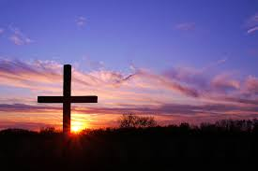
We are not praying our will, but God’s will. Praying is to know the heart of God. To pray for the Kingdom to come is to expand the heart of God. We pray that we have the right perspective of God. We seek first the Kingdom of God and His righteousness, and all things will be added to us. We are praying for people out there who needs Jesus.

Sermon summary by May.

