**Armour of God 1: Belt of Truth**

**(Ephesians 6:10-20; Genesis 3:1-13)**

**Pr Chris Kam**

Finally, be strong in the Lord and in his mighty power. Put on the full armor of God, so that you can take your stand against the devil’s schemes. For our struggle is not against flesh and blood, but against the rulers, against the authorities, against the powers of this dark world and against the spiritual forces of evil in the heavenly realms. Therefore put on the full armor of God, so that when the day of evil comes, you may be able to stand your ground, and after you have done everything, to stand. Stand firm then, with the belt of truth buckled around your waist, with the breastplate of righteousness in place, and with your feet fitted with the readiness that comes from the gospel of peace. In addition to all this, take up the shield of faith, with which you can extinguish all the flaming arrows of the evil one. Take the helmet of salvation and the sword of the Spirit, which is the word of God. (Ephesians 6:10-17)

Our struggle is within our mind. There is a need to surrender our minds to God, so that we can overcome the struggles.

For our struggle is not against flesh and blood, but against the rulers, against the authorities, against the powers of this dark world and against the spiritual forces of evil in the heavenly realms. (Ephesians 6:12)

Do not conform to the pattern of this world, but be transformed by the renewing of your mind. Then you will be able to test and approve what God’s will is—his good, pleasing and perfect will. (Romans 12:2)

There is an unseen world and forces fighting against us. In any sports or battle, knowledge of our opponent or enemy’s strategy is important. Once we know the enemy’s strategy, we are able to counteract it.

Be alert and of sober mind. Your enemy the devil prowls around like a roaring lion looking for someone to devour. Resist him, standing firm in the faith, because you know that the family of believers throughout the world is undergoing the same kind of sufferings. (1 Peter 5:8, 9)

The devil is like a roaring lion, but he is a toothless one. Resist his lies with God’s truth and we will defeat him.

Ephesians 6:14 read in a few Bible versions gives us a better understanding of the verse.

* Stand firm then, with the belt of truth buckled around your waist (NIV)
* Stand therefore, having fastened on the belt of truth (ESV)
* Stand your ground, putting on the belt of truth (NLT)
* Stand firm therefore, HAVING GIRDED YOUR LOINS WITH TRUTH (NASB)

Start with the belt. The Roman soldier had to “girded their loins” in order to run fast and not trip over their long tunics. The next picture shows how the soldier does this. The Roman soldier will tuck in the ends into the belt.

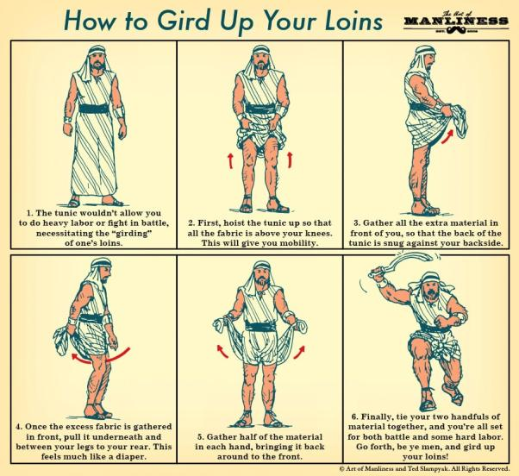

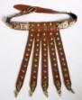

**BIG IDEA (Belt):**

**To counter deception, we must know the Truth.**

Truth is relative. When 2 people compare the time on their watches, we can have different time. No matter how much we debate over it, the correct time is only kept at several places on earth using an atomic clock. As Christians the truth is found in the word of God.

# The enemy creates doubt about the Truth. (Genesis 2:16,17; Genesis 3:1-3, 6)

A great example is the fall of man, the first sin, it shows how knowing truth was important. The devil questioned Eve and planted doubt.

Now the serpent was more crafty than any of the wild animals the Lord God had made. He said to the woman, “Did God really say, ‘You must not eat from any tree in the garden’?” (Genesis 3:1)

Let us look at the comparison of the Original Command and what Eve said. Note that God gave the command to Adam. It was Adam who taught it to Eve. Adam was also by Eve’s side when the conversation with the serpent was going on.

It is important to know the truth.

|  |  |
| --- | --- |
| God said (Original Command)  (Genesis 2:16-17) | Eve said  (Genesis 3:2, 3) |
| And the Lord God commanded the man, “You are free to eat from any tree in the garden; | The woman said to the serpent, “We may eat fruit from the trees in the garden, |
| but you must not eat from the tree of the knowledge of good and evil, | but God did say, ‘You must not eat fruit from the tree that is in the middle of the garden, |
| for when you eat from it you will certainly die.” | and you must not touch it, or you will die.’” |

# The enemy contradicts the Truth. (Genesis 2:17; Genesis 3:3,4)

**Eve said:** “...you will die.” (Genesis 3:3)

**The Devil:** “You will not certainly die,” the serpent said to the woman. (Genesis 3:4)

**God said:** “...you will certainly die.” (Genesis 2:17)

The devil said the opposite of what God had said. That is what the devil always does, the opposite of the good that God says and does.

# The enemy communicates an alternative to the Truth. (Genesis 3:5)

The devil’s words to Eve on eating the fruit.

“For God knows that when you eat from it your eyes will be opened, and you will be like God, knowing good and evil.” (Genesis 3:5)

This is what the devil always does. There are 2 lies.

* **Lie #1** – You are missing out on something.

God has already given man everything, dominion of the whole earth. Yet the devil tempts them that there is something more. A great example is we place before a child a Happy Meal and RM1 million. The child will choose the Happy Meal since the child does not understand the value of the money. The truth is the money is more valuable than the Happy Meal.

* **Lie #2** – You can be your own God.

The lie of being in control. To be our own man, to do things our way, to be independent of God. We need to dependent on God, to rely on Him. Ultimately man have to choose sides. There is no such thing as sitting on the fence.

So... if we are Not a servant of God, we then become a servant of the devil.

There is a sequence to the Fall: Devil’s lie: You will not certainly die. (Genesis 3:4)

* Sin (1 John 2:16)

For everything in the world—the lust of the flesh, the lust of the eyes, and the pride of life—comes not from the Father but from the world. (1 John 2:16)

The devil knows our weaknesses. That’s where he will attack. When we sin, we open ourselves to the devil and he will have a foothold in our lives. Confession will release us from the devil’s foothold.



* Shame (Genesis 3:10)

He answered, “I heard you in the garden, and I was afraid because I was naked; so I hid.” (Genesis 3:10)

Sin exposes our ‘nakedness’, we do not want people to know what we have done. Our shame, keeps us hiding in bondage.

* Blame (Genesis 3:12,13)

The man said, “The woman you put here with me—she gave me some fruit from the tree, and I ate it.” Then the Lord God said to the woman, “What is this you have done?” The woman said, “The serpent deceived me, and I ate.” (Genesis 3:12, 13)

We do not admit that we are at fault, that we are responsible.

* Consequences (Genesis 3:16-19)

To the woman he said, “I will make your pains in childbearing very severe; with painful labor you will give birth to children. Your desire will be for your husband, and he will rule over you.” To Adam he said, “Because you listened to your wife and ate fruit from the tree about which I commanded you, ‘You must not eat from it,’ “Cursed is the ground because of you; through painful toil you will eat food from it all the days of your life. It will produce thorns and thistles for you, and you will eat the plants of the field. By the sweat of your brow you will eat your food until you return to the ground, since from it you were taken; for dust you are and to dust you will return.” (Genesis 3:16-19)

Genesis 3:16 read in a few Bible versions.

* (NIV) Your desire will be for your husband, and he will rule over you.”
* (ESV) Your desire shall be contrary to your husband, but he shall rule over you.”
* (NLT) And you will desire to control your husband, but he will rule over you.”

This is what leads to problems and conflicts in marriages. The way to break this problem is for the “husbands, love your wives” (Ephesians 5:25) and “wives, submit yourselves to your own husbands” (Ephesians 5:22) .

Following is a list of lies that the devil uses against us and the bible verses to fight it.

1. My value is in my performance. (Ephesians 2:8,9)
2. My upbringing cannot be overcome - lost cause. (John 16:33)
3. If you look in the mirror and say, “God You must have made a mistake!” (Psalms 139:14)
4. I deserve better than this (You deserve the wrath of God - Romans 1,2,3)
5. If I do not feel love for him or her any more, our marriage is over. I sense that God is calling me to divorce my spouse. (Matthew 5:31,32, 19:1-12)
6. I am more important than those under me at work. (James 2:1-12)
7. To the anorexic girl – here is the lie – I am fat when I look in the mirror. (1 Samuel 16:7)
8. Trapped in materialism – I do not have enough. (Philippians 4:19)
9. To the unhappy husband - I deserve another relationship. (Ephesians 5:25)
10. To the sexually confused - homosexuality is natural.
11. If I do this, I will be satisfied and happy. (John 6:35)
12. No one will ever know. (Romans 14:12)
13. Grace covers it. God does not care. I should go for it. (Romans 6:1)
14. It is only one time. (The fall of King David - 2 Samuel 11)
15. Accusatory lies - (Romans 5:35; Romans 3:23,24; John 3:16; Hebrews 4:15,16)

When we sin, it is a choice that we make. Here are more truths for you.

**Fight these lies with these truths**

When tempted, no one should say, “God is tempting me.” For God cannot be tempted by evil, nor does he tempt anyone; but each person is tempted when they are dragged away by their own evil desire and enticed.  Then, after desire has conceived, it gives birth to sin; and sin, when it is full-grown, gives birth to death. (James 1:13-15)

The Word became flesh and made his dwelling among us. We have seen his glory, the glory of the one and only Son, who came from the Father, full of grace and truth. (John 1:14)

Jesus answered, “I am the way and the truth and the life. No one comes to the Father except through me. (John 14:6)

To the Jews who had believed him, Jesus said, “If you hold to my teaching, you are really my disciples.  Then you will know the truth, and the truth will set you free.” (John 8:31,32)

# Conclusion

3 things we need to do:

1. Take time to know the truth.

Read and study the Bible regularly.

1. Take your thoughts captive (2 Corinthians 10:4-5)

Take control of your thoughts and submit them to God.

1. Take your thoughts to the community

Join a cell group. God and even the devil know our thoughts. We need the community of the cell group to help us and keep us on the right path. It is the people in the cell group that is likely to know when we are falling away.

The roman soldier never stands alone. They always stand together.

“If you hold to my teaching, you are really my disciples. **32**Then you will know the truth, and the truth will set you free.”

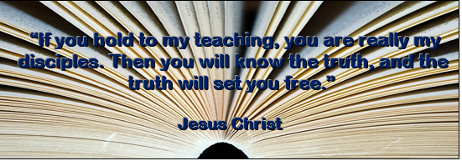

Sermon summary by Prudence.